

DBMS LAB ASSIG 1

• Name :HITU RAJ

• Roll no. :2005025

• Branch :CSE

-- 1. Create tables for - Student(student_id,

-- first_name, last_name, dept, Date_of_birth, gender,

-- religion), Employee, Product, Customer, and Account.

-- Identify relevant attributes for each table and make

-- sure each table has at least four columns. Ensure

-- each table has a _ID column e.g. Employee should

-- have EMPLOYEE_ID column, Student should have

-- STUDENT_ID column etc.

-- 2. Describe each table.

-- 3. Insert at least 5 distinct rows to each table.

-- 4. Fetch all data from the respective tables.

-- STUDENT TABLE:-

CREATE TABLE Student (

    student_id INT,

    first_name VARCHAR(20),

    last_name VARCHAR(20),

    dept VARCHAR(30),

    date_of_birth DATE,

    gender VARCHAR(1),

    religion VARCHAR(10)

);

INSERT INTO Student VALUES

    (11, 'Jake', 'Brown', 'Computer Applications', '2000-01-19', 'M', 'Christian'),

    (12, 'Priya', 'Agarwal', 'Fine Arts', '2001-12-24', 'F', 'Hindu'),

    (13, 'Shreya', 'Jain', 'Bussiness Studies', '2000-04-20', 'F', 'Jain'),

    (14, 'Adnan', 'Abraham', 'Computer Science', '2002-01-24', 'M', 'Muslim');

CREATE TABLE EmployeeA1

(

    employee_id INT,

    emp_name VARCHAR(20),

    emp_dept VARCHAR(30),

    emp_salary INT

);

INSERT INTO EmployeeA1 VALUES

    (1416, 'George Bay', 'Developer', 50000),

    (1381, 'James Scott', 'Finance',80000),

    (2384, 'Lindsay Ray', 'Sales', 60000),

    (1448, 'Kyle Mathew', 'Marketing', 60000),

    (3892, 'Sam Henry', 'Management',90000);

SELECT * FROM EmployeeA1;

SELECT employee_id, emp_name FROM EmployeeA1;

CREATE TABLE Product

(

    product_id INT,

    prod_name VARCHAR(20),

    prod_brand VARCHAR(30),

    prod_cost DECIMAL

);

INSERT INTO Product VALUES

    (2090, 'Handbag', 'Allen Solly',9000.00),

    (1780, 'Leather Shoes', 'Metro', 8500.00),

    (4671, 'Sneakers', 'Adidas', 5750.00),

    (2453, 'Belt', 'Fila', 8800.00),

    (5471, 'Coat', 'Van Heusen', 6600.00);

SELECT * FROM Product;

CREATE TABLE Customer

(

    customer_id INT,

    cust_name VARCHAR(40),

    cust_phno VARCHAR(10),

    item_purch VARCHAR(30)

);

INSERT INTO Customer VALUES

    (441, 'Sam Fischer',3928108734, 'Sneakers'),

    (442, 'Linda Roy',7782736213, 'Slippers'),

    (443, 'Carry Styles',8916372812, 'Belt'),

    (444, 'John Dan',8902378454, 'Leather Shoes'),

    (445, 'Jane Smith',2048301947, 'Long Sleeves');

SELECT * FROM Customer;

CREATE TABLE accounts

(

    account_no INT,

    acc_name VARCHAR(40),

    acc_bal DECIMAL,

    acc_bank VARCHAR(6)

);

INSERT INTO accounts VALUES

    (13212, 'James Matt',50150.00, 'SBI'),

    (21414, 'George Payne',70000.00, 'PNB'),

    (12017, 'Ashwin Thomas',30930.00, 'ICICI'),

    (31232, 'Eric Cherub',67402.00, 'HDFC'),

    (76766, 'Raymond Bay',70920.00, 'SBI');

-- Q6 Create table YOUTH (f_name, l_name, sex, DOB) from the Student table.

CREATE TABLE Youth AS SELECT first_name, last_name, gender, date_of_birth FROM Student;

ALTER TABLE Youth CHANGE first_name f_name VARCHAR(20);

ALTER TABLE Youth CHANGE last_name 1_name VARCHAR(20);

ALTER TABLE Youth CHANGE gender sex VARCHAR(1);

ALTER TABLE Youth CHANGE date_of_birth DOB DATE;

SELECT * FROM Youth;

--Q7 Delete all data from the customer table.

DELETE FROM Customer WHERE customer_id=441;

DELETE FROM Customer WHERE customer_id=442;

DELETE FROM Customer WHERE customer_id=443;

DELETE FROM Customer WHERE customer_id=444;

DELETE FROM Customer WHERE customer_id=445;

SELECT * FROM Customer;

-- Q8. Delete the Account table.

DROP Table accounts;

-- 9. Fetch the f_name and DOB from YOUTH table.

Select f_name,DOB from youth;

-- 10. Insert a new record into the Youth table. And keep NULL value in the l_name column.

INSERT INTO Youth VALUES ('Bruno',NULL, 'M', '2002-10-10');

SELECT * FROM Youth;

-- 11. Insert a new record into the Employee table. And keep NULL value in the employee_id

-- column.

INSERT INTO EmployeeA1 VALUES (NULL, 'Brian The Dog', 'Accounting',7512000);

SELECT * FROM EmployeeA1;

-- 13. Increase the size of the dept field in the student table by 10.

ALTER TABLE Student MODIFY dept VARCHAR(40);

-- 14. Add a column ph_no in the student table.

ALTER TABLE Student ADD COLUMN ph_no VARCHAR(10);

-- 15. Drop the religion attribute from the student table

ALTER TABLE Student DROP COLUMN religion;

-- 16. Rename the student_id field to roll_no in the student table.

ALTER TABLE Student CHANGE student_id roll_no INTEGER;

-- 17. Change the datatype and size of the product id column in the product table.

ALTER TABLE Product MODIFY product_id VARCHAR(10);

OUTPUTS :-

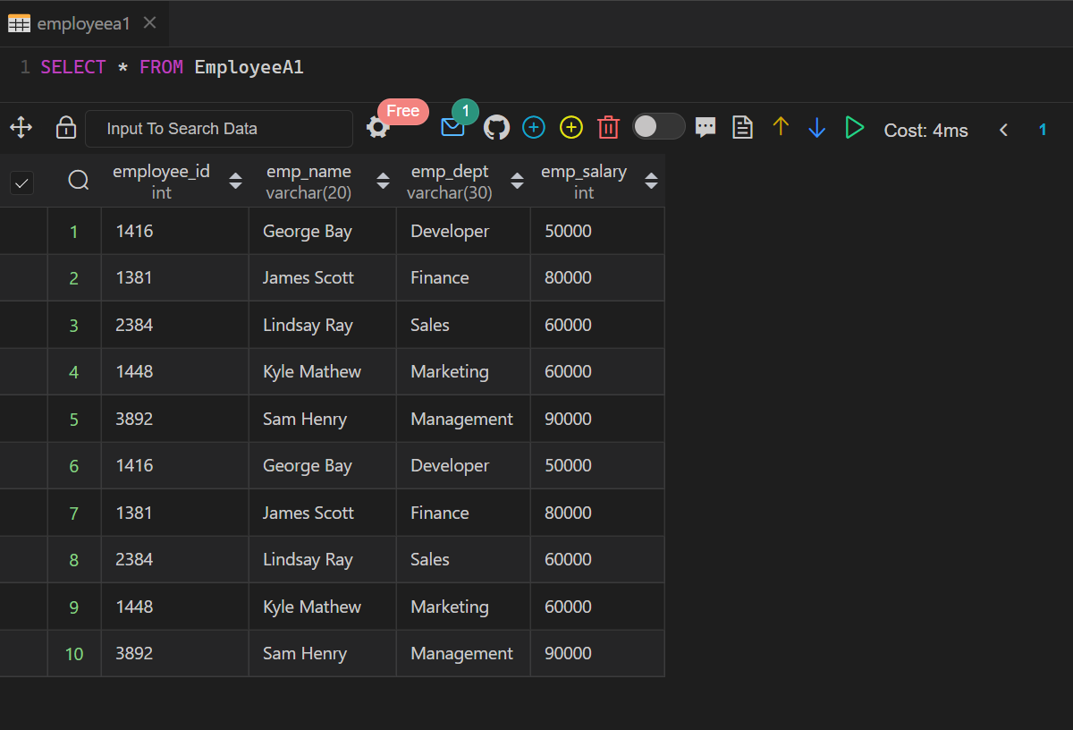

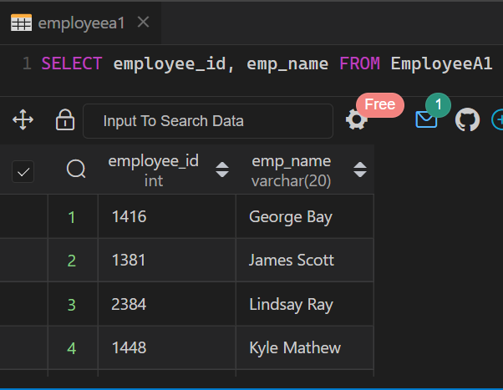

PRODUCT TABLE

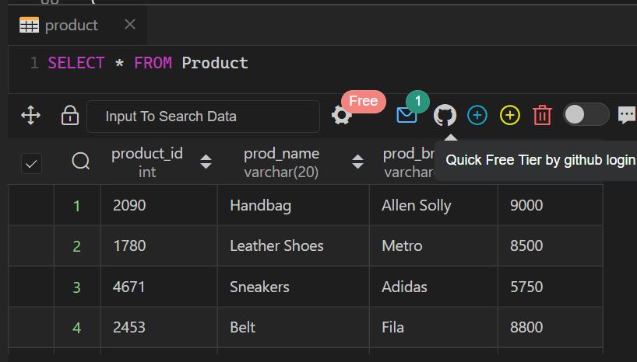

CUSTOMER TABLE

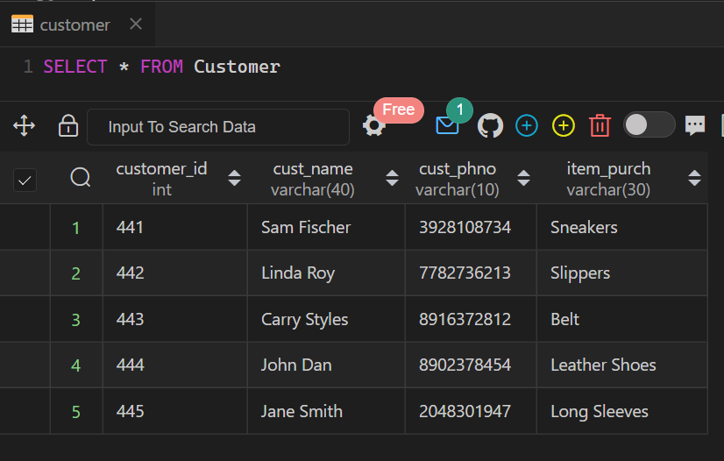

YOUTH TABLE

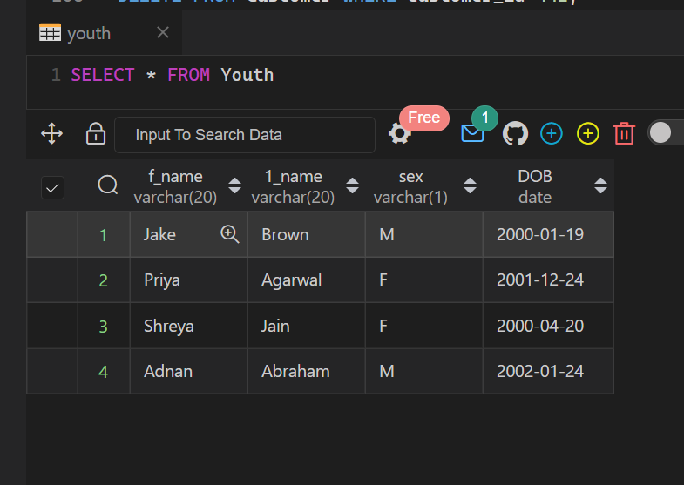

AFTER DELETING FROM CUSTOMER TABLE

DELETE FROM Customer WHERE customer_id=441;

DELETE FROM Customer WHERE customer_id=442;

DELETE FROM Customer WHERE customer_id=443;

DELETE FROM Customer WHERE customer_id=444;

DELETE FROM Customer WHERE customer_id=445;

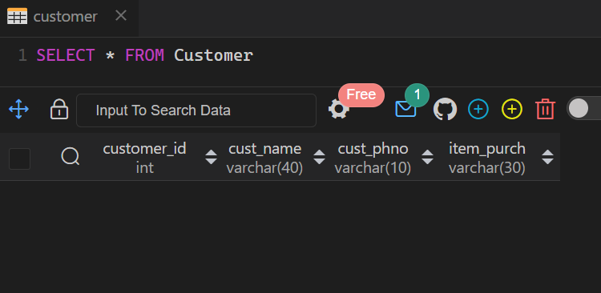

F_name ,DOB from youth table

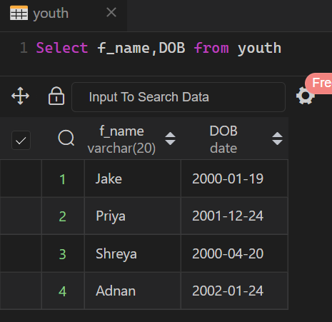

EMPLOYEE TABLE

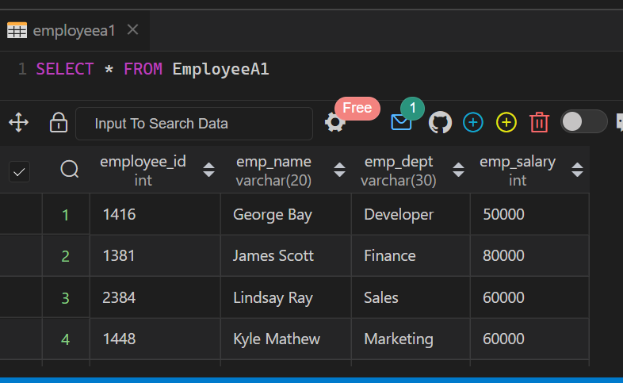

YOUTH TABLE

