OBJECT ORIENTED PROGRAMMING

LAB 10-Template

• Name :HITU RAJ

• Roll no. :2005025

• Branch :CSE

    /* Q1) (Function Template) Define a function template for finding

 the minimum value contained in an array.

  Write main() function to find the minimum value of integer array

   and minimum value of floating point numbers in an array.*/

#include <bits/stdc++.h>

using namespace std;

template <class T_025>

void min_025(T_025 arr_025[], int n_025)

{

    T_025 min_element_025 = arr_025[0];

    for (int i_025 = 1; i_025 < n_025; i_025++)

    {

        if (arr_025[i_025] < min_element_025)

        {

            min_element_025 = arr_025[i_025];

        }

    }

    cout << "Minimum Element is: " << min_element_025 << endl;

}

int main()

{

    int n_025;

    cout << "Enter the size of the Integer array: ";

    cin >> n_025;

    int arr_025[n_025];

    cout << "Enter the elements of the Integer array: ";

    for (int i_025 = 0; i_025 < n_025; i_025++)

    {

        cin >> arr_025[i_025];

    }

    min_025(arr_025, n_025);

    cout << "Enter the size of the Floating array:";

    cin >> n_025;

    float arr1_025[n_025];

    cout << "Enter the elements of the Floating array: ";

    for (int i_025 = 0; i_025 < n_025; i_025++)

    {

        cin >> arr1_025[i_025];

    }

    min_025(arr1_025, n_025);

    return 0;

}

**OUTPUT-1**

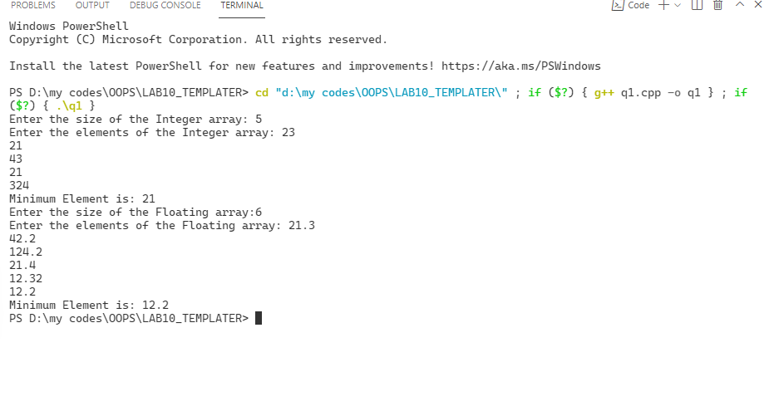

// q2.Write a program to define the function template for

// swapping the two items of various data types such as integers, float and

// characters etc.

#include <iostream>

using namespace std;

template <class T>

void swapping(T &x, T &y)

{

    T temp = x;

    x = y;

    y = temp;

}

int main()

{

    float p, q;

    int m, n;

    char a, b;

    cout << "\n Enter two integers : ";

    cin >> m >> n;

    cout << "\nThe values of integer  before swapping are : " << m << " " << n;

    swapping(m, n);

    cout << "\nThe values of integer  after swapping are : " << m << " " << n;

    cout << ".............................................................\n";

     cout << "\n Enter two floats : ";

    cin >> p >> q;

    cout << "\nThe values before swapping are : " << p << " " << q;

    swapping(p, q);

    cout << "\nThe values after swapping are : " << p << " " << q;

    cout << ".............................................................\n";

     cout << "\n Enter two char : ";

    cin >> a >> b;

    cout << "\nThe values before swapping are : " << a << " " << b;

    swapping(a, b);

    cout << "\nThe values after swapping are : " << a << " " << b;

    return 0;

}

**OUTPUT-2**

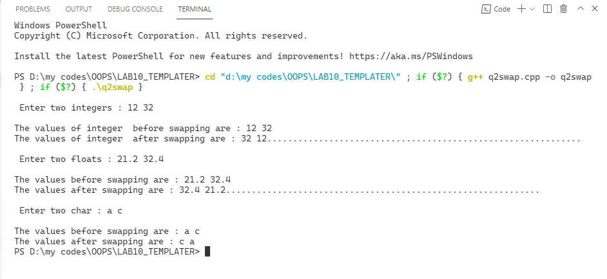

/*q3.Write a template function to search for a given key

element from an array. Illustrate how you perform search in integer,

character as well as double arrays using the same template function.*/

#include <iostream>

using namespace std;

template <class T>

void search(T a[], int x, T y)

{

    int count = 0;

    for (int i = 0; i < x; i++)

    {

        if (a[i] == y)

        {

            count++;

        }

    }

    if (count > 0)

    {

        cout << "element found";

    }

    else

    {

        cout << "element not found";

    }

}

int main()

{

    float p[100], q;

    int m[100], n;

    char a[100], b;

    cout << "\n Enter the 5 value in int array : ";

    for (int i = 0; i < 5; i++)

    {

        cin >> m[i];

    }

    cout << "enter element u want to search";

    cin >> n;

    search(m, 5, n);

    cout << "........................................\n";

    cout << "\n Enter the 5 value in char array : ";

    for (int i = 0; i < 5; i++)

    {

        cin >> a[i];

    }

    cout << "enter element u want to search";

    cin >> b;

    search(a, 5, b);

    cout << "........................................\n";

    cout << "\n Enter the 5 value in flaot array : ";

    for (int i = 0; i < 5; i++)

    {

        cin >> p[i];

    }

    cout << "enter element u want to search";

    cin >> q;

    search(p, 5, q);

    return 0;

}

**OUTPUT-3**

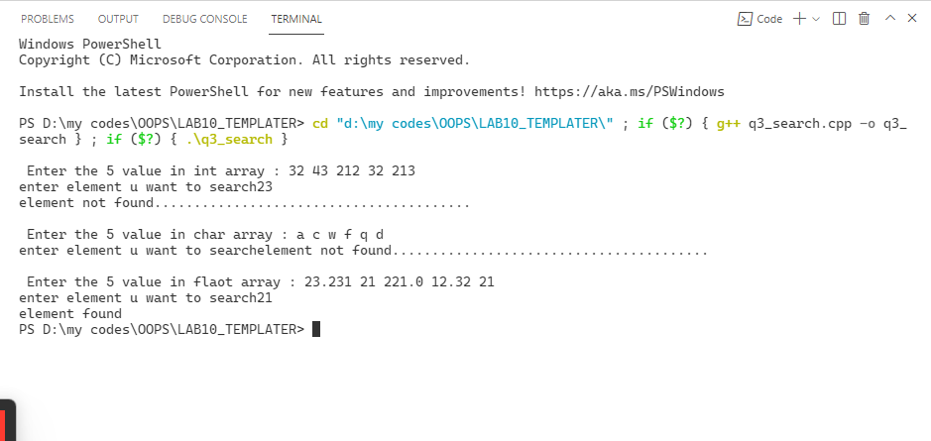

//Q4) (Non-type as function parameters) Write a program to demonstrate

//the concept behind function templates with non-type

//as function parameters by taking sorting an array of numbers

//as an example.

#include <bits/stdc++.h>

using namespace std;

template <class T_025>

void sort(T_025 *ar_025, int n_025)

{

    int i_025, j_025;

    T_025 temp_025;

    for (i_025 = 0; i_025 < n_025; i_025++)

    {

        for (j_025 = i_025 + 1; j_025 < n_025; j_025++)

        {

            if (ar_025[i_025] > ar_025[j_025])

            {

                temp_025 = ar_025[i_025];

                ar_025[i_025] = ar_025[j_025];

                ar_025[j_025] = temp_025;

            }

        }

    }

}

int main()

{

    int n_025;

    cout << "Enter the size of the Array:";

    cin >> n_025;

    int ar_025[n_025];

    cout << "Enter the elements of the Array: ";

    for (int i_025 = 0; i_025 < n_025; i_025++)

    {

        cin >> ar_025[i_025];

    }

    sort(ar_025, n_025);

    cout << "Sorted Array: ";

    for (int i_025 = 0; i_025 < n_025; i_025++)

    {

        cout << ar_025[i_025] << " ";

    }

    return 0;

**OUTPUT-4**

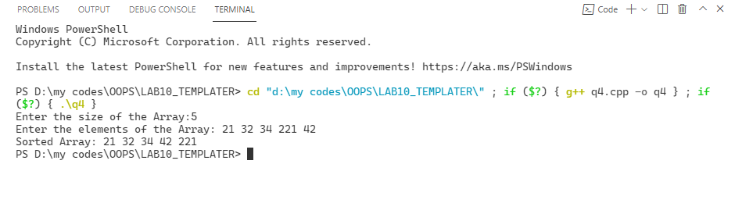

/*Q5) (Class Template) Write a program to define a class template for reading two

data items from the keyboard and find out their sum.*/

#include <iostream>

using namespace std;

template <class T>

class add

{

    int a, b;

public:

    T sum(T x, T y)

    {

        return x+y;

    }

};

    void SUM(int m,int n=50)

{

    m=m+n;

    n=m-n;

    cout<<m<<" "<<n;

}

int main()

{

SUM(50,10);

    /* add<int>a;

      add<float>b;

   cout<<"sum of int is "<< a.sum(2,3)<<endl;

   cout<<"sum of float no. are "<< b.sum(2.1,3.1);*/

    return 0;

}

**OUTPUT-5**

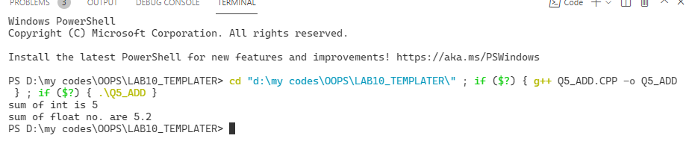

// Q6) (Class Template) Write a class template to represent a generic

// vector.

#include <bits/stdc++.h>

using namespace std;

template <class T_025>

class vector_025

{

private:

    T_025 *arr_025;

    int n_025;

public:

    vector_025(int size_025)

    {

        n_025 = size_025;

        arr_025 = new T_025[n_025];

    }

    void get_data_025()

    {

        cout << "Enter the elements of the vector: ";

        for (int i_025 = 0; i_025 < n_025; i_025++)

        {

            cin >> arr_025[i_025];

        }

    }

    void modify_data_025(T_025 new_val_025, int index_025)

    {

        arr_025[index_025] = new_val_025;

    }

    void multiply_data_025(T_025 new_val_025)

    {

        for (int i_025 = 0; i_025 < n_025; i_025++)

        {

            arr_025[i_025] *= new_val_025;

        }

    }

    void display_025()

    {

        cout << "The elements of the vector are: ";

        for (int i_025 = 0; i_025 < n_025; i_025++)

        {

            cout << arr_025[i_025] << " ";

        }

        cout << endl;

    }

};

int main()

{

    int n_025;

    cout << "Enter the size of the vector: ";

    cin >> n_025;

    vector_025<int> v_025(n_025);

    v_025.get_data_025();

    v_025.display_025();

    int index_025;

    cout << "Enter the index of the element to be modified: ";

    cin >> index_025;

    int new_val_025;

    cout << "Enter the new value: ";

    cin >> new_val_025;

    v_025.modify_data_025(new_val_025, index_025);

    v_025.display_025();

    int multiply_val_025;

    cout << "Enter the value to be multiplied: ";

    cin >> multiply_val_025;

    v_025.multiply_data_025(multiply_val_025);

    v_025.display_025();

    return 0;

}

**OUTPUT-6**

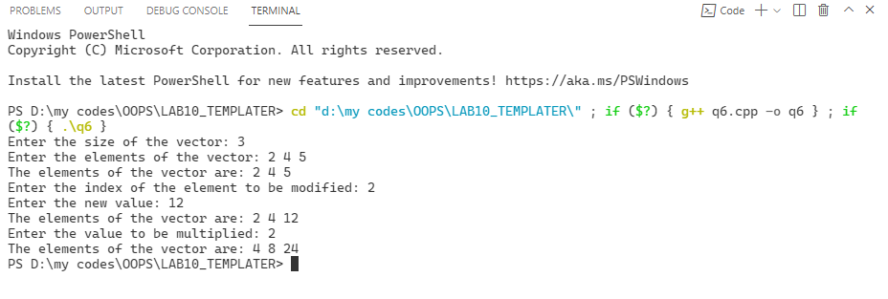

/*Q7) (Class Template) Write a program to explain class template

by creating a template T for a class named pair having two data

 members of type T which are inputted by a constructor and a member

  function get-max() return the greatest of two numbers to main.

  Note: the value of T depends upon the data type specified during

   object creation.*/

#include <bits/stdc++.h>

using namespace std;

template <class T_025>

class pair_025

{

private:

    T_025 a_025, b_025;

public:

    pair_025(T_025 x_025, T_025 y_025)

    {

        a_025 = x_025;

        b_025 = y_025;

    }

    T_025 greater_025()

    {

        if (a_025 > b_025)

            return a_025;

        else

            return b_025;

    }

};

int main()

{

    pair_025<int> p_025(10, 25);

    cout << p_025.greater_025() << endl;

    return 0;

**OUTPUT-7**

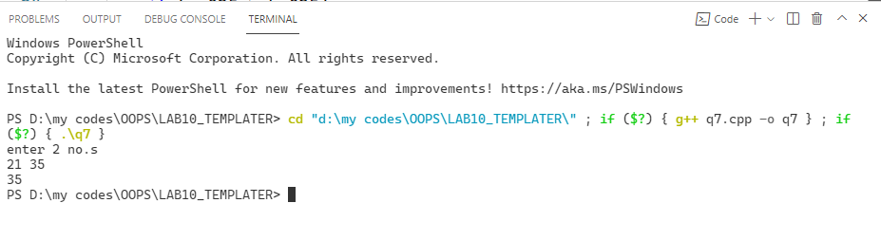

//Q8) Matrix Implementation using Template Class. Overload Addition

//Operator.

#include <bits/stdc++.h>

 using namespace std;

template <class T_025>

class matrix_025

{

private:

    int r_025, c_025;

    T_025 **arr_025;

public:

    matrix_025(int row_025, int col_025)

    {

        r_025 = row_025;

        c_025 = col_025;

        arr_025 = new T_025 *[r_025];

        for (int i_025 = 0; i_025 < r_025; i_025++)

        {

            arr_025[i_025] = new T_025[c_025];

        }

    }

    void get_data_025()

    {

        cout << "Enter the elements of the matrix: \n";

        for (int i_025 = 0; i_025 < r_025; i_025++)

        {

            for (int j_025 = 0; j_025 < c_025; j_025++)

            {

                cin >> arr_025[i_025][j_025];

            }

        }

    }

    matrix_025<T_025> operator+(matrix_025<T_025> m_025)

    {

        matrix_025<T_025> temp_025(r_025, c_025);

        for (int i_025 = 0; i_025 < r_025; i_025++)

        {

            for (int j_025 = 0; j_025 < c_025; j_025++)

            {

                temp_025.arr_025[i_025][j_025] = arr_025[i_025][j_025] + m_025.arr_025[i_025][j_025];

            }

        }

        return temp_025;

    }

    void display_025()

    {

        cout << "The matrix is: " << endl;

        for (int i_025 = 0; i_025 < r_025; i_025++)

        {

            for (int j_025 = 0; j_025 < c_025; j_025++)

            {

                cout << arr_025[i_025][j_025] << " ";

            }

            cout << endl;

        }

    }

};

int main()

{

    int row_025, col_025;

    cout << "Enter the number of rows and columns: ";

    cin >> row_025 >> col_025;

    matrix_025<int> m1_025(row_025, col_025);

    m1_025.get_data_025();

    m1_025.display_025();

    matrix_025<int> m2_025(row_025, col_025);

    m2_025.get_data_025();

    m2_025.display_025();

    matrix_025<int> m3_025 = m1_025 + m2_025;

    m3_025.display_025();

    return 0;

}

**OUTPUT-8**

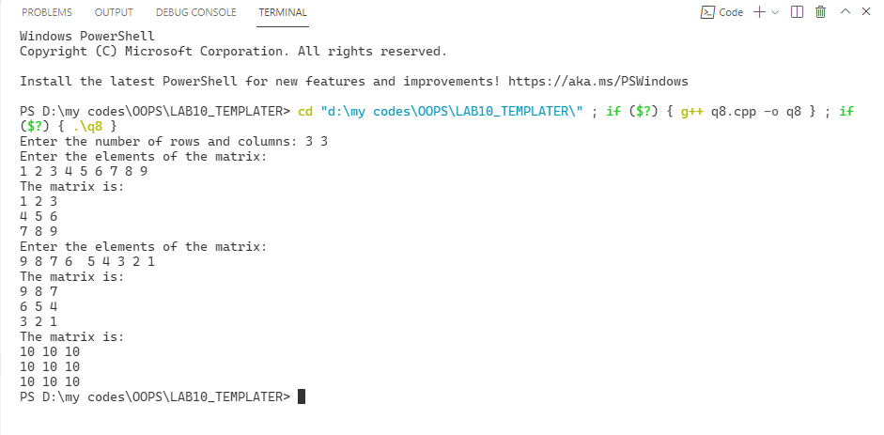

//Q9) (Class Template) Design a generic stack class which can be used to

// create integer, character or floating point stack objects.

//Provide all necessary data members and member functions

//(push, pop, display &amp; default constructor) to operate on the stack.

#include <bits/stdc++.h>

 using namespace std;

template <class T_025>

class Stack_025

{

private:

    int top_025;

    int capacity_025;

    T_025 *array_025;

public:

    T_025 last_pop_025;

    Stack_025(int capacity_025)

    {

        this->capacity_025 = capacity_025;

        top_025 = -1;

        array_025 = new T_025[capacity_025];

        last_pop_025 = -9999;

    }

    void push_025(T_025 element_025)

    {

        if (top_025 == capacity_025 - 1)

        {

            cout << "Stack Overflow" << endl;

            return;

        }

        top_025++;

        array_025[top_025] = element_025;

    }

    void pop_025()

    {

        if (top_025 == -1)

        {

            cout << "Stack Underflow" << endl;

            return;

        }

        int temp_025 = top_025--;

        last_pop_025 = array_025[temp_025];

        cout << "Popped Element - " << last_pop_025 << endl;

    }

    void display_025()

    {

        if (top_025 == -1)

        {

            cout << "Stack is Empty" << endl;

            return;

        }

        cout << "Stack Element: " << endl;

        for (int i_025 = top_025; i_025 >= 0; i_025--)

        {

            cout << array_025[i_025] << " ";

        }

        cout << endl;

    }

};

int main()

{

    int choice_025, n_025;

    cout << "Enter the size of the stack: ";

    cin >> n_025;

    cout << "Enter 1 for Char Stack." << endl;

    cout << "Enter 2 for Integer Stack." << endl;

    cout << "Enter 3 for Float Stack." << endl;

    cout << "Enter Your Choice - ";

    cin >> choice_025;

    switch (choice_025)

    {

    case 1:

    {

        Stack_025<char> s_025(n_025);

        char element_025;

        while (1)

        {

            cout << "1. Push" << endl;

            cout << "2. Pop" << endl;

            cout << "3. Display" << endl;

            cout << "4. Exit" << endl;

            cout << "Enter Your Choice - ";

            cin >> choice_025;

            switch (choice_025)

            {

            case 1:

            {

                cout << "Enter the element to be pushed - ";

                cin >> element_025;

                s_025.push_025(element_025);

                break;

            }

            case 2:

            {

                s_025.pop_025();

                break;

            }

            case 3:

            {

                s_025.display_025();

                break;

            }

            case 4:

            {

                exit(0);

            }

            default:

            {

                cout << "Wrong Choice" << endl;

            }

            }

        }

    }

    break;

    case 2:

    {

        Stack_025<int> s_025(n_025);

        int element_025;

        while (1)

        {

            cout << "1. Push" << endl;

            cout << "2. Pop" << endl;

            cout << "3. Display" << endl;

            cout << "4. Exit" << endl;

            cout << "Enter Your Choice - ";

            cin >> choice_025;

            switch (choice_025)

            {

            case 1:

            {

                cout << "Enter the element to be pushed - ";

                cin >> element_025;

                s_025.push_025(element_025);

                break;

            }

            case 2:

            {

                s_025.pop_025();

                break;

            }

            case 3:

            {

                s_025.display_025();

                break;

            }

            case 4:

            {

                exit(0);

            }

            default:

            {

                cout << "Wrong Choice" << endl;

            }

            }

        }

    }

    break;

    case 3:

    {

        Stack_025<float> s_025(n_025);

        float element_025;

        while (1)

        {

            cout << "1. Push" << endl;

            cout << "2. Pop" << endl;

            cout << "3. Display" << endl;

            cout << "4. Exit" << endl;

            cout << "Enter Your Choice - ";

            cin >> choice_025;

            switch (choice_025)

            {

            case 1:

            {

                cout << "Enter the element to be pushed - ";

                cin >> element_025;

                s_025.push_025(element_025);

                break;

            }

            case 2:

            {

                s_025.pop_025();

                break;

            }

            case 3:

            {

                s_025.display_025();

                break;

            }

            case 4:

            {

                exit(0);

            }

            default:

            {

                cout << "Wrong Choice" << endl;

            }

            }

        }

    }

    default:

        cout << "Wrong Choice" << endl;

    }

    return 0;

}

**OUTPUT-9**

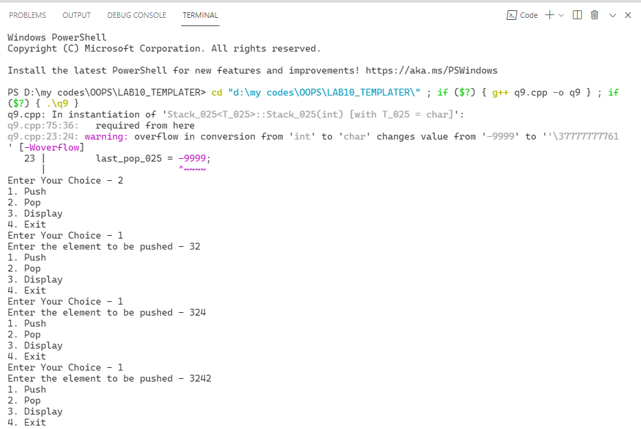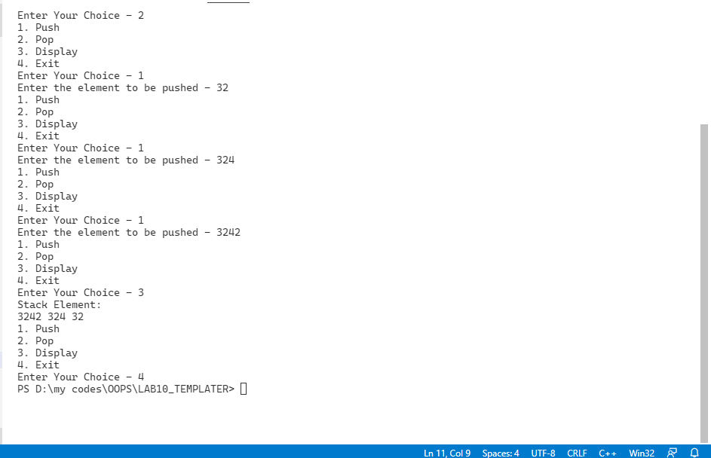

/*Q10) (Class Template) Design a template Stack which can

 work with either a Student record or an Employee record.

  [A Student record contains name, rollNo and cgpa.

   An Employee record contains name, empId and salary fields.

    Provide push, pop, display functions to the template stack class.]*/

#include <bits/stdc++.h>

using namespace std;

class Employee_025

{

private:

    string name_025;

    int id_025;

    int salary_025;

public:

    Employee_025()

    {

        name_025 = "";

        id_025 = 0;

        salary_025 = 0;

    }

    Employee_025(string name_025, int id_025, int salary_025)

    {

        this->name_025 = name_025;

        this->id_025 = id_025;

        this->salary_025 = salary_025;

    }

    void display_025()

    {

        cout << "Name: " << name_025 << endl;

        cout << "ID: " << id_025 << endl;

        cout << "Salary: " << salary_025 << endl;

    }

};

class Student_025

{

private:

    string name_025;

    int rollno_025;

    int cgpa_025;

public:

    Student_025()

    {

        name_025 = "";

        rollno_025 = 0;

        cgpa_025 = 0;

    }

    Student_025(string name_025, int rollno_025, int cgpa_025)

    {

        this->name_025 = name_025;

        this->rollno_025 = rollno_025;

        this->cgpa_025 = cgpa_025;

    }

    void display_025()

    {

        cout << "Name: " << name_025 << endl;

        cout << "Roll No: " << rollno_025 << endl;

        cout << "CGPA: " << cgpa_025 << endl;

    }

};

template <class T_025>

class stack_025

{

private:

    T_025 *arr_025;

    int top_025;

    int capacity_025;

public:

    T_025 last_pop_025;

    stack_025(int capacity_025)

    {

        this->capacity_025 = capacity_025;

        arr_025 = new T_025[capacity_025];

        top_025 = -1;

    }

    void push_025(T_025 ele_025)

    {

        if (top_025 == capacity_025 - 1)

        {

            cout << "Stack Overflow" << endl;

            return;

        }

        arr_025[++top_025] = ele_025;

    }

    void pop_025()

    {

        if (top_025 == -1)

        {

            cout << "Stack Underflow" << endl;

            return;

        }

        last_pop_025 = arr_025[top_025--];

    }

    void display_025()

    {

        if (top_025 == -1)

        {

            cout << "Stack is Empty" << endl;

            return;

        }

        for (int i_025 = top_025; i_025 >= 0; i_025--)

        {

            arr_025[i_025].display_025();

        }

    }

};

int main()

{

    int choice_025;

    while (1)

    {

        cout << "1. Employee" << endl;

        cout << "2. Student" << endl;

        cout << "3. Exit" << endl;

        cout << "Enter your choice: ";

        cin >> choice_025;

        switch (choice_025)

        {

        case 1:

        {

            cout << "Enter the size of the stack: ";

            int size_025;

            cin >> size_025;

            stack_025<Employee_025> s_025(size_025);

            choice_025 = 0;

            while (choice_025 != 4)

            {

                cout << "1 - Push Element to Stack.\n";

                cout << "2 - Pop Element from Stack.\n";

                cout << "3 - Display Stack.\n";

                cout << "4 - Exit.\n";

                cout << "Enter your choice: ";

                cin >> choice_025;

                switch (choice_025)

                {

                case 1:

                {

                    string name_025;

                    int id_025, salary_025;

                    cout << "Enter the name: ";

                    cin >> name_025;

                    cout << "Enter the id: ";

                    cin >> id_025;

                    cout << "Enter the salary: ";

                    cin >> salary_025;

                    s_025.push_025(Employee_025(name_025, id_025, salary_025));

                    break;

                }

                case 2:

                {

                    cout << "Popped Element - ";

                    s_025.pop_025();

                    s_025.last_pop_025.display_025();

                    break;

                }

                case 3:

                {

                    cout << "Stack : " << endl;

                    s_025.display_025();

                    break;

                }

                case 4:

                {

                    break;

                }

                default:

                {

                    cout << "Invalid Choice" << endl;

                }

                }

            }

        }

        break;

        case 2:

        {

            cout << "Enter the size of the stack: ";

            int size_025;

            cin >> size_025;

            stack_025<Student_025> s_025(size_025);

            choice_025 = 0;

            while (choice_025 != 4)

            {

                cout << "1 - Push Element to Stack.\n";

                cout << "2 - Pop Element from Stack.\n";

                cout << "3 - Display Stack.\n";

                cout << "4 - Exit.\n";

                cout << "Enter your choice: ";

                cin >> choice_025;

                switch (choice_025)

                {

                case 1:

                {

                    string name_025;

                    int rollno_025, cgpa_025;

                    cout << "Enter the name: ";

                    cin >> name_025;

                    cout << "Enter the rollno: ";

                    cin >> rollno_025;

                    cout << "Enter the cgpa: ";

                    cin >> cgpa_025;

                    s_025.push_025(Student_025(name_025, rollno_025, cgpa_025));

                    break;

                }

                case 2:

                {

                    s_025.pop_025();

                    break;

                }

                case 3:

                {

                    s_025.display_025();

                    break;

                }

                case 4:

                {

                    break;

                }

                default:

                {

                    cout << "Invalid Choice" << endl;

                }

                }

            }

        }

        break;

        case 3:

        {

            return 0;

        }

        default:

        {

            cout << "Invalid Choice" << endl;

        }

        }

    }

    return 0;

}

**OUTPUT-10**

