OBJECT ORIENTED PROGRAMMING

ASSIGNMENT -2

• Name :HITU RAJ

• Roll no. :2005025

• Branch :CSE

/*  Q1.

Assuming the class DRINKS_ dfined below, write functions in C++ to perform the following:

I)Write the objects of DRINKS_0 to a binary file.

(i)   Read the objects of DRINKS5 from binary file and display them onscreen when DNAME has value "INDY COLA".

class DRINKS_

{int DCODE;

 char DNAME[13]; //Name of the drink

int DSIZE; //Size in liters

float DPRICE;

public:void getdrinks( )

{cin>>DCODE>>DNAME>>DSIZE>>DPRICE;}

void showdrinks( )

{cout<<DCODE<<DNAME<<DSIZE<<DPRICE<<endl;}char *getname( ){return DNAME;} };

*/

#include <iostream>

#include <fstream>

#include<string.h>

#include<cstdio>

using namespace std;

class DRINKS_025

{

    int DCODE;

    char DNAME[13]; // Name of the drink

    int DSIZE;      // Size in liters

    float DPRICE;

public:

    void getdrinks()

    {

        cout << "enter dcode dname dsize and price\n";

        cin >> DCODE >> DNAME >> DSIZE >> DPRICE;

    }

    void showdrinks()

    {

        cout <<"\nDCODE--->"<< DCODE<<"\nDNAME--->" << DNAME<<"\nDSIZE--->" << DSIZE <<"\nPRICE--->" << DPRICE << endl;

    }

    char * getname()

    {

        return DNAME;

    }

} s;

int main()

{

    int n = 1,c=0;

    char a[10];

    ofstream f("drinks.txt", ios::out | ios::binary);

    while (n)

    {

        for (int i = 0; i < n; i++)

        {

            s.getdrinks();

            f.write((char *)&s, sizeof(s));

        }

        cout << "Press 1 to enter more or 0 to exit\n";

        cin >> n;

    }

    cout << "writing in binary file finished\n";

    f.close();

    cout<<"which drink details u want to show\n ";

cin>>a;

    //strcpy(a, "INDYCOLA");

    ifstream fi("drinks.txt", ios::in | ios::binary);

   while (  fi.read((char *)&s, sizeof(s)))

   {

       if(strcmp(a,s.getname())==0)

       {

        s.showdrinks();

       c++;

       }

    }

    if(c==0)

    {

        cout<<"no drinks found\n";

    }

    else

    {

        cout<<"drinks displayed....................... prog over\n";

    }

    return 0;

}

OUTPUT-1

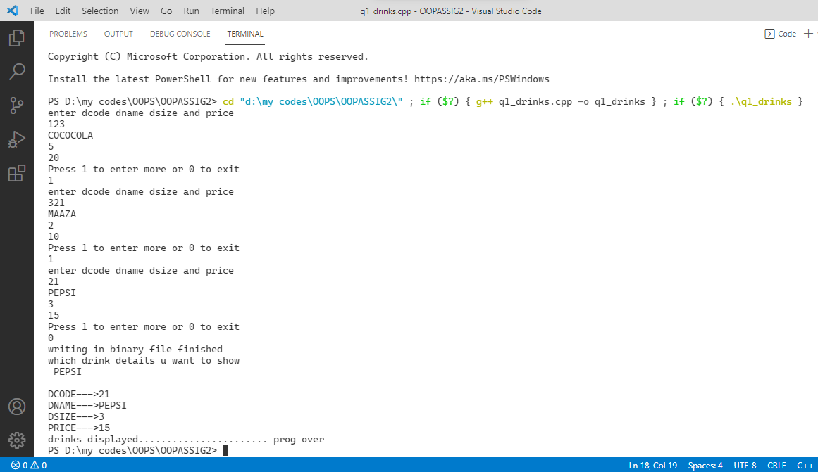

/*

Q2.Consider the following class declaration:

class STUDENT{

int addno;

 char name[90];

float totalmarks;

public :void getinfo() {cin>>addno>>name>>totalmarks ;}

void showinfo () { cout<< addno<<name<<totalmarks;}

float rettotmarks () { return totalmarks;}

 };

Give function definition to do the following :

(i)write the objects of STUDENT to a binary file.

(ii) Read the objects of STUDENT from a binary file and display all the objects on the screen

     where total marks is between 456 and 498 .

*/

#include <iostream>

#include <fstream>

#include <string.h>

using namespace std;

class STUDENT_025

{

    int addno;

    char name[90];

    float totalmarks;

public:

    void getinfo()

    {

        cout << "enter addressno. name and total marks\n";

        cin >> addno >> name >> totalmarks;

    }

    void showinfo()

    {

        cout << "\naddress--->" << addno << "\nName--->" << name << "\ntotalmarks--->" << totalmarks << "\n\n\n";

    }

    float rettotmarks()

    {

        return totalmarks;

    }

} s;

int main()

{

    int n = 1, c = 0;

    char a[10];

    ofstream f("studmarks.txt", ios::out | ios::binary);

    while (n)

    {

        n = 1;

        for (int i = 0; i < n; i++)

        {

            s.getinfo();

            f.write((char *)&s, sizeof(s));

        }

        cout << "Press 1 to enter more or 0 to exit\n";

        cin >> n;

    }

    cout << "writing in binary file finished\n";

    f.close();

    cout << "students whose marks are b/w 456 and 498 are\n ";

    ifstream fi("studmarks.txt", ios::in | ios::binary);

    while (fi.read((char *)&s, sizeof(s)))

    {

        if (s.rettotmarks() >= 456.00 && s.rettotmarks() <= 498)

        {

            s.showinfo();

            c++;

        }

    }

    if (c == 0)

    {

        cout << "no STUDENT_025 found\n";

    }

    else

    {

        cout << "req students displayed....................... prog over\n";

    }

    return 0;

}

OUTPUT-2

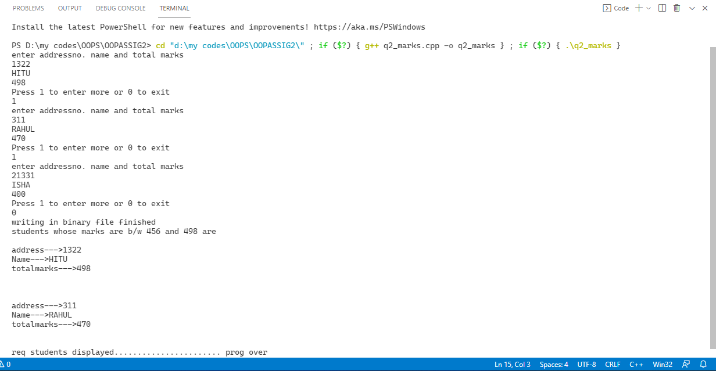

/*

Q3.Write a function in C++ to add new objects at the bottom of a binary file“STUD.DAT”,

 assuming the binary file is containing the objects of thefollowing class.

class STUD {

int Rno;

char Name[20];

public:void Enter()

{

cin>>Rno;

gets(Name);

}

void Display()

{

cout<<Rno<<Name<<endl;

}

};

*/

#include <iostream>

#include <fstream>

#include <stdio.h>

using namespace std;

class STUD

{

    int Rno;

    char Name[20];

public:

    void Enter()

    {

        cout << "enter roll no and name\n";

        cin >> Rno;

        getchar();

        gets(Name);

    }

    void Display()

    {

        cout << "\nRollno--->" << Rno << "\n name--->" << Name << endl;

    }

} s;

void copyabc()

{

    ifstream iff("stud.txt", ios::binary);

    ofstream of("newstud.txt", ios::binary);

    while (iff.read((char *)&s, sizeof(s)))

    {

        of.write((char *)&s, sizeof(s));

    }

    cout << "enter the new object at the end of file\n";

    s.Enter();

    of.write((char *)&s, sizeof(s));

    iff.close();

    of.close();

    remove("stud.txt");

    rename("newstud.txt", "stud.txt");

}

int main()

{

    int n = 1, c = 0;

    char a[10];

    ofstream f("stud.txt", ios::out | ios::binary);

    while (n)

    {

        n = 1;

        for (int i = 0; i < n; i++)

        {

            s.Enter();

            f.write((char *)&s, sizeof(s));

        }

        cout << "Press 1 to enter more or 0 to exit\n";

        cin >> n;

    }

    cout << "writing in binary file finished\n";

    f.close();

    copyabc();

    cout << "data in stud.dat after adding\n";

    ifstream fi("stud.txt", ios::in | ios::binary);

    while (fi.read((char *)&s, sizeof(s)))

    {

        s.Display();

    }

    return 0;

}

OUTPUT-3

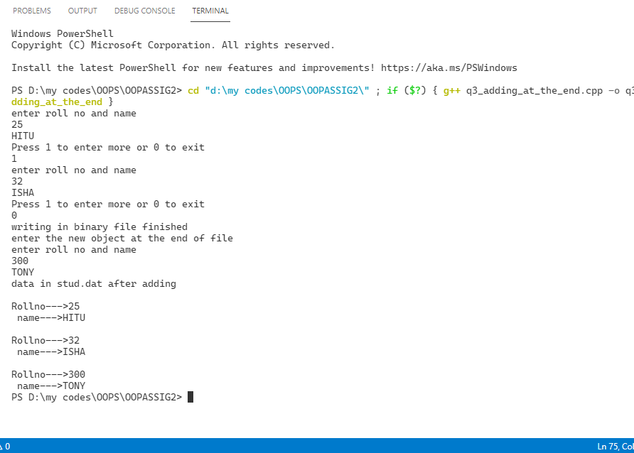

/*

Q4. Given a binary file APPLY.DAT containing records of the following classApplicant type

Class Applicant

{char Rno[10];

 char name[30];

 int A_score;

 public:void enroll()

 { gets(Rno);gets(Name);cin>>A_score; }

 void Status(){ cout<<Rno<<endl<<name<<endl<<A_score; }

 int ReturnScore() { return A_Score;}

  };

  Write a function in C++ that would read contents of file APPLY.DAT and

display the details of those students whose A_score is above 70.*/

#include <iostream>

#include <fstream>

#include <stdio.h>

using namespace std;

class Applicant

{

    char Rno[10];

    char name[30];

    int A_score;

public:

    void enroll()

    {

        cout << "enter roll name & score of applicant \n";

        cin >> Rno;

        cin >> name;

        cin >> A_score;

    }

    void Status()

    {

        cout << "\nrno--->" << Rno

             << "\nname--->" << name

             << "\nscore--->" << A_score << endl;

    }

    int ReturnScore()

    {

        return A_score;

    }

} s;

int main()

{

    int n = 1, c = 0;

    char a[10];

    ofstream f("appli.txt", ios::out | ios::binary);

    while (n)

    {

        n = 1;

            s.enroll();

            f.write((char *)&s, sizeof(s));

        cout << "Press 1 to enter more or 0 to exit\n";

        cin >> n;

    }

    cout << "writing in binary file finished\n";

    f.close();

  cout<<"applicant having score greater than 70 are \n";

    ifstream fi("appli.txt", ios::in | ios::binary);

    while (fi.read((char *)&s, sizeof(s)))

    {

        if (s.ReturnScore() >= 70)

        {

            s.Status();

            c++;

        }

    }

    if (c == 0)

    {

        cout << "no aplicant found\n";

    }

    else

    {

        cout << "req applicant displayed....................... prog over\n";

    }

    return 0;

}

OUTPUT-4

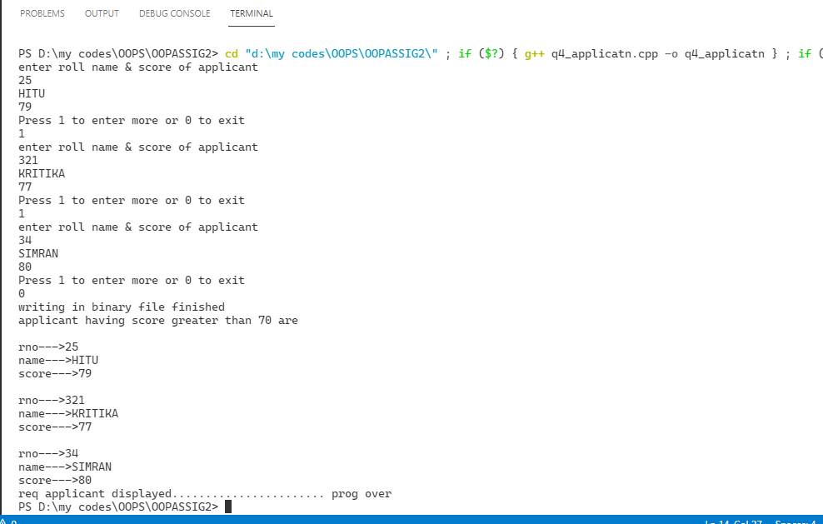

/*Q5..Write a function in C++ to search for a BookNo from a binary file“BOOK.DAT”,

 assuming the binary file is containing the objects of thefollowing class.

 class Book

 { int Bno;

 char Title[30];

 public : int RBno()

{ return Bno;}

void Enter()

{ cin>>Bno;gets(Title);}

void Display()

{ cout<<Bno<<Tilte<<endl; }

 };

*/

#include <iostream>

#include <fstream>

#include <string.h>

using namespace std;

class Book

{

    int Bno;

    char Title[30];

public:

    void Enter()

    {

        cout << "enter book no and title\n";

        cin >> Bno;

        cin >> Title;

    }

    void Display()

    {

        cout << "\nbook no--->" << Bno << "\ntiltle no--->" << Title << endl;

    }

    int RBno()

    {

        return Bno;

    }

} s;

void search()

{

    int c = 0, a;

    cout << "enter bookno. u want to search\n ";

    cin >> a;

    ifstream fi("book.txt", ios::in | ios::binary);

    while (fi.read((char *)&s, sizeof(s)))

    {

        if (a == s.RBno())

        {

            s.Display();

            c++;

        }

    }

    if (c == 0)

    {

        cout << "no books found\n";

    }

    else

    {

        cout << "required books displayed....................... prog over\n";

    }

}

int main()

{

    int n = 1, c = 0;

    int a;

    ofstream f("book.txt", ios::out | ios::binary);

    while (n)

    {

        s.Enter();

        f.write((char *)&s, sizeof(s));

        cout << "Press 1 to enter more or 0 to exit\n";

        cin >> n;

    }

    cout << "writing in binary file finished\n";

    f.close();

    search();

    return 0;

}

OUTPUT-5

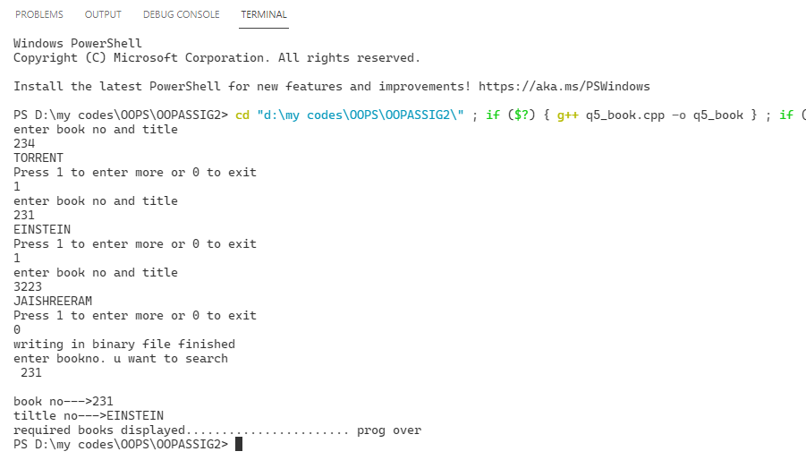

/*Q6.Given a binary file GAME.DAT, containing records of the following

 structuretype:

 Struct GAME

 {char Gamename[30];

 char participant[10][30];

 };

 write a functionin C++ that would read contents from the file GAME.DAt

 andcreates a file named BASKET.DAT copying only those records

from GAME.DATwhere the game name is “Basket Ball”.*/

#include <iostream>

#include <fstream>

#include <string.h>

using namespace std;

struct GAME

{

    char gamename[30];

    char participant[10][30];

} s;

void newgame(char newgame[])

{

    int c = 0;

    cout << "creating new file for the game--->" << newgame;

    ifstream fi("game.txt", ios::in | ios::binary);

    ofstream of("newgame.txt", ios::binary);

    while (fi.read((char *)&s, sizeof(s)))

    {

        if (strcmp(s.gamename, newgame) == 0)

        {

            of.write((char *)&s, sizeof(s));

            c++;

        }

    }

    if (c == 0)

    {

        cout << "no such game was found\n";

    }

    else

    {

        cout << "req game copied to new file\n";

    }

    of.close();

    fi.close();

}

int main()

{

    int n = 1, c = 0;

    ofstream f("game.txt", ios::out | ios::binary);

    while (n)

    {

        int a = 1, i = 0;

        ;

        cout << "enter the game name\n";

        cin >> s.gamename;

        cout << "enter the list of players\n";

        while (a)

        {

            cin >> s.participant[i];

            i++;

            strcpy(s.participant[i], "null");

            cout << "press 1 to enter more players else 0\n";

            cin >> a;

        }

        f.write((char *)&s, sizeof(s));

        cout << "Press 1 to enter more games or 0 to exit\n";

        cin >> n;

    }

    cout << "writing in binary file finished\n";

    f.close();

    cout << "which game u need to copy\n";

    char nwgame[100];

    cin >> nwgame;

    newgame(nwgame);

    fstream fi("newgame.txt", ios::in | ios::binary);

    while (fi.read((char *)&s, sizeof(s)))

    {

        {

            cout << s.gamename << endl

                 << "\n----------------------------";

            for (int i = 0; strcmp(s.participant[i], "null") != 0; i++)

            {

                cout << "\n"

                     << i + 1 << "------>" << s.participant[i] << endl;

            }

        }

        cout << "\n*************************************************************\n";

    }

    return 0;

}

OUTPUT-6

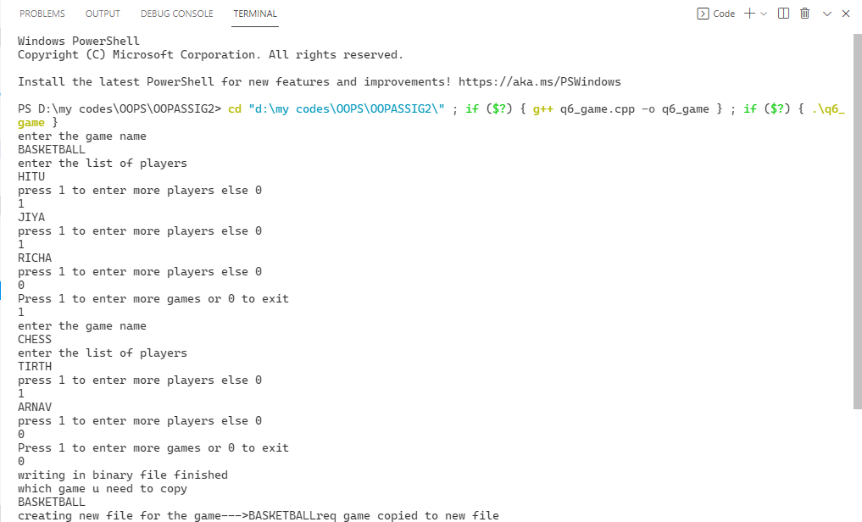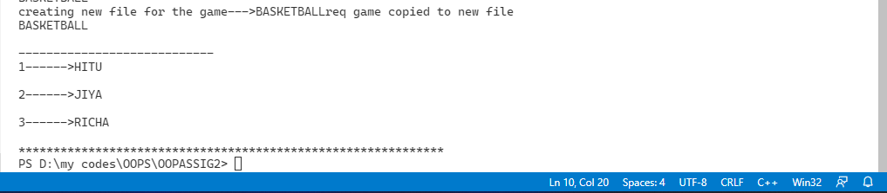

/*

Q7.Following is the structure of each record in a data file named“PRODUCT.DAT”.

Struct PROD

{char PCODE[10];

 char DESC[10];

 int stock;

 };

 Write a function in C++ to update the

file with a new value of stock. Thevalue of stock and the PCODE , whose stock to be updated

are read duringthe execution of the program.*/

#include <iostream>

#include <string.h>

#include <fstream>

#include <stdio.h>

using namespace std;

struct PROD

{

    char PCODE[10];

    char DESC[10];

    int stock;

} s;

void change_stock(char pcode[], int n)

{

    int c = 0,ro;

    ifstream iff("prod.txt", ios::binary);

    ofstream of("newprod.txt", ios::binary);

    while (iff.read((char *)&s, sizeof(s)))

    {

        if (strcmp(s.PCODE, pcode) == 0 && s.stock == n)

        {

            cout << "enter the value of new stock\n";

            cin >> s.stock;

            of.write((char *)&s, sizeof(s));

            c++;

        }

        else

        {

            of.write((char *)&s, sizeof(s));

        }

    }

    if (c == 0)

    {

        cout << "no prod found\n";

    }

    else

    {

        cout << "product updated successfully\n";

    }

    iff.close();

    of.close();

    remove("prod.txt");

    rename("newprod.txt", "prod.txt");

}

int main()

{

    int stck;

    char pcode[10];

    int n = 1;

    ofstream f("prod.txt", ios::out | ios::binary);

    while (n)

    {

            cout << "enter prodcode description and stock of product:";

            cin >> s.PCODE >> s.DESC >> s.stock;

            f.write((char *)&s, sizeof(s));

        cout << "press 1 to enter next prod and 0 to exit\n";

        cin >> n;

    }

    f.close();

    cout << "writing in binary file finished\n";

    cout << "enter the stock and pcode u want to change\n";

    cin >> stck >> pcode;

    change_stock(pcode, stck);

    ifstream fi("prod.txt", ios::in | ios::binary);

    while (fi.read((char *)&s, sizeof(s)))

    {

        cout << "Prodcode--->" << s.PCODE << "\ndesc--->" << s.DESC << "\nstock--->" << s.stock;

        cout << "\n........................................................\n";

    }

    fi.close();

    return 0;

}

OUTPUT-7

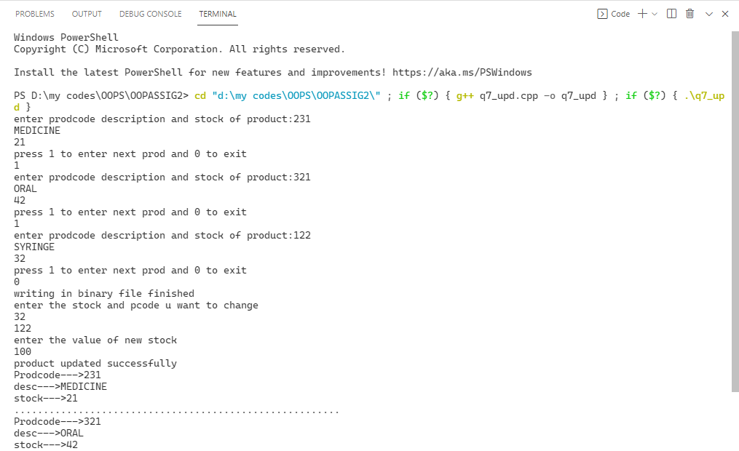

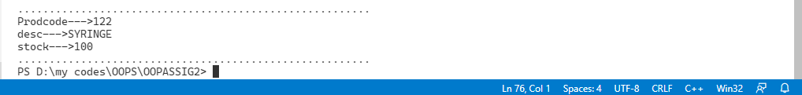

/*Q8. Given a binary file TELE.DAT, containing records of the following classdirector_025:

class director_025

{char Name[20];

char Address[30];

char areacode[5];

char phno[15];

public:void register();

 void show();

 int checkcode(char AC[])

  { return(strcmp(areacode,AC); }

   };

   Write a

function COPYABC() in C++ that would copy only those recordshaving areacode as “123” from

TELE.DAT to TELEBACK.DAT.*/

#include <iostream>

#include <string.h>

#include <fstream>

using namespace std;

class director_025

{

    char Name[20];

    char Address[30];

    char areacode[50];

    char phno[20];

public:

    void reegister()

    {

        cout << "enter name addresss areacode pone no.\n";

        cin >> Name >> Address >> areacode >> phno;

    }

    void show()

    {

        cout << "Nmae--->" << Name << "\nAdress--->" << Address << "\n areacode--->" << areacode << "\nphno ---->" << phno;

        cout << "\n........................................................\n";

    };

    int checkcode(char AC[])

    {

        return (strcmp(areacode, AC));

    }

} s;

void copyabc(char a[])

{

    ifstream iff("tele.txt", ios::binary);

    ofstream of("teleback.txt", ios::binary);

    while (iff.read((char *)&s, sizeof(s)))

    {

        if (s.checkcode(a) == 0)

        {

            of.write((char *)&s, sizeof(s));

        }

    }

    iff.close();

    of.close();

}

int main()

{

    int n = 1;

    ofstream f("tele.txt", ios::out | ios::binary);

    while (n)

    {

        s.reegister();

        f.write((char *)&s, sizeof(s));

        cout << "press 1 to continue entring and 0 to exit\n";

        cin >> n;

    }

    f.close();

    char a[10];

    strcpy(a, "123");

    copyabc(a);

    cout << "writing in binary file finished\n";

    cout << "DATA IN \"TELE.DAT\"\n";

    ifstream fi("tele.txt", ios::in | ios::binary);

    while (fi.read((char *)&s, sizeof(s)))

    {

        s.show();

    }

    cout << "\n....................................................\n";

    cout << "DATA IN \"TELEback.DAT\"\n";

    fi.close();

    ifstream foi("teleback.txt", ios::in | ios::binary);

    while (foi.read((char *)&s, sizeof(s)))

    {

        s.show();

    }

    foi.close();

    return 0;

}

OUTPUT-8

