OBJECT ORIENTED PROGRAMMING

LAB 12

• Name :HITU RAJ

• Roll no. :2005025

• Branch :CSE

//1.WAP to throw and handle ‘division by zero’ exception.

#include<iostream>

using namespace std;

int main()

{ int num_025 ,deno_025;

cout<<"enter num_025 and deno_025";

cin>>num_025>>deno_025;

try

{

    if(deno_025==0)

    {

        throw 0;

    }

}

catch(int)

{

    cout<<"denomerator cant be zero\n";

}

cout<<"prog ends";

    return 0;

}

OUTPUT-1

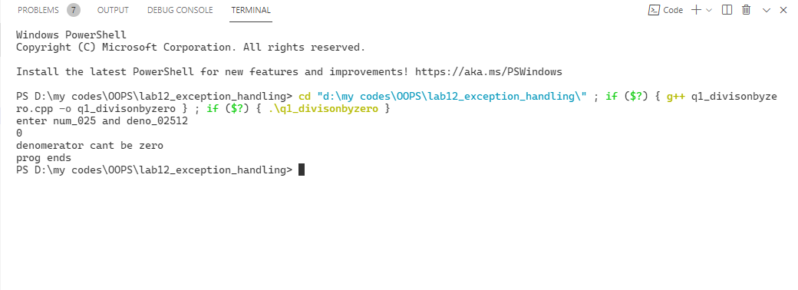

//2.WAP to throw and handle’ array out of bound’ exception.

#include<iostream>

using namespace std;

int main()

{ int arr_025[5],n;

cout<<"enter  5 elements in array " ;

for (int i = 0; i < 5; i++)

{

    cin>>arr_025[i];

}

cout<<"enter the inex no. u want to access";

cin>>n;

try

{

    if(n>4||n<0)

    {

        throw 0;

    }

}

catch(int)

{

    cout<<"\nwrong index\n";

}

cout<<"prog ends";

    return 0;

}

OUTPUT-2

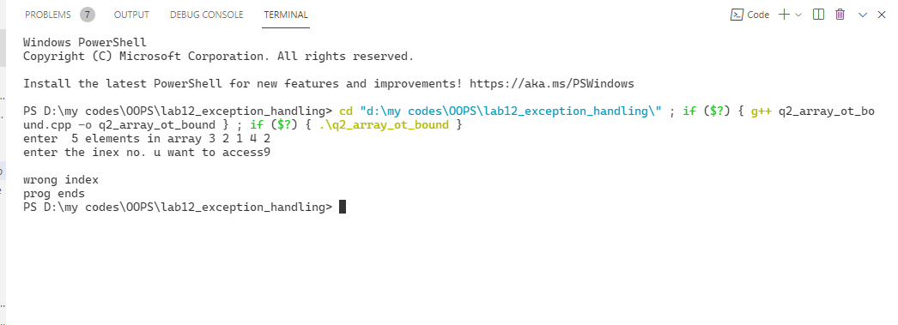

//3.WAP to demonstrate multiple catch .

#include <iostream>

using namespace std;

int main()

{

    int num_025;

    cout<< "\n Enter a positive number : ";

    cin >> num_025;

    try

    {

        if (num_025 == 0)

            throw(char *)"Zero"; // Exception 1

        else if (num_025 == -1)

            throw num_025; // Exception 2

        else if (num_025 == 1)

            cout <<"\n NUMBER = " << num_025;

        else

            throw(float) num_025;

    }

    catch (int num_025)

    {

        cout <<" \n" << num_025 << " is negative";

    }

    catch (char *msg)

    {

        cout <<"\n The number is " << msg;

    }

    cout << " Exiting main()";

    return 0;

}

OUTPUT-3

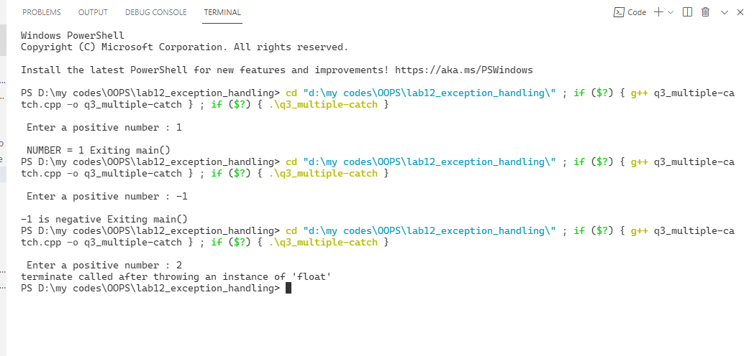

//4.WAP to demonstrate multiple catch and catch all.

#include <iostream>

using namespace std;

int main()

{

    int num_025;

    cout<< "\n Enter a positive number : ";

    cin >> num_025;

    try

    {

        if (num_025 == 0)

            throw(char *)"Zero"; // Exception 1

        else if (num_025 == -1)

            throw num_025; // Exception 2

        else if (num_025 == 1)

            cout <<"\n NUMBER = " << num_025;

        else

            throw(float) num_025;

    }

    catch (int num_025)

    {

        cout <<" \n" << num_025 << " is negative";

    }

    catch (char *msg)

    {

        cout <<"\n The number is " << msg;

    }

    catch (...) // caught exception 3

    {

        cout << "\n catch all code executed ";

    }

    cout << " Exiting main()";

    return 0;

}

OUTPUT-4

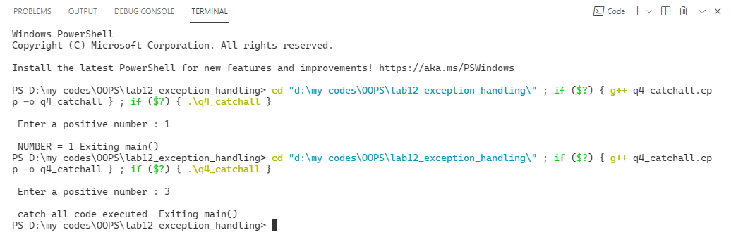

//5.WAP that dynamically allocates memory for n no.objects for

//student class ,throw exception if memory is not allocated.

#include<iostream>

#include<stdlib.h>

using namespace std;

int main()

{ int *a_025,n;

a_025=new int[5];

try

{

    if(a_025==NULL)

    {

        throw 0;

    }

    else

    cout<<"memory allocated\n";

}

catch(int)

{

    cout<<"\nmemory not allocated\n";

}

cout<<"prog ends";

    return 0;

}

OUTPUT-5

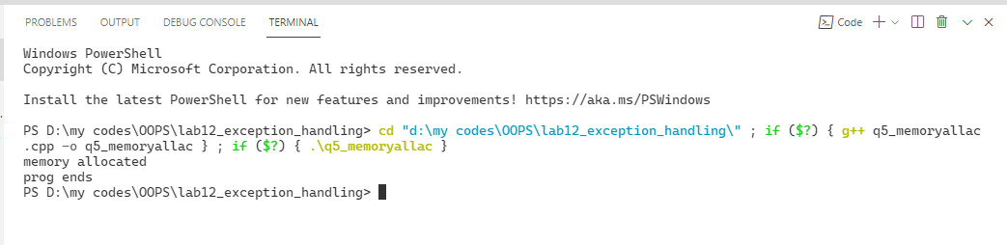

//6)WAP that calculates the square root of a number. Throw an exception if a negative

number is taken

#include <iostream>

#include <math.h>

using namespace std;

int main()

{

    int num_025;

    cout << "enter the number to fing sqr root";

    cin >> num_025;

    try

    {

        if (num_025 >= 0)

        {

            cout << "sqroot of the number is ";

            float sqroot;

            sqroot = pow((float)num_025, 1.0 / 2.0);

            cout<<sqroot;

        }

        else

            {

                throw num_025;

            }

    }

    catch (int)

    {

        cout << "number cannot be negetive\n";

    }

    cout << "\nprog ends";

    return 0;

}

OUTPUT-6

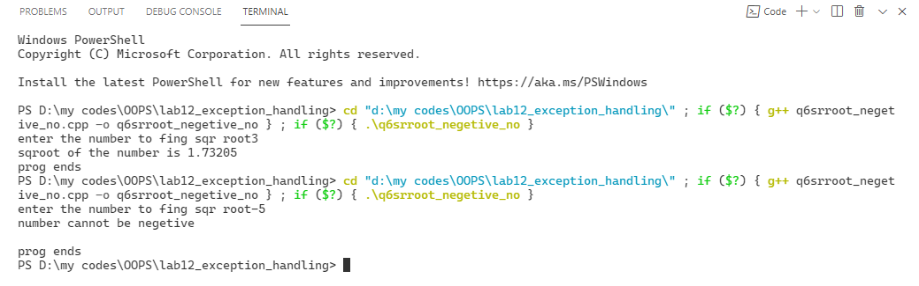

//7) WAP to check the expiry date of a medicine. If the expiry date&lt;current date, then

//throw an exception.

#include <iostream>

#include <math.h>

using namespace std;

struct datee

{

    int month_025,day_025,year_025;

}e,c;

int main()

{

    int num;

    cout << "enter the expiry date and current date in dd/mm/yy format\n";

    cin>>e.day_025>>e.month_025>>e.year_025;

    cin>>c.day_025>>c.month_025>>c.year_025;

    try

    {

        if (c.year_025>e.year_025)

        {

          throw 0;

        }

        else if(c.year_025==e.year_025&&c.month_025>e.month_025)

            {

                throw 0;

            }

            else if(c.year_025==e.year_025&&c.month_025==e.month_025&&c.day_025>e.day_025)

            {

                throw 0;

            }

            else

            {

                 cout << "your medicine is not expired yet \n";

            }

    }

    catch (int)

    {

        cout << "the medicine is expired\n";

    }

    return 0;

}

OUTPUT-7

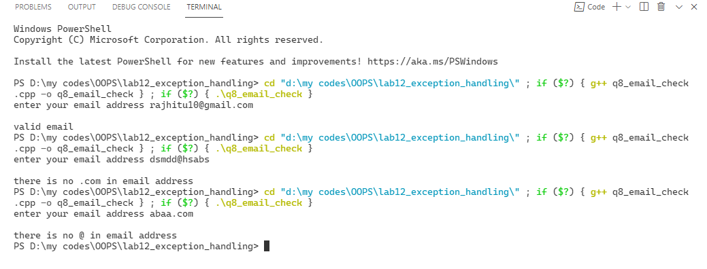

/*8) WAP to take email address as input raise an exception if the email address violates

any one of the following conditions

I. It should have &#39;@&#39; symbol in the email address

Ii.The string must be terminated with .com*/

#include <iostream>

//#include<stdio.h>

using namespace std;

int main()

{

    char a_025[50];

    int i, c = 0, com = 0;

    cout << "enter your email address ";

    gets(a_025);

    for (i = 0; a_025[i] != '\0'; i++)

    {

        if (a_025[i] == '@')

        {

            c++;

        }

    }

    if (a_025[i - 1] == 'm' && a_025[i - 2] == 'o' && a_025[i - 3] == 'c' && a_025[i - 4] == '.')

    {

        com++;

    }

    try

    {

        if (c == 0)

        {

            throw 1.1;

        }

         if (com == 0)

        {

            throw 1;

        }

        if(com==1&&c==1)

        {

            cout<<"\nvalid email\n";

        }

    }

    catch (double)

    {

        cout << "\nthere is no @ in email address \n";

    }

    catch (int)

    {

        cout << "\nthere is no .com in email address \n";

    }

    return 0;

}

OUTPUT-8

