

DBMS LAB OS LAB TEST1

• Name :HITU RAJ

• Roll no. :2005025

• Branch :CSE

#1 print prime no. b/w 3 to 21 and print factorial of 5

fact=1

for((i=1; i<=21; i++))

do

  c=0

  for((j=1; j<=i; j++))

  do

    if [ `expr $i % $j` -eq 0 ]

    then

     c=`expr $c + 1`

     fi

     if [ $i -eq 5 ]

     then

     fact=`expr $fact \* $j`

     fi

  done

  if [ $c -eq 2 ]

  then

   echo "$i is prime"

   else

    echo "$i is not  prime"

    fi

done

echo "factorial of 5 is $fact"

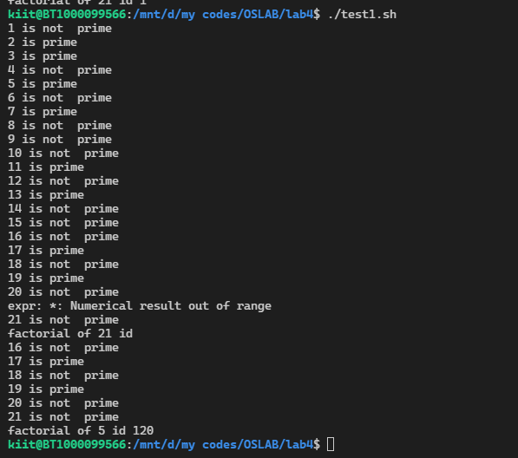

# 2. print the following pattern

rows=4

for((i=1; i<=rows; i++))

do

  for((j=1; j<=i; j++))

  do

    echo -n "* "

  done

  echo

done

OUTPUT 2

