

OS LAB ASSIG 10

• Name :HITU RAJ

• Roll no. :2005025

• Branch :CSE

1. BANKERS ALGORITHM

1.

// BANKERS ALGORITHM

#include <stdio.h>

#include <conio.h>

int main()

{

    int Max[10][10], need[10][10], alloc[10][10], avail[10], completed[10], safeSequence[10];

    int p, r, i, j, process, count;

    count = 0;

    printf("Enter the no of processes : ");

    scanf("%d", &p);

    for (i = 0; i < p; i++)

        completed[i] = 0;

    printf("\n\nEnter the no of resources : ");

    scanf("%d", &r);

    printf("\n\nEnter the Max Matrix for each process : ");

    for (i = 0; i < p; i++)

    {

        printf("\nFor process %d : ", i + 1);

        for (j = 0; j < r; j++)

            scanf("%d", &Max[i][j]);

    }

    printf("\n\nEnter the allocation for each process : ");

    for (i = 0; i < p; i++)

    {

        printf("\nFor process %d : ", i + 1);

        for (j = 0; j < r; j++)

            scanf("%d", &alloc[i][j]);

    }

    printf("\n\nEnter the Available Resources : ");

    for (i = 0; i < r; i++)

        scanf("%d", &avail[i]);

    for (i = 0; i < p; i++)

        for (j = 0; j < r; j++)

            need[i][j] = Max[i][j] - alloc[i][j];

    do

    {

        printf("\n Max matrix:\tAllocation matrix:\n");

        for (i = 0; i < p; i++)

        {

            for (j = 0; j < r; j++)

                printf("%d  ", Max[i][j]);

            printf("\t\t");

            for (j = 0; j < r; j++)

                printf("%d  ", alloc[i][j]);

            printf("\n");

        }

        process = -1;

        for (i = 0; i < p; i++)

        {

            if (completed[i] == 0) // if not completed

            {

                process = i;

                for (j = 0; j < r; j++)

                {

                    if (avail[j] < need[i][j])

                    {

                        process = -1;

                        break;

                    }

                }

            }

            if (process != -1)

                break;

        }

        if (process != -1)

        {

            printf("\nProcess %d runs to completion!", process + 1);

            safeSequence[count] = process + 1;

            count++;

            for (j = 0; j < r; j++)

            {

                avail[j] += alloc[process][j];

                alloc[process][j] = 0;

                Max[process][j] = 0;

                completed[process] = 1;

            }

        }

    } while (count != p && process != -1);

    if (count == p)

    {

        printf("\nThe system is in a safe state!!\n");

        printf("Safe Sequence : < ");

        for (i = 0; i < p; i++)

            printf("%d  ", safeSequence[i]);

        printf(">\n");

    }

    else

        printf("\nThe system is in an unsafe state!!");

    getch();

}

OUTPUT

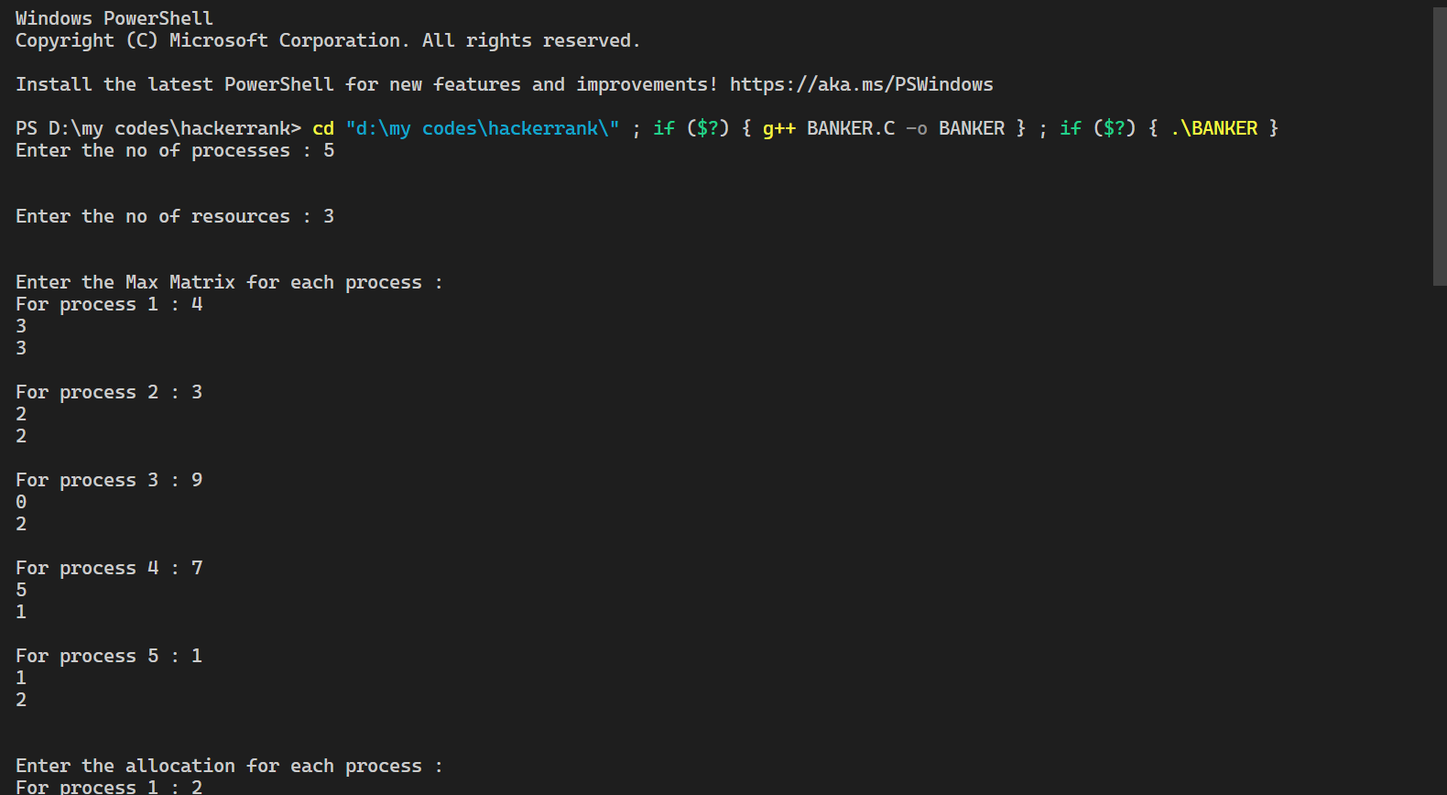 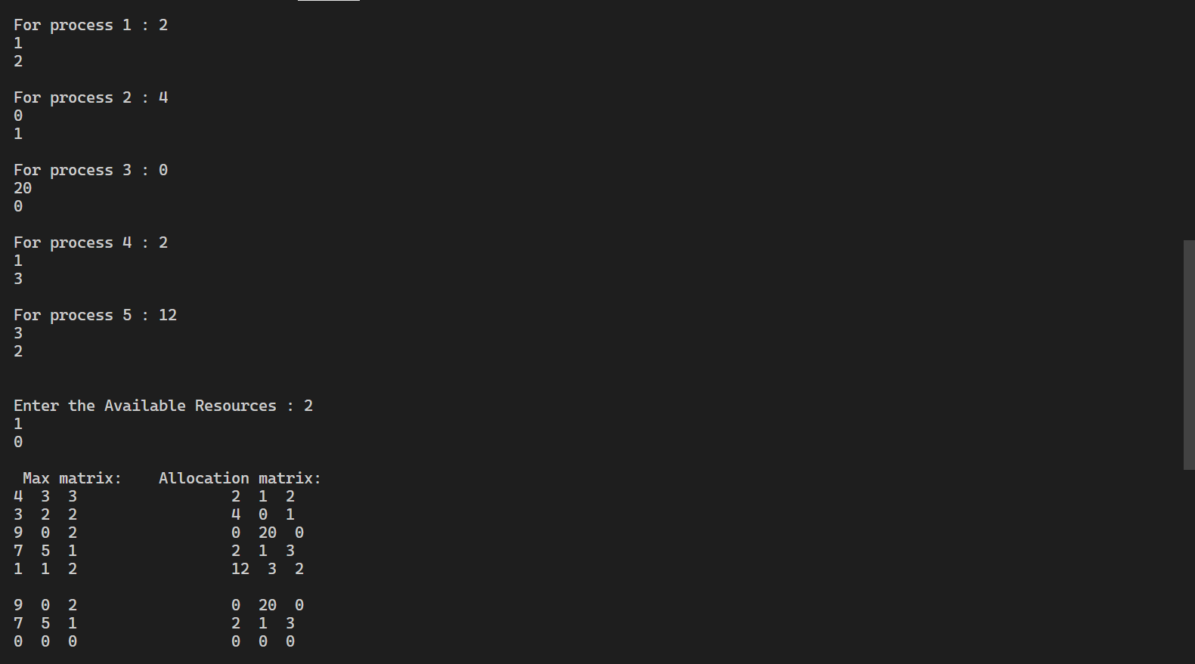 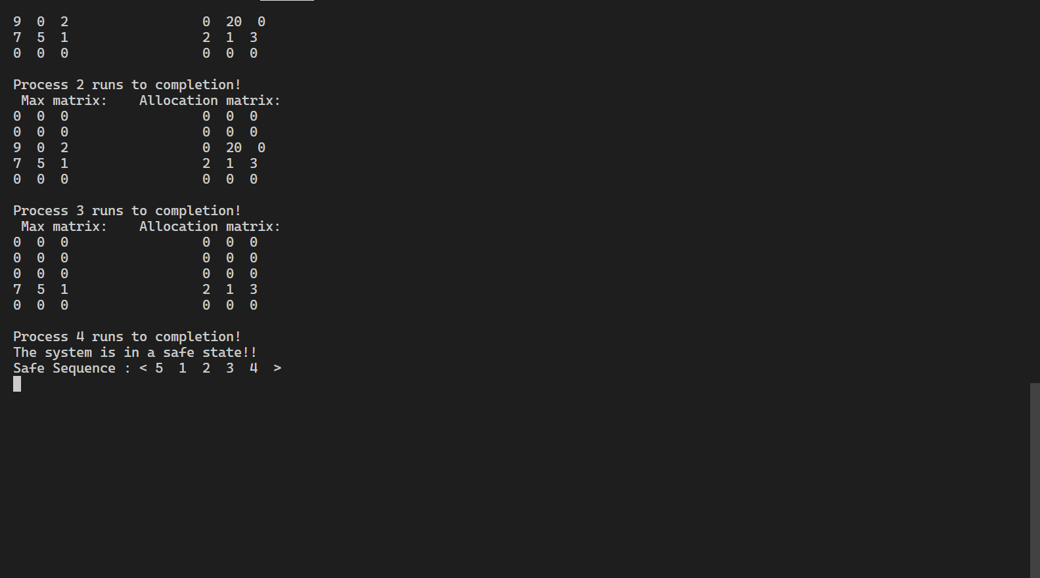

2.FIRST FIT

// FIRST FIT:

#include <stdio.h>

void main()

{

    int bsize[10], psize[10], bno, pno, flags[10], allocation[10], i, j;

    for (i = 0; i < 10; i++)

    {

        flags[i] = 0;

        allocation[i] = -1;

    }

    printf("Enter no. of blocks: ");

    scanf("%d", &bno);

    printf("\nEnter size of each block: ");

    for (i = 0; i < bno; i++)

        scanf("%d", &bsize[i]);

    printf("\nEnter no. of processes: ");

    scanf("%d", &pno);

    printf("\nEnter size of each process: ");

    for (i = 0; i < pno; i++)

        scanf("%d", &psize[i]);

    for (i = 0; i < pno; i++) // allocation as per first fit

        for (j = 0; j < bno; j++)

            if (flags[j] == 0 && bsize[j] >= psize[i])

            {

                allocation[j] = i;

                flags[j] = 1;

                break;

            }

    // display allocation details

    printf("\nBlock no.\tsize\t\tprocess no.\t\tsize");

    for (i = 0; i < bno; i++)

    {

        printf("\n%d\t\t%d\t\t", i + 1, bsize[i]);

        if (flags[i] == 1)

            printf("%d\t\t\t%d", allocation[i] + 1, psize[allocation[i]]);

        else

            printf("Not allocated");

    }

}

OUTPUT

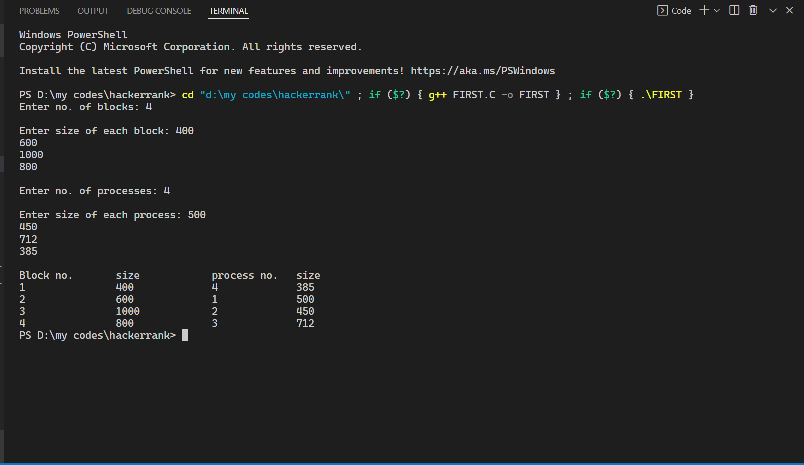

3.BEST FIT

// BEST FIT:

#include <stdio.h>

int main()

{

    int fragment[20], b[20], p[20], i, j, nb, np, temp, lowest = 9999;

    static int barray[20], parray[20];

    printf("\n\t\t\tMemory Management Scheme - Best Fit");

    printf("\nEnter the number of blocks:");

    scanf("%d", &nb);

    printf("Enter the number of processes:");

    scanf("%d", &np);

    printf("\nEnter the size of the blocks:-\n");

    for (i = 1; i <= nb; i++)

    {

        printf("Block no.%d:", i);

        scanf("%d", &b[i]);

    }

    printf("\nEnter the size of the processes :-\n");

    for (i = 1; i <= np; i++)

    {

        printf("Process no.%d:", i);

        scanf("%d", &p[i]);

    }

    for (i = 1; i <= np; i++)

    {

        for (j = 1; j <= nb; j++)

        {

            if (barray[j] != 1)

            {

                temp = b[j] - p[i];

                if (temp >= 0)

                    if (lowest > temp)

                    {

                        parray[i] = j;

                        lowest = temp;

                    }

            }

        }

        fragment[i] = lowest;

        barray[parray[i]] = 1;

        lowest = 10000;

    }

    printf("\nProcess_no\tProcess_size\tBlock_no\tBlock_size\tFragment");

    for (i = 1; i <= np && parray[i] != 0; i++)

        printf("\n%d\t\t%d\t\t%d\t\t%d\t\t%d", i, p[i], parray[i], b[parray[i]], fragment[i]);

        return 0;

}

OUTPUT

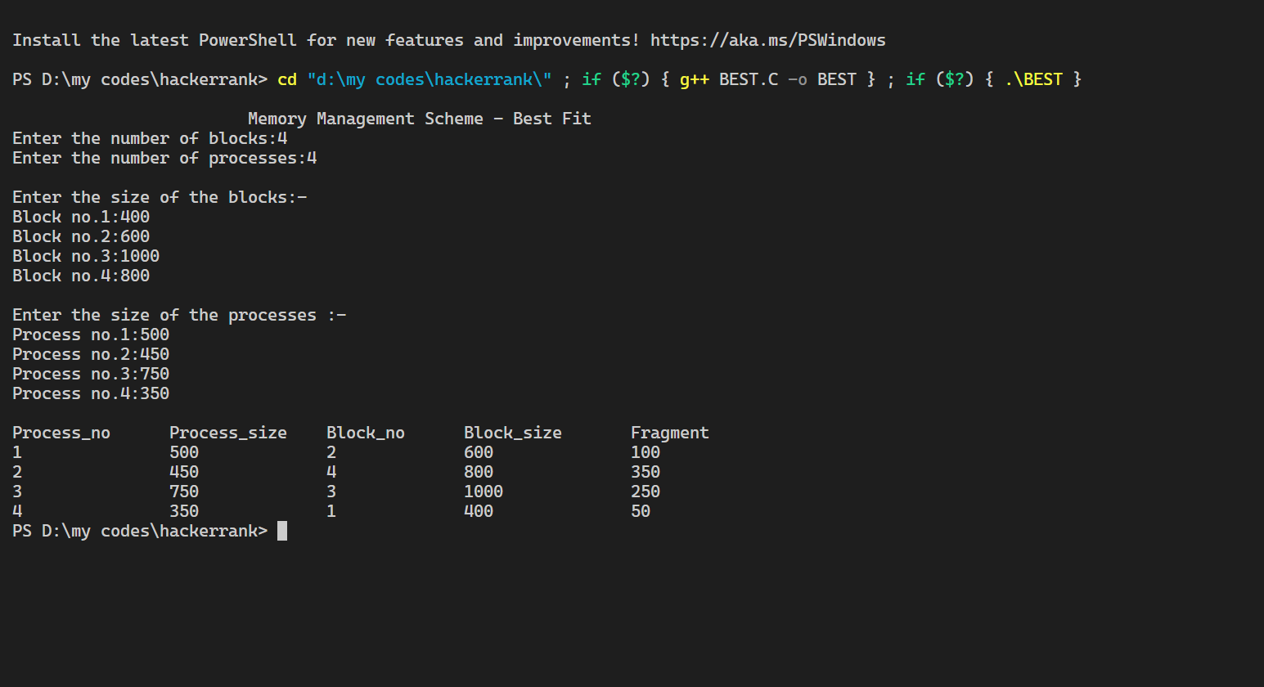

4.WORST FIT

// WORST FIT:

#include <stdio.h>

void implimentWorstFit(int blockSize[], int blocks, int processSize[], int processes)

{

    // This will store the block id of the allocated block to a process

    int allocation[processes];

    int occupied[blocks];

    // initially assigning -1 to all allocation indexes

    // means nothing is allocated currently

    for (int i = 0; i < processes; i++)

    {

        allocation[i] = -1;

    }

    for (int i = 0; i < blocks; i++)

    {

        occupied[i] = 0;

    }

    // pick each process and find suitable blocks

    // according to its size ad assign to it

    for (int i = 0; i < processes; i++)

    {

        int indexPlaced = -1;

        for (int j = 0; j < blocks; j++)

        {

            // if not occupied and block size is large enough

            if (blockSize[j] >= processSize[i] && !occupied[j])

            {

                // place it at the first block fit to accomodate process

                if (indexPlaced == -1)

                    indexPlaced = j;

                // if any future block is larger than the current block where

                // process is placed, change the block and thus indexPlaced

                else if (blockSize[indexPlaced] < blockSize[j])

                    indexPlaced = j;

            }

        }

        // If we were successfully able to find block for the process

        if (indexPlaced != -1)

        {

            // allocate this block j to process p[i]

            allocation[i] = indexPlaced;

            // make the status of the block as occupied

            occupied[indexPlaced] = 1;

            // Reduce available memory for the block

            blockSize[indexPlaced] -= processSize[i];

        }

    }

    printf("\nProcess No.\tProcess Size\tBlock no.\n");

    for (int i = 0; i < processes; i++)

    {

        printf("%d \t\t\t %d \t\t\t", i + 1, processSize[i]);

        if (allocation[i] != -1)

            printf("%d\n", allocation[i] + 1);

        else

            printf("Not Allocated\n");

    }

}

// Driver code

int main()

{

    int n;

    printf("Enter no of blocks:");

    scanf("%d", &n);

    int blockSize[n];

    int m;

    printf("Enter no of process:");

    scanf("%d", &m);

    int processSize[m];

    for (int i = 0; i < n; i++)

    {

        printf("Enter size for block %d ", i + 1);

        scanf("%d", &blockSize[i]);

    }

    for (int i = 0; i < n; i++)

    {

        printf("Enter size for process no %d ", i + 1);

        scanf("%d", &processSize[i]);

    }

    int blocks = sizeof(blockSize) / sizeof(blockSize[0]);

    int processes = sizeof(processSize) / sizeof(processSize[0]);

    implimentWorstFit(blockSize, blocks, processSize, processes);

    return 0;

}

OUTPUT

