OPERATING SYSTEM LAB

LAB 3

• Name :HITU RAJ

• Roll no. :2005025

• Branch :CSE

# 1. write a shell programme to input 2 no.s and display it.?

echo "enter 2 no."

read a b

echo "$a $b"

OUTPUT-1

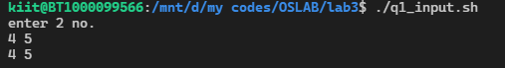

# 2. Write a shell programme input 2 no. and swap them with using third variable

echo "enter 2 no."

read a b

echo "before swapping values are $a $b"

temp=`expr $a`

a=`expr $b`

b=`expr $temp`

# temp=$a

# a=$b

# b=$temp

echo "after swapping values are $a $b"

OUTPUT-2

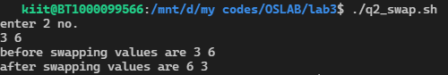

# 3. Write a shell programme input 2 no. and swap them without using third variable

echo "enter 2 no."

read a b

echo "before swapping values are $a $b"

temp=`expr $a`

a=`expr $b`

b=`expr $temp`

# temp=$a

# a=$b

# b=$temp

echo "after swapping values are $a $b"

OUTPUT-3

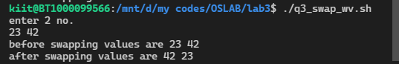

# 4. write a shell programe to input 2 no. and perform arithmetic operations

echo "enter 2 no."

read a b

sum=`expr $a + $b`

echo "sum= $sum"

sub=`expr $a - $b`

echo "sub= $sub"

divide=`expr $a / $b`

echo "divide= $divide"

mul=`expr $a \* $b`

echo "mutliply= $mul"

OUTPUT-4

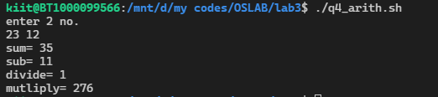

# 5. write a shell script programme input radius of a circle

# and find out its area and perimeter

echo "enter the radius"

read a

area=`echo 3.14 \* $a \* $a|bc`

echo "area=$area"

perim=`echo 2\* 3.14 \* $a |bc`

echo "perimeter=$perim"

output-5

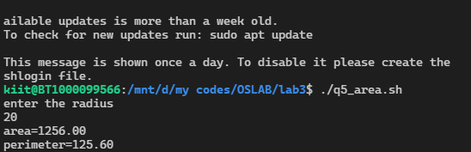

# 6. write a sheLl script programme input time in second and

#  convert it into hour min andsecond

echo "enter the time in second"

read a

hr=`expr $a / 60 / 60`

a=`expr $a % 3600`

min=`expr $a / 60`

a=`expr $a `

echo " hr=$hr min=$min sec=$a"

OUTPUT-6

