OPERATING SYSTEM LAB

LAB 4

• Name :HITU RAJ

• Roll no. :2005025

• Branch :CSE

# 1. - Write a shell script to check to see if the file “file_path” exists. If it does exist, display “file_path passwords are enabled.” Next, check to see if you can write to the file. If you can, display “You have permissions to edit “file_path.””If you cannot, display “You do NOT have permissions to edit “file_path””

echo "enter a filename"

read filename

if [ -e $filename ]

 then

    echo "$filename exist"

    if [ -w $filename ]

    then

       echo "you have permission to edit file $filename "

    else

       echo "you donot have permission to edit file $filename "

    fi

else

 echo  "$filename  do not exist"

fi

OUTPUT-1

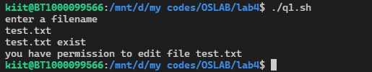

# 2. write a shell script that prompts the user for a name of a file or directory and reports if it is a regular file, a directory, or another type of file. Also perform an ls command against the file or directory with the long listing option.

echo "enter a filename"

read filename

if [ -d $filename ]

 then

    echo "$filename is a directory"

 elif [ -f $filename ]

   then

    echo "$filename is a regular or ordinary file"

 else

 echo  "$filename is another type of file"

fi

ls -l $filename

OUTPUT -2

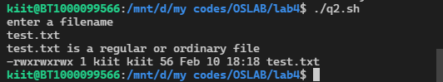

# 3. Modify the previous script to that it accepts the file or directory name as an argument instead of prompting the user to enter it.

echo "enter a filename"

filename=test.txt

if [ -d $filename ]

 then

    echo "$filename is a directory"

 elif [ -f $filename ]

   then

    echo "$filename is a regular or ordinary file"

 else

 echo  "$filename is another type of file"

fi

ls -l $filename

OUTPUT -3

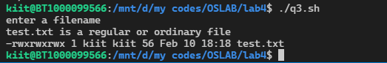

# 4. Enter two number if first is greater than second one perform subtraction and division other wise perform addition and multiplication

echo "enter  2 number"

read a b

if [[ $a -gt $b ]]

 then

 sub=`expr $a - $b`

 div=`expr $a / $b`

    echo "$a - $b = $sub"

     echo "$a / $b = $div"

  else

     add=`expr $a + $b`

     mul=`expr $a \* $b`

     echo "$a + $b = $add"

     echo "$a * $b = $mul"

fi

OUTPUT -4

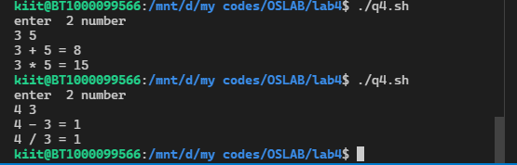

# 5. Check whether a give filename is directory or not, if not check the permission on the files, if  #it has write permission append some data to it.

echo "enter a filename"

read filename

if [ -d $filename ]

 then

    echo "$filename is a directory"

 else

 echo  "$filename is not a durectory"

    if [ -w $filename ]

    then

    echo "file have write permision"

    echo "write something to append"

    cat >> $filename

    else

    echo "file doesnt have write permsiion"

   fi

fi

ls -l $filename

OUPTUT -5

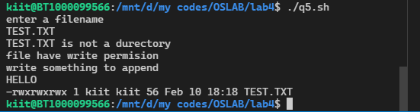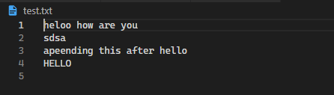

# 6.Take a number and whether it is greater than 10 or not, print the message accordingly

echo "enter a number"

read a

if [[ $a -gt 10 ]]

then

    echo "$a is greater than 10"

else

echo "$a is not  greater than 10"

fi

OUTPUT -6

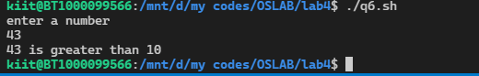

# 7.Take two number from command line argument and check whether they equal or not . If not equal

#print the greater value

echo "enter  2 number"

read a b

if [[ $a -ne $b ]]

 then

    echo "$a is not equal to $b"

if [[ $a -gt $b ]]

then

echo "$a is   greater than 10"

else

echo "$a is  not  greater than 10"

fi

fi

OUTPUT -7

