

WT ASSIG 1

• Name :HITU RAJ

• Roll no. :2005025

• Branch :CSE

// 5. Write a program that displays the results of a series of 10 coin tosses. Use

// Math.random() function to generate a number between 0 and 1. After each coin toss,

// display whether the toss represents ‘heads’ or ‘tails’. If the result is 0.5 or less, the

// result represents ‘heads’; otherwise, it represents ‘tails’.

public class Main {

   public static void main(String[] args) {

      int i;

      for (i = 0; i < 10; i++) {

         if (Math.random() < 0.5) {

            System.out.println("Heads");

         } else {

            System.out.println("Tails");

         }

      }

   }

}

OUTPUT-5

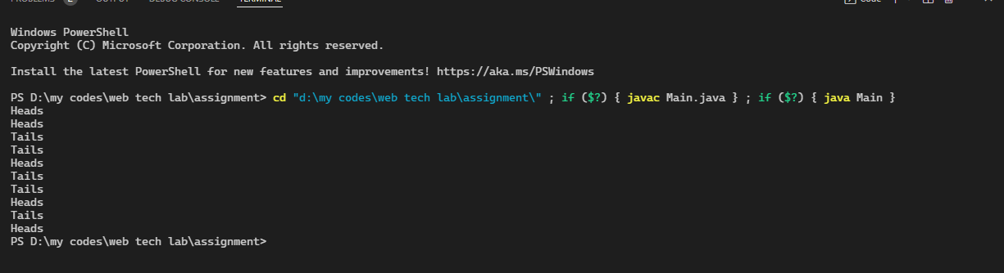

// // 6. Write a program in Java to implement the concept of dynamic method dispatch using

// method overriding.

import java.util.Scanner;

class trees {

    int no;

    void tree() {

        System.out.println("this is tree class");

    }

}

class mango extends trees {

    int no;

    void tree() {

        System.out.println("this is mango class");

    }

}

class apple extends mango {

    int no;

    void tree() {

        System.out.println("this is appple class");

    }

}

public class q2

{

    public static void main(String[] args) {

int x;

        Scanner sc=new Scanner(System.in);

        System.out.println("from the object of apple class and mangoclass acceesing method of tree class ehich is inherited hierachial");

        mango m = new apple();

        m.tree();

        trees a= new mango();

        a.tree();

    }

}

OUTPUT-6

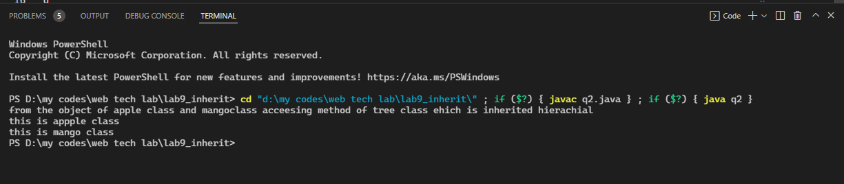

// 7. Write a program in Java to implement constructor overloading.

class shape {

    void area() {

        System.out.println("the is use to calculate area method");

    }

    void showarea() {

        System.out.println("this the use to siplay area");

    }

}

class circle extends shape {

    int r = 20;

    float area;

    void area(int x) {

        area = (float) 3.14 * x * x;

    }

    void showarea() {

        System.out.println("area of circle is " + area);

    }

}

class rectangle extends shape {

    int l = 5, b = 3;

    float area;

    void area(int x, int y) {

        area = (float) l * b;

    }

    void showarea() {

        System.out.println("area of rectangle is " + area);

    }

}

 public class q3_area

{

    public static void main(String[] args) {

        circle m = new circle();

        m.area(20);

        m.showarea();

        rectangle a = new rectangle();

        a.area(20, 40);

        a.showarea();

    }

}

OUTPUT-7

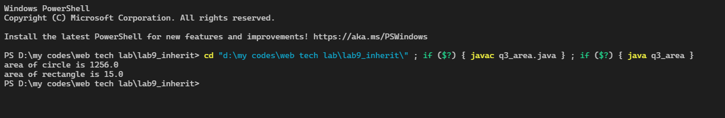

// 8. Write a program that prompts the user to input two numbers, first and diff. The

// program then creates a one dimensional array of 10 elements and initializes them with

// an arithmetic sequence. The first number of the sequence is the first value and the

// next number is generated by adding the diff to the number preceding it. This formula

// is repeated for the rest of the sequence. E.g. if first =11 and diff = 4, then the

// arithmetic sequence will be 11, 15, 19, 23, 27, 31 ... and so on.

import java.util.*;

public class Q8other {

    public static void main(String args[]) {

        Scanner sc = new Scanner(System.in);

        System.out.print("Enter first- ");

        int first = sc.nextInt();

        System.out.print("Enter diff- ");

        int diff = sc.nextInt();

        int array[] = new int[10];

        array[0] = first;

        for (int i = 1; i < 10; i++) {

            array[i] = array[i - 1] +

                    diff;

        }

        System.out.println("The arithematic sequence is:");

        for (int i = 0; i < 10; i++) {

            System.out.print(array[i]);

            if (i != 9) {

                System.out.print(",");

            }

        }

    }

}

OUTPUT-8

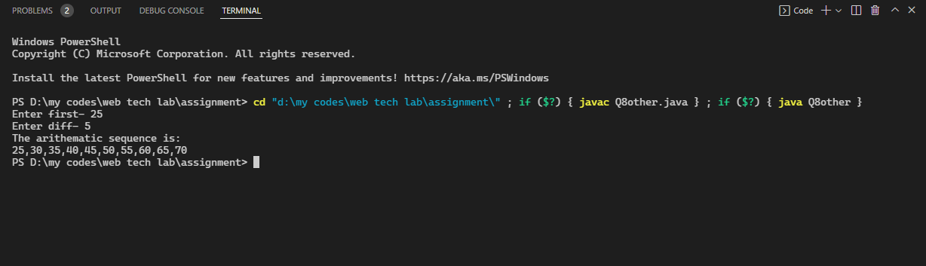

// 10. Implement the concept of abstract class for the following:

import java.util.*;

abstract class Q10 {

  abstract int moneyconversion();

  static class rupeetodollar extends Q10 {

    int moneyconversion() {

      return 78;

    }

  }

  static class rupeetoeuro extends Q10 {

    int moneyconversion() {

      return 85;

    }

  }

  public static void main(String args[]) {

    int x;

    System.out.println("Enter your amount in rupees:");

    Scanner sc = new Scanner(System.in);

    x = sc.nextInt();

    Q10 obj;

    obj = new rupeetodollar();

    System.out.println("Your amount in dollars is =" + (x / obj.moneyconversion()));

    obj = new rupeetoeuro();

    System.out.println("Your amount in euro is =" + (x / obj.moneyconversion()));

  }

}

OUTPUT-10

