

WT LAB -11

• Name :HITU RAJ

• Roll no. :2005025

• Branch :CSE

// 1. Illustrate the usage of abstract class with following Java classes -

// i)An abstract class ,,student" with data member roll no, reg no and a abstract method course()

// ii)A subclass ,,kiitian" with course() method implementation

import java.util.Scanner;

abstract class student {

     int roll, reg;

    abstract void course(int a, int b);

}

class kiitian extends student {

    void course(int a, int b)

    {

        roll = a;

        reg = b;

        System.out.println("Roll No:- " + a + " Reg No:- " + b);

    }

}

class q1

{

    public static void main(String[] args) {

        Scanner s = new Scanner(System.in);

        int a, b;

        System.out.println("Enter the roll:-");

        a = s.nextInt();

        System.out.println("Enter the reg:-");

        b = s.nextInt();

        kiitian k = new kiitian();

        k.course(a, b);

    }

}

**OUTPUT-1**

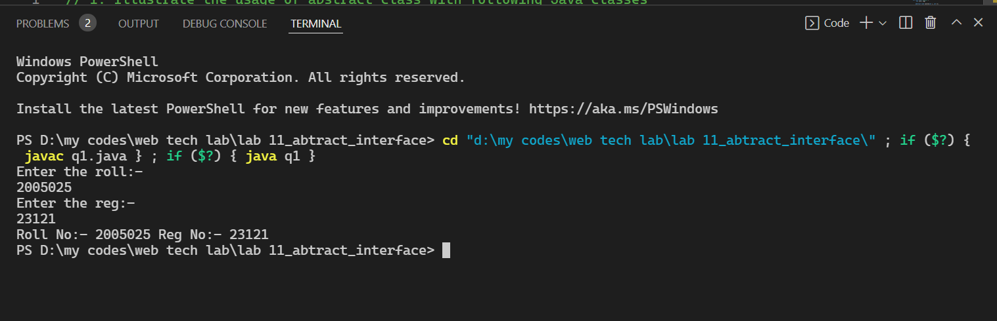

// 2. Define an interface Motor with a data member -capacity and two methods such as run() and consume(). Define a Java class,Washing machine" which implements this interface and write the code to check the value of the interface data member thru an object of the class.

import java.util.Scanner;

interface motor {

    void run();

    int capacity = 10;

    void consume();

}

class WM implements motor {

    Scanner input = new Scanner(System.in);

    int lt;

    public void consume() {

        System.out.println("how much water do u want to consume");

        lt = input.nextInt();

    }

    public void run() {

        if (lt > capacity) {

            System.out.println("Error,washing machine cannot run");

        } else {

            System.out.println("Okay,you can run wachine machine");

        }

    }

}

class q2 {

    public static void main(String[] args) {

        motor a = new WM();

        a.consume();

        a.run();

    }

}

**OUTPUT-2**

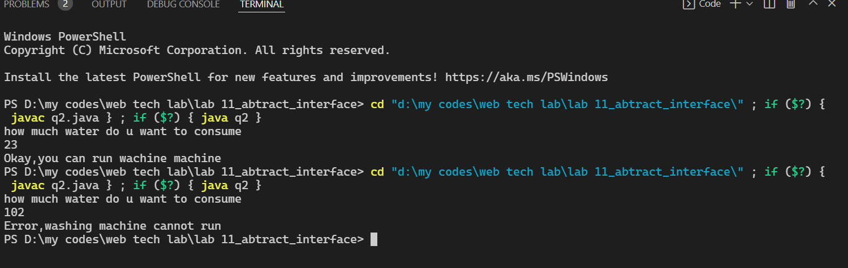

// 3. Define an interface with three methods - earnings(). deductions() and bonus) and define a Java class,Manager" which uses this interface without implementing bonus() method. Also define another Java class ,Substaff" which extends from Manager" class and implements bonus() method. Write the complete program to find out earnings, deduction and bonus of a sbstaff with basic salary amount entered by the user as per the following guidelines -

// earnings→basic +DA (80% of basic) + HRA (15% of basic)

// deduction PF -12% of basic

// bonus -50% of basic

import java.util.Scanner;

interface Payment {

    void deduction();

    void bonus();

    void earning();

}

class Manager implements Payment {

    Scanner in = new Scanner(System.in);

    double bs, da, hra, earning_val, deduction_val,

            bonus_val;

    Manager() {

        System.out.println("enter your basic salary");

        bs = in.nextInt();

    }

    public void earning() {

        earning_val = bs + 0.8 * bs + 0.15 * bs;

        System.out.println("Earning =" + earning_val);

    }

    public void deduction() {

        deduction_val = 0.12 * bs;

        System.out.println("Deduction =" +deduction_val);

    }

    public void bonus() {

    }

}

class Substaff extends Manager {

    public void bonus() {

        bonus_val = 0.12 * bs;

        System.out.println("Bonus =" + bonus_val);

    }

}

class q3 {

    public static void main(String args[]) {

        Manager ob1 = new Manager();

        ob1.earning();

        ob1.deduction();

        Substaff ob2 = new Substaff();

        ob2.bonus();

    }

}

**OUTPUT-3**

