

WT LAB -12

• Name :HITU RAJ

• Roll no. :2005025

• Branch :CSE

Q1.java

// 1. Define two packages as - General and Marketing. In General package define a class ,employee" with data members as empid(protected), ename(private) and a public method as earnings() which calculate total earnings as earnings → basic +DA (80% of basic) + HRA (15% of basic)

// In Marketing package define a class ,sales" which is extending from employee" class and has a method tallowance() which calculates Travelling Allowance as 5% of total earning. Write the programs to find out total earning of a sales person for the given basic salary amount and print along with the emp id.

import java.util.Scanner;

import marketing.*;

public class q1 {

    public static void main(String[] args) {

        Scanner scan = new Scanner(System.in);

        System.out.println("Enter employee name");

        String name = scan.next();

        System.out.println("Enter empid");

        int id = scan.nextInt();

        System.out.println("Enter basic salary");

        int basic = scan.nextInt();

        sales s = new sales(name, id);

        s.printdetails();

        System.out.println("Earnings");

        System.out.println(s.earnings(basic));

        System.out.println("Travel allowance");

        System.out.println(s.tallowance(basic));

        scan.close();

    }

}

Sales.java

package marketing;

import general.*;

public class sales extends Employee {

    public sales(String name, int id) {

        super(name, id);

    }

    public double tallowance(int basic) {

        double earn = this.earnings(basic);

        double t = 0.05 * earn;

        return t;

    }

}

Employee.java

package general;

public class Employee {

    protected int empid;

    private String ename;

    public Employee(String name, int id) {

        ename = name;

        empid = id;

    }

    public double earnings(int basic) {

        double earn = basic + (0.8 * basic) + (0.15 * basic);

        return earn;

    }

    public void printdetails() {

        System.out.println("Employee name");

        System.out.println(ename);

        System.out.println("Employee id");

        System.out.println(empid);

    }

}

OUTPUT-1

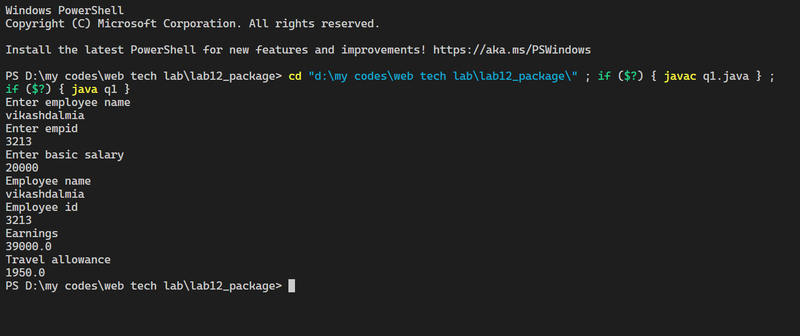

// 2. Write a program to perform following operations on user entered strings -

// i) Change the case of the string

// ii) Reverse the string

// iii) Compare two strings

// iv) Insert one string into another string

import java.util.*;

class q2 {

    public static void main(String[] args) {

        Scanner sc = new Scanner(System.in);

        String s;

        System.out.println("Enter a string");

        s = sc.nextLine();

        String s2 = "";

        for (int i = 0; i < s.length(); i++) {

            char ch = s.charAt(i);

            int t = ch;

            if (t >= 65 && t <= 90)

                ch = (char) (t + 32);

            else if (t >= 97 && ch <= 122)

                ch = (char) (t - 32);

            s2 += ch;

        }

        System.out.println("The string after changing the case is " + s2);

        s2 = "";

        for (int i = s.length() - 1; i >= 0; i--)

            s2 += s.charAt(i);

        System.out.println("The string after reversing is " + s2);

        String s3;

        System.out.println("Enter the second string for comparison");

        s3 = sc.nextLine();

        System.out.println("The difference between ASCII value is " +

                s.compareTo(s3));

        System.out.println("Enter the string to be inserted into first string");

        s3 = sc.nextLine();

        System.out.println("The two strings after insertion is " + (s + s3));

        sc.close();

    }

}

**OUTPUT -2**

