

WT LAB -13

(EXCEPTION-HANDLING)

• Name :HITU RAJ

• Roll no. :2005025

• Branch :CSE

// 1. Write a Java program to generate an ArrayIndexOutofBounds Exception and handle it using catch statement.

import java.util.Scanner;

public class q1 {

    public static void main(String[] args) {

        int[] arr = {1,2,3,4,5};

        System.out.println("The Array is:");

        for(int i=0;i<arr.length;i++){

            System.out.print(arr[i]+" ");

        }

        Scanner sc = new Scanner(System.in);

        System.out.print("\nEnter the index to access the array: ");

        try {

            int index = sc.nextInt();

            sc.close();

            System.out.println(arr[index] + " is at index " + index + " of the array");

        }

        catch (ArrayIndexOutOfBoundsException e) {

            System.out.println(e);

        }

        System.out.println("Rest of the Code");

    }

}

OUTPUT -1

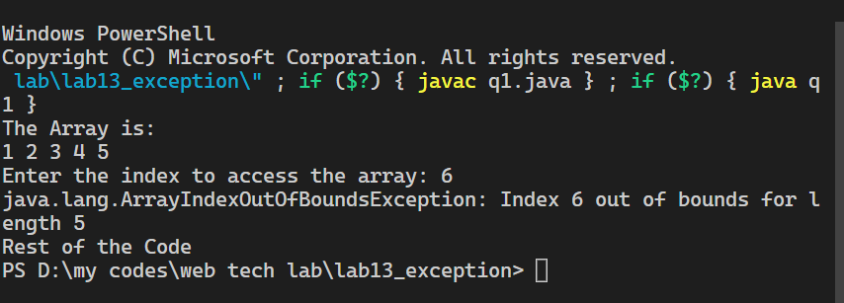

// 2. A subclass exception must appear before super-class exception. Justify this with suitable Java programs.

public class q2 {

    public static void main(String[] args) {

        try {

            int result = 5 / 0;

            System.out.println("Result is: " + result);

        }

        // catch(ArithmeticException e2){

        // System.out.println("Subclass ArithmeticException Occured");

        // }

        catch (Exception e1) {

            System.out.println("Superclass Exception Occured");

        }

        catch (ArithmeticException e2) {

            System.out.println("Subclass ArithmeticException Occured");

        }

        System.out.println("Program Ended");

    }

}

**OUTPUT-2**

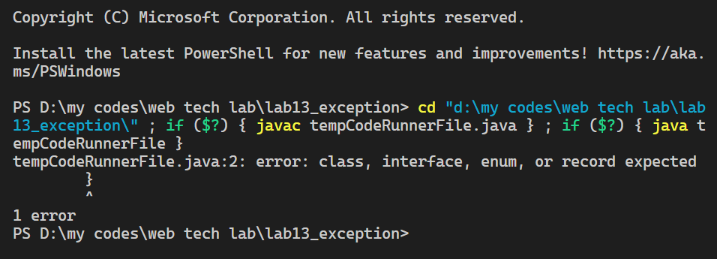

// 3. Write a Java program to illustrate try..catch..finally block.

import java.util.Scanner;

public class q3 {

    public static void main(String[] args) {

        try{

            System.out.println("This program will print the result of a/b");

            Scanner sc = new Scanner(System.in);

            System.out.print("Enter value of a: ");

            int data1 = sc.nextInt();

            System.out.print("Enter value of b: ");

            int data2 = sc.nextInt();

            sc.close();

            System.out.println(data1/data2);

        }

        catch(ArithmeticException e){ //here if any the exception is not handled

           System.out.println(e);    //then the code after finally block wont run

        }

        // catch(NullPointerException e){

        //    System.out.println(e);

        // }

        finally{

            System.out.println("Inside finally block");

        }

        System.out.println("Program Ended");

    }

}

**OUTPUT-3**

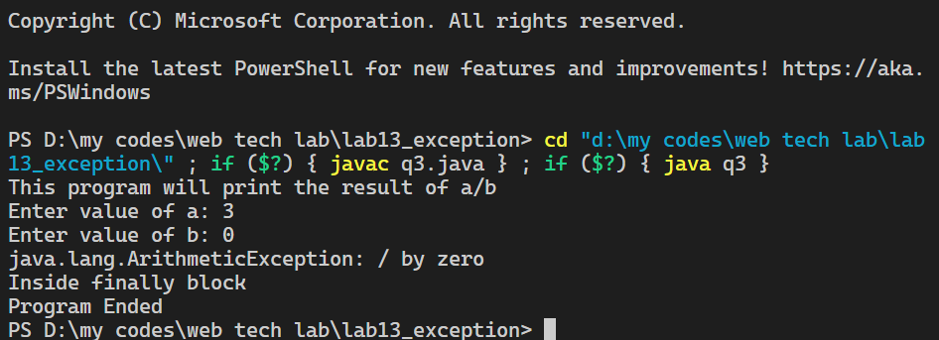

// 4. Write a Java class which has a method called ProcessInput(). This method checks the number entered by the user. If the entered number is negative then throw an user defined exception called NegativeNumberException, otherwise it displays the double value of the entered number.

import java.util.Scanner;

class NegativeNumberException extends Exception {

    NegativeNumberException(String s) {

        super(s);

    }

}

public class q4 {

    static void processInput(int num) throws NegativeNumberException

    {

        if (num < 0)

            throw new NegativeNumberException("Number Entered is a Negative Number");

        else

            System.out.println("The Number " + (double) num + " is Positive");

    }

    public static void main(String[] args) {

        System.out.print("Enter a number: ");

        Scanner sc = new Scanner(System.in);

        try {

            int input = sc.nextInt();

            sc.close();

            processInput(input);

        } catch (NegativeNumberException e) {

            System.out.println("Exception Occured " + e);

        }

        System.out.println("Rest of the Code");

    }

}

**OUTPUT-4**

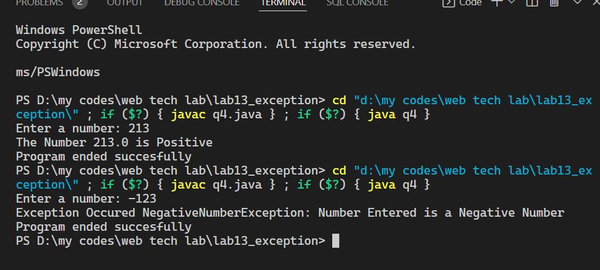

// 5. Write a program to create user defined exceptions called HrsException. MinException and SecException. Create a class Time which contains data members hours. minutes. seconds and throw the user defined exceptions if hours (>24 & <0).minutes(>60 & <0).seconds(>60 & <0).

import java.util.Scanner;

class HrsException extends Exception {

    HrsException(String s) {

        super(s);

    }

}

class MinException extends Exception {

    MinException(String s) {

        super(s);

    }

}

class SecException extends Exception {

    SecException(String s) {

        super(s);

    }

}

class Time {

    int hrs, min, sec;

    Time(int hrs, int min, int sec) {

        this.hrs = hrs;

        this.min = min;

        this.sec = sec;

    }

    void display() throws HrsException,MinException,SecException {

        if (hrs < 0 || hrs > 24)

            throw new HrsException("Either Hrs value is less than 0 or greater than 24");

        else

            System.out.print(hrs + " hr ");

        if (min < 0 || min > 60)

            throw new MinException("Either Min value is less than 0 or greater than 60");

        else

            System.out.print(min + " min ");

        if (sec < 0 || sec > 60)

            throw new SecException("Either Sec value is less than 0 or greater than 60");

        else

            System.out.print(sec + " sec");

    }

}

public class q5 {

    public static void main(String[] args) {

        Scanner sc = new Scanner(System.in);

        System.out.print("Enter the hrs value: ");

        int hours = sc.nextInt();

        System.out.print("Enter the min value: ");

        int minutes = sc.nextInt();

        System.out.print("Enter the sec value: ");

        int seconds = sc.nextInt();

        sc.close();

        Time mytime = new Time(hours,minutes,seconds);

        try{

            System.out.print("\nThe Time is: ");

            mytime.display();

        }

        catch(HrsException e){

            System.out.println(e);

        }

        catch(MinException e){

            System.out.println(e);

        }

        catch(SecException e){

            System.out.println(e);

        }

    }

}

**OUTPUT-5**

