WEB TECHNOLOGY LAB

LAB 2

• Name :HITU RAJ

• Roll no. :2005025

• Branch :CSE

<!-- 1. WAP in HTML to create two unordered list having 5 items each- one is of domestic animals and another is of wild animals.-->

<!DOCTYPE html>

<html lang="en">

<head>

    <meta charset="UTF-8">

    <meta http-equiv="X-UA-Compatible" content="IE=edge">

    <meta name="viewport" content="width=device-width, initial-scale=1.0">

    <title>UNORDERED LIST</title>

</head>

<body>

    <center><h2>2 unordered list</h2></center>

    <ul type="square">

        <h4>DOMESTIC ANIMAL</h4>

        <li>dog</li>

        <li>rabbbit</li>

        <li>cat</li>

        <li>lion</li>

        <li>monkey</li>

    </ul>

     <br>

     <br>

    <ul type="circel">

        <h4>WILD ANIMAL</h4>

        <li>Lion</li>

        <li>tiger</li>

        <li>elephant</li>

        <li>deer</li>

        <li>fox</li>

    </ul>

</body>

</html>

OUTPUT-1

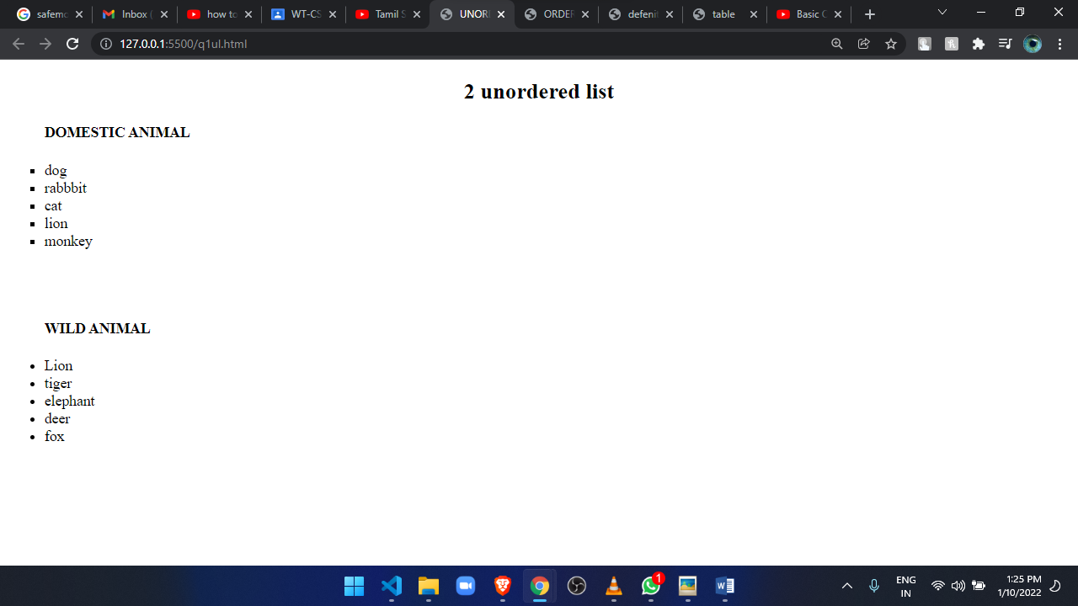

<!-- 2. WAP in HTML to create two ordered list showing menu of a restaurant - one is veg items and another is non-veg items. -->

<!DOCTYPE html>

<html lang="en">

<head>

    <meta charset="UTF-8">

    <meta http-equiv="X-UA-Compatible" content="IE=edge">

    <meta name="viewport" content="width=device-width, initial-scale=1.0">

    <title>ORDERED LIST</title>

</head>

<body>

    <center><h2>2 ordered list</h2></center>

    <ol type="I">

        <h4>VEG MENU</h4>

        <li>veg chiili</li>

        <li>pannerchiili</li>

        <li>vegchwmin</li>

        <li>panner butter masala</li>

        <li>veg soup</li>

    </ol>

     <br>

     <br>

    <ol type="A">

        <h4>NON VEG MENU</h4>

        <li>chicken chiili</li>

        <li>chicken chowmin</li>

        <li>chicken butter masala</li>

        <li>chicken soup</li>

        <li>mutton </li>

    </ol>

</body>

</html>

OUTPUT-2

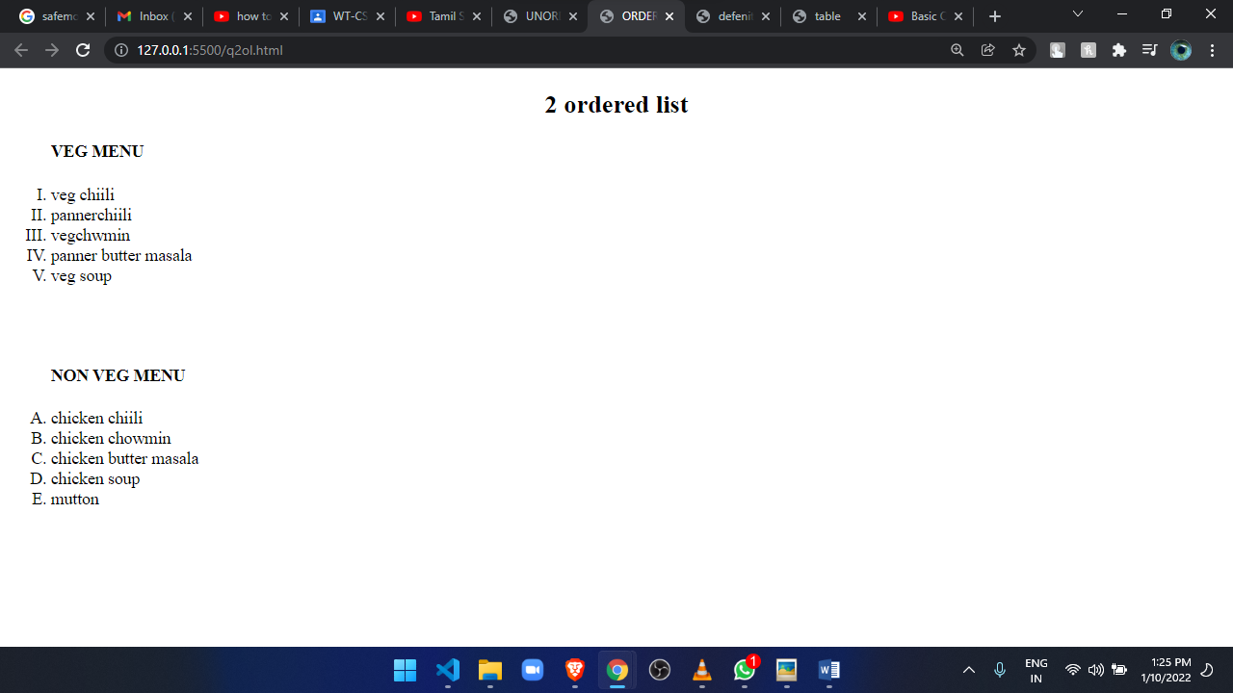

<!-- 3. WAP in HTML to create a definition list explaining working of 5 important HTML tags -->

<!DOCTYPE html>

<html lang="en">

<head>

    <meta charset="UTF-8">

    <meta http-equiv="X-UA-Compatible" content="IE=edge">

    <meta name="viewport" content="width=device-width, initial-scale=1.0">

    <title>defenition LIST</title>

</head>

<body>

    <center>

        <h2>Defenition list</h2>

    </center>

    <dl>

        <b>

            <dl>paragraph tag</dl>

        </b>

        <dd>used to write a content in a paragraph</dd>

        <b>

            <dl>bold tag</dl>

        </b>

        <dd>used to bold a text</dd>

        <b>

            <dl>br tag</dl>

        </b>

        <dd>use to brak a line</dd>

        <b>

            <dl>title tag</dl>

        </b>

        <dd>it is used in head part and is use to give title</dd>

        <b>

            <dl>hr tag</dl>

        </b>

        <dd>it is use to give horizontal rulwe</dd>

    </dl>

</body>

</html>

OUTPUT-3

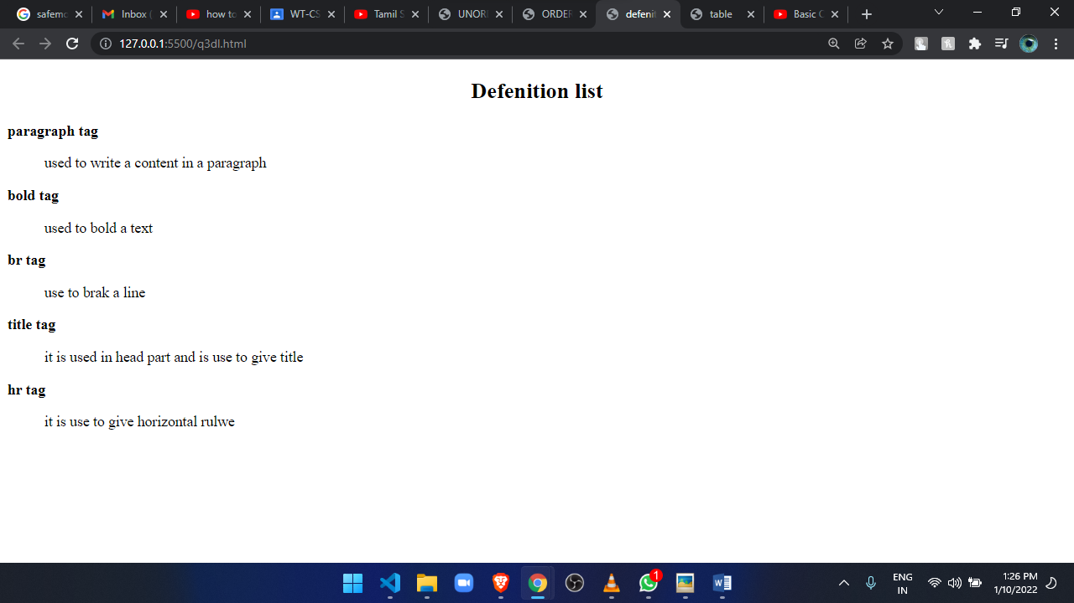

<!-- 4. WAP to display your qualification details(marks obtained and percentage of 10th, 11th, 12th and all the sems of Btech till -->

<!-- now) in tabular format (use rowspan, colspan, cell spacing and cell padding) and organize it as given below. --> -->

<!DOCTYPE html>

<html lang="en">

<head>

    <meta charset="UTF-8">

    <meta http-equiv="X-UA-Compatible" content="IE=edge">

    <meta name="viewport" content="width=device-width, initial-scale=1.0">

    <title>table</title>

</head>

<body>

    <center><table border="4" cellpadding="4" cellspacing="2"  height="400" weidth="400" >

        <thead>

                <tr>

                    <th colspan="2">class</th>

                    <th>institution</th>

                    <th>total marks</th>

                    <th> marks obtained</th>

                    <th> percentage</th>

                </tr>

                       </thead>

        <tbody>

            <tr>

                <td>matric</td>

                <td>10th</td>

                <td>dav</td>

                <td>500</td>

                <td>480</td>

                <td>93%</td>

            </tr>

            <tr>

                <td rowspan="2">intermediate</td>

                <td>11th</td>

                <td>dps</td>

                <td>500</td>

                <td>440</td>

                <td>94%</td>

            </tr>

            <tr>

                <td>12th</td>

                <td>dps</td>

                <td>500</td>

                <td>470</td>

                <td>95%</td>

            </tr>

            <tr>

                <td rowspan="2">graduation</td>

                <td>1st sem</td>

                <td>KIIT</td>

                <td>500</td>

                <td>480</td>

                <TD>95&</TD>

            </tr>

            <tr>

                <td>2ND SEM</td>

                <td>KIIT</td>

                <td>500</td>

                <td>470</td>

                <td>95%</td>

            </tr>

        </tbody>

    </table>

</center>

</body>

</html>

OUTPUT-4

