

WT LAB -4

• Name :HITU RAJ

• Roll no. :2005025

• Branch :CSE

Q1 STYLE.CSS

.blue{

    color: blue;

}

.bigg{

    font-size: 10px;

}

.cent{

    text-align: center;

}

<!-- 1. Create an external stylesheet containing three classes, blue: which colors blue, bigg: which increses the font to 10px,

cent: which aligns to center. Import the css in a html file and use all the three classes. -->

<!DOCTYPE html>

<html lang="en"

QUESTION -1(EXTERNAL.HTML)

<head>

    <meta charset="UTF-8">

    <meta http-equiv="X-UA-Compatible" content="IE=edge">

    <meta name="viewport" content="width=device-width, initial-scale=1.0">

    <title>External Css</title>

    <link rel="stylesheet" href="q1_style.css">

</head>

<body>

    <div class="blue">Text color blue</div>

    <br>

    <div class="bigg">Font size 10px</div>

    <br>

    <div class="cent">Aligns text to center</div>

</body>

</html>

OUTPUT-1

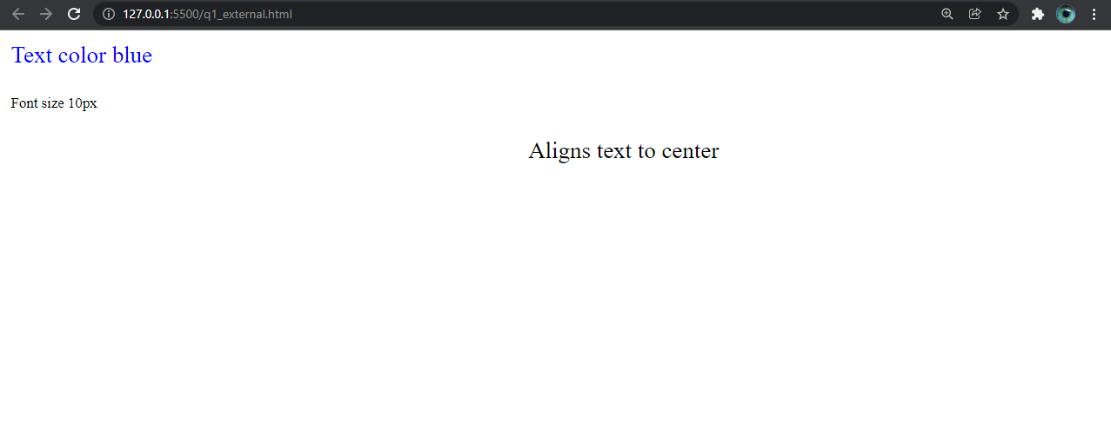

QUESTION-2

<!-- 2. Create an internal stylesheet containing three classes, blue: which colors blue, bigg: which increses the font to 10px,

cent: which aligns to center, in a html file and use all the three classes. -->

<!DOCTYPE html>

<html lang="en">

  <head>

    <meta charset="UTF-8" />

    <meta http-equiv="X-UA-Compatible" content="IE=edge" />

    <meta name="viewport" content="width=device-width, initial-scale=1.0" />

    <title>Document</title>

    <style>

      .blue {

        color: blue;

      }

      .bigg {

        font-size: 10px;

      }

      .cent {

        text-align: center;

      }

    </style>

  </head>

  <body>

    <div class="blue">text color blue</div>

    <div class="bigg">font size 10px</div>

    <div class="cent">aligns text to center</div>

  </body>

</html>

OUTPUT-2

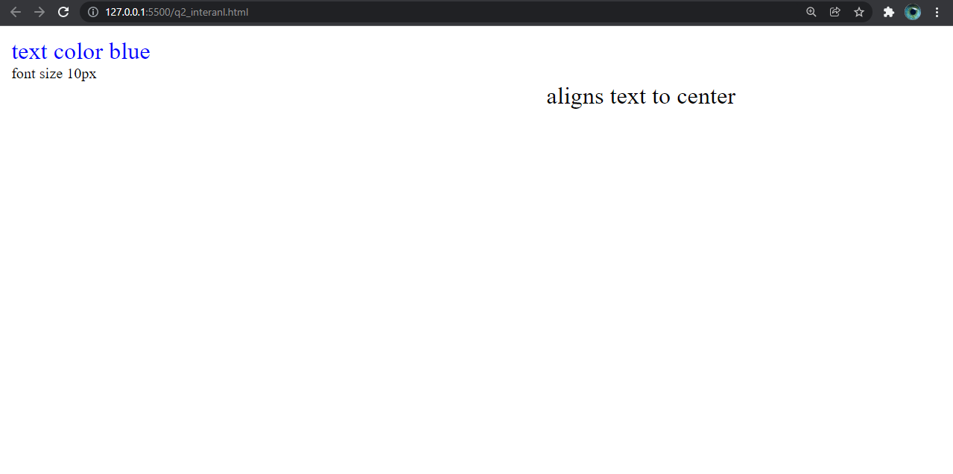

QUESTION -3

<!—3. Use inline style sheet containing three classes, blue: which colors blue, bigg: which increses the font to 10px,

cent: which aligns to center, in a html file -->

<!DOCTYPE html>

<html lang="en">

  <head>

    <meta charset="UTF-8" />

    <meta http-equiv="X-UA-Compatible" content="IE=edge" />

    <meta name="viewport" content="width=device-width, initial-scale=1.0" />

    <title>Document</title>

  </head>

  <body>

    <div style="color: blue;">text color blue</div>

    <div style="font-size: 10px;">font size 10px</div>

    <div style="text-align: center;">aligns text to center</div>

  </body>

</html>

OUTPUT-3



QUESTION-4

<!-- 4. Use <meta> tag in a html file to store meta data. -->

<!DOCTYPE html>

<html lang="en">

  <head>

    <meta charset="UTF-8" />

    <meta http-equiv="X-UA-Compatible" content="IE=edge" />

    <meta name="viewport" content="width=device-width, initial-scale=1.0" />

    <meta name="keywords" content="html, css" />

    <meta name="description" content="adding meta tags" />

    <title>Document</title>

  </head>

  <body>

      <h1>

          <div>

              ADDED META TAGS IN HTML FILE

          </div>

      </h1>

  </body>

</html>

OUTPUT-4

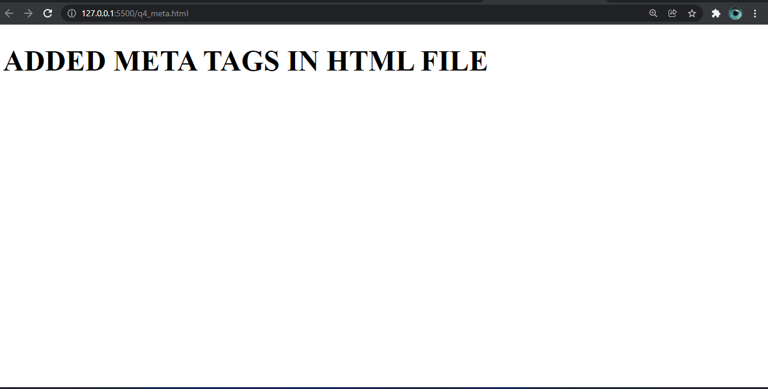

QUESTION-5

// 5. WAP in java to print your biodata.

class first{

    public static void main(String[] args)

    {

        System.out.println("Name---->hitu raj");

        System.out.println("Date of birth:10-10-2001");

        System.out.println("2nd year B.Tech Student,Kiit");

        System.out.println("Address ------>Ranchi");

        System.out.println("Intrests-->exploring");

        System.out.println("Aim -->success");

    }

}

OUTPUT-5

