

WT LAB -6

• Name :HITU RAJ

• Roll no. :2005025

• Branch :CSE

// 1. WAP in java to create a class Faculty having members id, name, gender and a static member college="KIIT". Change the name of the college to "KIIT-SCE" and create, initialize and print the values of three objects

class staff {

    int memid;

    String name;

    char gender;

    static String clg = "KIIT";

    static void change() {

        clg = "kIIT-SCE";

    }

    void input() {

        System.out.println("enter the id name and genger");

    }

    void display() {

        System.out.println("");

        System.out.println(+memid + " & " + name + " & " + gender + " & " + clg);

    }

}

public class ques1 {

    public static void main(String[] args) {

        staff a = new staff();

        staff b = new staff();

        staff c = new staff();

        a.memid = 111;

        a.name = "hitu";

        a.gender = 'M';

        b.memid = 114321;

        b.name = "heroo";

        b.gender = 'M';

        c.memid = 13211;

        c.name = "tonny";

        c.gender = 'M';

        staff.change();

        a.display();

        b.display();

        c.display();

    }

}

OUTPUT-1

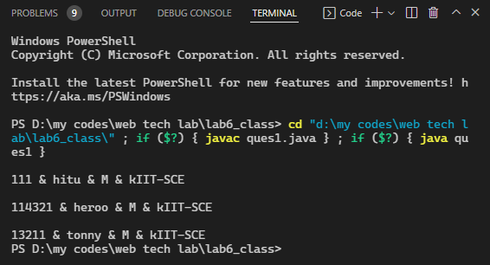

// 2. WAP to print "An object is created" everytime when you create an object of a class.

class displayobj {

    int i;

     displayobj()

    {

        System.out.println("AN OBJECT IS CREATED");

    }

    void display()

    {

        System.out.println("heloo");

    }

}

public class ques2 {

    public static void main(String[] args)

    {

        displayobj a = new displayobj();

        displayobj b = new displayobj();

        displayobj c = new displayobj();

        a.display();

        b.display();

        c.display();

    }

}

OUTPUT-2

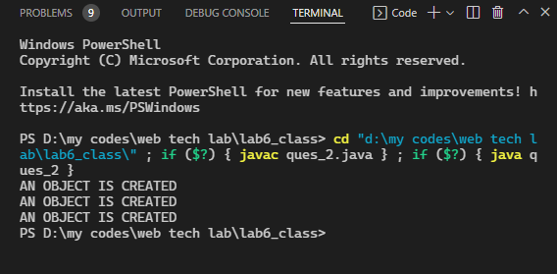

// 3. WAP to print "This is th object created" when an object will be created (Note: it will print the no. of object created, hint: parameterized constructor)

class display{

static int i=0;

display()

{

    i++;

    System.out.println( i +"object created" );

}

}

public class ques3

{

    public static void main(String[] args)

    {

        display a = new display();

        display b = new display();

        display c = new display();

    }

}

OUTPUT-3

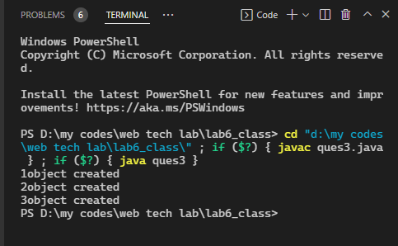

// 4. Initialize an integer array in java and print only those elements which are greater than 10.

public class ques4 {

    public static void main(String[] args) {

        int a[] = {4, 43,21,300,400,239};// 1ST METHOD TO DECLARE AARAY

        // a[0] = 11;    2ND METHOD

        // a[1] = 1;

        // a[2] = 131;

        // a[3] = 141;

        // a[4] = 3;

        // a[5] = 001;

        // a[6] = 7;

        for (int i:a)

         {

            if (i > 10)

                System.out.println(i);

        }

    }

}

OUTPUT-4

