

WT LAB -9

• Name :HITU RAJ

• Roll no. :2005025

• Branch :CSE

// 1. A plastic manufacturer sells plastic in different shapes like 2D sheet and 3D box. The cost of sheet is Rs 40/ per square ft. and the cost of box is Rs 60/ per cubic ft. Implement it in Java to calculate the cost of plastic as per the dimensions given by the user where 3D inherits from 2D.

class sheet

{

   int costp=40;

   void calcp(int x)

   {

   System.out.println("cost of 2d plastic sheet forr" + x + "is Rs" +(x*40));

   }

}

class box extends sheet

{

int costb=60;

void calcb(int x)

{

System.out.println("cost of plasticbox forr" + x + "cubic ft is Rs"  + (x*60) );

}

}

  class q1

{

     public static void main(String[] args)

     {

        //System.outprintln();

        box b=new box();

        b.calcb(20);

        b.calcp(30);

    }

}

**OUTPUT -1**

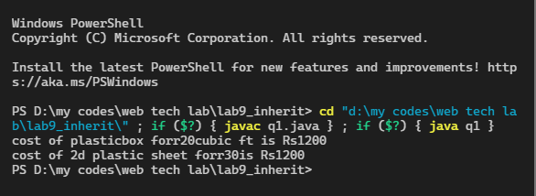

// 2. Illustrate the execution of constructors in multi-level inheritance with three Java

// classes – plate(length, width), box(length, width, height), wood box (length, width,

// height, thick)

class  plate

{ int length,width;

    plate()

    {

    System.out.println("constructor od class plate");

    }

}

class box extends plate

{

    int length,width,height;

 box()

 {

     System.out.println("constructor od class box");

 }

}

class woodbox extends box

{

    int length,width,height,thick;

    woodbox()

    {

    System.out.println("constructor od class woodbox");

    }

}

public class q2 {

    public static void main(String[] args) {

        woodbox wd = new woodbox();

        // we can clearly see that the constructor of parent class is called first then the base class constructor is caleed

    }

}

**OUTPUT -2**

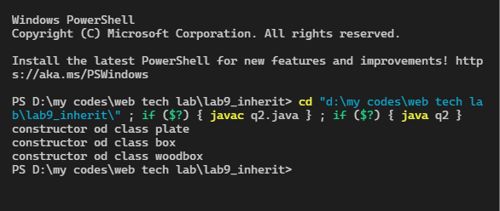

// 3. Program on Dynamic Method Dispatch.

import java.util.Scanner;

class trees {

    int no;

    void tree() {

        System.out.println("this is tree class");

    }

}

class mango extends trees {

    int no;

    void tree() {

        System.out.println("this is mango class");

    }

}

class apple extends mango {

    int no;

    void tree() {

        System.out.println("this is appple class");

    }

}

public class q3

{

    public static void main(String[] args) {

int x;

        Scanner sc=new Scanner(System.in);

        System.out.println("from the object of apple class and mangoclass acceesing method of tree class ehich is inherited hierachial");

        mango m = new apple();

        m.tree();

        trees a= new mango();

        a.tree();

    }

}

**OUTPUT-3**

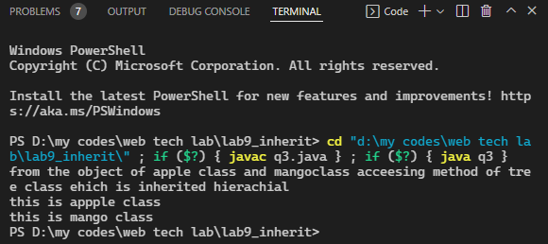

// 4.   Write a program in java to define a class Shape which has data member area and a member function showArea(). Derive two classes Circle and Rectangle from Shape class. Add appropriate data members and member functions to calculate and display the area of Circle and Rectangle.

class shape {

    void area() {

        System.out.println("the is use to calculate area method");

    }

    void showarea() {

        System.out.println("this the use to siplay area");

    }

}

class circle extends shape {

    int r = 20;

    float area;

    void area(int x) {

        area = (float) 3.14 * x * x;

    }

    void showarea() {

        System.out.println("area of circle is " + area);

    }

}

class rectangle extends shape {

    int l = 5, b = 3;

    float area;

    void area(int x, int y) {

        area = (float) l * b;

    }

    void showarea() {

        System.out.println("area of rectangle is " + area);

    }

}

 public class q4

{

    public static void main(String[] args) {

        circle m = new circle();

        m.area(20);

        m.showarea();

        rectangle a = new rectangle();

        a.area(20, 40);

        a.showarea();

    }

}

**OUTPUT-4**

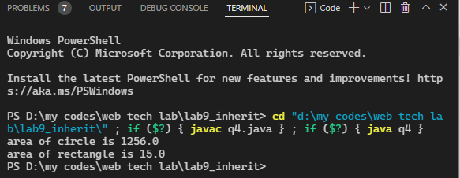

// 5. Write a program to create an Account class containing acc_no, balance as data

// members and disp() to display the details. Inherit it in Person class with all mentioned

// data members and functions. Person class also has name and aadhar_no as extra data

// members of its own. Override disp() function. Create 5 persons’ details.

class Account {

    int accno=200, bal=2000;

    void display() {

        System.out.println("account no is --->" + accno);

        System.out.println("balance  is --->" + bal);

    }

}

class person extends Account {

    String  name ;

    int adharno=32131211;

    void input(String na,int add)

    {

        name=na;

        adharno=add;

    }

    void display() {

        System.out.println("name no is --->" + name);

        System.out.println("adhar no. is  is --->" + adharno);

        super.display();

        System.out.println();

    }

}

public class q5 {

    public static void main(String[] args)

     {

          for (int i = 0; i < 5; i++)

          {

            person a= new person();

            a.input("hitu",(i+2*2234));

            a.display();

          }

    }

}

**OUTPUT-5**

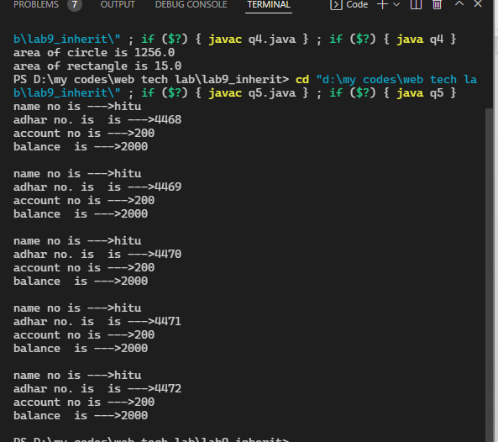

// 6.   Write a program in java using inheritance to show how to call the base class parameterized constructors from the derived class using super

class base {

    base(int x) {

        System.out.println("this is base class constructor and value is" +x);

    }

}

class derive extends base

 {

    derive()

    {

        super (20);

        System.out.println("this is derive class comstrucutor");

    }

}

public class q6 {

    public static void main(String[] args) {

        derive d = new derive();

    }

}

**OUTPUT-6**

