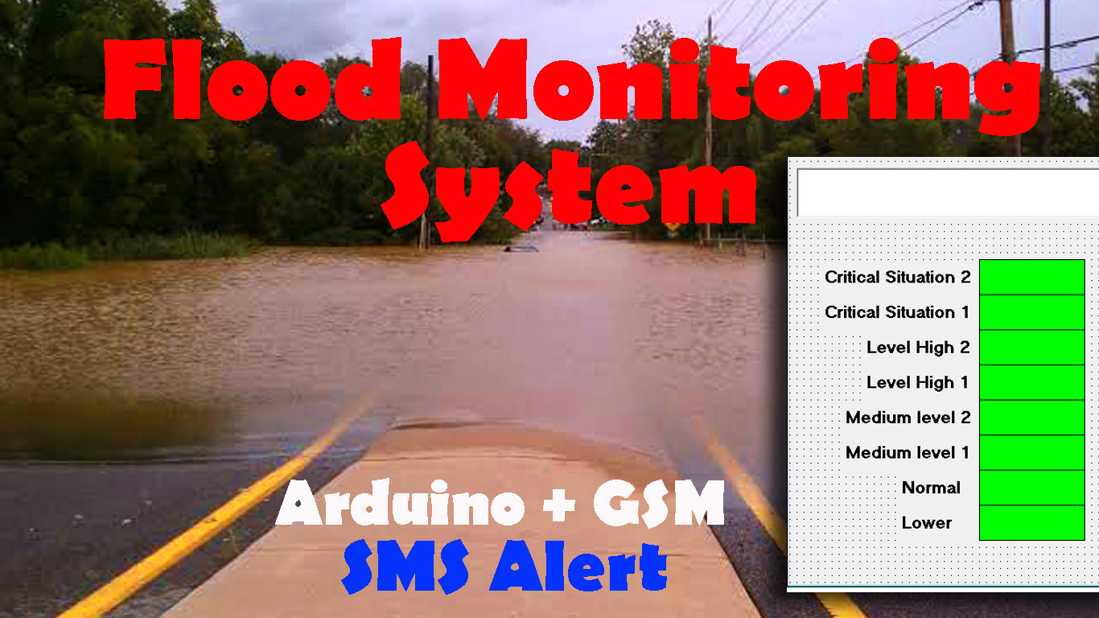

FLOOD MONITORING & EARLY WARNING

PHASE – 5

DOCUMENTED SUBMISSION

**FLOOD MONITORING & EARLY waRNING**

INTRODUCTION:

A flood monitoring and early warning system is a comprehensive solution that combines state-of-the-art technology, data collection, analysis, and real-time communication to track weather conditions, water levels, and other environmental parameters. Its primary objective is to provide advance notice of potential floods, allowing residents and authorities to take preemptive actions to safeguard lives and property.

This system leverages various components, such as IoT sensors, data processing platforms, and alert mechanisms, to detect flood risks and disseminate crucial information. Through accurate data collection and predictive analytics, it empowers decision-makers and the public to make informed choices in the face of impending floods.

**Components of a Flood Monitoring and Early Warning System:**

1. **IoT Sensors:** These sensors are strategically deployed in flood-prone areas to collect real-time data on various parameters, including water levels, rainfall, temperature, and humidity.

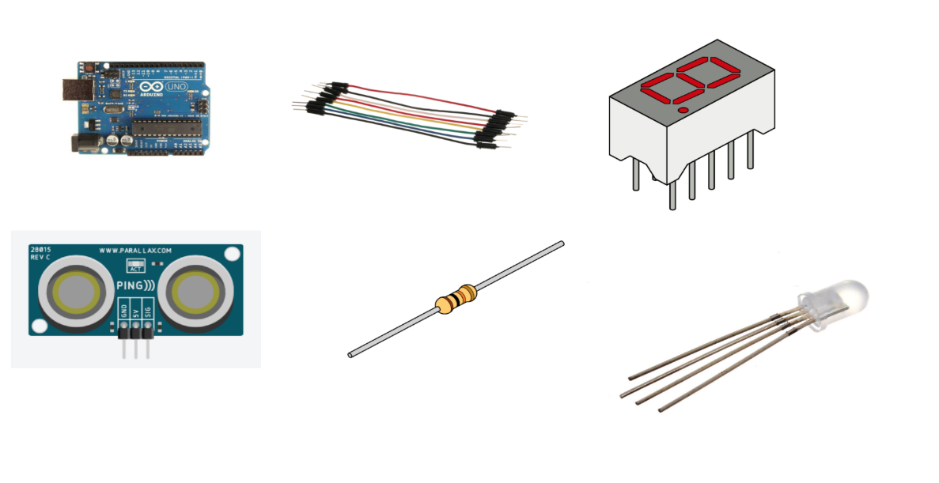

1. **Data Processing Platforms:** Collected data is transmitted to central servers or cloud platforms where it is processed, cleaned, and analyzed. Advanced algorithms and machine learning models are employed to assess flood risk based on the sensor data.



1. 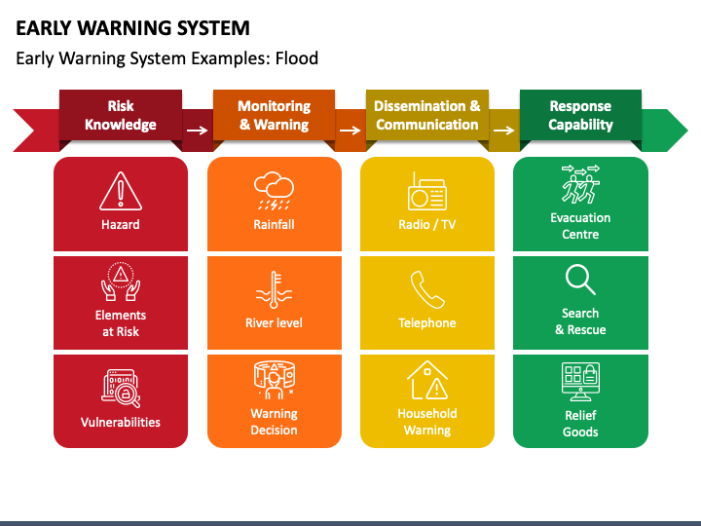**Early Warning Mechanisms:** When the system detects conditions indicative of an imminent flood, it triggers warnings. These alerts are disseminated to relevant authorities, emergency services, and the public via various communication channels, such as mobile apps, SMS, email, sirens, and social media.
2. **User Interface:** User-friendly dashboards and mobile applications provide access to real-time data, flood risk assessments, and early warnings, enabling individuals and authorities to make informed decisions.

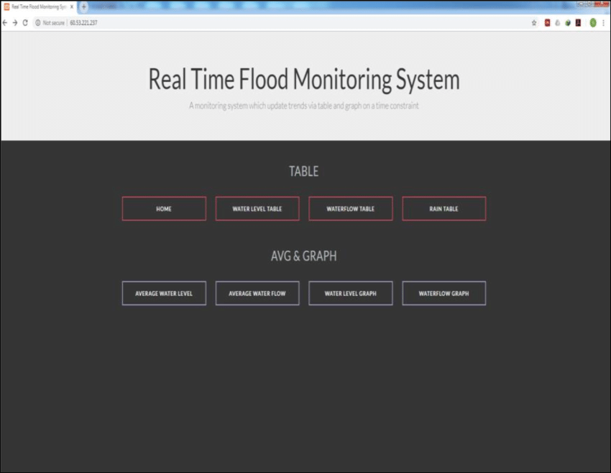

**How Flood Monitoring and Early Warning Systems Enhance Safety and Response Coordination:**

1. **Early Detection**: These systems offer real-time monitoring and early detection of rising water levels and heavy rainfall, giving communities time to prepare and evacuate if necessary.
2. **Data-Driven Decision-Making**: The availability of accurate data and predictive analytics empowers authorities to make informed decisions regarding resource allocation and emergency response coordination.
3. **Public Awareness**: Warnings issued through various communication channels raise public awareness of flood risks, encouraging individuals to take preventive actions and follow evacuation orders.
4. **Remote Monitoring**: Emergency responders can monitor flood conditions remotely through the user interface, reducing the need for physical presence in dangerous areas and enhancing overall safety.
5. **Community Resilience**: Flood monitoring and early warning systems contribute to the development of resilient communities that are better equipped to cope with flooding, recover more quickly, and adapt to changing conditions.

**IoT Sensor Deployment:**

**1. Water Level Sensors:**

* Deploy water level sensors at key locations near rivers and streams.
* These sensors use ultrasonic technology to measure water levels and transmit data wirelessly to a central server.
* 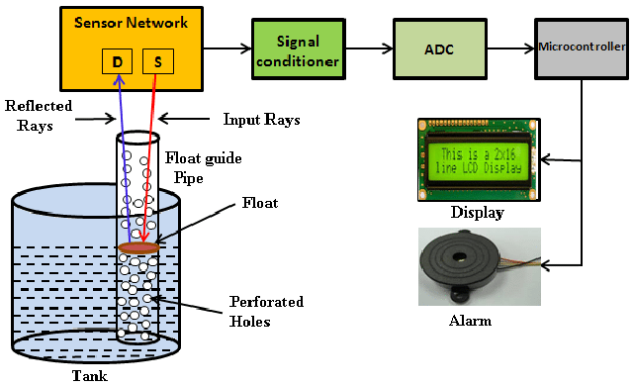Sensors are powered by solar panels for sustainability.

**2. Rainfall Sensors:**

* Install rainfall sensors in strategic locations.
* These sensors use tipping buckets to measure rainfall and transmit data wirelessly.
* Also powered by solar panels.

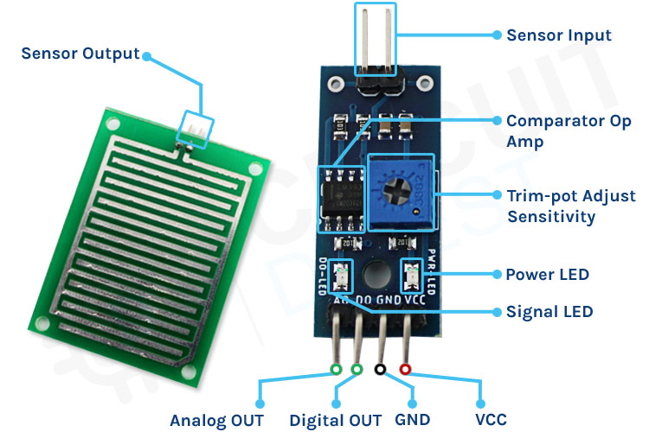

**3. Communication Module:**

* Each sensor is equipped with a communication module (e.g., LoRaWAN or cellular) for data transmission.
* Data is sent to a central server for processing.

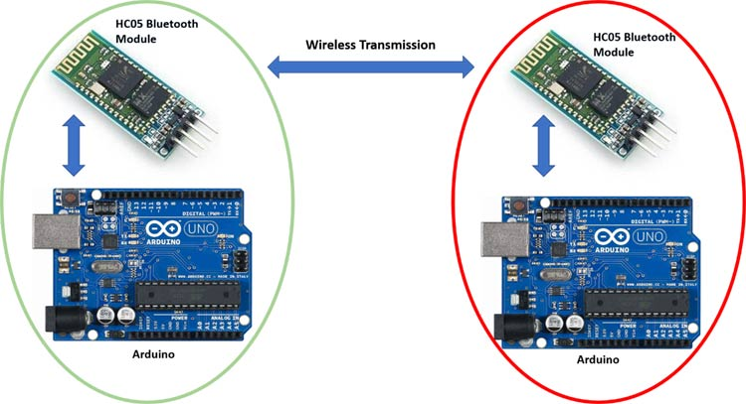

**PROJECT OBJECTIVES:**

1. **Early Detection and Warning:** The primary objective is to detect the early signs of flooding, such as rising water levels or heavy rainfall, and issue timely warnings to alert the public and relevant authorities. Early warnings are crucial in giving people sufficient time to take protective measures and evacuate if necessary.
2. **Public Safety:** The foremost goal is to protect human lives. By providing advance notice of floods, these systems aim to minimize the risk to individuals, families, and communities. Public safety is of paramount importance.
3. **Property Protection:** Flood monitoring and early warning systems also aim to reduce property damage. By providing early warnings, they help individuals and businesses take measures to safeguard their assets and reduce financial losses.
4. **Risk Mitigation:** These systems support efforts to mitigate the risks associated with flooding. By monitoring weather conditions and water levels, they help assess the potential for flooding and contribute to informed decision-making in land use planning and development.
5. **Emergency Response Coordination:** Enhancing the coordination of emergency response efforts is another key objective. By providing accurate and timely information to authorities and first responders, these systems enable them to allocate resources efficiently and respond effectively to flood events.
6. **Community Resilience:** Building resilient communities is an overarching objective. These systems contribute to increasing community preparedness, awareness, and adaptive capacity in the face of flood events. This resilience reduces the long-term impact of floods on communities.
7. **Data-Driven Decision-Making:** Flood monitoring and early warning systems provide valuable data for informed decision-making. They offer insights into flood patterns, severity, and potential impacts, allowing authorities to make decisions based on data and analysis.
8. **Reduction of Economic Losses:** By mitigating the damage caused by floods, these systems aim to reduce the economic losses associated with property damage and disruption to businesses and infrastructure.
9. **Enhanced Public Awareness:** These systems raise public awareness about flood risks and the importance of preparedness and response. Informed individuals are more likely to take preventive measures and follow evacuation orders.
10. **Environmental Protection:** Flood monitoring can also contribute to the protection of the environment by providing early warning of potential pollution events, allowing authorities to respond proactively to mitigate environmental damage.

**DEVICE SETUP:**

**1. IoT Sensors:**

* **Water Level Sensors:** These sensors measure water levels at key locations near rivers, streams, or flood-prone areas. Common types of water level sensors include ultrasonic sensors or pressure transducers. Install these sensors at a suitable height above the expected maximum water level.
* **Rainfall Sensors:** Rain gauges or weather stations can be deployed to monitor rainfall in real-time. They provide data on precipitation rates and accumulations, which are essential for flood risk assessment.
* **Temperature and Humidity Sensors:** These sensors provide data on weather conditions, which can be used to assess the likelihood of floods, especially in cases of rapid snowmelt or heavy rainfall.

**2. Communication Modules:**

* Each sensor is equipped with a communication module to transmit data to a central server or cloud platform. Common communication options include Wi-Fi, cellular networks, LoRaWAN, or satellite communication, depending on the availability of network coverage in the deployment area.

**3. Central Server or Cloud Platform:**

* Data from the sensors is sent to a central server or cloud platform for processing and analysis. These platforms store data securely and facilitate real-time monitoring.

**4. Data Processing and Analysis:**

* The central server or cloud platform processes and analyzes the incoming sensor data. This involves data aggregation, data validation, and the application of machine learning algorithms to assess flood risk. The system may use historical data for predictive modeling.

**5. Early Warning System:**

* An early warning system is implemented to trigger alerts when flood risk exceeds predefined thresholds. Alerts are generated based on the data analysis and may include notifications to authorities, emergency services, and the public.

**6. User Interface:**

* Develop a user-friendly web-based dashboard and mobile app for users, authorities, and emergency responders. The interface provides access to real-time data, flood risk assessments, and early warnings.

**7. Alert Mechanisms:**

* Implement various communication channels to disseminate alerts. These can include mobile apps, SMS, email, sirens, social media, and integration with public alert systems.

**8. Power Supply:**

* Ensure a reliable power supply for the IoT sensors. Depending on the location, solar panels, batteries, or a combination of power sources may be used to ensure continuous operation.

**9. Redundancy and Resilience:**

* Consider backup power sources, redundant communication channels, and data storage to ensure the system's operation even in adverse conditions.

**10. Sensor Maintenance and Calibration:**

* Regular maintenance and calibration of the sensors are essential to ensure data accuracy. The sensors should be cleaned and calibrated according to the manufacturer's recommendations.

**11. Data Security:**

* Implement robust data security measures to protect sensor data from unauthorized access or tampering.

**12. Training and Education:**

* Provide training to users and authorities on how to interpret and respond to the data and alerts generated by the system.

**PLATFORM DEVELOPMENT:**

**1. Define Requirements:**

* Clearly define the objectives of the platform, including the parameters to be monitored, the geographic area it will cover, and the desired response time.

**2. Select Technology Stack:**

* Choose the appropriate technology stack for the platform, considering factors like sensor compatibility, data processing needs, and scalability. Common technologies include cloud platforms (AWS, Azure, Google Cloud), database systems (SQL or NoSQL), and programming languages (Python, Java, etc.).

**3. Data Ingestion:**

* Implement data ingestion mechanisms to receive and store data from IoT sensors. Ensure a reliable data transmission protocol, such as MQTT or HTTP, and secure data encryption during transmission.

**4. Data Storage:**

* Store sensor data in a database. Organize the database to efficiently manage historical and real-time data.

**5. Data Processing:**

* Develop algorithms and scripts to process the incoming data. This includes cleaning, validation, and aggregation of data for further analysis.

**6. Data Analysis:**

* Utilize machine learning models, statistical analysis, and historical data to assess flood risk. Algorithms can determine patterns, anomalies, and thresholds that indicate potential flooding.

**7. Early Warning System:**

* Design and implement the early warning system that triggers alerts based on the results of the data analysis. Define the criteria for issuing warnings, such as specific water level thresholds or rainfall accumulation.

**8. User Interface:**

* Develop a user-friendly web-based dashboard and/or mobile application for users, authorities, and emergency responders. The interface should display real-time data, flood risk assessments, and early warnings.

**9. Alert Mechanisms:**

* Integrate various communication channels to disseminate alerts. These may include mobile apps, SMS, email, sirens, social media, and other public alert systems. Ensure that alerts are delivered promptly and reliably.

**10. Geospatial Integration:**

* Incorporate geospatial information to visualize flood-prone areas, evacuation routes, and infrastructure locations. Maps and geospatial data can assist in decision-making and response coordination.

**11. Data Security:**

* Implement strong security measures to protect sensor data and the platform from unauthorized access or cyber threats. This includes encryption, access control, and regular security audits.

**12. Redundancy and Disaster Recovery:**

* Ensure system resilience with redundancy and disaster recovery measures. Redundant servers and backup data storage can prevent system failures.

**13. User Training and Documentation:**

* Provide training and documentation for users, authorities, and emergency responders on how to use the platform, interpret data, and respond to alerts effectively.

**14. Testing and Validation:**

* Thoroughly test the platform in real-world conditions, including simulation of flood events, to ensure its reliability and accuracy.

**15. Continuous Improvement:**

* Implement a process for continuous improvement and updates to adapt to changing conditions and emerging technologies.

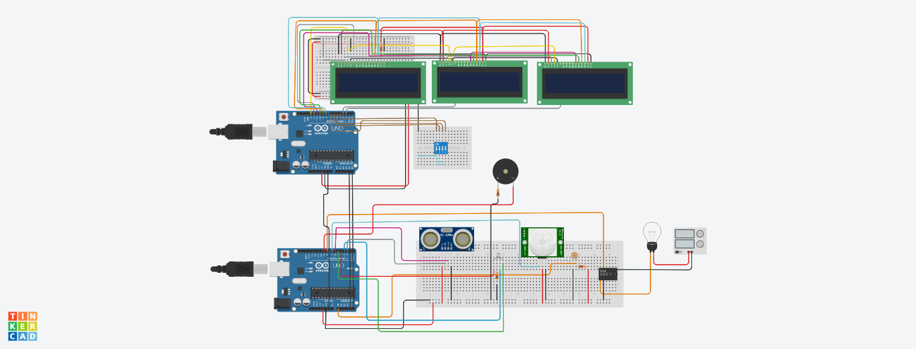CIRCUIT MODEL:

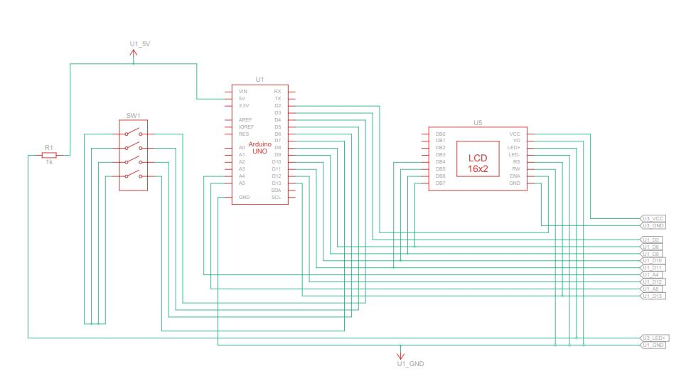CIRCUIT DIAGRAM:

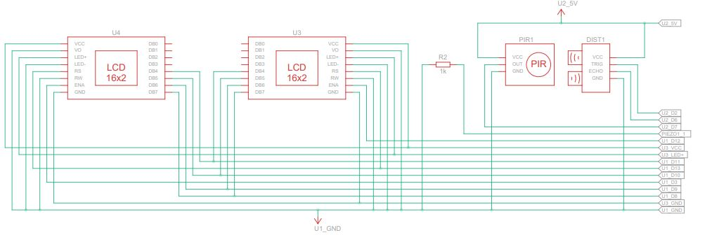

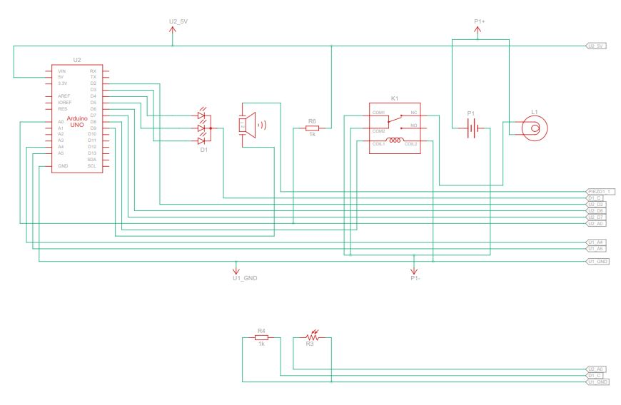

MODEL LINK:

<https://www.tinkercad.com/things/90RpiLbS5kc-spectacular-wolt-luulia/editel?sharecode=VM_bWvcRc85tv2EpeSEYUN0ebgUr8fy4r1bQITlfN6g>

OUTPUT:

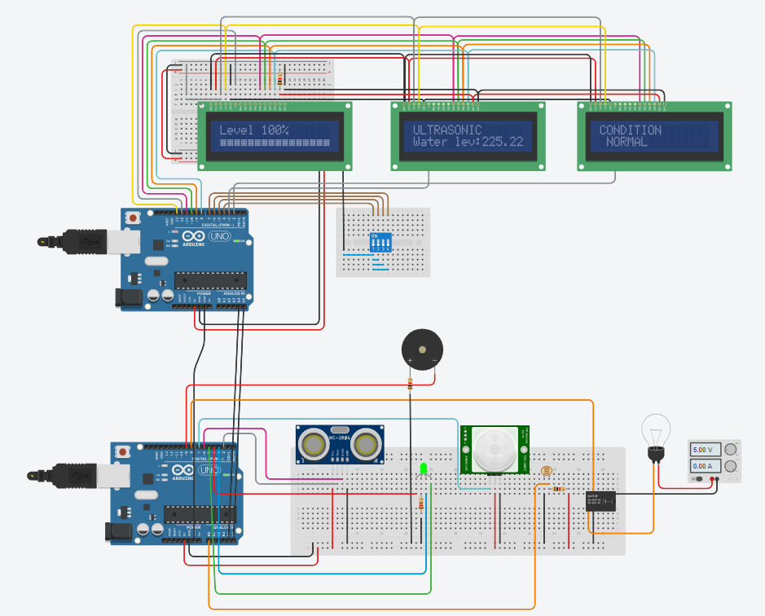

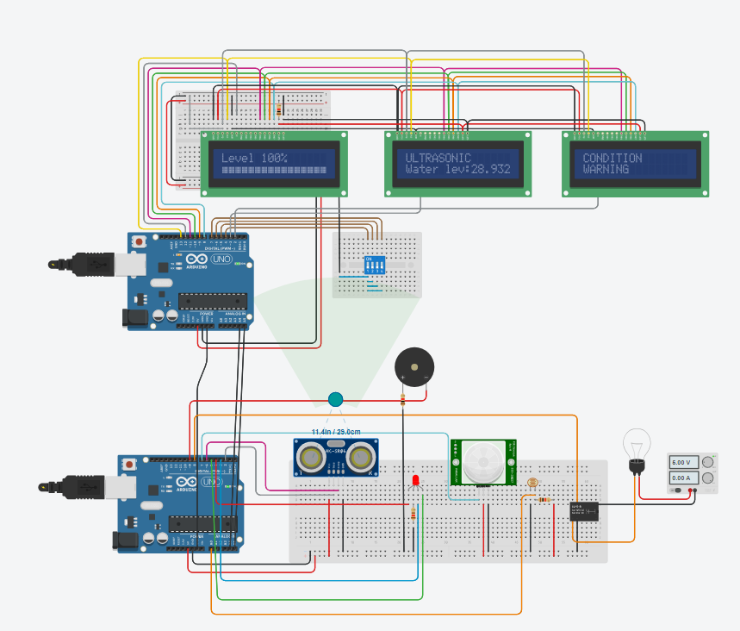

CODING:

#include <Wire.h>

#define PIR 7

#define LDR A0

#define bulb 8

#define buzzer 9

#define SLAVE_ADDR 9

#define ANSWERSIZE 5

#define led1 4

#define led2 3

#define led3 5

int trigPin = 2;

int echoPin = 6;

int val = 0;

int duration;

float distance;

float meter;

union

{

float x;

byte myData[4];

}data;

void setup() {

Wire.begin(SLAVE_ADDR);

Wire.onRequest(sendEvent);

Serial.begin (9600);

pinMode(trigPin, OUTPUT);

digitalWrite(trigPin, LOW);

delayMicroseconds(2);

pinMode(echoPin, INPUT);

pinMode(PIR, INPUT);

pinMode(LDR, INPUT);

pinMode(bulb, OUTPUT);

pinMode(led1, OUTPUT);

pinMode(led2, OUTPUT);

pinMode(led3, OUTPUT);

pinMode(buzzer, OUTPUT);

delay(6000);

Serial.println("Distance:");

Serial.println("Water detect:");

}

void loop() {

delay(50);

int i = 0;

digitalWrite(trigPin, HIGH);

delayMicroseconds(10);

digitalWrite(trigPin, LOW);

duration = pulseIn(echoPin, HIGH);

distance = (duration/2) / 29.1;

data.x = distance;

Serial.print(distance);

Serial.print("cm");

Serial.print("\n");

val = digitalRead(PIR);

if (val == HIGH && distance <= 30) {

RGB_color(255, 0, 0); // Red

digitalWrite(buzzer, HIGH);

}

else {

digitalWrite(buzzer, LOW);

}

if (distance <= 30) {

RGB_color(255, 0, 0);

}

else {

}

if (distance <= 100 && distance > 30) {

RGB_color(255, 255, 0);

}

else {

}

if (distance > 100) {

RGB_color(0, 255, 0);

}

else {

}

if (analogRead(A0) > 500 && val == HIGH && distance <= 30) {

digitalWrite(8, LOW);

}

else {

digitalWrite(8, HIGH);

}

}

void RGB_color(int red_light_value, int green_light_value, int blue_light_value)

{

analogWrite(led1, red_light_value);

analogWrite(led3, green_light_value);

analogWrite(led2, blue_light_value);

}

void sendEvent()

{

Wire.write(data.myData, sizeof(data.myData));

}

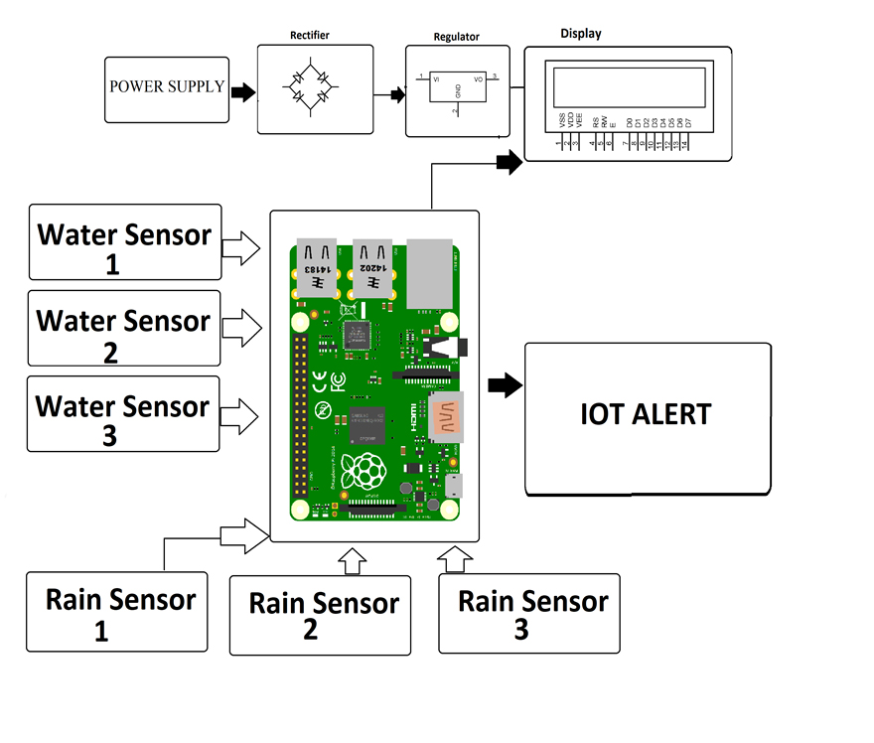APP DEVELOPMENT:

**1. Define Objectives and User Requirements:**

* Clearly define the objectives of the mobile app, such as providing real-time flood data and early warnings to the public. Consider the needs and preferences of the app's target users, including residents in flood-prone areas, authorities, and emergency responders.

**2. Choose Development Platforms:**

* Decide whether to develop separate apps for iOS and Android platforms or opt for cross-platform development using frameworks like React Native or Flutter.

**3. Design the User Interface:**

* Create an intuitive and user-friendly interface. Use wireframes and prototypes to plan the app's layout, navigation, and features. Incorporate geospatial elements, charts, and alerts for a comprehensive user experience.

**4. Implement Real-Time Data Integration:**

* Develop features to collect and display real-time flood data from the central server or cloud platform. Ensure data is presented in a clear and easy-to-understand manner.

**5. Early Warning System Integration:**

* Integrate the early warning system to trigger alerts to app users when flood risk exceeds predefined thresholds. Implement a notification mechanism that includes push notifications, SMS, and email alerts.

**6. User Registration and Profiles:**

* Allow users to create accounts and profiles. This can help personalize alerts, store user preferences, and enable two-way communication between users and authorities.

**7. Geospatial Integration:**

* Incorporate geospatial features to display flood-prone areas, evacuation routes, and the current location of the user. Maps and geospatial data should be interactive and user-friendly.

**8. Accessibility and Multilingual Support:**

* Ensure the app is accessible to users with disabilities and consider providing multilingual support for a broader user base.

**9. Security Measures:**

* Implement robust security features to protect user data and the app itself. This includes secure data transmission, encryption, authentication, and authorization mechanisms.

**10. Offline Mode:**

* Create an offline mode that allows users to access critical information even when an internet connection is unavailable.

**11. Testing and Quality Assurance:**

* Thoroughly test the app to identify and fix bugs, ensure the app's reliability, and validate the accuracy of the information it provides.

**12. User Training and Support:**

* Provide onboarding resources and support for users to understand how to use the app effectively. Include in-app tutorials, help sections, and contact information for technical support.

**13. Data Privacy Compliance:**

* Ensure compliance with data privacy regulations and obtain user consent for data collection and usage.

**14. Regular Updates and Maintenance:**

* Plan for ongoing updates and maintenance to keep the app up-to-date, secure, and compatible with evolving mobile operating systems.

**15. Deployment and Distribution:**

* Publish the app on app stores like Google Play Store and Apple App Store, making it accessible to a wide audience. Promote the app to raise awareness among target users.

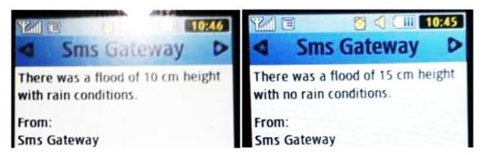

(OUTPUT IN SMS)

**Results and Discussion:**

Based on the analysis and design of a flood notification system using SMS Gateway, the prototype of the flood notification system follows in Figure 3. In the prototype SMS Gateway based flood notification system uses several main components, namely rain sensor and ultrasonic sensor as a component input, Raspberry pi as data processing or processing component. While the GSM modem as an output component that sends SMS to system users. In the flood detection pipe, there are rain sensors and ultrasonic sensors on the top side. And on the Raspberry Pi, there is a GSM Modem. In the SMS Gateway-based flood notification system construction was built in a condition as a prototype. The prototype in question is a condition in the form of laboratory experiments. In Figure 4 is the result of SMS received by users of the flood notification system using the SMS gateway. The editorial format sent from the SMS gateway based flood notification system is "Flooding occurred with a height of 5cm in rain conditions". And on the other SMS, you can see the editor "There was a flood with a height of 10cm in conditions not raining". Of the two SMS sent, when the SMS was sent, information consisted of conditions when floods and rain occurred. The test is carried out using water placed in a container with the water level changed, as shown in Table 1. The test is carried out to find out the status of the SMS sent, and the time the user's Mobile received the SMS. In this test, the rain sensor only sends information that there is rain or no rain on the SMS. Also, SMS sent at flood height 5cm, 10cm, 15cm and 20cm.In this case, the program flow runs every multiple of 5 cm. As seen in numbers 5 cm and 6 cm that at the height of 5cm, the status of the SMS sent with the time of receiving an SMS is 6 seconds. While at the height of 6 cm not sent because the height is not a multiple of 5 cm. This test applies up to a height of 30cm. While testing is carried out at the height of 20cm. While the SMS time received, there are several time differences, and this is due to the processing time on the system of the cellular operator. In this test, when an SMS is received, it is not part of the error of the flood notification system that was built but is influenced by the service provider itself. From this research, it is expected to provide the latest information on prototype disaster mitigation engineering by implementing ultrasonic sensors, rain sensors, Raspberry Pi, and GSM modems in sending flood information to users. And this research is useful for reducing disaster victims in general.

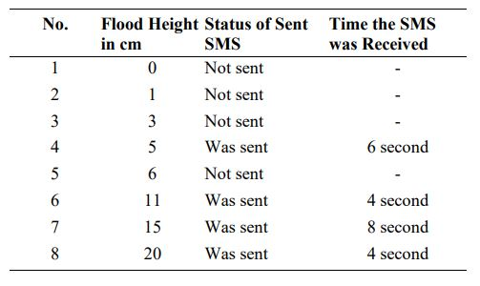

**ADVANTAGES:**

1. **Early Detection and Alert:** These systems provide early detection of rising water levels, heavy rainfall, or other flood-related factors. Early warnings are issued promptly, allowing residents and authorities to take preventive actions and evacuate if necessary, reducing the risk of loss of life.
2. **Minimized Property Damage:** By providing advance notice of impending floods, individuals and businesses can take protective measures to safeguard their property, reducing property damage and financial losses.
3. **Effective Emergency Response:** The availability of real-time data and early warnings enables authorities and emergency responders to allocate resources efficiently and respond effectively. They can deploy personnel, equipment, and supplies to areas in immediate need, improving response time and effectiveness.
4. **Data-Driven Decision-Making:** Flood monitoring and early warning systems provide valuable data for decision-makers. Authorities can make informed decisions regarding evacuation, resource allocation, and public safety measures based on accurate, real-time information.
5. **Public Awareness:** By disseminating alerts and information through various communication channels, these systems raise public awareness of flood risks. Informed individuals are more likely to take preventive measures, follow evacuation orders, and cooperate with authorities during flood events.
6. **Remote Monitoring:** Emergency responders and decision-makers can monitor flood conditions remotely, reducing the need for physical presence at dangerous locations. This enhances overall safety for those involved in emergency response.
7. **Community Resilience:** Flood monitoring systems contribute to the development of resilient communities. By increasing preparedness and adaptive capacity, communities can better cope with floods, recover more quickly, and adapt to changing conditions.
8. **Economic Loss Reduction:** Mitigating property damage, disruption to businesses, and infrastructure damage results in economic losses being minimized. Effective early warning systems can save communities significant financial resources in recovery and reconstruction.
9. **Environmental Protection:** Early detection of flood events can also help protect the environment. By providing advance notice, authorities can take proactive measures to mitigate pollution and environmental damage caused by floods.
10. **Enhanced Infrastructure Planning:** Flood monitoring systems provide critical data that can be used for better planning and development of infrastructure. This includes decisions regarding flood control structures, land use planning, and floodplain zoning.
11. **Safety during Extreme Weather Events:** These systems are not limited to floods alone; they can also monitor extreme weather conditions that may lead to other disasters such as landslides, storms, or flash floods, enhancing safety in various weather-related emergencies.
12. **Reduced Stress and Anxiety:** Public access to reliable information and early warnings can alleviate stress and anxiety during flood events. Knowing what to expect and what steps to take can provide a sense of control and reduce panic.

**DISADVANTAGES:**

1. **Technological Dependence:** These systems rely heavily on technology, including IoT sensors, communication networks, and data processing platforms. Technical failures, such as sensor malfunctions or network outages, can disrupt the effectiveness of the system.
2. **False Alarms:** There is a risk of false alarms or inaccurate predictions, which can lead to complacency and erode public trust in the system. Frequent false alarms may cause people to ignore warnings when they are genuinely needed.
3. **Limited Coverage:** The effectiveness of these systems depends on the deployment of sensors and infrastructure. In remote or underdeveloped areas, there may be limited or no coverage, leaving communities vulnerable to floods.
4. **Cost and Maintenance:** Establishing and maintaining flood monitoring systems can be expensive. The costs include sensor deployment, data infrastructure, personnel, and ongoing maintenance. Small or financially constrained communities may struggle to implement and maintain these systems.
5. **Data Privacy and Security:** Collecting and storing sensitive flood-related data can pose data privacy and security risks. Unauthorized access to this data could have adverse consequences, including potential misuse.
6. **Accessibility Challenges:** Not all residents in flood-prone areas may have access to the technology required to receive warnings, such as smartphones or internet connectivity. This can result in some individuals not receiving critical alerts.
7. **Language and Communication Barriers:** In multicultural or multilingual regions, communicating warnings and information effectively to all residents may be challenging, as language barriers can hinder understanding and response.
8. **Social Vulnerability:** Vulnerable populations, such as the elderly, disabled, or those with limited mobility, may face difficulties in evacuating or responding to warnings, which can lead to increased risks during flood events.
9. **Response Uncertainty:** Even with accurate warnings, individual and community responses may vary. Some residents may not take warnings seriously, while others may panic and make impulsive decisions, potentially complicating emergency response efforts.
10. **Environmental Impact:** The deployment of monitoring equipment and sensors can have an environmental impact. Careful consideration is needed to minimize disruption to local ecosystems and habitats.
11. **Community Acceptance and Trust:** Building trust and acceptance of the system within the community is a challenge. Residents must have confidence in the accuracy and reliability of the system for it to be effective.
12. **Evacuation Challenges:** Issuing early warnings is only part of the solution. Ensuring that residents have safe and efficient evacuation routes, shelters, and support during flood events is equally important and can be challenging to coordinate.
13. **Information Overload:** In regions prone to frequent or seasonal floods, the constant flow of flood-related data and alerts can lead to information overload, making it difficult for individuals to distinguish between routine alerts and genuinely critical warnings.

**USES of FLOOD MONITORING & EARLY WARNING:**

1. **Early Detection and Alerting:** These systems are primarily designed to detect and provide early warnings of impending floods. By monitoring water levels, rainfall, and other relevant parameters in real time, they can issue timely alerts to authorities and the public.
2. **Public Safety:** One of the primary uses is to protect human lives. Flood warnings allow individuals and communities to take protective measures, evacuate if necessary, and stay out of harm's way during flood events.
3. **Property Protection:** Early warnings enable property owners to secure their assets and reduce the risk of property damage. This includes actions such as moving valuables to higher ground, installing flood barriers, or raising electrical equipment.
4. **Effective Emergency Response:** Flood monitoring systems provide data and early warnings that are crucial for authorities and emergency responders. This information helps them deploy resources, allocate personnel, and coordinate response efforts efficiently.
5. **Data-Driven Decision-Making:** The data generated by these systems aids decision-makers in evaluating the potential severity of floods, guiding evacuation plans, and optimizing resource allocation during flood events.
6. **Public Awareness and Education:** Flood monitoring and early warning systems contribute to raising public awareness about flood risks. Educated individuals are more likely to take preventive measures and follow evacuation orders.
7. **Community Resilience:** These systems promote the development of resilient communities by increasing preparedness, adaptability, and awareness. Resilient communities can cope more effectively with flood events and recover more quickly.
8. **Economic Loss Reduction:** By mitigating property damage, disruptions to businesses, and infrastructure damage, early warning systems help reduce economic losses resulting from floods.
9. **Environmental Protection:** Early detection of flood events allows authorities to take proactive measures to mitigate environmental damage, prevent pollution, and safeguard ecosystems and natural habitats.
10. **Infrastructure Planning and Development:** Data from flood monitoring can inform infrastructure planning and development, including decisions regarding flood control structures, land use planning, and floodplain zoning.
11. **Safety During Extreme Weather Events:** These systems are not limited to floods alone; they can also monitor extreme weather conditions that may lead to other disasters, enhancing safety in various weather-related emergencies.
12. **Data for Research and Analysis:** Collected data can be used for scientific research and analysis to better understand flood patterns, climate change impacts, and flood risk modeling.
13. **Climate Change Adaptation:** Flood monitoring systems are valuable tools for adapting to the effects of climate change, which are expected to increase the frequency and severity of extreme weather events, including floods.
14. **Improved Urban Planning:** Data from these systems can inform urban planning by identifying flood-prone areas and influencing the design and development of cities to reduce flood risk.

**CONCLUSION:**

In conclusion, flood monitoring and early warning systems represent a vital component of disaster risk reduction and emergency management. These systems provide a lifeline for individuals, communities, and authorities in flood-prone areas, offering crucial advantages in terms of public safety, property protection, and efficient emergency response coordination.

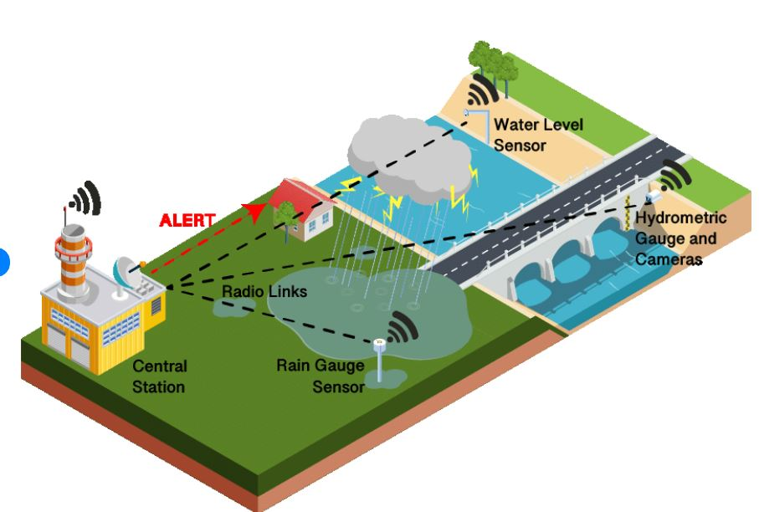By detecting and alerting to impending floods, these systems save lives and reduce the impact of one of the most devastating natural disasters. Their data-driven approach empowers decision-makers to allocate resources effectively, while raising public awareness enhances preparedness and encourages informed responses from individuals.

As we face the growing challenges of climate change and increasing extreme weather events, the role of flood monitoring and early warning systems becomes even more pronounced. Their ability to provide accurate, real-time information and timely alerts is a testament to their significance in mitigating the consequences of floods.

It is crucial that these systems continue to evolve and adapt to meet the ever-changing needs of communities, taking into account the unique challenges posed by geography, demographics, and infrastructure. By addressing the disadvantages, improving technical reliability, and ensuring accessibility for all, we can strengthen these systems to better serve society.

Flood monitoring and early warning systems are more than just technological solutions; they are tools that promote resilience, protect lives, and create a safer, more sustainable future in the face of increasing flood risks. Their significance cannot be overstated, and their ongoing development and implementation are of paramount importance in disaster management and public safety.

**THANK YOU………**