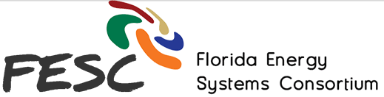

Website Re-design Plan

**O1. COLOR PALETTE**

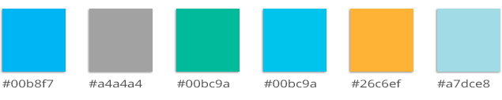

**02. TYPOGRAPHY**

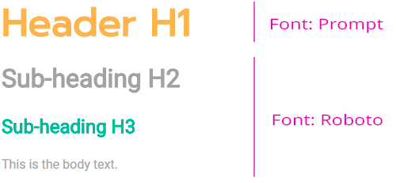

**H1**  
Font Type: Prompt  
Font Size: 3rem  
Color: #26c6ef

**H2**  
Font Type: Roboto  
Font Size: 2rem  
Color: #a4a4a4

**H3**  
Font Type: Roboto  
Font Size: 1.5rem  
Color: #00b69a

**BODY**  
Font Type: Roboto  
Font Size: 1rem  
Color: #a4a4a4

**03. BUTTONS**



Normal: #00b8f7  
Hover: #00bc9a

**04. ICONS**



**PROTOTYPE: HOME PAGE**  
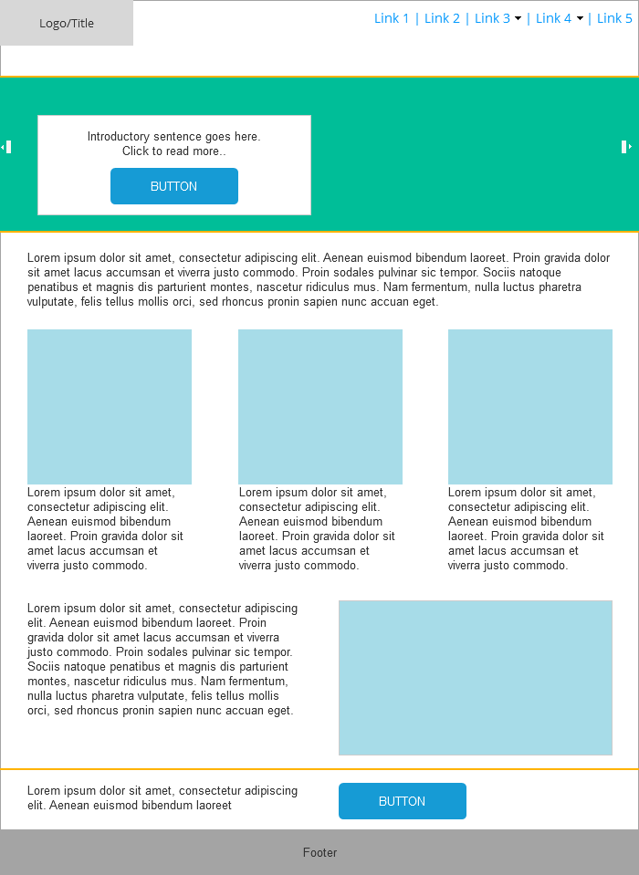

**PROTOTYPE: INNER PAGES**  
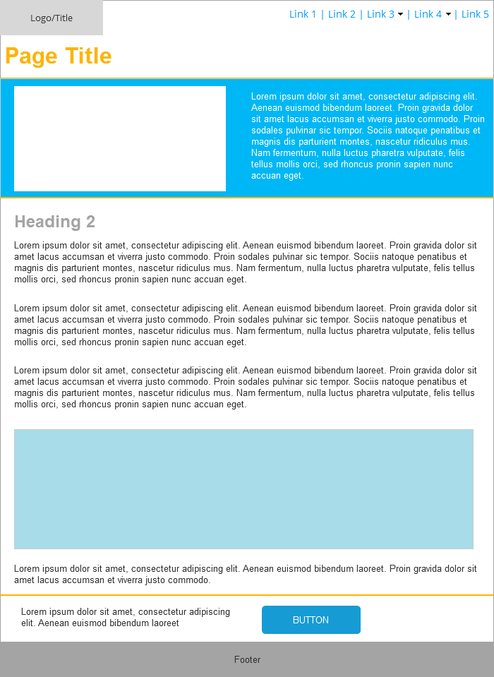

**MODULES: PRIMARY NAVIGATION**  
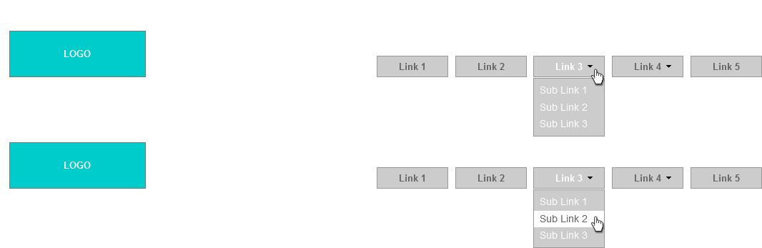

**MODULES: FOOTER**

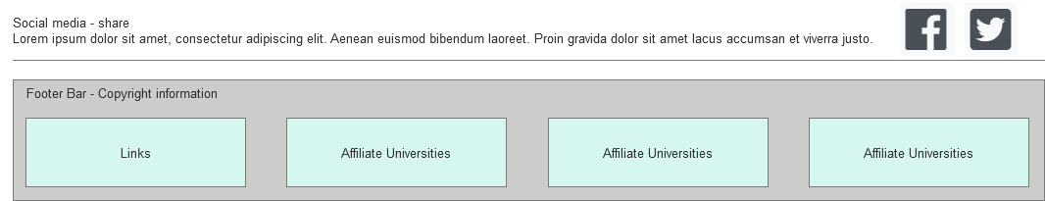

MOOD BOARD

{[https://www.freshbooks.com](https://www.freshbooks.com/)/}

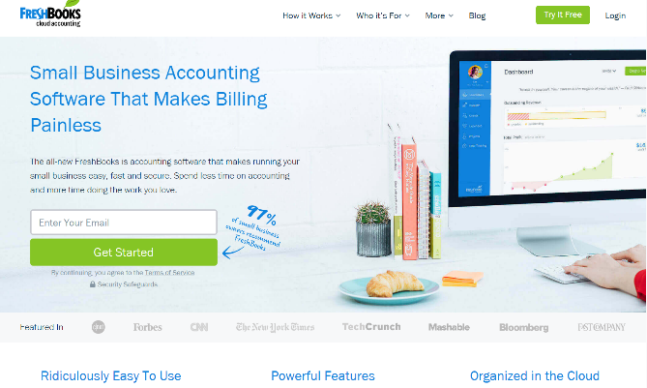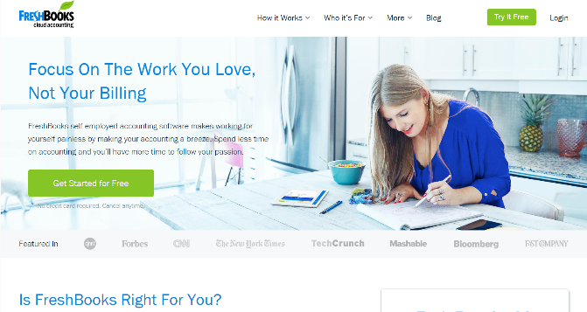

* Clean design   
* Clear call to action items   
* Good sub-navigation placement

{<https://www.mint.com/>}  
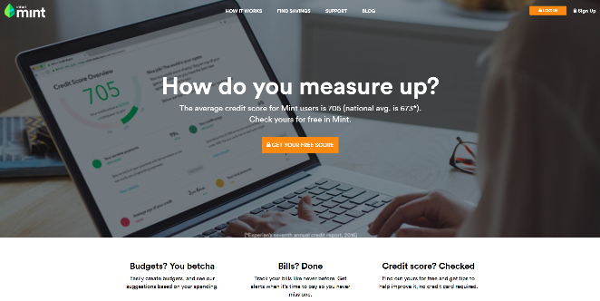 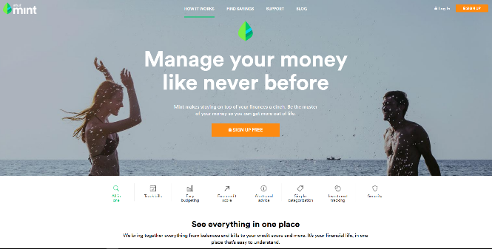

* White space and clean design   
* Well organized navigation interface   
* Pleasing color palette

{<https://flowmapp.com/>}  
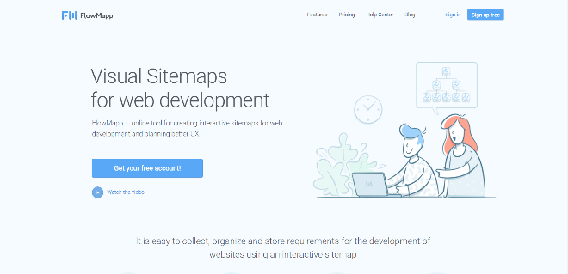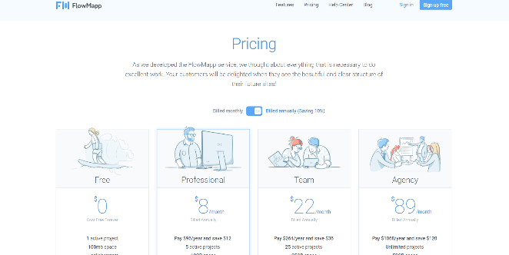

* Cool illustrations   
* Good color palette  
* Nice usage of space

{<https://www.inturn.co/>}

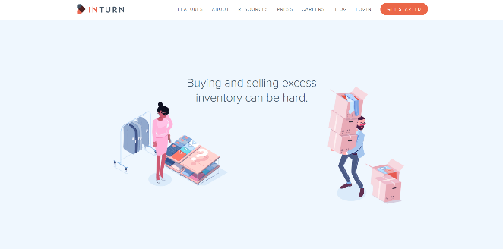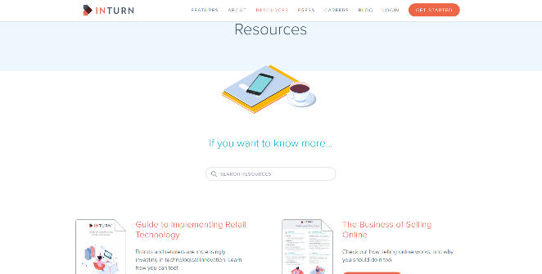

* Cool animations   
* Clear call to action  
* Responsive design