

**Renewable energy production chart:**

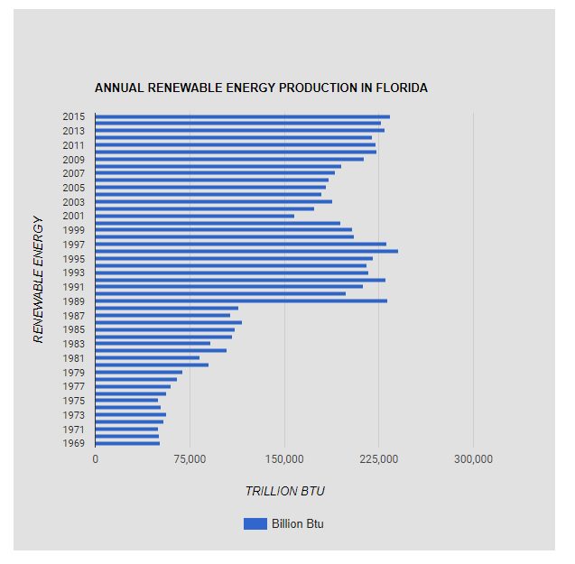

**Electricity consumption in Florida:**

**Type: Column bar chart**

