**Step1:** Created table Empl and stored employee details successfully.

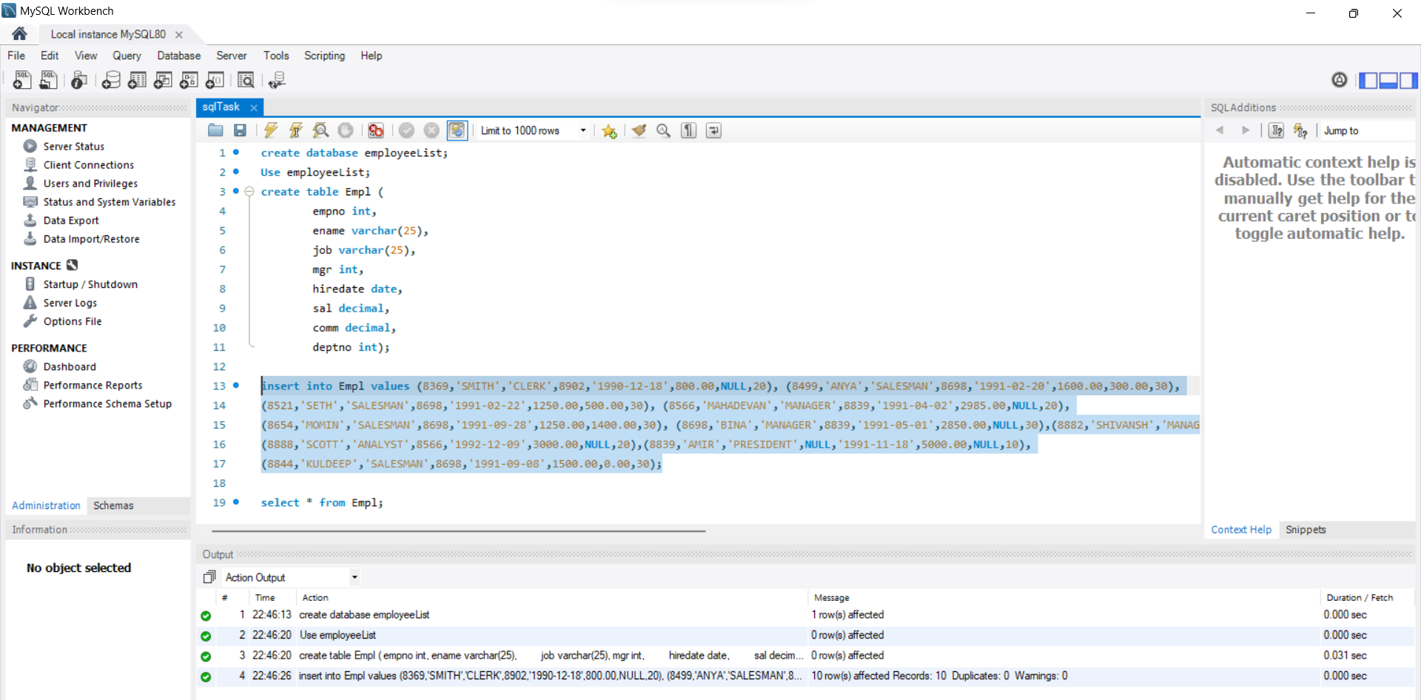

A. Write a query to display EName and Sal of employees whose salary are greater than or equal to 2200?

**SQL Query:** select ename, sal from Empl where sal >= '2200';

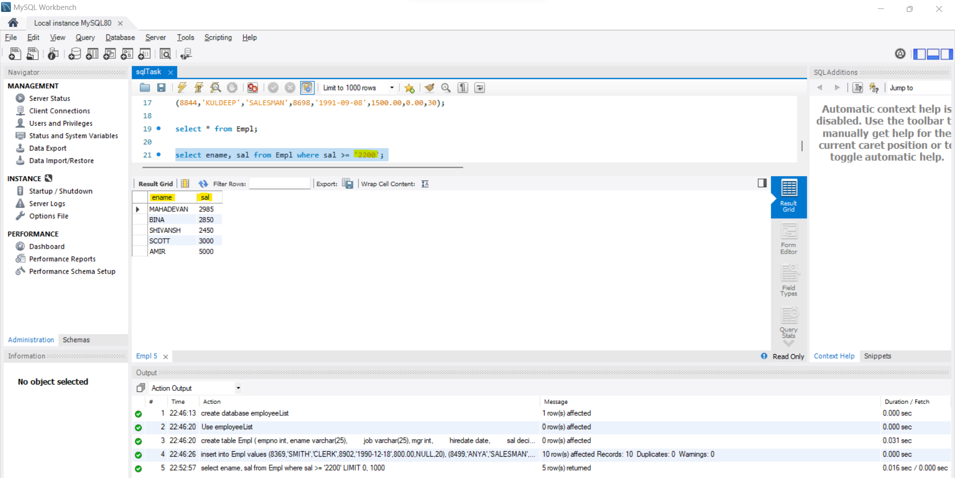

B. Write a query to display details of employees who are not getting commission?

**SQL Query:** select * from Empl where comm IS NULL;

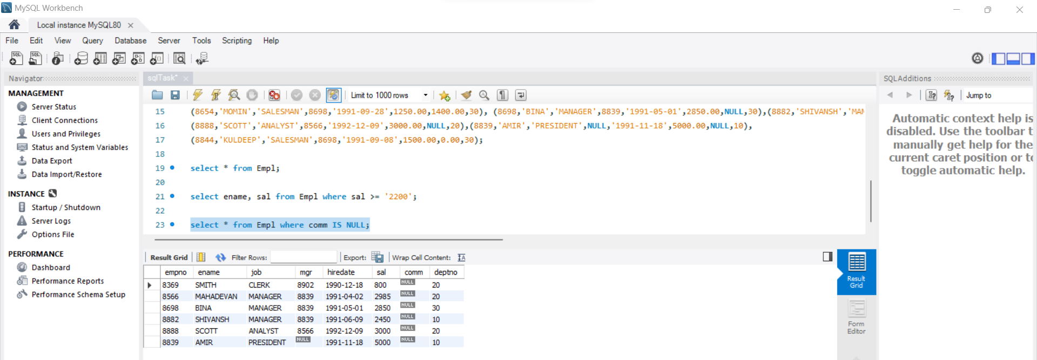

C. Write a query to display employee name and salary of those employees who don't have their salary in the range of 2500 to 4000?

**SQL Query:** select ename, sal from Empl where sal between 2500 and 4000;

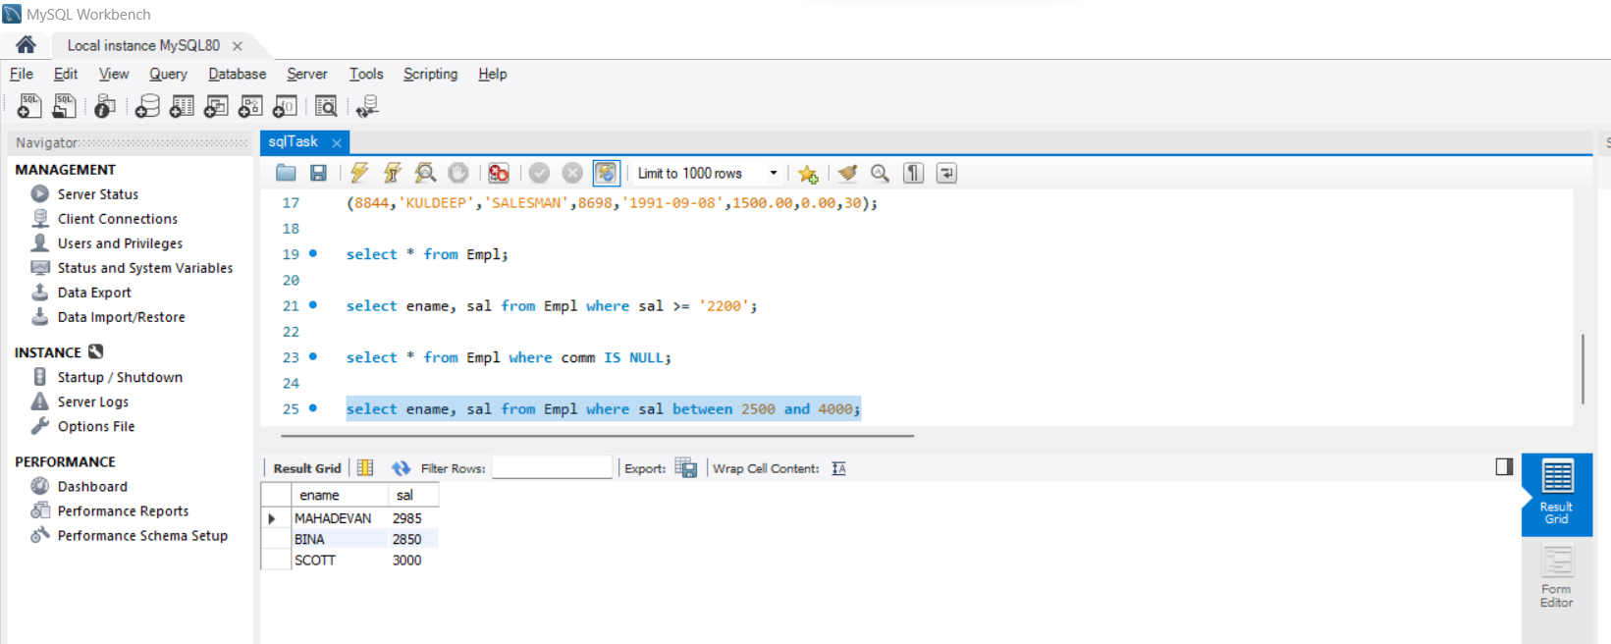

D. Write a query to display the name, job title and salary of employees who don't have a manager?

**SQL Query:**  select ename, job, sal from Empl where mgr IS NULL;

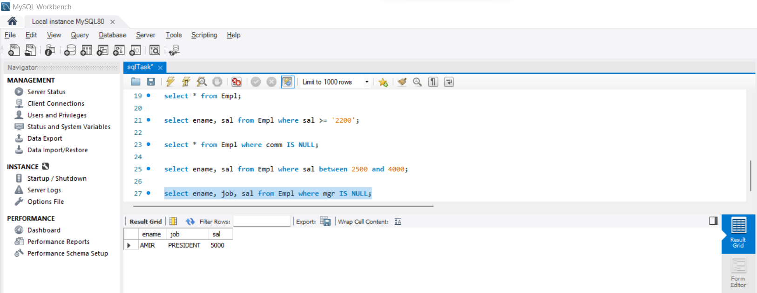

E. Write a query to display the name of an employee whose name contains "A" as third alphabet?

**SQL Query:** select ename from Empl where ename like '__A%' ;

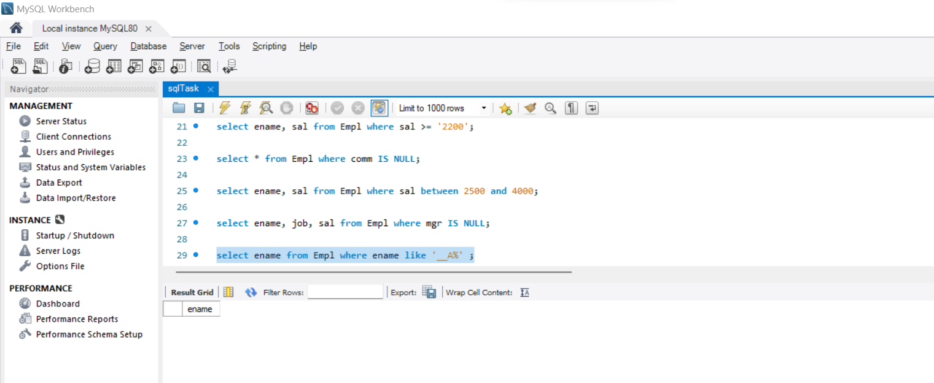

F. Write a query to display the name of an employee whose name contains "T" as the last alphabet?

**SQL Query:** select ename from Empl where ename like '%T' ;

