**Rajyalakshmi Chebrolu**

**ID: 20220728**

**DATE: 8/12/2023**

**Countries Quiz design document**

Table of Contents

**Mobile App Design Document** 2

**1.** **Mobile App Title:** 2

**2.** **App Goals and Objective:** 2

**3.** **Reasons To Develop This App:** 3

**4.** **Features of the App:** 3

**5.** **Target Audience:** 4

**6.** **Sketches/Wireframes screenshots:** 4

**Wireframes:** 6

**7.** **Problems to solve for users:** 7

**8.** **Competitors:** 8

**9.** **Different strategies:** 8

**10. Best platforms to launch:** 8

**10. Marketing:** 8

**Build:** 8

**Git:** 9

**App Testing:** 10

**Introduction:** 10

**List of Testing pages:** 10

**Objective:** 10

**Scope:** 10

**Summary:** 11

# **Mobile App Design Document**

This is a mobile app design document for a Quiz app, which allows users to play quiz about guessing capitals of different countries in Oceania continent. It has questions and options to choose the correct answer and get the result at the end. This app provides information to read the data about the quiz before you play.

This mobile app design document follows the below mentioned steps.

1. Mobile app title
2. App goals and objectives
3. Reasons to develop this app.
4. Features of the app
5. Target audience
6. Sketches and wireframes
7. Screenshots for mobile app
8. Testing methods and testing proof

# **Mobile App Title:**

I have named my app name is “**Countries Quiz!!**”. It is a simple quiz for learners who want to participate on quiz games, and it is a best practice for them. Quiz is another learning game system. It is great for teachers to entertain their students in the classroom in a great way. It is accessible through any mobile or internet connected devices.

I have named this app as a countries quiz because it is guessing the capitals of the countries. A quiz is a game during a kind of tricking brain under which the players try to answer the subsequent questions being asked in several types like multiple choice. Also, it is a game to check the person’s knowledge and skill to trick their brains on certain subject or topic.

# **App Goals and Objective:**

This app is typically involves testing the knowledge of the capital cities of various countries around the world. In this quiz, presented with the name of a country, and 4 options to choose the correct answer.

The primary objective is to enhance participants’ knowledge of world geography and to engage students in an entertainment way because they can learn more about countries and their respective capitals.

The main goal and objective of a countries quiz app is to provide:

1. Geography education
2. Cultural awareness
3. Entertainment and fun way of education
4. Memory improvement
5. Engagement and competition
6. Social interaction and online education

# **Reasons To Develop This App:**

This app can serve various purposes and the reason for creating this app depends on the goals and objectives of the development. Some common reasons are mentioned below:

1. This app is for educational purposes.
2. For promoting geographical literacy.
3. To entertain and engage the students or users in an educational way.
4. Social interaction
5. This kind of apps improve memory and cognitive skills.
6. It helps for global awareness campaigns.

# **Features of the App:**

This mobile app has various features to make it engage, educational, and user-friendly. The main features are:

1. Simple user login and registration
2. Home page with two options: Countries list to read, Quiz.
3. Countries list to read has an information about each countries capital list. After reading this information can enter the Quiz link.
4. There are few instructions to play quiz that page will open. They after reading the instructions there is a button to play quiz.
5. Quiz has Questions with options.
6. Each question has a time limit of 10 seconds.
7. After finishing all the questions, user gets result and a restart button.

The Mobile app and its design need to be:

* Easily to operate
* Easy to understand and comprehend.
* Work across Android and Ios
* Every non text item should be accompanied by text.
* If links provided, their functions must be described.

Readability

* Used simple language.
* Supplement text with icons and images
* Check spelling and grammar.

Content Navigation

* Create links to all the pages.
* Create semantic structure with regions, headings, and lists.

Colour

* Ensure that text, icons, and UI elements have strong luminance contrast.
* Use red/green colour combinations cautiously.

Links and Buttons

* Ensure links and buttons contain descriptive texts.
* Ensure they are visually differentiated from other contents on the page.

Images

* Exposure – the image is too bright or too dark must check.
* Shapes
* Texture

# **Target Audience:**

The target audience for countries quiz app can be diverse because this app is a combination of education, entertainment, and social interaction. Some of the audience lists are:

1. Students
2. Educational institutions
3. Geography enthusiasts
4. Gamers
5. Quiz fans
6. Families and friends
7. Learners to improve their knowledge.

# **Sketches/Wireframes screenshots:**

The below image shows the sketches of my entire view.

1. **Login Page**: App’s first page is login page; it has a logo. There is an option for email and password to login and register.
2. **Home page**: Second page is Home page sketch is the second image. It is a logo, and welcome message. It shows two links to read about countries and quiz option. User can choose depends on their choice.
3. **CountriesList page**: It has list of all Oceania countries and capitals to read the data.
4. **Quiz instructions page**
5. **Quiz page**: Quiz page has list of questions with options. Each question has 4 options to select so that user can choose the option.
6. **Result Page**: Result pages produce percentage, score details, and number of questions correct details. Also, it has reset button to play the quiz again and home button link to go back to the home page.
7. **Contact page**

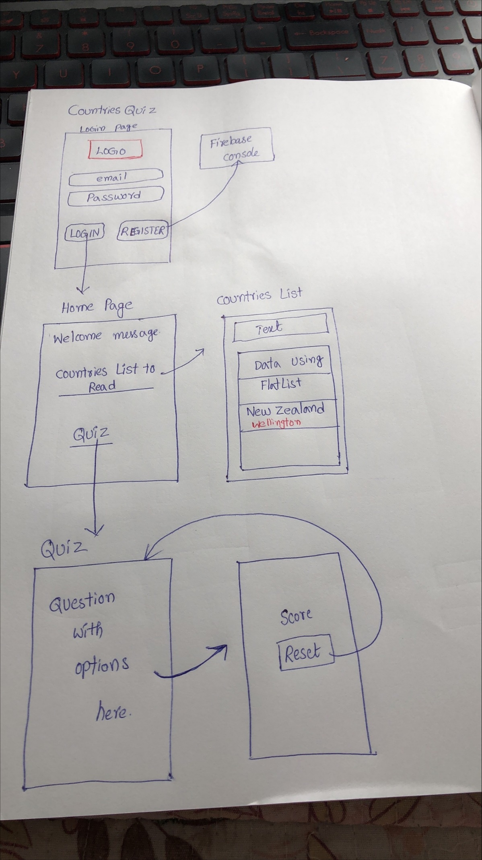

## **Wireframes:**

I used **Figma** to createall prototypes and these are attached below:

Link to show the prototypes: <https://www.figma.com/file/Rf0qQQIEjBP1iHcGiJo0KO/CountriesQuiz?type=design&node-id=0-1&mode=design&t=FriOGqqh2bCPn77u-0>

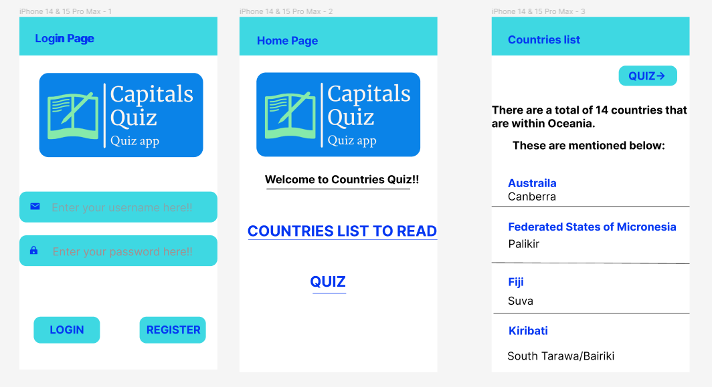

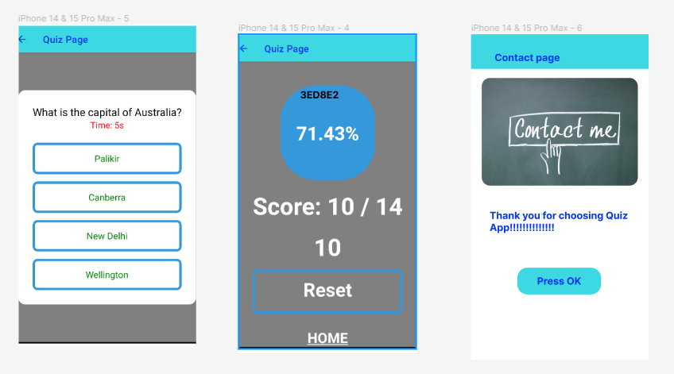

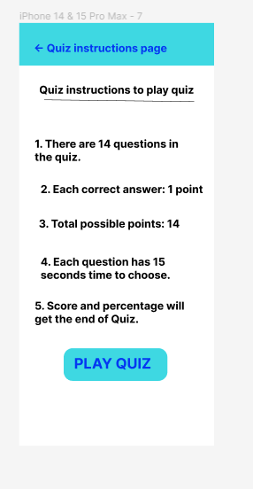

# **Problems to solve for users:**

This app will address the several needs and benefits for users. Some of the solutions are:

1. Knowledge enhancement – This app will help users to improve their geographical knowledge by providing a fun and interactive experience. So that users learn different countries and capitals.
2. Educational tool – It works an education tool for students and any users who are interested in quizzes.
3. Competitive learning purpose.
4. Brain exercise.

# **Competitors:**

Generally, Countries quiz app works for students so Educational Apps, Similar Quiz apps are the competitors. There are many other apps designed for students like geography quizzes like trivia.

# **Different strategies:**

My strategy is to provide the app in an interactive and engaging for the users. Also, it should be simple. In future, I have a plan to provide multi language support.

I will provide this app in offline mode so that users can use this app with limited internet access.

# **10. Best platforms to launch:**

There are so many platforms available to launch this app.

Mobile platforms: iOS, Android (Google play store)

Desktop: Windows, Linux, Mac

Browser based apps.

# **10. Marketing:**

Marketing and promoting this app involve strategies to increase awareness, attract the users, and approach to educational institutions. Finally, I will use social media marketing like Facebook, Twitter, Instagram.

# **Build:**

As per the design document, sketches, and prototypes, I have developed quiz app using React Native. The project folder is “**countiries_quiz**”.

The pages I have developed are:

1. Login page
2. Home page
3. Counties list page
4. Quiz instructions
5. Quiz page and result
6. Contact page.

It has included all the features:

1. Simple design and great responsive.
2. It has **offline support**. The quiz app works in offline as well, but the login page requires online because for email and password authentication I used firebase console.

Once the app loaded in the local system, user can play the quiz without internet support because I used async storage and imported in my app page.

1. **Resolution**: This app works fine with all resolutions like screen , images, code.
2. Countries quiz app has clear and easy **navigation**.
3. It has autofill feature: **Autofill** is a feature that allows users to automatically fill the fields with previously entered data, for example usernames, email addresses, and passwords.

For this app email text box loads automatically.

1. **Advanced Feature**: I have used **Cloud storage** for an advance feature. I have uploaded logo image in fire base storage. I have downloaded that locally and fetched in the login page and home page. That is why it takes time to load the image.

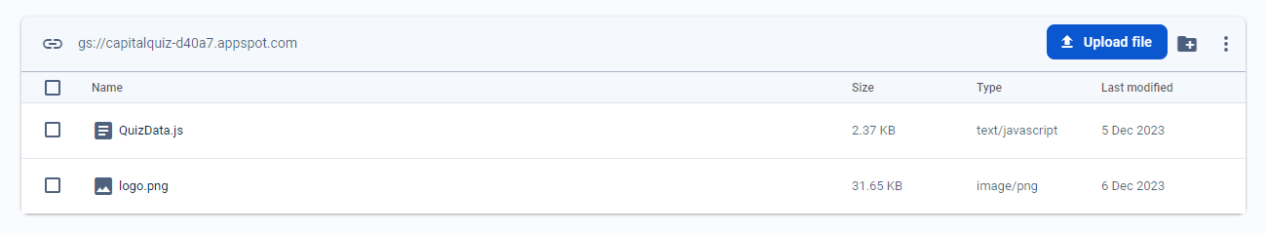

# **Git:**

I have pushed all my code into the git repository. The link of this has given below:

<https://github.com/RajiChebrolu/CountriesQuizApp.git>

# **App Testing:**

I have exhibited my project in Whitecliffe tech exhibition, Wellington on 7th Dec 2023. People visited me and known about my app. One person gave me a suggestion to develop a quiz instructions page. I followed that and developed the page.

User acceptance testing is also called application testing or end user testing. It is a phase of software development in which the software is tested in the real world by its intended users, developers, and testers. It is the last phase of software testing process, and it is performed before the tested software is going to be released in the real world.

The **primary goal** of user acceptance testing is to validate that each unit of the Countries quiz app performs as designed.

## **Introduction:**

Application name: Countries quiz app

Application type: Mobile app

Prepared by: Rajyalakshmi Chebrolu

Version: 1.0

Date: 8/12/2023

Environment: React native, visual studio code, Android studio

This is the testing report of a Countries quiz app prototype. It is a simple quiz for learners who want to participate on quiz games, and it is a best practice for them. Quiz is another learning game system. It is great for teachers to entertain their students in the classroom in a great way. It is accessible through any mobile or internet connected devices.

## **List of Testing pages:**

1. Login page
2. Home page
3. Counties list page
4. Quiz instructions
5. Quiz page and result
6. Contact page.

## **Objective:**

The primary objective of this user acceptance testing is to validate the functionality of the Countries quiz. The test items two emulators. Those are Pixel 2 API 30 mobile and Pixel C API 30 tablet:

## **Scope:**

The testing effort focused on the specified features provided in the design requirements section. I have followed the features and tested all the pages which I mentioned. The result of all pages Pass.

## **Summary:**

In summary of the test results recorded during testing. All the testing has been done with two emulators and attached all the screen shots in the “**Testing-Pixel2API30** document and **Testing--Tablet--PixelCAPI30**” documents.

In conclusion, this is a mobile app design document for a Quiz app, which allows users to play quizzes about guessing capitals of different countries in Oceania continent. It has questions and options to choose the correct answer and get the result at the end. This app provides information to read the data about the quiz before you play. It has details about the build and testing documentation. Testing is done with two types of emulators: mobile and tablet. I am going to upload all the screen shots for reference.