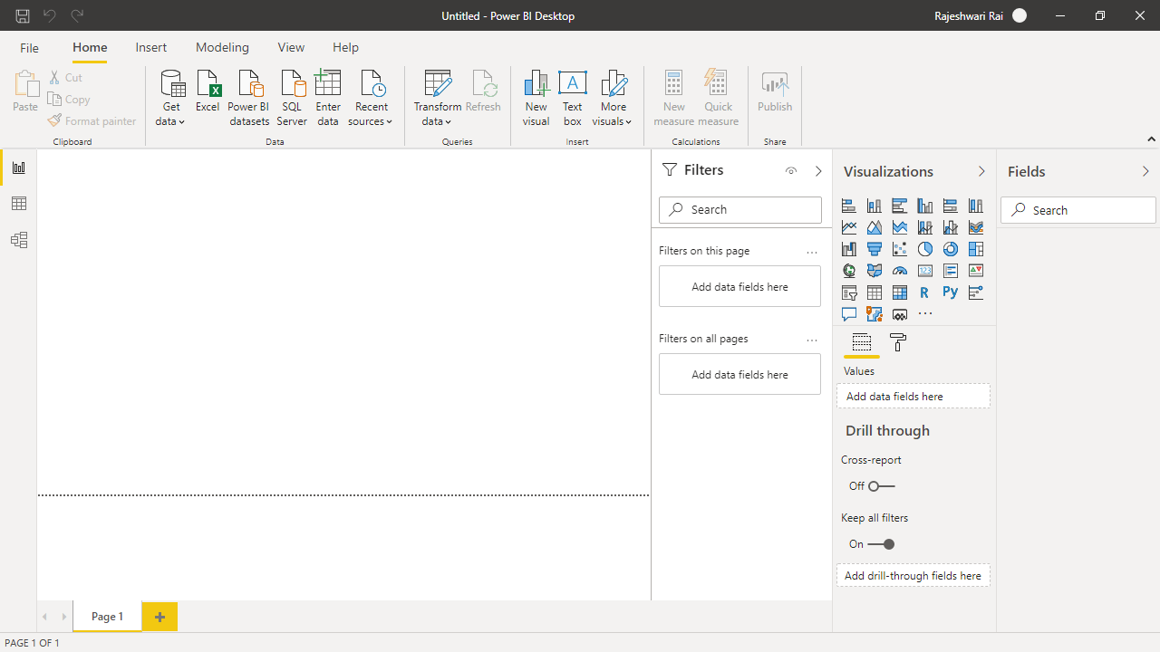

Report View

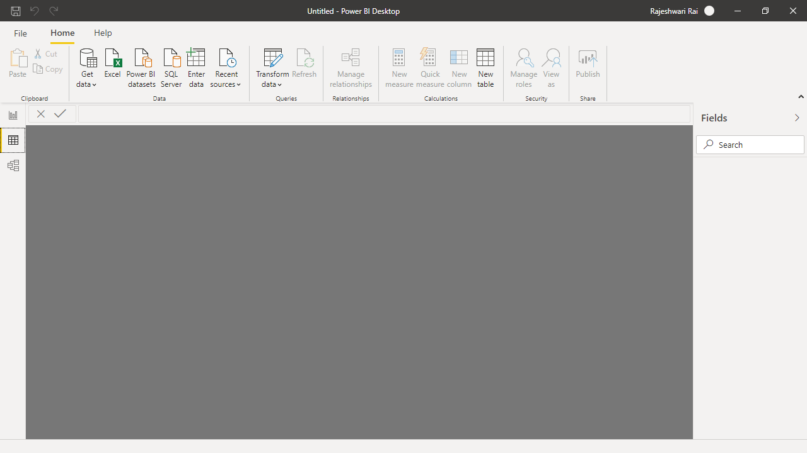

Data View

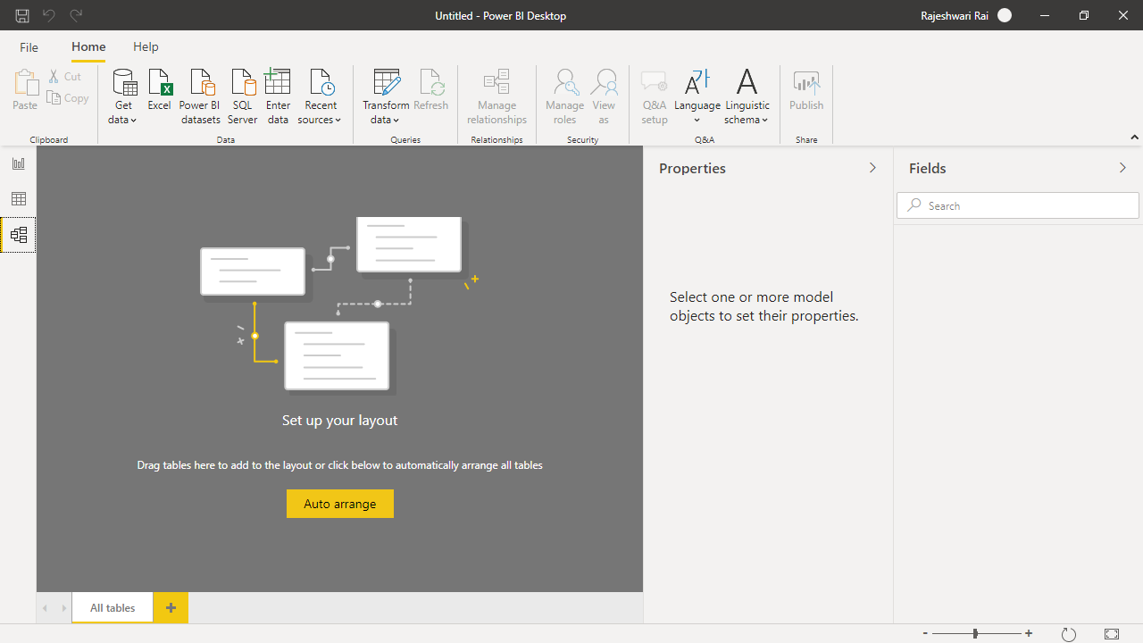

Model View

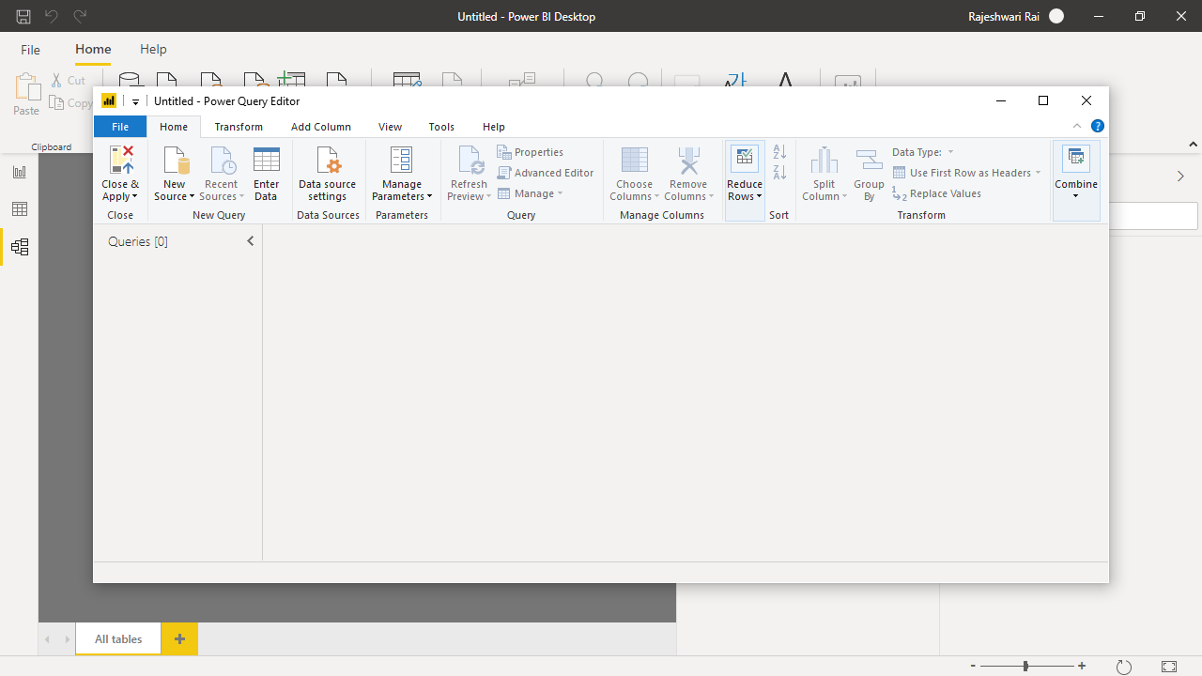

Power Query Editor

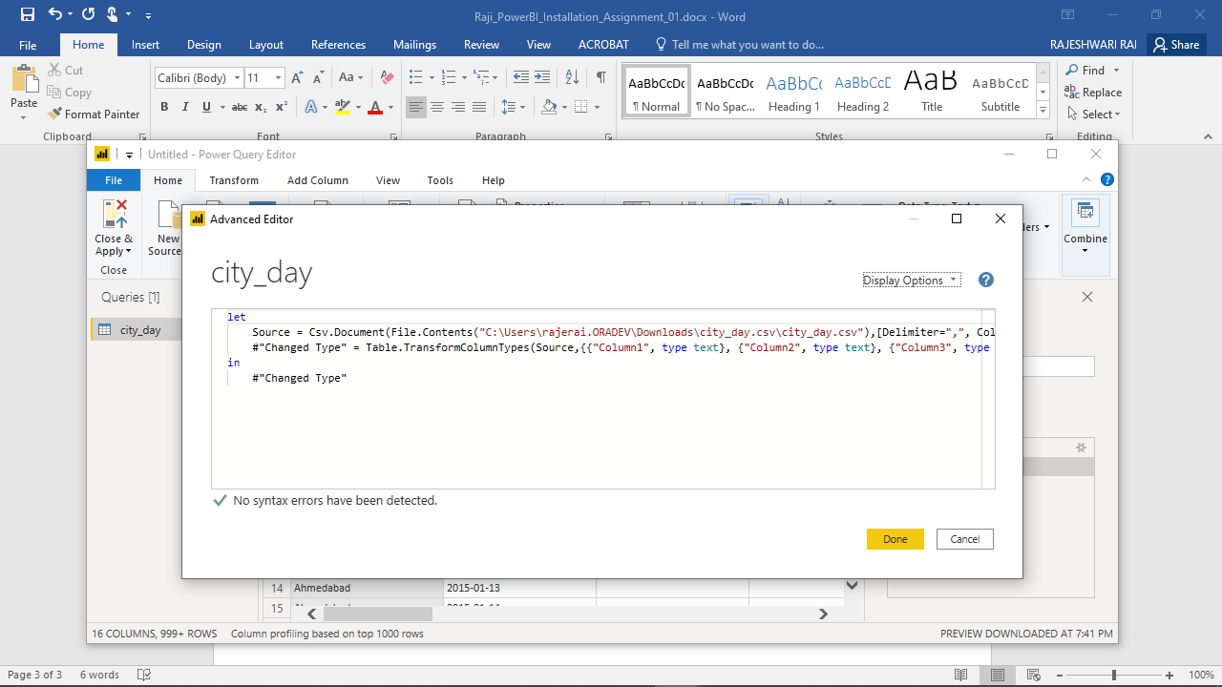

Advance Query Editor

Power BI Desktop− Free

With the Power BI Desktop you can visually explore your data through a free-form drag-and-drop canvas, a broad range of modern data visualizations, and an easy-to-use report authoring experience.

Power BI Pro – $9.99 user/month

Create a data-driven culture throughout your organization. Easily share and collaborate on interactive data visualizations using Power BI Pro for self-service analytics.

Power BI Premium – $4,995

Monthly price per dedicated cloud compute and storage resource with annual subscription

Power BI Premium offers advanced, self-service data preparation that allows every user—from business analyst to data scientist—to accelerate the delivery of insights and collaborate with ease.