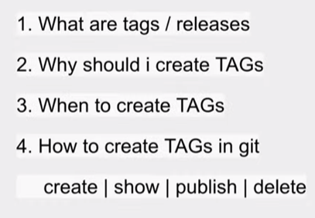
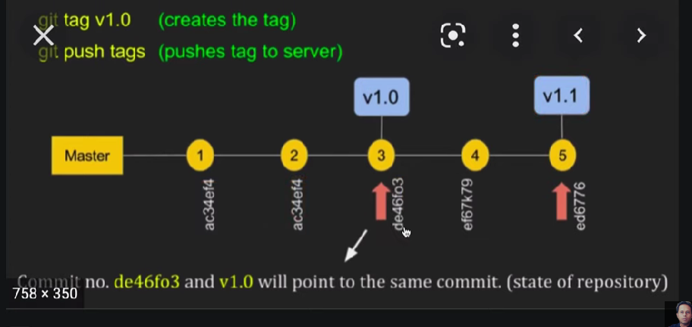
We create tags for releasing our application or our projects. It will help us to see history to see created, released , commited versions etc.
- checkout branchname where you want to create the tag
git checkout branchname
- create tag with some name- git tag v1.0
- git tag – to see tags
- git log – to see tags with particular commit we created the tag version v1.0
- git show v1.0 -to see all details of tag
- git -a tag v1.0 -m “annotation-ie why I created tag”
- git push origin v1.0
- verify it in git repository and you can now set releases there.
- To delete tags:
From local: git tag -d v1.0
git tag –delete v1.0
- To delete tag from remote:
git push origin -d v1.0
git push origin –delete v1.0

- To delete multiple tags at once:
git tag -d v1.0 v1.1 (local)
git push origin -d v1.0 v1.1 (remote)

- We can create a branch from a tag and checkout the branch
git checkout -b “branchname” “tagname”
eg: git checkout -b releasever1 v1.0

- To create TAGS from past commits
git tag “tagname” “reference of commit”
ex: git tag v1.2 5fcdb03 (first 7 digits from checksum- on command git log)

- If you need to get code from thirdparty like VS code, eclipse or Jenkins, you need to get TOKENS instead of passwords. For that you go to github and person profile icon-settings
Next at left side you may get “developer settings” -> select (at left) “personal access tokens” and create token for third party softwares.

