Study Material
(Formal Language and Automata Theory (PCC-CSD404))

Table of Contents
Module I: [7H]
Introduction: Alphabet, languages and grammars, productions and derivation, Chomsky hierarchy of languages.

Introduction:
The automata theory is the study of abstract machines and their application in solving computational problems. Automata theory (also known as Theory of Computation) is a theoretical branch of Computer Science and Mathematics, which mainly deals with the logic of computation with respect to simple machines, referred to as automata.

Alphabet:
An alphabet is a finite set of symbols denoted by Σ in automata. Alphabets are a set of symbols used to construct a language. Example, {0, 1} is binary alphabet, {A…, Z, a… z} is the alphabet set for the English language. String: A string is defined as a sequence of symbols of finite length.
Theory of computation is entirely based on symbols. These symbols are generally letters and digits. Alphabets are defined as a finite set of symbols.
Examples:
∑ = {0, 1} is an alphabet of binary digits
∑ = {A, B, C, …., Z} is an alphabet.

Strings:
A string is a finite sequence of symbols selected from some alphabet. It is generally denoted as w. For example for alphabet ∑ = {0, 1} w = 010101 is a string.
Length of a string is denoted as |w| and is defined as the number of positions for the symbol in the string. For the above example length is 6.
The empty string is the string with zero occurrence of symbols. This string is represented as є or λ. The set of strings, including the empty string, over an alphabet ∑ is denoted by ∑*.
For ∑ = {0, 1} we have set of strings as ∑* = {є, 0, 1, 01, 10, 00, 11, 10101,…}.
and ∑1 = {0, 1} , ∑2 = {00, 01, 10, 11} and so on.
∑* contains an empty string є. The set of non- empty string is denoted by ∑+. From this we get:
∑* = ∑+ U {є }

Concatenation of strings
Let w1 and w2 be two strings then w1w2 denotes their concatenation w. The concatenation is formed by making a copy of w1 and followed by a copy of w2.
For example w1 = xyz, w2 = uvw then w = w1w2 = xyzuvw
Also w1³ = w1w1w1

Languages:
A language is a set of string all of which are chosen from some ∑*, where ∑ is a particular alphabet. This means that language L is subset of ∑*. An example is English language, where the collection of legal English words is a set of strings over the alphabet that consists of all the letters. Another example is the C programming language where the alphabet is a subset of the ASCII characters and programs are subset of strings that can be formed from this alphabet.

Concatenation of Languages
If L1 and L2 are two languages then their concatenation can be defined as : L = L1 . L2 where L = {w: w = xy where x є L1, y є L2}
It means that all the strings in the language L are concatenation of stings of language L1 and L2

Kleen Closure
If S is a set of words then by S* we mean the set of all finite strings formed by concatenating words from S, where any word may be used as often we like, and where the null string is also included.

S* is the Kleen closure for S. We can think of kleen star (S*) as an operation that makes an infinite language of strings of letters out of an alphabet.
For example for ∑ = {a}
∑* = {є, a, aa, aaa, ….}

Grammars:
A Grammar is a 4-tuple such that- G = (V, T, P, S)
Where-
V = Finite non-empty set of non-terminal/Variable symbols T = Finite set of terminal symbols
P = Finite non-empty set of production rules S = Start symbol
A Grammar is mainly composed of two basic elements-

Terminal symbols
  - Terminal symbols are those which are the constituents of the sentence generated using a grammar.
  - Terminal symbols are denoted by using small case letters such as a, b, c etc.

Non-terminal symbols
  - Non-Terminal symbols are those which take part in the generation of the sentence but are not part of it.
  - Non-Terminal symbols are also called as auxiliary symbols or variables.
  - Non-Terminal symbols are denoted by using capital letters such as A, B, C etc.

Productions:
A production or production rule in computer science is a rewrite rule specifying a symbol substitution that can be recursively performed to generate new symbol sequences. A finite set of productions is the main component in the specification of a formal grammar (specifically a generative grammar).

Derivation:
Derivation is a sequence of production rules. It is used to get the input string through these production rules. During parsing, we have to take two decisions. These are as follows:

  - We have to decide the non-terminal which is to be replaced.
  - We have to decide the production rule by which the non-terminal will be replaced.

Chomsky hierarchy of languages:
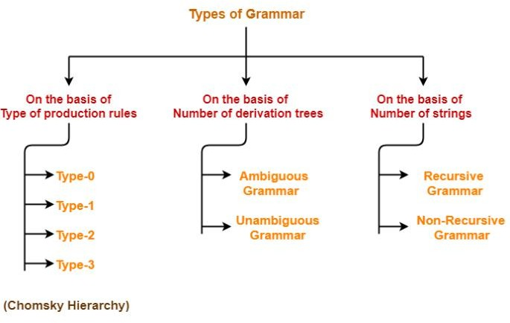
According to Noam Chomsky, there are four types of grammars − Type 0, Type 1, Type 2, and Type 3. The following table shows how they differ from each other –

Grammar Type | Grammar Accepted | Language Accepted | Automaton
Type 0 | Unrestricted grammar | Recursively enumerable language | Turing Machine
Type 1 | Context-sensitive grammar | Context-sensitive language | Linear-bounded automaton
Type 2 | Context-free grammar | Context-free language | Pushdown automaton
Type 3 | Regular grammar | Regular language | Finite state automaton

Take a look at the following illustration. It shows the scope of each type of grammar −

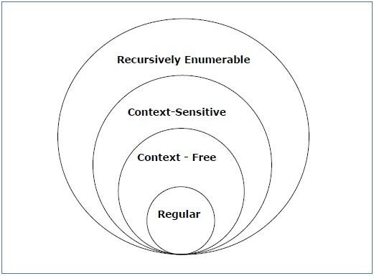

Type - 3 Grammar
Type-3 grammars generate regular languages. Type-3 grammars must have a single non-terminal on the left-hand side and a right-hand side consisting of a single terminal or single terminal followed by a single non-terminal.
The productions must be in the form X → a or X → aY where X, Y ∈ N (Non terminal)
and a ∈ T (Terminal)
The rule S → ε is allowed if S does not appear on the right side of any rule.
Example X → ε
X → a | aY Y → b

Type - 2 Grammar
Type-2 grammars generate context-free languages.
The productions must be in the form A → γ where A ∈ N (Non terminal)
and γ ∈ (T ∪ N)* (String of terminals and non-terminals).
These languages generated by these grammars are be recognized by a non-deterministic pushdown automaton.
Example S → X a X → a
X → aX X → abc X → ε

Type - 1 Grammar
Type-1 grammars generate context-sensitive languages. The productions must be in the form α A β → α γ β
where A ∈ N (Non-terminal)
and α, β, γ ∈ (T ∪ N)* (Strings of terminals and non-terminals) The strings α and β may be empty, but γ must be non-empty.

The rule S → ε is allowed if S does not appear on the right side of any rule. The languages generated by these grammars are recognized by a linear bounded automaton.
Example
AB → AbBc
A → bcA
B → b

Type - 0 Grammar
Type-0 grammars generate recursively enumerable languages. The productions have no restrictions. They are any phase structure grammar including all formal grammars.
They generate the languages that are recognized by a Turing machine.
The productions can be in the form of α → β where α is a string of terminals and nonterminals with at least one non-terminal and α cannot be null. β is a string of terminals and non-terminals.
Example S → ACaB Bc → acB CB → DB
aD → Db

Right and Left linear Regular Grammars
Regular grammar is a type of grammar that describes a regular language. A regular grammar is a mathematical object, G, which consists of four components, G = (V, T, P, S), where
- V: non-empty, finite set of non-terminal symbols,
- T: a finite set of terminal symbols, or alphabet, symbols,
- P: a set of grammar rules, each of one having one of the forms
- A ⇢ aB
- A⇢ a
- A ⇢∈, Here ∈=empty string, A, B ∈ N, a ∈ ∑
- S ∈ V is the start symbol.
This grammar can be of two forms:
- Right Linear Regular Grammar
- Left Linear Regular Grammar

Right Linear Regular Grammar
In this type of regular grammar, all the non-terminals on the right-hand side exist at the rightmost place, i.e; right ends.
Examples :
A ⇢ a, A ⇢ aB, A ⇢ ∈
where,
A and B are non-terminals, a is terminal, and
∈ is empty string S ⇢ 00B | 11S

B ⇢ 0B | 1B | 0 | 1 where,
S and B are non-terminals, and 0 and 1 are terminals

Left Linear Regular Grammar
In this type of regular grammar, all the non-terminals on the right-hand side exist at the leftmost place, i.e; left ends.
Examples :
A ⇢ a, A ⇢ Ba, A ⇢ ∈
where,
A and B are non-terminals, a is terminal, and
∈ is empty string S ⇢ B00 | S11
B ⇢ B0 | B1 | 0 | 1 where
S and B are non-terminals, and 0 and 1 are terminals

Left linear to Right Linear Regular Grammar
In this type of conversion, we have to shift all the left-handed non-terminals to right as shown in example given below:
Left linear Right linear

A -> Ba A -> abaB
B -> ab B -> epsilon OR
A -> abB
B -> a

