**INTRODUCTION TO MATLAB AND ITS BASIC COMMANDS**

**OBJECTIVES**

* To learn basic commands of MATLAB
* To plot functions in graphs

**INTRODUCTION**

MATLAB (Matrix Laboratory) is a matrix programming language popular for numerical computing environment. It is quite popularly used for data analytics, wireless communications, deep learning, computer vision, signal processing, robotics, control systems and so on. Engineers and scientists worldwide rely on MATLAB. MATALAB also includes Simulink which adds graphical multi-domain simulation and model-based design for dynamic and embedded system. It allows matrix manipulations, plotting of functions and data, implementation of algorithms, creation of user interfaces, and interfacing with programs written in other languages, including, C, C++, C#, Java, Fortran and Python.

**EXERCISES**

1. Given f(x) = (x^2 + 2x + 3)/(x+3). Plot f(x) for 0<x<=100.

for x = 1:1:10

a(x)=x;

res = (power(x,2)+2*x+3)/(x+3);

b(x) = res;

end

plot(a,b);

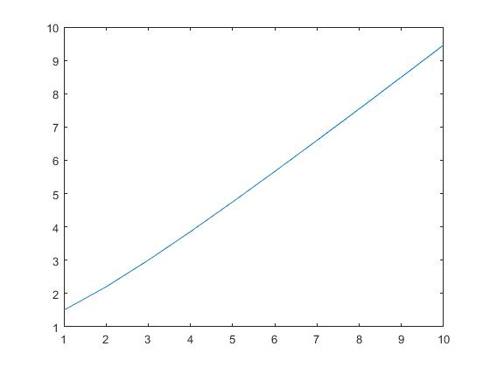

1. Plot the graph for y=e^(-at)*cos(wt) for w=5, a=2 and t runs from 0 to 10.

for t = 1:1:10

a(t) = t;

res = exp(-2*t)*cos(5*t);

b(t) = res;

end

plot(a,b);

xlabel(“time”);

ylabel(“amplitude”);

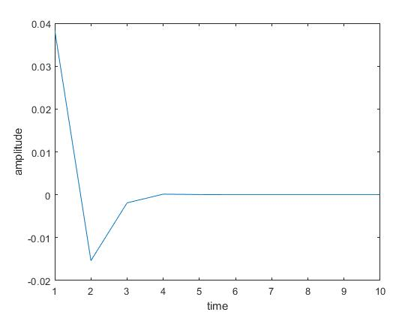

1. Plot the function f(x)=3e^x for any suitable range

x=-10:1:10;

y=3*exp(x);

plot(x,y);

xlabel("time");

ylabel("amplitude");

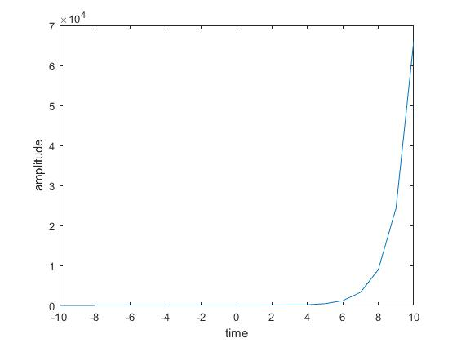

1. Plot cos and sine wave functions.

amplitude = 10;

frequency = 10;

time_T = 1/frequency;

t = 0:0.01:4*time_T;

y1 = amplitude*sin(2*pi*frequency*t);

subplot(2,1,1);

plot(t,y1);

subplot(2,1,2);

y2=amplitude*cos(2*pi*frequency*t);

plot(t,y2);

**Output:**

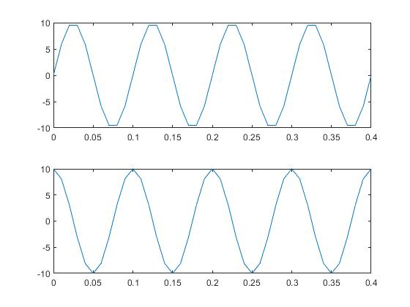

1. Find the factorial of a number.

function [res] = factorials(num)

fact=1;

for i=num:-1:1

fact=fact*i;

end

res=fact;

end

**Output:**

factorials(3)

ans =

6

1. Generate Fibonacci Series

function [] = fibonacci(a,b,len)

disp([a,b]);

for i=1:1:len

c=a+b;

a=b;

b=c;

p(i) = c;

end

disp(p);

end

**Output:**

fibonacci(1,1,15)

1 1

Columns 1 through 10

2 3 5 8 13 21 34 55 89 144

Columns 11 through 13

233 377 610

1. Find size, mean, number of elements and sum of a matrix.

a=1:1:10

a =

1 2 3 4 5 6 7 8 9 10

disp(a);

1 2 3 4 5 6 7 8 9 10

disp(size(a));

1 10

disp(sum(a));

55

disp(mean(a));

5.5000

disp(numel(a));

10

1. Perform complex number operations.

function [] = complexes(a)

disp("Absolute Value");

disp(abs(a));

disp("Angle:");

disp(angle(a));

disp("Real Part:");

disp(real(a));

disp("Imaginary Part:");

disp(imag(a));

end

**Output:**

complexes(5+7i)

Absolute Value

8.6023

Angle:

0.9505

Real Part:

5

Imaginary Part:

7

1. Perform matrix operations

function [] = matrixoperat(a,b)

disp("matrix transpose of a");

disp(transpose(a));

disp("matrix inversion of b");

disp(inv(b));

disp("Elementwise matrix multiplication");

disp(a.*b);

disp("matrix multiplication");

disp(a*b);

end

**Output:**

a=[1 2 3;4 5 6;7 8 9]

a =

1 2 3

4 5 6

7 8 9

b=[9 8 7;6 5 4;3 2 1]

b =

9 8 7

6 5 4

3 2 1

matrixoperat(a,b)

matrix transpose of a

1 4 7

2 5 8

3 6 9

matrix inversion of b

Warning: Matrix is close to singular or badly scaled. Results

may be inaccurate. RCOND = 3.083953e-18.

In matrixoperat (line 5)

1.0e+15 *

2.2518 -4.5036 2.2518

-4.5036 9.0072 -4.5036

2.2518 -4.5036 2.2518

Elementwise matrix multiplication

9 16 21

24 25 24

21 16 9

matrix multiplication

30 24 18

84 69 54

138 114 90

**DISCUSSION AND CONCLUSION**

In this lab, we were introduced to some basic MATLAB commands and programming techniques. We performed array manipulation, matrix operations, factorial calculations, Fibonacci series generation, plotting graph of functions and so on.