**CONVERT RAW(JSON) DATA TO FORMATTED(CSV) DATA:**

**Objective:**

To design a pipeline which triggers the lambda function to format the raw data in a streaming manner.

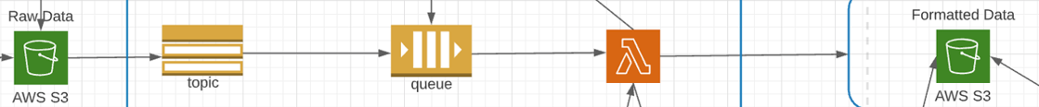**Pipeline:**

**Steps Included:**

1. AWS S3
2. Simple Notification Service (SNS) topic
3. Simple Queue Service (SQS)
4. AWS Lambda
5. IAM

**ARCHITECTURE:**

1. Create a SNS Topic
2. Create a SQS Queue
3. Subscribe the Queue to a SNS topic
4. Create one source folder and one target folder in one S3 bucket name it as your wish.
5. Create a Lambda function to convert JSON file in source folder to CSV format and place in target folder
6. Add permissions to IAM role associated with Lambda function for receiving SQS msg, putting files into S3
7. Add SQS queue as trigger source for Lambda fn
8. Create a Event notification for S3 bucket source folder to send notification destined to SNS topic whenever new file inserted into the folder

**To understand how the message is getting travelled, Broken down the pipeline into 3 ways.**

**Getting started**

**Method 1:**

To convert JSON file in source folder to CSV format and place in target folder only using lambda function and S3.

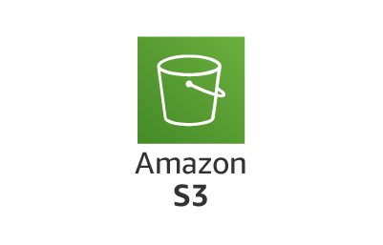

Step1: Navigate to S3. Create source folder and target folder.

Step2: Navigate to Lambda. Create a new lambda function.

Step3: Create Event notification for S3 bucket source folder destined as lambda to get triggered.

Step4: Add S3 as the trigger source to the lambda function.

Step5:Give permissions to IAM role of lambda function for read and write to the s3.

**Method2:**

To convert JSON file in source folder to CSV format and place in target folder only using ***:*** Included Lambda, S3, SNS in pipeline.

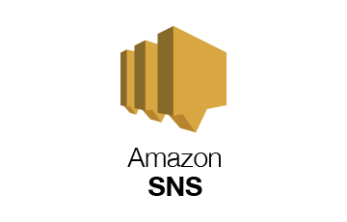

Step1: Created lambda function to format the data in the source folder of S3 bucket.

Step2: Create SNS topic.

Step3: Create Event notification for S3 bucket raw folder destined as SNS topic

Step4: Add SNS as the trigger source to the lambda function

Step5: Give permissions to IAM role of lambda function for read and write to the s3, receive notification from SNS

Step6: SNS will send notification to lambda function to get it triggered whenever there is new data in the raw folder of S3 bucket.

**Method3:**

To convert JSON file in source folder to CSV format and place in target folder only using ***:*** Included Lambda, S3, SNS,SQS in pipeline.

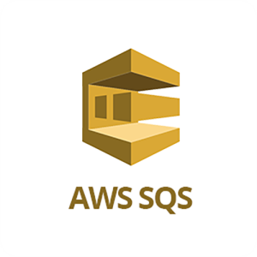

Step1: Created lambda function to format the data in the raw folder of S3 bucket.

Step2: Create SNS topic, SQS Queue

Step3: In SNS, Create a Subscription to the SQS queue

Step4: Create Event notification for S3 bucket source folder destined as SNS topic

Step5: Add SQS as the trigger source to the lambda function

Step6: Give permissions to IAM role of lambda function for read and write to the s3, receive notification from SQS