American International University-Bangladesh (AIUB)
Faculty of Science and Technology
Department of Computer Science

Web Technologies
CSE 4101
PROJECT REPORT

Project Title:
Online Medicine Shop

Semester: Spring 2025–2026
Submission Date: 05, 18, 2026
Section: H

Submitted To:
WAHIDUL ALAM RIYAD
faculty of science & technology
American International University-Bangladesh

Group Information

Group Number: 11
Project Title: Online Medicine Shop

Student Information:
Full Name: Md Abu Rajin
Student ID: 23-50257-1
Program: CSE
Email: marajin57@gmail.com
Signature: _____________________________

Student Information:
Full Name: Ak Hasan Mahamudul Haque
Student ID: 23-50297-1
Program: CSE
Email: 23-50297-1@student.aiub.edu

Signature: _____________________________

Student Information:
Full Name: Md Ashiqur Rahman
Student ID: 23-54596-1
Program: CSE
Email: 23-54596-3@student.aiub.edu

Signature: ____________________________

Declaration: We hereby declare that this project report is our original work. Any external resources or references used have been properly cited. We have not engaged in any form of academic dishonesty.

Marks Sheet
To be filled by the instructor only. Students must NOT write in this section.

Group No. | 11 | Section | H
Member 1 ID | 23-50257-1

CO3: Illustrate Multi-Tier Web Application for Targeted Society
Feature Implementation (0-3) |  |  | Feature Implementation (0-3) |  | Completeness (0-3)
Basic Web Security | UI (HTML/CSS) | Feature Completeness | DB | Auth (Session/cookie) | MVC
CO4: Coordinate with Group Members to Develop Multi-Tier Application
Technical Knowledge (0-3) |  |  | Collaborative Teamwork (0-3) |  |  | Communication/Promptness (0-3)
JS validation | PHP Validation | Ajax/JSON | Git Contribution |  |  | VIVA
Expected Outcome (0-2) |  | CO3 Total | CO4 Total |  |  | Project Total

Evaluated By: __________________________ Date: __________________

Course Teacher Signature: _______________________

Marks Sheet
To be filled by the instructor only. Students must NOT write in this section.

Group No. | 11 | Section | H
Member 1 ID | 23-50297-1

CO3: Illustrate Multi-Tier Web Application for Targeted Society
Feature Implementation (0-3) |  |  | Feature Implementation (0-3) |  | Completeness (0-3)
Basic Web Security | UI (HTML/CSS) | Feature Completeness | DB | Auth (Session/cookie) | MVC
CO4: Coordinate with Group Members to Develop Multi-Tier Application
Technical Knowledge (0-3) |  |  | Collaborative Teamwork (0-3) |  |  | Communication/Promptness (0-3)
JS validation | PHP Validation | Ajax/JSON | Git Contribution |  |  | VIVA
Expected Outcome (0-2) |  | CO3 Total | CO4 Total |  |  | Project Total

Evaluated By: __________________________ Date: __________________

Course Teacher Signature: _______________________

Marks Sheet
To be filled by the instructor only. Students must NOT write in this section.

Group No. | 11 | Section | H
Member 1 ID | 23-54596-1

CO3: Illustrate Multi-Tier Web Application for Targeted Society
Feature Implementation (0-3) |  |  | Feature Implementation (0-3) |  | Completeness (0-3)
Basic Web Security | UI (HTML/CSS) | Feature Completeness | DB | Auth (Session/cookie) | MVC
CO4: Coordinate with Group Members to Develop Multi-Tier Application
Technical Knowledge (0-3) |  |  | Collaborative Teamwork (0-3) |  |  | Communication/Promptness (0-3)
JS validation | PHP Validation | Ajax/JSON | Git Contribution |  |  | VIVA
Expected Outcome (0-2) |  | CO3 Total | CO4 Total |  |  | Project Total

Evaluated By: __________________________ Date: __________________

Course Teacher Signature: _______________________

Table of Contents

1. Group Information 2
2. Marks Sheet 3
3. Table of Contents 4
4. Chapter 1: Project Overview 9
4.1 Project Description 9
4.1 Technologies Used 10
4.3 System Architecture / MVC Diagram 11
4.4 Database Schema 12
5. Chapter 2: Git Contribution & Task Allocation 13
5.1 GitHub Repository Link 13
5.2 Git Contribution Screenshot 14
6. Chapter 3: Features, Source Code & Screenshots 16
7. Chapter 5: Conclusion & Future Work 18

Chapter 1: Project Overview

1.1 Project Description
online medicine shop is a simple web store where people can browse medicines, add them to a cart, and place orders from home.

Many people find it hard or inconvenient to visit a pharmacy in person. This app lets them search medicines by category, order online, choose cash on delivery or pay early, and track orders. Shop admin can manage stock, categories, and approve or reject orders in one place.

1.2 Technologies Used
List all technologies, frameworks, and tools used in this project.

Layer | Technology / Tool | Purpose
Frontend | HTML5, CSS3 | UI & Styling
 | JavaScript | Client-side validation, AJAX
Backend | PHP | Server-side logic
Database | MySQL | Data storage
Auth | PHP Sessions & Cookies | Authentication
Version Control | Git / GitHub | Collaboration & versioning
Server | Laragon server | Local development

1.3 System Architecture / MVC Diagram
├── index.php
├── config/
│ ├── app.php
│ ├── db.php
│ ├── admin_auth.php
│ └── csrf.php
├── controller/
│ ├── home.php
│ ├── shopController.php
│ ├── cartCheckout.php
│ ├── medicineController.php
│ ├── categoryController.php
│ ├── adminController.php
│ ├── adminOrderController.php
│ └── customerController.php
├── model/
│ ├── User.php
│ ├── CartModel.php
│ └── OrderModel.php
├── views/
│ ├── home.php
│ ├── auth/
│ ├── admin/
│ ├── ashiqur/
│ └── partials/
├── api/
│ ├── medicines/search.php
│ └── cart_add.php, cart_update.php…
└── public/

1.4 Database Schema
List your database tables and their key fields.
Table Name | Field Name | Data Type | Description
users | id | INT | AUTO_INCREMENT PRIMARY KEY
 | name | VARCHAR(255) | NOT NULL
 | email | VARCHAR(255) | NOT NULL UNIQUE
 | password_hash | VARCHAR(255) | NOT NULL
 | role | ENUM('admin', 'customer') | NOT NULL DEFAULT 'customer'
 | profile_picture | VARCHAR(500) | NULL
 | phone | VARCHAR(30) | NULL
 | remember_token | VARCHAR(64) | NULL
 | address | TEXT | NULL
 | created_at | TIMESTAMP | NOT NULL DEFAULT CURRENT_TIMESTAMP
categories | id | INT | Primary Key
 | name | VARCHAR(255) | NOT NULL
 | category_type | ENUM | NOT NULL
 | created_at | TIMESTAMP | NOT NULL DEFAULT CURRENT_TIMESTAMP
medicines | id | INT | Primary Key, AUTO_INCREMENT
 | name | VARCHAR(255) | NOT NULL
 | category_id | INT | NOT NULL
 | vendor_name | VARCHAR(255) | NOT NULL
 | price | DECIMAL(10,2) | NOT NULL
 | availability | INT | NOT NULL DEFAULT 0 (stock quantity)
 | description | TEXT | NULL
 | image_path | VARCHAR(500) | NULL
 | created_at | TIMESTAMP | NOT NULL DEFAULT CURRENT_TIMESTAMP
cart | id | INT | Primary Key, AUTO_INCREMENT
 | user_id | INT | NOT NULL
 | medicine_id | INT | NOT NULL
 | quantity | INT | NOT NULL DEFAULT 1
 | added_at | TIMESTAMP | NOT NULL DEFAULT CURRENT_TIMESTAMP
orders | id | INT | Primary Key, AUTO_INCREMENT
 | user_id | INT | NOT NULL
 | total_amount | DECIMAL(10,2) | NOT NULL
 | shipping_address | TEXT | NOT NULL
 | status | ENUM('pending','accepted','rejected') | NOT NULL DEFAULT 'pending'
 | payment_method | VARCHAR(50) | NOT NULL
 | order_date | TIMESTAMP | NOT NULL DEFAULT CURRENT_TIMESTAMP
order_items | id | INT | Primary Key, AUTO_INCREMENT
 | order_id | INT | NOT NULL
 | medicine_id | INT | NOT NULL
 | quantity | INT | NOT NULL
 | unit_price | DECIMAL(10,2) | NOT NULL
payments | id | INT | Primary Key, AUTO_INCREMENT
 | order_id | INT | NOT NULL
 | amount | DECIMAL(10,2) | NOT NULL
 | payment_method | VARCHAR(50) | NOT NULL
 | transaction_id | VARCHAR(100) | NULL
 | payment_date | TIMESTAMP | NOT NULL DEFAULT CURRENT_TIMESTAMP

Chapter 2: Git Contribution & Task Allocation

2.1 GitHub Repository Link
Repository URL: https://github.com/Rajin-257/wbt-2026-final-project-group-11.git

2.2 Git Contribution Screenshot

Md Abu Rajin [23-50257-1]
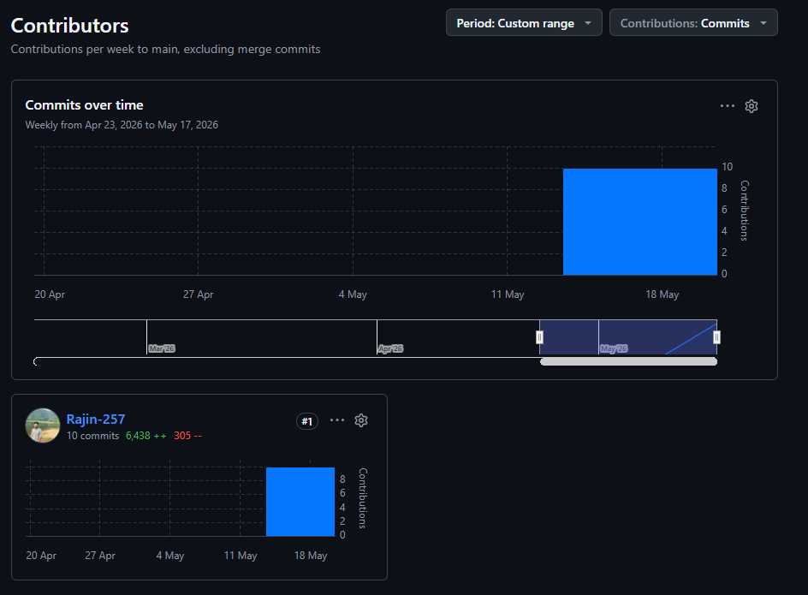

Ak Hasan Mahamudul Haque [23-50297-1] 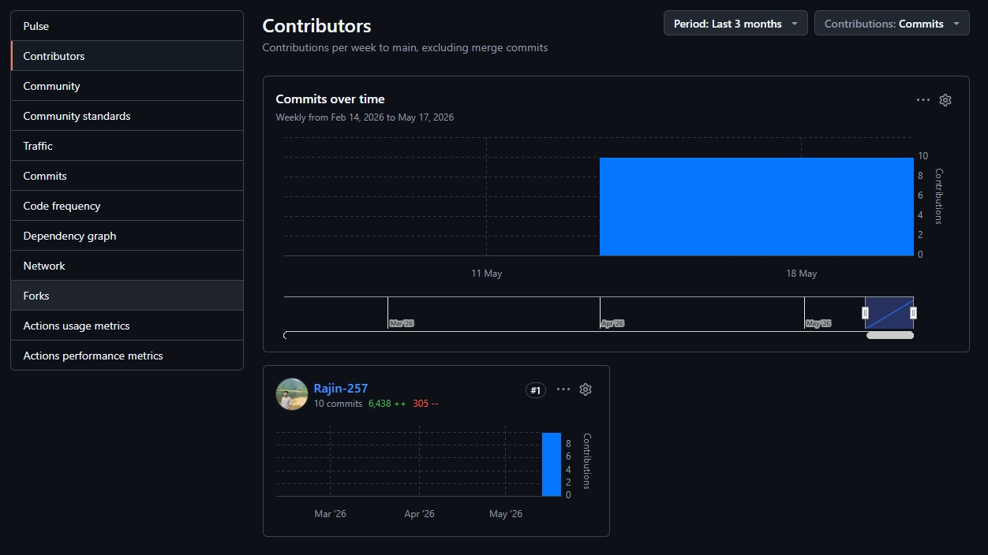

Md Ashiqur Rahman [23-54596-1]

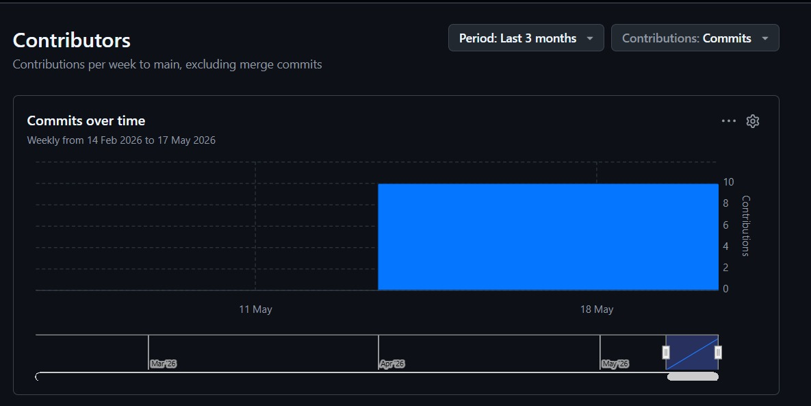

Chapter 3: Features, Source Code & Screenshots

Md Abu Rajin [23-50257-1]

Feature : Authentication

Description
Authentication checks who you are when you use the site. It stores your account safely (hashed password) and keeps you logged in with a session. Each user has a role: customer or admin.

- Register -- new customers sign up with name, email, password (and optional address/phone).
- Login -- enter email and password; optional “remember me” stays logged in.
- Profile -- logged-in users can view and update their details.
- Logout -- ends the session and leaves the account.

Why needs it:
- Security -- only the right person can see their cart, orders, and profile.
- Personal Data -- orders and addresses are tied to a real user account.
- Admin Control -- only admins can add/edit medicines and approve or reject orders.

Relevant Source Code For Registration Page

File: [/controller/Home.php]
function register()
{
if (session_status() === PHP_SESSION_NONE) session_start();

$errors = [];
$success = '';
$old = [];

if ($_SERVER['REQUEST_METHOD'] === 'POST') {
csrf_require();
$name= trim($_POST['name']?? '');
$email= trim($_POST['email']?? '');
$password= $_POST['password']?? '';
$address= trim($_POST['address']?? '');
$phone= trim($_POST['phone']?? '');
$role= $_POST['role']?? '';

$old=compact('name', 'email', 'address', 'phone', 'role');

//server-side validation
if ($name === '')
{
$errors[] = 'Name is required.';
}
if ($email === '' || !filter_var($email, FILTER_VALIDATE_EMAIL))
{
$errors[] = 'A valid email is required.';
}
if (strlen($password) < 8)
{
$errors[] = 'Password must be at least 8 characters.';
}
if (!in_array($role, ['admin', 'customer']))
{
$errors[] = 'Please select a valid role.';
}
if (empty($errors)) {
$result = user_create([
'name'=> $name,
'email'=> $email,
'password'=> $password,
'address'=> $address,
'phone'=> $phone,
'role'=> $role,
]);

if ($result === true) {
header('Location: index.php?page=login&registered=1');
exit();
} elseif ($result === 'email_taken') {
$errors[] = 'That email address is already registered.';
} else {
$errors[] = 'Something went wrong. Please try again.';
}
}
}

$title = 'Register — Medicine Shop';
$view = __DIR__ . '/../views/auth/registration.php';
$layout = __DIR__ . '/../views/layout.php';
include $layout;
}

Code Explanation
This function handles new user sign-up.
- Starts a session and prepares empty error/success messages.
- On form submit (POST):
  - Checks CSRF token for safety.
  - Reads name, email, password, address, phone, and role from the form.
  - Validates on the server: name required, valid email, password at least 8 characters, role must be admin or customer.
- If validation passes, it calls user_create() to save the user (password is hashed in the model).
  - Success → redirect to login with ?registered=1.
  - Email already used → show error.
  - Other failure → generic error message.
- If not POST or there are errors, it loads the registration view inside the main layout so the user can see the form again (with old input and error messages).

Ui Screenshot
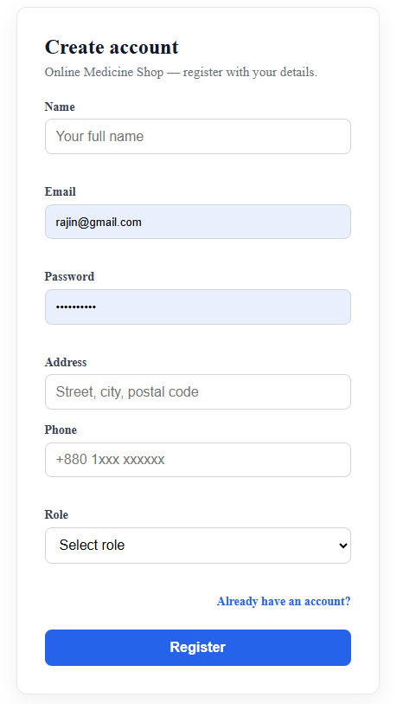

Client Side Validation in Regestration Page: (views/auth/registration.php)

(function () {
var form = document.getElementById('reg-form');
if (!form) return;

function setError(id, msg) {
var el = document.getElementById(id);
if (el) el.textContent = msg;
}
function clearErrors() {
['err-name','err-email','err-password','err-phone','err-role'].forEach(function(id){
setError(id, '');
});
}

form.addEventListener('submit', function (e) {
clearErrors();
var valid = true;

var name = document.getElementById('name').value.trim();
if (name === '') {
setError('err-name', 'Name is required.');
valid = false;
}

var email = document.getElementById('email').value.trim();
var emailRe = /^[^\s@]+@[^\s@]+\.[^\s@]+$/;
if (!emailRe.test(email)) {
setError('err-email', 'Enter a valid email address.');
valid = false;
}

var pw = document.getElementById('password').value;
if (pw.length < 8) {
setError('err-password', 'Password must be at least 8 characters.');
valid = false;
}

var phone = document.getElementById('phone').value.trim();
if (phone !== '' && !/^[+]?[\d\s\-()]{7,20}$/.test(phone)) {
setError('err-phone', 'Enter a valid phone number.');
valid = false;
}

var role = document.getElementById('role').value;
if (!role) {
setError('err-role', 'Please select a role.');
valid = false;
}

if (!valid) e.preventDefault();
});
})();

This script adds client-side validation on the registration form before submit.
On submit it clears old errors, then checks: name (required), email (valid format), password (at least 8 characters), phone (optional, but must match a valid pattern if filled), and role (must be selected). Errors show next to each field; if anything fails, it uses preventDefault() so the form is not sent until fixed.

Relevant Source Code For Login Page:1

File: [/controller/Home.php]
function login()
{
if (session_status() === PHP_SESSION_NONE) session_start();

// already logged in?
if (!empty($_SESSION['user_id'])) {
_redirect_after_login($_SESSION['role']);
}

$errors= [];
$success= '';

if (isset($_GET['registered'])) {
$success = 'Account created! Please sign in.';
}

if ($_SERVER['REQUEST_METHOD'] === 'POST') {
csrf_require();
$email = trim($_POST['email']?? '');
$password = $_POST['password']?? '';
$remember = !empty($_POST['remember']);

//server-side validation
if ($email === '' || !filter_var($email, FILTER_VALIDATE_EMAIL))
{
$errors[] = 'Please enter a valid email address.';
}
if ($password === '')
{
$errors[] = 'Password is required.';
}

if (empty($errors)) {
$user = user_login($email, $password);

if ($user === false) {
$errors[] = 'Invalid email or password.';
} else {
// populate session
session_regenerate_id(true);
csrf_regenerate();
$_SESSION['user_id'] = $user['id'];
$_SESSION['name'] = $user['name'];
$_SESSION['role'] = $user['role'];
$_SESSION['email']= $user['email'];

// remember-me cookie (30 days)
if ($remember) {
$token = bin2hex(random_bytes(32));
user_save_token((int)$user['id'], $token);
setcookie('remember_token',$token, time() + 30 * 24 * 3600,'/','',false,true
);
}

_redirect_after_login($user['role']);
}
}
}

$title = 'Sign in — Medicine Shop';
$view = __DIR__ . '/../views/auth/login.php';
$layout = __DIR__ . '/../views/layout.php';
include $layout;
}

function _redirect_after_login(string $role)
{
if ($role === 'admin')
{
header('Location: index.php?page=admin/dashboard');
}
else
{
header('Location: index.php');
}
}

This function handles user sign-in.
- Starts a session. If the user is already logged in, it redirects them (home or admin dashboard by role).
- Shows a success message if they just registered (?registered=1).
- On form submit (POST):
  - Checks CSRF token.
  - Reads email, password, and optional “remember me”.
  - Validates: valid email and password not empty.
- If validation passes, it calls user_login() to check email and password against the database.
  - Wrong credentials → error: “Invalid email or password.”
  - Correct → refreshes session ID and CSRF token, stores user_id, name, role, and email in $_SESSION.
  - Remember me → saves a token in the DB and sets a 30-day secure cookie.
  - Then redirects by role (customer → shop, admin → dashboard).
- Otherwise it shows the login page in the main layout (with errors if any).

And Client Side Validation Js Code (views/auth/login.php)

(function () {
var form = document.getElementById('login-form');
if (!form) return;

function setError(id, msg) {
var el = document.getElementById(id);
if (el) el.textContent = msg;
}

form.addEventListener('submit', function (e) {
setError('err-email', '');
setError('err-password', '');
var valid = true;

var email = document.getElementById('email').value.trim();
var emailRe = /^[^\s@]+@[^\s@]+\.[^\s@]+$/;
if (!emailRe.test(email)) {
setError('err-email', 'Enter a valid email address.');
valid = false;
}

var pw = document.getElementById('password').value;
if (pw === '') {
setError('err-password', 'Password is required.');
valid = false;
}

if (!valid) e.preventDefault();
});
})();

This script adds client-side validation on the login form before it is sent to the server.
When the user clicks submit, it clears old error messages, then checks the email (must look like a valid email) and password (cannot be empty). If something is wrong, it shows messages in err-email and err-password and stops the form with preventDefault() so the page does not reload until the fields are fixed.

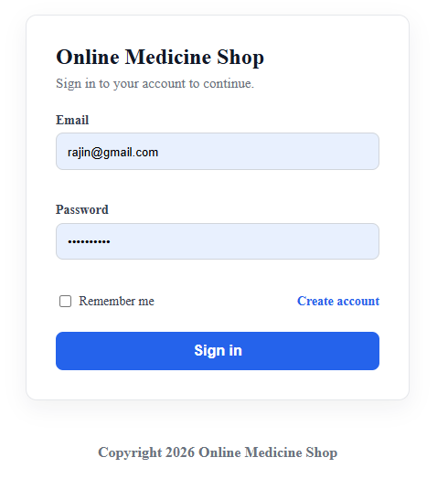

Relevant Source Code For Cookies And Session’s
File: [/controller/Home.php]
function require_login()
{
if (session_status() === PHP_SESSION_NONE) session_start();
if (empty($_SESSION['user_id'])) {
header('Location: index.php?page=login');
exit();
}
}

function require_customer()
{
require_login();
if (($_SESSION['role'] ?? '') !== 'customer') {
header('Location: index.php?page=login');
exit();
}
}

/* auto-login via remember-me cookie */

function try_remember_me()
{
if (session_status() === PHP_SESSION_NONE) session_start();
if (!empty($_SESSION['user_id'])) return;

$token = $_COOKIE['remember_token'] ?? '';
if ($token === '') return;

$user = user_find_by_token($token);
if (!$user) return;

$_SESSION['user_id'] = $user['id'];
$_SESSION['name'] = $user['name'];
$_SESSION['role'] = $user['role'];
$_SESSION['email'] = $user['email'];
}

require_login()
- Starts the session if needed.
- If no user is logged in ($_SESSION['user_id'] is empty), redirects to the login page and stops the script.
- Used on pages that need any logged-in user (e.g. profile).

require_customer()
- Calls require_login() first.
- Then checks the role is customer.
- If not (e.g. admin or guest), redirects to login.
- Used on cart, checkout, and orders so only customers use those features.

try_remember_me()
- Runs when the user is not already in a session.
- Reads the remember_token cookie.
- Looks up the user in the database with user_find_by_token().
- If valid, fills the session (user_id, name, role, email) so they stay logged in without typing password again.

Relevant Source Code For Logout
File: [/controller/Home.php]

function logout()
{
if (session_status() === PHP_SESSION_NONE) session_start();

// clear remember-me
if (!empty($_SESSION['user_id'])) {
{
user_clear_token((int)$_SESSION['user_id']);
}
}

setcookie('remember_token', '', time() - 3600, '/');
$_SESSION = [];
if (ini_get('session.use_cookies')) {
{
$p = session_get_cookie_params();
setcookie(session_name(), '', time() - 42000,
$p['path'], $p['domain'], $p['secure'], $p['httponly']);
}
session_destroy();
if (session_status() === PHP_SESSION_NONE) {
session_start();
}
csrf_regenerate();
header('Location: index.php?page=login');
}
}

This function signs the user out safely.
- Starts the session if it is not already active.
- Clears “remember me” — removes the token from the database (user_clear_token) for the logged-in user.
- Deletes the remember-me cookie by setting it to expire in the past.
- Clears session data — empties $_SESSION.
- Ends the session — deletes the PHP session cookie (when cookies are enabled), calls session_destroy(), starts a fresh session, and regenerates the CSRF token.
- Redirects to the login page.

Feature : Profile

Relevant Controller Source Code For Profile
File: [/controller/Home.php]
function profile()
{
require_login();

$errors = [];
$success = '';
$userId = (int)$_SESSION['user_id'];
$user = user_find_by_id($userId);

if (!$user) {
logout();
}

if ($_SERVER['REQUEST_METHOD'] === 'POST') {
csrf_require();
$action = $_POST['action'] ?? 'update_profile';

/* update basic info */
if ($action === 'update_profile') {
$name = trim($_POST['name'] ?? '');
$email = trim($_POST['email'] ?? '');
$address = trim($_POST['address'] ?? '');
$phone = trim($_POST['phone'] ?? '');

if ($name === '')
$errors[] = 'Name is required.';
if ($email === '' || !filter_var($email, FILTER_VALIDATE_EMAIL))
$errors[] = 'A valid email is required.';

// handle profile picture upload
$picturePath = $user['profile_picture'];
if (!empty($_FILES['profile_picture']['name'])) {
$file = $_FILES['profile_picture'];
$allowed = ['image/jpeg', 'image/png', 'image/gif', 'image/webp'];
if (!in_array($file['type'], $allowed)) {
$errors[] = 'Profile picture must be a JPEG, PNG, GIF, or WEBP image.';
} elseif ($file['size'] > 2 * 1024 * 1024) {
$errors[] = 'Profile picture must be smaller than 2 MB.';
} else {
$uploadDir = __DIR__ . '/../public/uploads/';
if (!is_dir($uploadDir)) mkdir($uploadDir, 0755, true);

$ext = pathinfo($file['name'], PATHINFO_EXTENSION);
$filename = 'user_' . $userId . '_' . time() . '.' . $ext;
$destination = $uploadDir . $filename;

if (move_uploaded_file($file['tmp_name'], $destination)) {
$picturePath = 'public/uploads/' . $filename;
} else {
$errors[] = 'Failed to upload picture. Please try again.';
}
}
}

if (empty($errors)) {
$updated = user_update_profile($userId, [
'name' => $name,
'email' => $email,
'address'=> $address,
'phone' => $phone,
]);

if ($updated === false) {
$errors[] = 'That email address is already used by another account.';
} else {
// save picture separately if changed
if ($picturePath !== $user['profile_picture']) {
user_update_picture($userId, $picturePath);
$user['profile_picture'] = $picturePath;
}
// refresh session
$_SESSION['name'] = $name;
$_SESSION['email']= $email;
$user['name'] = $name;
$user['email'] = $email;
$user['address']= $address;
$user['phone'] = $phone;
$success = 'Profile updated successfully.';
}
}
}

/* change password */
if ($action === 'change_password') {
$current= $_POST['current_password'] ?? '';
$newPass = $_POST['new_password'] ?? '';
$confirm = $_POST['confirm_password'] ?? '';

if ($current === '')
$errors[] = 'Current password is required.';
if (strlen($newPass) < 8)
$errors[] = 'New password must be at least 8 characters.';
if ($newPass !== $confirm)
$errors[] = 'New passwords do not match.';

if (empty($errors)) {
$result = user_change_password($userId, $current, $newPass);
if ($result === 'wrong_password') {
$errors[] = 'Current password is incorrect.';
} elseif ($result !== 'ok') {
$errors[] = 'Something went wrong. Please try again.';
} else {
$success = 'Password changed successfully.';
}
}
}

// re-fetch user after updates
$user = user_find_by_id($userId);
}

$title= 'My Profile — Medicine Shop';
$view = __DIR__ . '/../views/auth/profile.php';
$layout = __DIR__ . '/../views/layout.php';
include $layout;
}

This function handles the logged-in user’s profile page.
- Requires login — guests are sent to the login page.
- Loads user data from the database by user_id. If the user no longer exists, it calls logout().
- On form submit (POST) with CSRF check, it handles two actions:

update_profile
  - Updates name, email, address, and phone.
  - Validates name and email.
  - Optional profile picture upload (JPEG/PNG/GIF/WEBP, max 2 MB) → saved under public/uploads/.
  - Saves via user_update_profile() and user_update_picture() if needed.
  - Refreshes session name/email and shows success or errors (e.g. email already taken).
change_password
  - Needs current password, new password (min 8 chars), and confirmation.
  - Uses user_change_password() — checks current password, then updates the hash.
- After updates, reloads user data from the database.
- Shows the profile view inside the main layout (form, picture, messages).

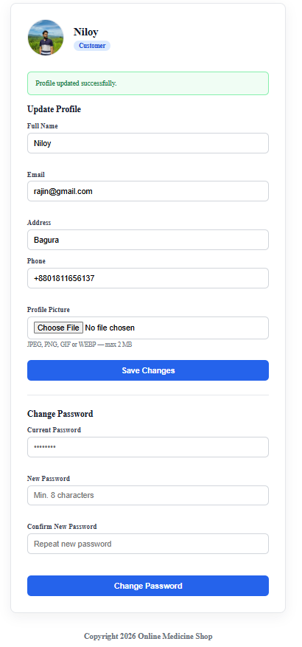

Client Side Validation for profile (views/auth/profile.php)

(function () {

/* ── profile info form ── */

var profileForm = document.getElementById('profile-form');

if (profileForm) {

profileForm.addEventListener('submit', function (e) {

var valid = true;

function setError(id, msg) {

var el = document.getElementById(id);

if (el) el.textContent = msg;

}

['err-name','err-email','err-phone'].forEach(function(id){ setError(id,''); });

var name = document.getElementById('name').value.trim();

if (name === '') { setError('err-name', 'Name is required.'); valid = false; }

var email = document.getElementById('email').value.trim();

if (!/^[^\s@]+@[^\s@]+\.[^\s@]+$/.test(email)) {

setError('err-email', 'Enter a valid email address.');

valid = false;

}

var phone = document.getElementById('phone').value.trim();

if (phone !== '' && !/^[+]?[\d\s\-()]{7,20}$/.test(phone)) {

setError('err-phone', 'Enter a valid phone number.');

valid = false;

}

if (!valid) e.preventDefault();

});

}

/* ── change password form ── */

var passwordForm = document.getElementById('password-form');

if (passwordForm) {

passwordForm.addEventListener('submit', function (e) {

var valid = true;

function setError(id, msg) {

var el = document.getElementById(id);

if (el) el.textContent = msg;

}

['err-current','err-newpw','err-confirm'].forEach(function(id){ setError(id,''); });

var cur = document.getElementById('current_password').value;

if (cur === '') { setError('err-current', 'Current password is required.'); valid = false; }

var nw = document.getElementById('new_password').value;

if (nw.length < 8) { setError('err-newpw', 'New password must be at least 8 characters.'); valid = false; }

var cf = document.getElementById('confirm_password').value;

if (nw !== cf) { setError('err-confirm', 'Passwords do not match.'); valid = false; }

if (!valid) e.preventDefault();

});

}

})();

This script adds client-side validation for two forms on the profile page.

Profile form (profile-form): On submit, it checks name (required), email (valid format), and phone (optional, but must be valid if filled). Errors show in err-name, err-email, and err-phone. If anything fails, submit is blocked.

Password form (password-form): On submit, it checks current password (required), new password (at least 8 characters), and confirm password (must match new password). Errors show in err-current, err-newpw, and err-confirm.

User Model

This is the Model for users. It talks to the users table in MySQL and handles all account data. Controllers like home.php call these functions.
File: [/models/Users.php]

<?php

require_once __DIR__ . '/../config/db.php';

/* CREATE */

function user_create(array $data)

{

$conn = getConnection();

// unique-email check

$chk = mysqli_prepare($conn, 'SELECT id FROM users WHERE email = ?');

mysqli_stmt_bind_param($chk, 's', $data['email']);

mysqli_stmt_execute($chk);

mysqli_stmt_store_result($chk);

if (mysqli_stmt_num_rows($chk) > 0) {

mysqli_stmt_close($chk);

mysqli_close($conn);

return 'email_taken';

}

mysqli_stmt_close($chk);

$name = trim($data['name']);

$email= trim($data['email']);

$hash = password_hash($data['password'], PASSWORD_DEFAULT);

$role = in_array($data['role'], ['admin', 'customer']) ? $data['role'] : 'customer';

$address = trim($data['address'] ?? '');

$phone = trim($data['phone'] ?? '');

$stmt = mysqli_prepare(

$conn,

'INSERT INTO users (name, email, password_hash, role, address, phone) VALUES (?, ?, ?, ?, ?, ?)'

);

mysqli_stmt_bind_param($stmt, 'ssssss', $name, $email, $hash, $role, $address, $phone);

$ok = mysqli_stmt_execute($stmt);

mysqli_stmt_close($stmt);

mysqli_close($conn);

return $ok ? true : 'db_error';

}

/* FIND */

function user_find_by_email(string $email)

{

$conn = getConnection();

$stmt = mysqli_prepare($conn, 'SELECT * FROM users WHERE email = ? LIMIT 1');

mysqli_stmt_bind_param($stmt, 's', $email);

mysqli_stmt_execute($stmt);

$result = mysqli_stmt_get_result($stmt);

$user = mysqli_fetch_assoc($result);

mysqli_stmt_close($stmt);

mysqli_close($conn);

return $user ?: false;

}

function user_find_by_id(int $id)

{

$conn = getConnection();

$stmt = mysqli_prepare($conn, 'SELECT * FROM users WHERE id = ? LIMIT 1');

mysqli_stmt_bind_param($stmt, 'i', $id);

mysqli_stmt_execute($stmt);

$result = mysqli_stmt_get_result($stmt);

$user = mysqli_fetch_assoc($result);

mysqli_stmt_close($stmt);

mysqli_close($conn);

return $user ?: false;

}

/* LOGIN */

function user_login(string $email, string $password)

{

$user = user_find_by_email($email);

if (!$user) return false;

if (!password_verify($password, $user['password_hash'])) return false;

unset($user['password_hash']);

return $user;

}

/* REMEMBER-ME TOKEN */

function user_save_token(int $userId, string $token)

{

$conn = getConnection();

$hash = hash('sha256', $token);

$stmt = mysqli_prepare($conn, 'UPDATE users SET remember_token = ? WHERE id = ?');

if ($stmt) {

mysqli_stmt_bind_param($stmt, 'si', $hash, $userId);

mysqli_stmt_execute($stmt);

mysqli_stmt_close($stmt);

}

mysqli_close($conn);

}

function user_find_by_token(string $token)

{

$conn = getConnection();

$hash = hash('sha256', $token);

$stmt = mysqli_prepare($conn, 'SELECT * FROM users WHERE remember_token = ? LIMIT 1');

if (!$stmt) { mysqli_close($conn); return false; }

mysqli_stmt_bind_param($stmt, 's', $hash);

mysqli_stmt_execute($stmt);

$result = mysqli_stmt_get_result($stmt);

$user = mysqli_fetch_assoc($result);

mysqli_stmt_close($stmt);

mysqli_close($conn);

return $user ?: false;

}

function user_clear_token(int $userId)

{

$conn = getConnection();

$null = null;

$stmt = mysqli_prepare($conn, 'UPDATE users SET remember_token = NULL WHERE id = ?');

if ($stmt) {

mysqli_stmt_bind_param($stmt, 'i', $userId);

mysqli_stmt_execute($stmt);

mysqli_stmt_close($stmt);

}

mysqli_close($conn);

}

/* UPDATE PROFILE */

function user_update_profile(int $id, array $data)

{

$conn = getConnection();

$name = trim($data['name']);

$email = trim($data['email']);

$address = trim($data['address'] ?? '');

$phone = trim($data['phone'] ?? '');

$chk = mysqli_prepare($conn, 'SELECT id FROM users WHERE email = ? AND id != ?');

mysqli_stmt_bind_param($chk, 'si', $email, $id);

mysqli_stmt_execute($chk);

mysqli_stmt_store_result($chk);

if (mysqli_stmt_num_rows($chk) > 0) {

mysqli_stmt_close($chk);

mysqli_close($conn);

return false;

}

mysqli_stmt_close($chk);

$stmt = mysqli_prepare(

$conn,

'UPDATE users SET name = ?, email = ?, address = ?, phone = ? WHERE id = ?'

);

mysqli_stmt_bind_param($stmt, 'ssssi', $name, $email, $address, $phone, $id);

$ok = mysqli_stmt_execute($stmt);

mysqli_stmt_close($stmt);

mysqli_close($conn);

return $ok;

}

function user_update_picture(int $id, string $picturePath)

{

$conn = getConnection();

$stmt = mysqli_prepare($conn, 'UPDATE users SET profile_picture = ? WHERE id = ?');

mysqli_stmt_bind_param($stmt, 'si', $picturePath, $id);

$ok = mysqli_stmt_execute($stmt);

mysqli_stmt_close($stmt);

mysqli_close($conn);

return $ok;

}

function user_change_password(int $id, string $currentPassword, string $newPassword)

{

$user = user_find_by_id($id);

if (!$user) return 'not_found';

if (!password_verify($currentPassword, $user['password_hash'])) return 'wrong_password';

$conn = getConnection();

$hash = password_hash($newPassword, PASSWORD_DEFAULT);

$stmt = mysqli_prepare($conn, 'UPDATE users SET password_hash = ? WHERE id = ?');

mysqli_stmt_bind_param($stmt, 'si', $hash, $id);

$ok = mysqli_stmt_execute($stmt);

mysqli_stmt_close($stmt);

mysqli_close($conn);

return $ok ? 'ok' : 'db_error';

}

/* ALL / DELETE (admin) */

function user_all()

{

$conn = getConnection();

$result = mysqli_query($conn, 'SELECT id, name, email, role, created_at FROM users ORDER BY created_at DESC');

$rows = mysqli_fetch_all($result, MYSQLI_ASSOC);

mysqli_close($conn);

return $rows;

}

function user_delete(int $id)

{

$conn = getConnection();

$stmt = mysqli_prepare($conn, 'DELETE FROM users WHERE id = ?');

mysqli_stmt_bind_param($stmt, 'i', $id);

$ok = mysqli_stmt_execute($stmt);

mysqli_stmt_close($stmt);

mysqli_close($conn);

return $ok;

}

User.php is the Model for user accounts. It connects to the database and handles all user data. Controllers call these functions;

Create and find: user_create() registers a new user, checks that the email is unique, hashes the password, and saves name, email, role, address, and phone. user_find_by_email() and user_find_by_id() load one user by email or ID for login and profile.

Login: user_login() checks email and password with password_verify(). It returns user data without the password hash, or false if login fails.

Remember me: user_save_token(), user_find_by_token(), and user_clear_token() store, find, and remove a hashed remember-me token so users can stay logged in or log out safely.

Profile: user_update_profile() updates name, email, address, and phone. user_update_picture() saves the profile image path. user_change_password() checks the current password and saves a new hashed password.

Admin: user_all() lists all users. user_delete() removes a user by ID.

The file uses prepared statements and password hashing to keep user data safe.

Navbar shows links based on role:

<?php

if (session_status() === PHP_SESSION_NONE) {

session_start();

}

$cartCount = 0;

if (!empty($_SESSION['user_id']) && ($_SESSION['role'] ?? '') === 'customer') {

require_once __DIR__ . '/../../config/app.php';

require_once __DIR__ . '/../../model/CartModel.php';

$cartCount = (new CartModel())->getCartCount((int) $_SESSION['user_id']);

}

?>

<nav class="navbar" aria-label="Main navigation">

<div class="navbar__inner">

<a href="index.php" class="navbar__brand">

<span class="navbar__brand-text">Medicine Shop</span>

</a>

<div class="navbar__actions">

<a class="navbar__btn navbar__btn--ghost" href="index.php">Home</a>

<?php if (!empty($_SESSION['user_id'])): ?>

<?php if (($_SESSION['role'] ?? '') === 'admin'): ?>

<a class="navbar__btn navbar__btn--ghost"

href="index.php?page=admin/dashboard">Admin Panel</a>

<?php endif; ?>

<?php if (($_SESSION['role'] ?? '') === 'customer'): ?>

<a class="navbar__btn navbar__btn--ghost"

href="index.php?page=my_orders">My Orders</a>

<a class="navbar__btn navbar__btn--ghost navbar__cart"

href="index.php?page=cart">

Cart<?php if ($cartCount > 0): ?>

<span class="cart-badge"><?= $cartCount ?></span>

<?php endif; ?>

</a>

<?php endif; ?>

<a class="navbar__btn navbar__btn--ghost"

href="index.php?page=profile">

<?= e($_SESSION['name'] ?? '') ?>

</a>

<a class="navbar__btn navbar__btn--primary"

href="index.php?page=logout">Logout</a>

<?php else: ?>

<a class="navbar__btn navbar__btn--ghost"

href="index.php?page=login">Login</a>

<a class="navbar__btn navbar__btn--primary"

href="index.php?page=register">Register</a>

<?php endif; ?>

</div>

</div>

</nav>

This partial is the top navigation bar used on public pages

It starts the session and, for logged-in customers, loads the cart item count from CartModel to show a badge on the Cart link.

Links change by login state:

Guest: Home, Login, Register

Logged in: Profile (user name), Logout

Admin: also Admin Panel

Customer: also My Orders and Cart (with count badge)

User names are escaped with e() for safe output.

Customer Navbar

Admin Navbar

Feature : Home Page

function home()

{

if (session_status() === PHP_SESSION_NONE){

session_start();

}

try_remember_me();

$title = 'Home — Medicine Shop';

$view = __DIR__ . '/../views/home.php';

$layout = __DIR__ . '/../views/layout.php';

include $layout;

}

This function shows the main home page of the medicine shop.

It starts the session, runs try_remember_me() so users with a remember-me cookie can stay logged in, then loads views/home.php inside the main layout (layout.php) with the page title “Home Medicine Shop”

Live Medicines search and filtering using ajax (Views/home.php)

var IS_CUSTOMER = <?php echo json_encode(!empty($_SESSION['user_id']) && ($_SESSION['role'] ?? '') === 'customer'); ?>;

(function () {

/* elements */

var qInput = document.getElementById('search-q');

var selVendor = document.getElementById('filter-vendor');

var selGenre = document.getElementById('filter-genre');

var selType = document.getElementById('filter-type');

var grid = document.getElementById('medicine-grid');

var spinner = document.getElementById('search-spinner');

var countEl = document.getElementById('results-count');

var btnClear = document.getElementById('btn-clear-search');

var debounceTimer = null;

var currentXhr = null;

function setSpinner(loading) {

if (!spinner) return;

spinner.hidden = !loading;

spinner.classList.toggle('is-loading', loading);

}

setSpinner(false);

/* card template */

function renderCard(m) {

var inStock = m.availability > 0;

var img = m.image_path

? '<img src="' + escUrl(m.image_path) + '" alt="' + escHtml(m.name) + '" class="med-card__img" loading="lazy">'

: '<div class="med-card__img-placeholder"><svg viewBox="0 0 48 48" fill="none" width="40" height="40"><rect x="8" y="14" width="32" height="22" rx="3" stroke="#d1d5db" stroke-width="2"/><path d="M24 20v10M19 25h10" stroke="#9ca3af" stroke-width="2" stroke-linecap="round"/></svg></div>';

var catType = escCssClass(m.category_type, ['liquid', 'solid']);

var typeBadge = catType

? '<span class="med-badge med-badge--' + catType + '">' + escHtml(m.category_type) + '</span>'

: '';

var stockBadge = inStock

? '<span class="med-badge med-badge--stock">In stock (' + m.availability + ')</span>'

: '<span class="med-badge med-badge--out">Out of stock</span>';

return '<div class="med-card">' +

'<div class="med-card__media">' + img + '</div>' +

'<div class="med-card__body">' +

'<div class="med-card__badges">' + typeBadge + stockBadge + '</div>' +

'<h3 class="med-card__name">' + escHtml(m.name) + '</h3>' +

'<p class="med-card__vendor">' + escHtml(m.vendor_name) + '</p>' +

'<div class="med-card__footer">' +

'<span class="med-card__price">৳ ' + Number(m.price).toFixed(2) + '</span>' +

cartActionHtml(m, inStock) +

'</div>' +

'</div>' +

'</div>';

}

function cartActionHtml(m, inStock) {

if (!inStock) {

return '<button class="btn btn--ghost btn--sm" disabled>Unavailable</button>';

}

if (IS_CUSTOMER) {

return '<div class="med-card__cart-wrap">' +

'<input type="number" class="med-card__qty" value="1" min="1" max="' + m.availability + '" aria-label="Quantity">' +

'<button type="button" class="btn btn--primary btn--sm med-card__cart" data-id="' + m.id + '" data-stock="' + m.availability + '">Add to Cart</button>' +

'</div>';

}

return '<a href="index.php?page=login" class="btn btn--primary btn--sm">Add to Cart</a>';

}

/* fetch & render */

function doSearch() {

var q = qInput.value.trim();

var vendor = selVendor.value;

var genre = selGenre.value;

var type = selType.value;

// if all empty just skip XHR and show native PHP result

var params = new URLSearchParams({ q: q, vendor: vendor, genre: genre, type: type });

if (currentXhr) { currentXhr.abort(); }

setSpinner(true);

grid.style.opacity = '0.4';

var xhr = new XMLHttpRequest();

currentXhr = xhr;

xhr.open('GET', 'api/medicines/search.php?' + params.toString());

xhr.onload = function () {

if (currentXhr !== xhr) return;

setSpinner(false);

grid.style.opacity = '1';

if (xhr.status !== 200) return;

try {

var res = JSON.parse(xhr.responseText);

if (!res.success) return;

var list = res.data;

countEl.textContent = list.length + ' medicine' + (list.length !== 1 ? 's' : '') + ' found';

if (list.length === 0) {

grid.innerHTML = '<div class="empty-state"><p>No medicines match your search.</p></div>';

} else {

grid.innerHTML = list.map(renderCard).join('');

}

} catch (e) {}

};

xhr.onerror = function () {

if (currentXhr !== xhr) return;

setSpinner(false);

grid.style.opacity = '1';

};

xhr.onabort = function () {

if (currentXhr !== xhr) return;

setSpinner(false);

grid.style.opacity = '1';

};

xhr.send();

}

function scheduleSearch() {

clearTimeout(debounceTimer);

debounceTimer = setTimeout(doSearch, 300);

}

/* bind events */

qInput.addEventListener('input', scheduleSearch);

selVendor.addEventListener('change', scheduleSearch);

selGenre.addEventListener('change', scheduleSearch);

selType.addEventListener('change', scheduleSearch);

btnClear.addEventListener('click', function () {

qInput.value = '';

selVendor.value = '';

selGenre.value = '';

selType.value = '';

doSearch();

});

})();

This script powers live medicine search and filtering on the home page without reloading the whole page.

It reads the search box and filters (vendor, category/genre, type). When the user types or changes a filter, it waits 300ms (debounce), then calls api/medicines/search.php with AJAX. A spinner shows while loading; older requests are cancelled if a new search starts.

Results are drawn as medicine cards in JavaScript. Text uses escHtml(), URLs use escUrl(), and CSS classes use escCssClass() to reduce XSS risk. Each card shows image, name, vendor, price, stock, and type badge.

Add to Cart depends on login: logged-in customers get quantity + Add to Cart button; guests get a link to login; out-of-stock items show “Unavailable”.

Clear Search resets all filters and runs search again.

In one line: AJAX search/filter for medicines with safe HTML building and role-based cart buttons.

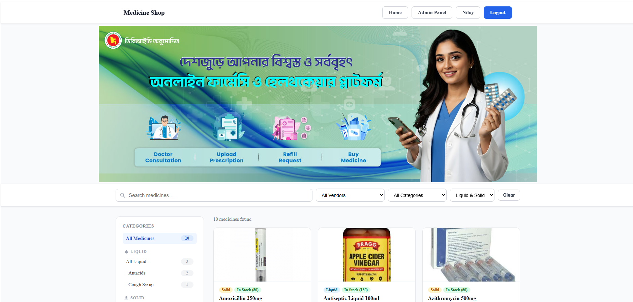

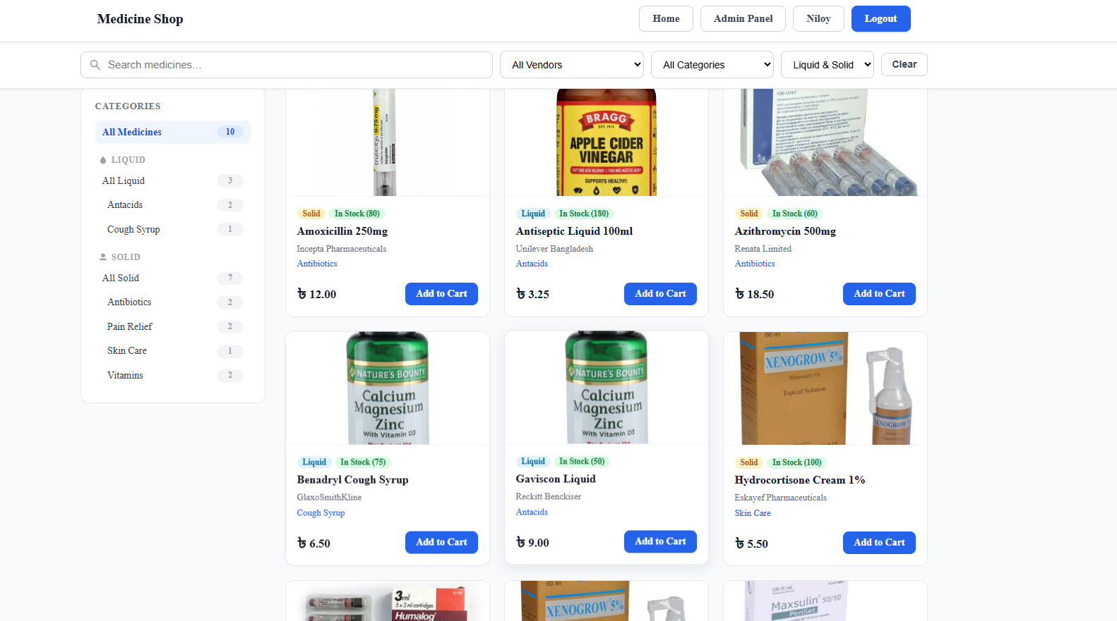

Ak Hasan Mahamudul Haque [23-50297-1]
Feature 1: Admin Gate & Dashboard
Restricts all admin pages to authenticated admin users only, and displays a summary dashboard with live counts.
Description
Every admin page checks the active PHP session to confirm the user is logged in and has the 'admin' role. If not, the user is immediately redirected to the login page. The dashboard page shows four stat cards: total medicines, categories, customers, and pending orders — all fetched live from the database.
Relevant Source Code
File: config/admin_auth.php
<?php
// No session_start() here — already called in index.php
if (!isset($_SESSION['user_id']) || $_SESSION['role'] !== 'admin') {
header('Location: index.php?page=login');
exit();
}
File: controller/adminController.php
<?php
require_once 'config/admin_auth.php';
require_once 'config/db.php';

function admin_dashboard() {
$conn = getConnection();
$medicines = mysqli_fetch_row(mysqli_query($conn, "SELECT COUNT(*) FROM medicines"))[0];
$categories = mysqli_fetch_row(mysqli_query($conn, "SELECT COUNT(*) FROM categories"))[0];
$customers = mysqli_fetch_row(mysqli_query($conn, "SELECT COUNT(*) FROM users WHERE role='customer'"))[0];
$pending = mysqli_fetch_row(mysqli_query($conn, "SELECT COUNT(*) FROM orders WHERE status='pending'"))[0];
require_once 'views/admin/dashboard.php';
}
Code Explanation
admin_auth.php: Checks $_SESSION['role'] === 'admin'. If the check fails, header() redirects to login and exit() stops any further execution, preventing unauthorised access.
admin_dashboard(): Calls getConnection() to get the mysqli link, then runs four COUNT(*) queries using mysqli_fetch_row() to retrieve single integer values. These are passed as PHP variables to the view file which renders them inside stat cards.
Screenshot(s)
Feature 2: Category Management (CRUD)
Admin can create, edit, and delete medicine categories with liquid/solid type segmentation.
Description
The admin can add new categories by entering a name and selecting a type (liquid or solid). Existing categories can be edited — the form pre-fills with current values. Deleting a category is blocked if any medicines are currently assigned to it, preventing orphaned records. Both JS and PHP validation ensure all fields are filled before any database write.
Relevant Source Code
File: controller/categoryController.php
<?php
require_once 'config/admin_auth.php';
require_once 'config/db.php';

function admin_categories() {
$conn = getConnection();
$error = ''; $success = ''; $edit_category = null;

// DELETE — block if medicines exist
if (isset($_GET['delete'])) {
$id = intval($_GET['delete']);
$check = mysqli_query($conn, "SELECT COUNT(*) FROM medicines WHERE category_id = $id");
$count = mysqli_fetch_row($check)[0];
if ($count > 0) {
$error = "Cannot delete — medicines exist under this category.";
} else {
$stmt = mysqli_prepare($conn, "DELETE FROM categories WHERE id = ?");
mysqli_stmt_bind_param($stmt, "i", $id);
mysqli_stmt_execute($stmt);
$success = "Category deleted successfully.";
}
}

// CREATE
if ($_SERVER['REQUEST_METHOD'] === 'POST' && $_POST['action'] === 'create') {
$name = trim($_POST['name']);
$type = trim($_POST['category_type']);
if (empty($name) || empty($type)) {
$error = "All fields are required.";
} else {
$stmt = mysqli_prepare($conn, "INSERT INTO categories (name, category_type) VALUES (?, ?)");
mysqli_stmt_bind_param($stmt, "ss", $name, $type);
mysqli_stmt_execute($stmt);
$success = "Category created successfully.";
}
}
// ... UPDATE and fetch logic omitted for brevity
$result = mysqli_query($conn, "SELECT * FROM categories ORDER BY created_at DESC");
$categories = mysqli_fetch_all($result, MYSQLI_ASSOC);
require_once 'views/admin/categories.php';
}
Code Explanation
intval($_GET['delete']): Casts the URL parameter to an integer, preventing SQL injection via the GET parameter. The COUNT(*) check before deletion ensures referential integrity — if any medicine references this category, the delete is blocked and an error message is shown. mysqli_prepare() + mysqli_stmt_bind_param() are used for all INSERT/UPDATE/DELETE queries to prevent SQL injection. JS validateCategoryForm() checks that both name and type fields are non-empty before form submission, giving instant feedback without a page reload.
Screenshot(s)
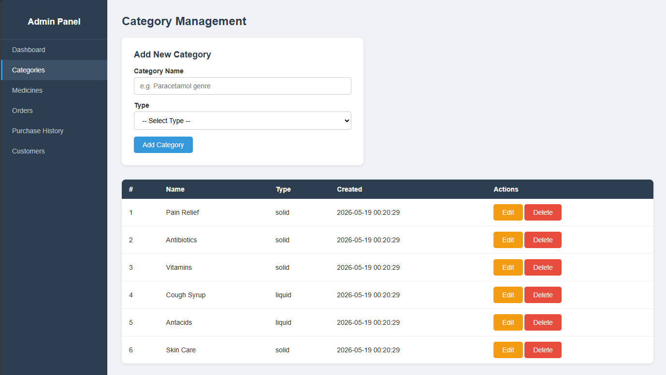

Feature 3: Medicine Management (Full CRUD + Image Upload)
Admin can add, edit, and delete medicines including image uploads with MIME-type and size validation.
Description
The admin can create medicines by filling a form with name, category, vendor, price, stock, description, and an optional image. Images are validated server-side using finfo_file() to check MIME type (JPEG/PNG only) and file size (max 2MB), then saved to public/uploads/medicines/. The edit form pre-fills all existing values. Delete is blocked if the medicine appears in any pending order. All inputs are validated with both JS (client-side) and PHP (server-side) before any DB write.
Relevant Source Code
File: controller/medicineController.php (image upload section)
// Image upload validation
if (isset($_FILES['image']) && $_FILES['image']['error'] === 0) {
$allowed_mime = ['image/jpeg', 'image/png'];
$finfo = finfo_open(FILEINFO_MIME_TYPE);
$mime = finfo_file($finfo, $_FILES['image']['tmp_name']);
finfo_close($finfo);

if (!in_array($mime, $allowed_mime)) {
$error = "Only JPEG and PNG images are allowed.";
} elseif ($_FILES['image']['size'] > 2 * 1024 * 1024) {
$error = "Image must be under 2MB.";
} else {
$upload_dir = 'public/uploads/medicines/';
if (!is_dir($upload_dir)) mkdir($upload_dir, 0777, true);
$filename = time() . '_' . basename($_FILES['image']['name']);
$image_path = $upload_dir . $filename;
move_uploaded_file($_FILES['image']['tmp_name'], $image_path);
}
}
File: controller/medicineController.php (delete block check)
// Block delete if medicine is in a pending order
$check = mysqli_query($conn, "SELECT COUNT(*) FROM order_items oi
JOIN orders o ON oi.order_id = o.id
WHERE oi.medicine_id = $id AND o.status = 'pending'");
$count = mysqli_fetch_row($check)[0];
if ($count > 0) {
$error = "Cannot delete — medicine is in a pending order.";
}
Code Explanation
finfo_open(FILEINFO_MIME_TYPE) + finfo_file(): Reads the actual binary content of the uploaded file to determine its true MIME type — this is more secure than checking the file extension, which can be faked. time() prefix on filename: Prevents filename collisions when multiple images are uploaded. The JOIN query on order_items and orders checks if the medicine is referenced in any order with status='pending' before allowing deletion, maintaining data integrity.
Screenshot(s)
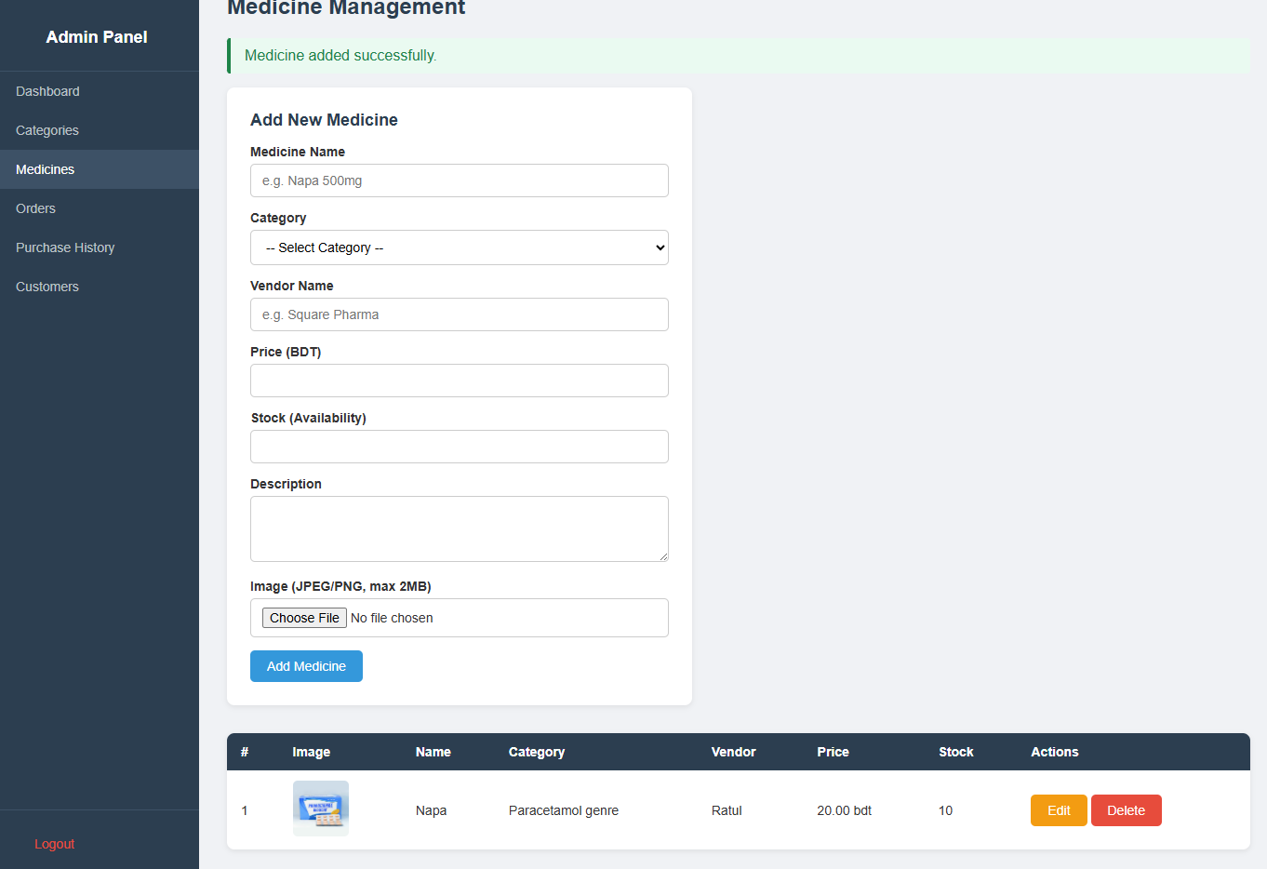
Feature 4: Order Management with AJAX Accept/Reject
Admin views all purchase requests and accepts or rejects orders in real time without page reload using AJAX.
Description
The orders page lists all orders with customer name, total amount, shipping address, payment method, date, and current status shown as a colour-coded badge (pending/accepted/rejected). For pending orders, Accept and Reject buttons trigger a JavaScript fetch() call to a PHP AJAX endpoint that updates the order status in the database and returns JSON. The JS then updates the badge and removes the buttons — no page reload required. A separate Purchase History page shows only accepted orders with full item breakdowns.
Relevant Source Code
File: controller/orderController.php (AJAX endpoint)
function admin_order_update_status() {
header('Content-Type: application/json');
require_once 'config/admin_auth.php';
require_once 'config/db.php';
$conn = getConnection();

$data = json_decode(file_get_contents('php://input'), true);
$id = intval($data['order_id'] ?? 0);
$status = $data['status'] ?? '';

$allowed = ['accepted', 'rejected'];
if ($id === 0 || !in_array($status, $allowed)) {
echo json_encode(['success' => false, 'message' => 'Invalid data.']);
exit();
}
$stmt = mysqli_prepare($conn, "UPDATE orders SET status = ? WHERE id = ?");
mysqli_stmt_bind_param($stmt, "si", $status, $id);
mysqli_stmt_execute($stmt);
echo json_encode(['success' => true, 'status' => $status]);
exit();
}
File: views/admin/orders.php (JavaScript fetch)
function updateStatus(orderId, status) {
if (!confirm('Mark this order as ' + status + '?')) return;

fetch('index.php?page=admin/orders/update-status', {
method: 'POST',
headers: { 'Content-Type': 'application/json' },
body: JSON.stringify({ order_id: orderId, status: status })
})
.then(function(res) { return res.json(); })
.then(function(data) {
if (data.success) {
var badge = document.getElementById('badge-' + orderId);
badge.textContent = data.status.charAt(0).toUpperCase() + data.status.slice(1);
badge.className = 'badge badge-' + data.status;
var row = document.getElementById('order-row-' + orderId);
row.querySelector('td:last-child').innerHTML = '<span>—</span>';
} else {
alert('Error: ' + data.message);
}
});
}
Code Explanation
header('Content-Type: application/json'): Tells the browser this response is JSON, not HTML. file_get_contents('php://input'): Reads the raw POST body sent by fetch() as JSON. in_array($status, $allowed): Whitelist validation — only 'accepted' or 'rejected' are permitted, preventing arbitrary status values from being written to the DB. On the JS side, fetch() sends a POST request with JSON body. On success, the DOM is updated directly: the badge text and class are changed, and the action buttons are removed — giving instant UI feedback.
Screenshot(s)
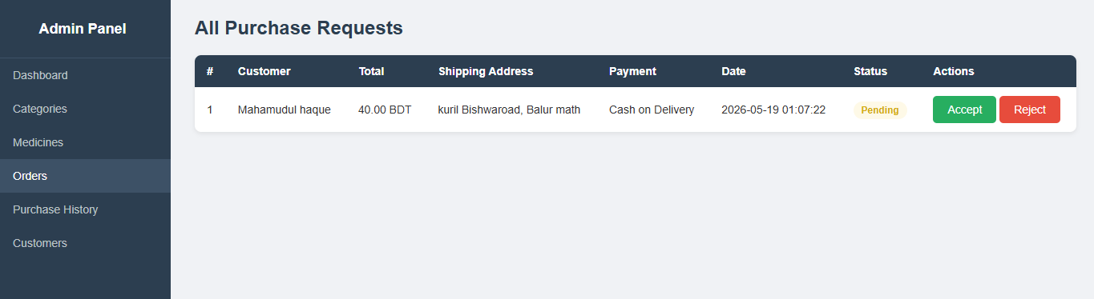
Feature 5: Customer Management
Admin can view all registered customers and delete them with cascade removal of their cart and orders.
Description
The customers page lists all users with role='customer', showing their name, email, phone, address, and registration date. The admin can delete any customer — this cascades to remove their cart entries and order records first, then deletes the user, maintaining database integrity and preventing orphaned records.
Relevant Source Code
File: controller/customerController.php
function admin_customers() {
$conn = getConnection();
$error = ''; $success = '';

if (isset($_GET['delete'])) {
$id = intval($_GET['delete']);

// Cascade: delete cart first
$stmt = mysqli_prepare($conn, "DELETE FROM cart WHERE user_id = ?");
mysqli_stmt_bind_param($stmt, "i", $id);
mysqli_stmt_execute($stmt);

// Cascade: delete orders
$stmt = mysqli_prepare($conn, "DELETE FROM orders WHERE user_id = ?");
mysqli_stmt_bind_param($stmt, "i", $id);
mysqli_stmt_execute($stmt);

// Delete user
$stmt = mysqli_prepare($conn, "DELETE FROM users WHERE id = ? AND role = 'customer'");
mysqli_stmt_bind_param($stmt, "i", $id);
mysqli_stmt_execute($stmt);

$success = "Customer deleted successfully.";
}

$result = mysqli_query($conn, "SELECT * FROM users WHERE role = 'customer' ORDER BY created_at DESC");
$customers = mysqli_fetch_all($result, MYSQLI_ASSOC);
require_once 'views/admin/customers.php';
}
Code Explanation
The deletion runs in three ordered steps: cart → orders → user. This order is important — deleting the user first would leave orphaned cart and order records with a user_id pointing to a non-existent user. AND role = 'customer' in the final DELETE adds a safety guard so admin accounts can never be accidentally deleted through this function even if an admin ID is passed in the URL. intval() on the GET parameter prevents SQL injection.
Screenshot(s)
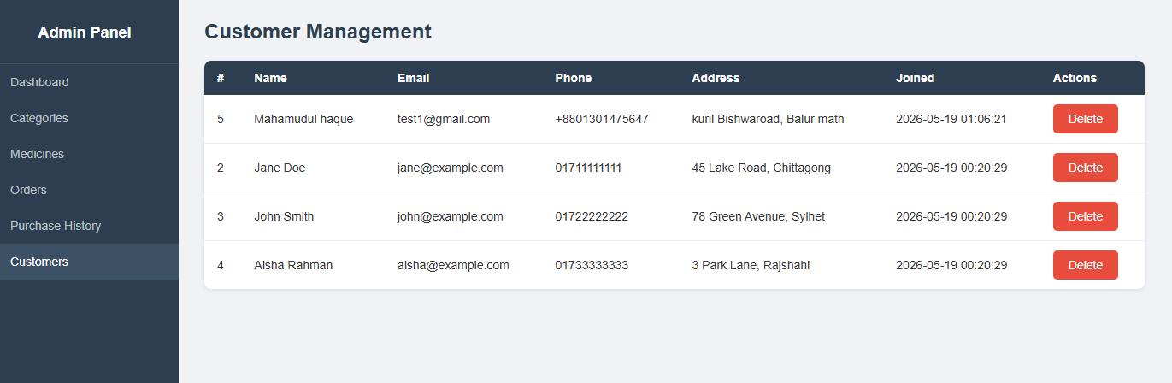
Feature 6: Purchase History
Admin views completed (accepted) orders with full item breakdowns per customer.
Description
The purchase history page shows all orders with status='accepted'. For each order, it displays the customer’s name, order date, payment method, shipping address, total amount, and a breakdown table of all medicines purchased with quantity, unit price, and subtotal per item.
Relevant Source Code
File: controller/orderController.php (purchase history)
function admin_purchase_history() {
$conn = getConnection();

$result = mysqli_query($conn,
"SELECT o.*, u.name as customer_name
FROM orders o
JOIN users u ON o.user_id = u.id
WHERE o.status = 'accepted'
ORDER BY o.order_date DESC");
$orders = mysqli_fetch_all($result, MYSQLI_ASSOC);

$order_items = [];
foreach ($orders as $order) {
$res = mysqli_query($conn,
"SELECT oi.*, m.name as medicine_name
FROM order_items oi
JOIN medicines m ON oi.medicine_id = m.id
WHERE oi.order_id = " . $order['id']);
$order_items[$order['id']] = mysqli_fetch_all($res, MYSQLI_ASSOC);
}
require_once 'views/admin/purchase_history.php';
}
Code Explanation
The main query JOINs orders with users to get the customer name alongside each order. The foreach loop runs a second query per order to fetch its items, storing them in the $order_items associative array keyed by order ID. The view then loops through $orders and uses $order_items[$order['id']] to render the item breakdown table for each order.
Screenshot(s)
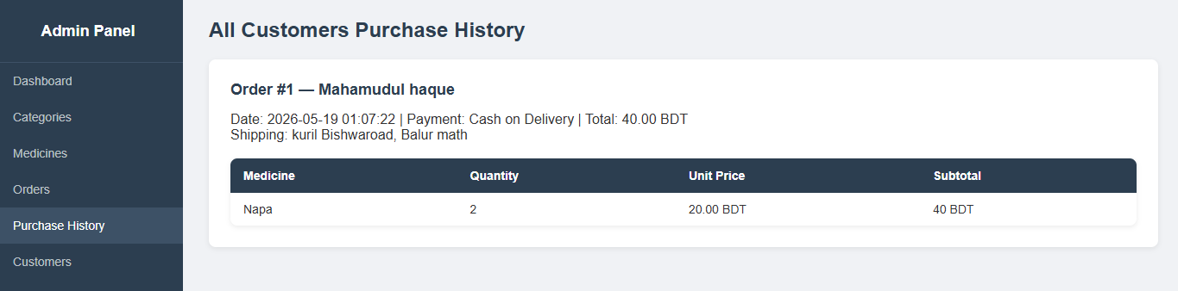

Md Ashiqur Rahman [23-54596-1]
For each feature implemented in the project, provide the following: a description, the relevant source code with explanation, and screenshot(s) of the UI.
Duplicate the feature section (Feature 1 block) as many times as needed — one block per feature.

Feature 01: [Add To Cart]
Describe what this feature does and its purpose in the application.

Description
Allows a logged-in customer to add medicines to their cart from the medicine listing page. The quantity is validated against available stock before adding. The cart icon in the navbar updates instantly without page reload using AJAX.

Relevant Source Code
Paste the key source code snippet(s) below. Add the file path and language above each block.

File: [api/cart_add.php]
(PHP):
if (empty($_SESSION['user_id'])) {
http_response_code(401);
echo json_encode(['success' => false, 'message' => 'Please login to add items to cart.']);
exit;
}

if (($_SESSION['role'] ?? '') !== 'customer') {
http_response_code(403);
echo json_encode(['success' => false, 'message' => 'Only customers can add to cart.']);
exit;
}

csrf_require();

$data = json_decode(file_get_contents('php://input'), true) ?? $_POST;
$medicineId = isset($data['medicine_id']) ? (int) $data['medicine_id'] : 0;
$quantity = isset($data['quantity']) ? (int) $data['quantity'] : 1;

if ($medicineId <= 0) {
http_response_code(400);
echo json_encode(['success' => false, 'message' => 'Invalid medicine ID.']);
exit;
}
if ($quantity < 1) {
http_response_code(400);
echo json_encode(['success' => false, 'message' => 'Quantity must be at least 1.']);
exit;
}

$cartModel = new CartModel();
$result = $cartModel->addItem((int) $_SESSION['user_id'], $medicineId, $quantity);

if (!$result['success']) {
http_response_code(400);
}
echo json_encode($result);

File: [model/CartModel.php – add Item()]

(PHP):
public function addItem(int $userId, int $medicineId, int $quantity): array
{
// Check medicine exists
$stmt = mysqli_prepare($conn, 'SELECT id, availability FROM medicines WHERE id = ?');
mysqli_stmt_bind_param($stmt, 'i', $medicineId);
mysqli_stmt_execute($stmt);
$medicine = mysqli_fetch_assoc(mysqli_stmt_get_result($stmt));

// Check if already in cart
$stmt = mysqli_prepare($conn, 'SELECT id, quantity FROM cart WHERE user_id = ? AND medicine_id = ?');
mysqli_stmt_bind_param($stmt, 'ii', $userId, $medicineId);
mysqli_stmt_execute($stmt);
$existing = mysqli_fetch_assoc(mysqli_stmt_get_result($stmt));

$newQty = $existing ? (int)$existing['quantity'] + $quantity : $quantity;

if ($newQty > (int)$medicine['availability']) {
return ['success' => false, 'message' => 'Requested quantity exceeds available stock.'];
}

if ($existing) {
$stmt = mysqli_prepare($conn, 'UPDATE cart SET quantity = ? WHERE id = ?');
mysqli_stmt_bind_param($stmt, 'ii', $newQty, $existing['id']);
} else {
$stmt = mysqli_prepare($conn, 'INSERT INTO cart (user_id, medicine_id, quantity) VALUES (?, ?, ?)');
mysqli_stmt_bind_param($stmt, 'iii', $userId, $medicineId, $quantity);
}
mysqli_stmt_execute($stmt);

return ['success' => true, 'cart_count' => $this->getCartCount($userId)];
}

Code Explanation
- Role check ensures only customers (not admins) can add to cart
- csrf_require() verifies the CSRF token — blocks forged cross-site requests
- Input is read as JSON from php://input supporting both JSON and form-encoded POST
- addItem() checks if the medicine is already in cart; if yes it updates quantity, if no it inserts — preventing duplicate rows
- Stock is validated before any DB write to prevent overselling
- Returns JSON with cart_count so the navbar badge updates without page reload

Screenshot(s) 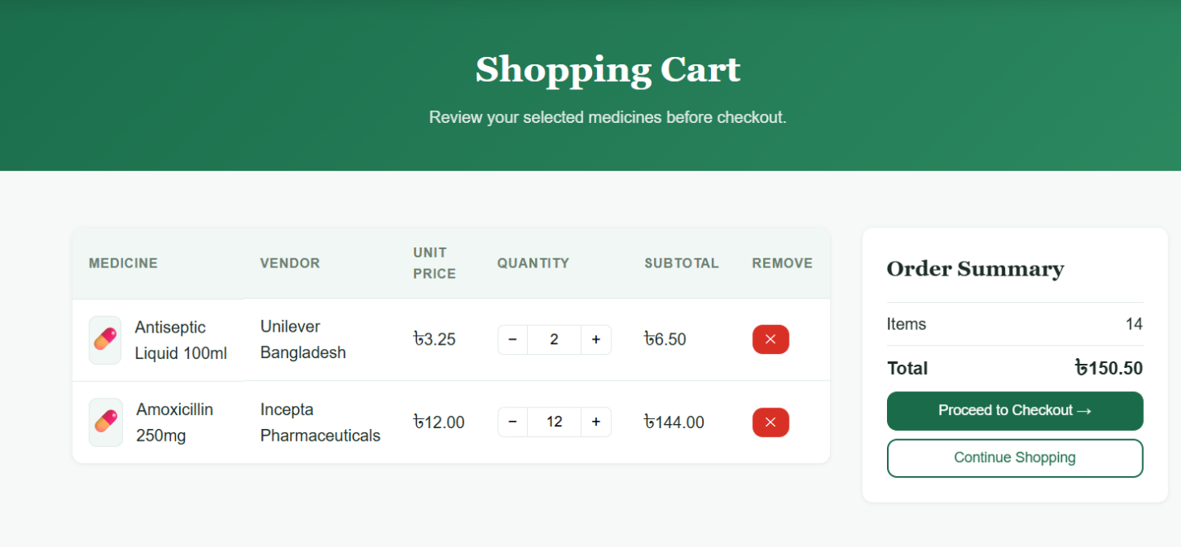

Fig 01: Add To Cart

Feature 02 : [Cart Management (increase, decrease, remove)]
Describe what this feature does and its purpose in the application.

Description
The cart page lets customers increase or decrease item quantities using +/- buttons, or remove items entirely. Every action calls an AJAX endpoint and updates the page total instantly without reload.

Relevant Source Code
Paste the key source code snippet(s) below. Add the file path and language above each block.

File: [models/CartModel.php (or models.php)]
(PHP):
function updateCartItemQty($conn, int $cartId, int $userId, int $quantity): bool {
$stmt = mysqli_prepare($conn,
"UPDATE cart SET quantity = ? WHERE id = ? AND user_id = ?");
mysqli_stmt_bind_param($stmt, 'iii', $quantity, $cartId, $userId);
$ok = mysqli_stmt_execute($stmt);
mysqli_stmt_close($stmt);
return $ok;
}

function deleteCartItem($conn, int $cartId, int $userId): bool {
$stmt = mysqli_prepare($conn,
"DELETE FROM cart WHERE id = ? AND user_id = ?");
mysqli_stmt_bind_param($stmt, 'ii', $cartId, $userId);
mysqli_stmt_execute($stmt);
$affected = mysqli_stmt_affected_rows($stmt);
mysqli_stmt_close($stmt);
return $affected > 0;
}

Code Explanation
- updateCartItemQty() uses a prepared statement to safely update quantity for a specific cart row belonging to the logged-in user
- deleteCartItem() deletes the row and checks affected_rows to confirm deletion
- Both functions use user_id in the WHERE clause so users can only modify their own cart

Screenshot(s)

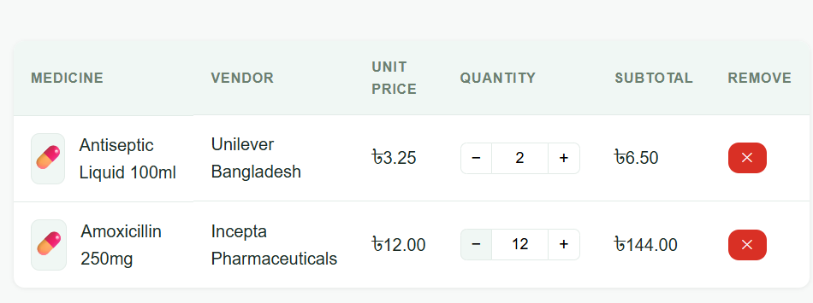
Fig 02 : Cart Management (increase, decrease, remove)

Feature 03: [Checkout with Shipping Address]
Describe what this feature does and its purpose in the application.

Description
After reviewing the cart, the customer proceeds to checkout where they enter a delivery address. The address is pre-filled from their profile. PHP validates the address server-side and JavaScript validates it client-side before submission.

Relevant Source Code
Paste the key source code snippet(s) below. Add the file path and language above each block.

File: [controllers/CheckoutController.php (or controllers.php)]
(PHP):
$shippingAddress = trim($_POST['shipping_address'] ?? '');

$errors = [];
if (empty($shippingAddress)) {
$errors[] = 'Shipping address is required.';
}
foreach ($cartItems as $item) {
if ($item['quantity'] > $item['stock']) {
$errors[] = "'{$item['name']}' only has
{$item['stock']} units in stock.";
}
}
if (!empty($errors)) {
$_SESSION['checkout_errors'] = $errors;
redirect(BASE_URL . '/index.php?page=checkout');
}
$_SESSION['pending_address'] = $shippingAddress;
redirect(BASE_URL . '/index.php?page=payment');

Code Explanation
- Trims and validates the shipping address is not empty
- Re-validates stock for every cart item to prevent overselling
- Stores address in session and redirects to payment page if all checks pass.

Screenshot(s)
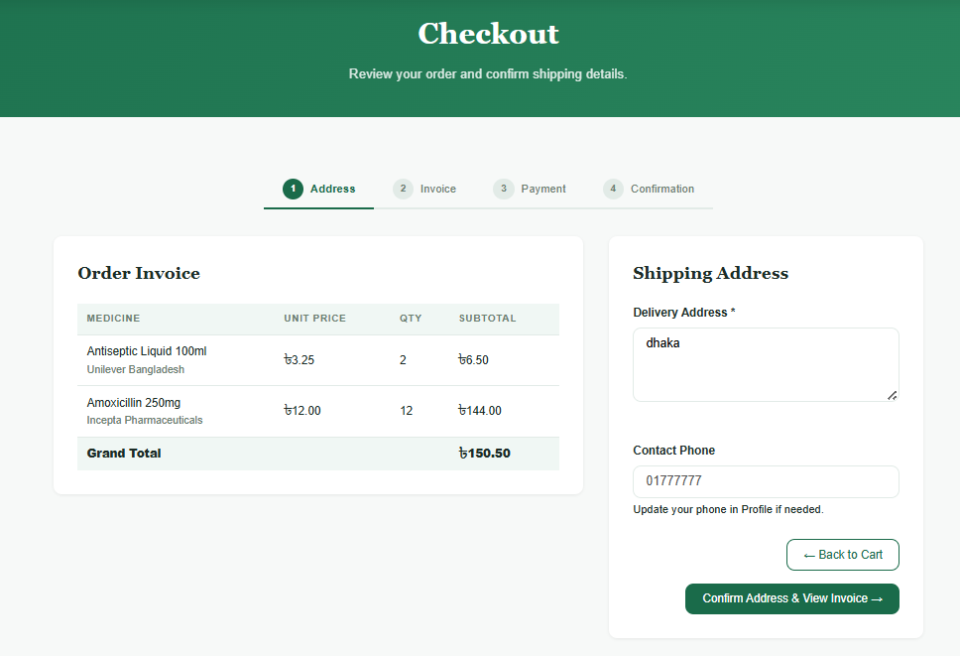
Fig 03: Checkout with Shipping Address

Feature 04: [Invoice Preview]
Describe what this feature does and its purpose in the application.

Description
Before confirming the order the customer sees a full invoice showing all medicines, quantities, unit prices and the grand total. This is shown side by side with the address/payment form.

Relevant Source Code
Paste the key source code snippet(s) below. Add the file path and language above each block.

File: [views/checkout/index.php]
(PHP):
<?php foreach ($cartItems as $item): ?>
<tr>
<td><?= e($item['name']) ?></td>
<td>৳<?= number_format($item['price'], 2) ?></td>
<td><?= $item['quantity'] ?></td>
<td>৳<?= number_format($item['price'] *
$item['quantity'], 2) ?></td>
</tr>
<?php endforeach; ?>
<tfoot>
<tr>
<td colspan="3">Grand Total</td>
<td>৳<?= number_format($cartTotal, 2) ?></td>
</tr>
</tfoot>

Code Explanation
- Loops through all cart items and displays each with calculated subtotal
- Uses e() (htmlspecialchars) on all output to prevent XSS attacks number_format() formats prices to 2 decimal places
- Grand total is calculated server-side in the model

Screenshot(s)
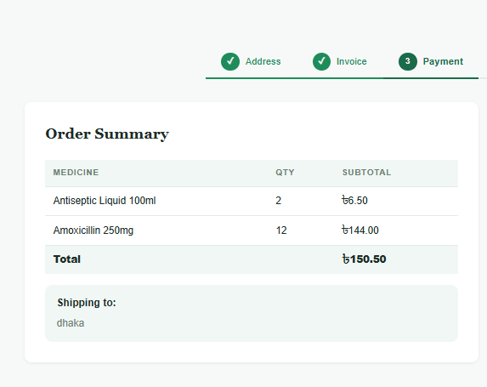
Fig 04: Invoice Preview

Feature 05: [Payment Method Selection]
Describe what this feature does and its purpose in the application.

Description
The customer selects a payment method from 5 options: Credit Card, bKash, Nagad, Bank Transfer, or Cash on Delivery. JavaScript ensures one must be selected before submitting. PHP whitelists valid methods server-side.

Relevant Source Code
Paste the key source code snippet(s) below. Add the file path and language above each block.

File: [controllers/CheckoutController.php (or controllers.php)]
(PHP):
$allowedMethods = ['Credit Card', 'bKash', 'Nagad',
'Bank Transfer', 'Cash on Delivery'];

if (!in_array($paymentMethod, $allowedMethods, true)) {
$error = 'Please select a valid payment method.';
}

File: [views/checkout/payment.php (JavaScript validation)]
(javascript)
document.getElementById('paymentForm')
.addEventListener('submit', function(e) {
const selected = document.querySelector(
'input[name="payment_method"]:checked');
if (!selected) {
e.preventDefault();
document.getElementById('pmErr').textContent =
'Please select a payment method.';
}
});

Code Explanation
- PHP uses in_array() with strict mode (true) to whitelist only allowed payment methods — prevents any injected values
- JavaScript blocks form submission if no radio button is selected
- Both client and server validation work together (JS for UX, PHP for security)

Screenshot(s)
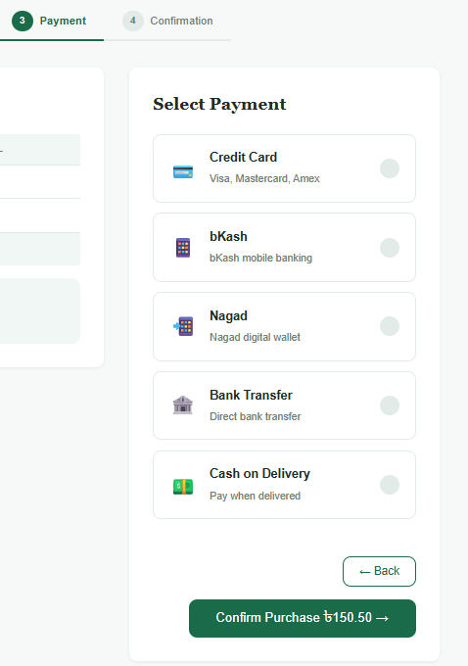
Fig 05: Payment Method Selection

Feature 06: [Order Confirmation]

Description
After payment selection the order is saved to the database in a single transaction covering the orders, order_items, and payments tables. The cart is cleared and the customer is redirected to a confirmation receipt page showing order ID, transaction ID and status "pending".

Relevant Source Code

File: [models/OrderModel.php (or models.php)]
(PHP):
mysqli_begin_transaction($conn);

// Insert order
$stmt = mysqli_prepare($conn,
"INSERT INTO orders (user_id, total_amount,
shipping_address, status, payment_method, order_date)
VALUES (?, ?, ?, 'pending', ?, NOW())");
mysqli_stmt_bind_param($stmt, 'idss',
$userId, $total, $address, $paymentMethod);
mysqli_stmt_execute($stmt);
$orderId = (int) mysqli_insert_id($conn);

// Insert order items
foreach ($cartItems as $item) {
$stmt = mysqli_prepare($conn,
"INSERT INTO order_items
(order_id, medicine_id, quantity, unit_price)
VALUES (?, ?, ?, ?)");
mysqli_stmt_bind_param($stmt, 'iiid',
$orderId, $item['medicine_id'],
$item['quantity'], $item['price']);
mysqli_stmt_execute($stmt);
}

// Clear cart
clearCart($conn, $userId);
mysqli_commit($conn);

Code Explanation
- Wraps everything in mysqli_begin_transaction() — if anything fails, mysqli_rollback() undoes all changes
- Inserts the order, then loops through cart items inserting each into order_items Generates a unique transaction ID and inserts into payments table
- Clears the cart only after everything succeeds
- Commits the transaction at the end

Screenshot(s)
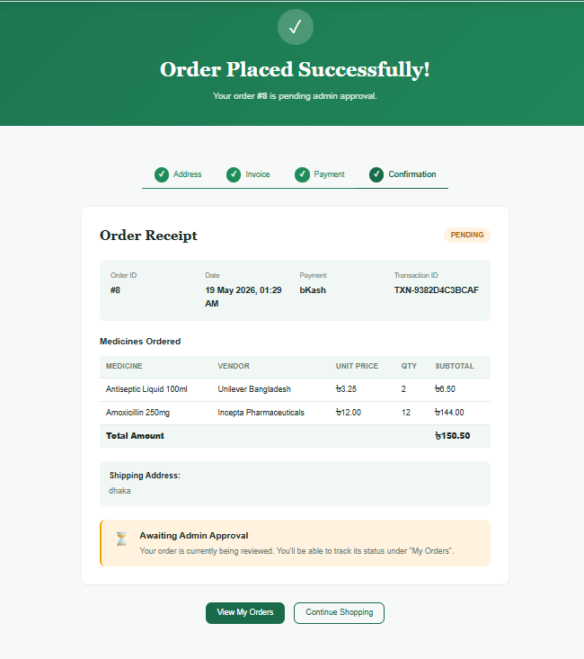
Fig 06: Order Confirmation

Chapter 5: Conclusion & Future Work

5.1 Summary
We built an online medicine shop web app. Customers can browse medicines, search and filter, add items to a cart, checkout (COD or early payment), and track orders. Admins can manage medicines and categories, view customers, and approve or reject orders. The site uses PHP, MySQL, HTML, CSS, and JavaScript in an MVC-style structure (controllers, models, views).

Goals achieved
- User accounts -- register, login, logout, profile, password change, remember me
- Role-based access -- customers vs admins see different pages
- Shop home -- categories, search/filter with AJAX, medicine cards
- Shopping flow -- cart, checkout, payment choice, order confirmation
- Admin panel -- CRUD for medicines and categories, order management, customer list
- Security basics -- password hashing, prepared SQL, CSRF, XSS escaping

5.2 Challenges Faced
- Correct file paths -- assets like the hero image needed paths relative to the project folder, not the server root
- Two ways to load products -- first load with PHP, then live search with JavaScript and API
- Mixed MVC -- some logic is in controllers and some in API files; keeping code organized took care
- Validation in two places -- client-side (fast feedback) and server-side (real security)
- Role checks -- making sure only customers use the cart and only admins use the admin panel
- Merging are quite lengthy
- Csrf and Xss Prevention Setup was Critical

5.3 Future Improvements
- Online payment -- connect bKash, card, or Stripe (not only COD / “pay early” choice).
- Prescription upload – For medicines that need a doctor;s Prescription
- Block public admin Regestration
- Rate limiting on login

References

[1] Html5. HTML Tutorial.
[2] Css3 . CSS Tutorial
[3] js, JavaScript Tutorial
[4] Sql, SQL Tutorial
[5] Php, PHP Tutorial
[6] csrf technique, CSRF Protection with PHP
[5] cookie & session technique , (97) 27: Session and Cookies in PHP | PHP Tutorial | Learn PHP Programming | PHP for Beginners - YouTube
[6] XSS prevention and Csrf & sql injection prevention, 🛡️ PHP Form Security: Prevent XSS, CSRF & SQL Injection Attacks! & XSS (Cross-Site Scripting) in PHP Websites and how to prevent it!.

