Step:1-----

Copy Below Code And Paste Into "theme.liquid" above just "</body>" tag.

{{ 'Wishlist.js' | asset\_url | script\_tag }}

<script>

(function() {

Wishlist.init();

}());

</script>

Example: ----

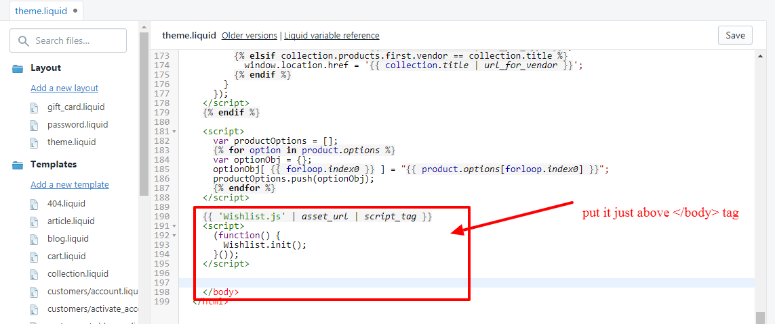

Step:2-----

Create a New Snippets.

snippets name is " **wishlist-button**" and paste below code in it.....

<div class="wishlist\_icon">

<a class="action--wishlist tile-actions--btn flex wishlist-btn" href="#" data-product-handle="{{ product.handle }}">

<img class="btn--main wish\_icon" src="{{ 'wish\_icon.png' | asset\_url }}" alt="add to wishlist" title="Add To Wishlist">

<img class="btn--main wish\_icon\_b" src="{{ 'wish\_icon\_b.png' | asset\_url }}" alt="add to wishlist" title="Remove From Wishlist">

</a>

</div>

<style>

.action--wishlist .wish\_icon\_b,

.action--wishlist.is-active .wish\_icon{ display:none; }

.action--wishlist .wish\_icon,

.action--wishlist.is-active .wish\_icon\_b{ display:block; }

</style>

this code is wishlist button to add product in wishlist. it was look like below screenshot

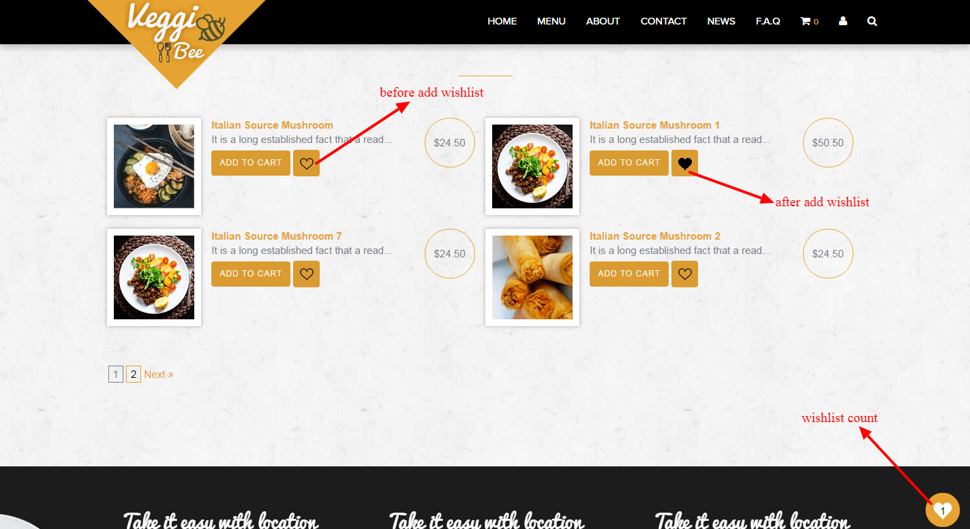

Step:3-----

create new js from assets

js name is "**Wishlist.js"** and paste code from "Wishlist.js" I already put in the folder. Or Just Upload "Wishlist.js" From The folder in to assets.

Step:4-----

Also Upload This Two png file in to assets.

Name is must like this

for white png file =" wish\_icon.png" and for black =" wish\_icon\_b.png"

D:\shopify_demo\wishlist\wish_icon.png D:\shopify_demo\wishlist\wish_icon_b.png

Step:4-----

create new snippets and name is '' **product-tile**'' and paste below code in it .

<div class="product-tile-container wishlist-tile-container" data-product-id="{{ product.id }}" data-product-handle="{{ product.handle }}">

<div class="product-tile wishlist-tile">

<div class="product-tile--tile-media">

<a class="tile-media--media-link" href="{{ product.url }}">

<div class="media-link--image">

<img class="image--main" src="{{ product.featured\_image | product\_img\_url: 'grande' }}" alt="{{ product.title }}">

</div>

</a>

</div>

<div class="product-tile--tile-content flex text-center">

<div class="tile-content--text">

<p class="h4 grid-view-item\_\_title">{{ product.title }}</p>

{% if product.compare\_at\_price > product.price %}

<p class="product-price\_\_price">

<s><span class="price--compare strike-through">{{ product.compare\_at\_price | money }}</span></s> <span class="price--sale">{{ product.price | money }}</span>

</p>

{% else %}

<p class="product-price\_\_price">{{ product.price | money }}</p>

{% endif %}

</div>

<div class="product-tile--tile-actions flex">

{% comment %} {% include 'wishlist-button'%} {% endcomment %}

<a class="action--quick-cart tile-actions--btn flex cart-btn main\_site\_btn" href="/cart/add?id={{ product.selected\_or\_first\_available\_variant.id }}&quantity=1">{{ 'products.product.add\_to\_cart' | t }}</a>

</div>

</div>

</div>

</div>

Step:5-----

now create page templetes and name is " **page.wishlist**" and paste below code in it

<div class="full-width-container wishlist-container">

<!-- Hero Banner -->

<div class="wishlist-hero">

<h1 class="wishlist-hero--title">{{ page.title }}</h1>

</div>

<!-- Product Tile Grid -->

<div class="wishlist-grid flex">

{% for product in collections.all.products %}

{% include 'product-tile' %}

{% endfor %}

<div class="wishlist-grid--empty-list flex">

<div class="empty-list--info">

<h6 class="empty-list--text black">{{ 'general.wishlist\_page.empty\_wishlist\_content' | t }}</h6>

<a class="btn btn-primary empty-list--btn" href="/collections/all">{{ 'general.wishlist\_page.shopping\_button' | t }}</a>

</div>

</div>

</div>

<!-- Loader -->

<div class="wishlist-loader">

<img class="wishlist-loader--image" src="{{ 'wish\_icon.png' | asset\_url }}" alt="Wishlist loading">

<p class="wishlist-loader--text">{{ 'general.wishlist\_page.wishlist\_loading' | t }}</p>

</div>

</div>

.aftter creating this templates must add new page from **pages->Add new Page**

and this page name is must "wishlist" only . and then assign "page.wishlist" templates to this page.

Step:5-----

now paste this code where you want see wishlist count. i recommended in footer .

<div class="wish\_list\_icon">

<a href="/pages/wishlist" class="a\_wishlist\_count">

<span id="wishlist" class="wishlist\_count"></span>

</a>

</div>