REAL TIME RESEARCH PROJECT REPORT
On

GAMING GALAXY
Submitted in partial fulfillment of the requirements for the award of the degree of
BACHELOR OF TECHNOLOGY
In
COMPUTER SCIENCE AND ENGINEERING
By

B. RAMYA(23D21A05C7), B. SUSHMA SREE(23D21A05C8) and CHEVVURU RAJINI (23D21A05D1)

-
Department of Computer Science and Engineering

SRIDEVI WOMEN'S ENGINEERING COLLEGE
(An UGC Autonomous Institution)
Estd.2001|Approved by AICTE& Govt. of TS | Affiliated to JNTUH
Accredited by NBA& NAAC A+ +|Certified with ISO 9001:2015

V.N.PALLY, Gandipet, Hyderabad-75
2024-2025



Department of Computer Science and Engineering

SRIDEVI WOMEN'S ENGINEERING COLLEGE
(An UGC Autonomous Institution)
ESTD 2001 | Approved by AICTE & Govt. of TS | Affiliated to JNTUH
Accredited by NBA, NAAC with A++ | Certified with ISO 9001:2015
V.N, PALLY, Gandipet, Hyderabad-75
2024-2025

CERTIFICATE
This is to certify that the Real Time Research Project Report entitled
“GAMING GALAXY” is being submitted by B. RAMYA(23D21A05C7), B. SUSHMA SREE(23D21A05C8) and CHEVVURU RAJINI (23D21A05D1) in a partial fulfillment of the frequent for the award of the degree of B. Tech in COMPUTER SCIENCE AND ENGINEERING is a record of bonafide work carried out by them.
Coordinator | Head of the Department
Mrs. E. Krishnaveni Reddy | Dr.A. Ravi Kumar
Associate Professor | Professor

DECLARATION
We hereby declare that Real Time Research Project report entitled “TREK INDIA” is the work done during the period of 3th March 2024 to 16th July 2024 and is submitted in partial fulfilment of the requirements for the award of Bachelor of Technology in Computer Science and Engineering from Jawaharlal Nehru Technological University, Hyderabad.
B. RAMYA 23D21A05C7 B. SUSHMA SREE 23D21A05C8 CHEVVURU RAJINI 23D21A05D1

ACKNOWLEDGEMENT

We would like to express our sincere gratitude and indebtedness to our Coordinators, Mrs. E. KRISHNAVENI REDDY, Associate Professor, Mr. BIBHU RANJAN SAHOO, Associate Professor, Mrs. SHAIK SHARMILA, Assistant
Professor, ASHWATHI S. SHEELAN, Assistant Professor, D. SOWMYA, Assistant Professor, Department of Computer Science and Engineering for her valuable guidance, suggestions, and keen personal interest throughout the course of this project.
We would like to express our sincere gratitude to Head of the Department Dr. A. RAVIKUMAR, Professor, Department of Computer Science and Engineering for his valuable suggestions and advices.
We are also extremely thankful to our Principal Dr. A. NARMADA for providing excellent facilities to carry out our project work.
Finally, we would like to take this opportunity to thank all our faculty, family, and friends for their support throughout this work. We also sincerely acknowledge and thank all those who gave directly or indirectly their support in completion of this work.
B. RAMYA 23D21A05C7 B. SUSHMA SREE 23D21A05C8 CHEVVURU RAJINI 23D21A05D1

LIST OF CONTENTS

S.No Page No
1 Title page
2 Certificate
3 Declaration
4 Acknowledgement
5 Abstract
6 Introduction
7 Objective
8 Scope and features
9 Purpose
10 Hardware Requirements
11 Software Requirements
12 System Design
13 Existing System
14 Proposing System
15 Implementation
16 System Testing
17 Conclusion
ABSTRACT

- The Gaming Galaxy web page is a dynamic online platform designed to offer users an engaging hub for discovering, playing, and interacting with a wide variety of games. It serves as a central destination for gamers to explore curated content, track achievements, compete on leaderboards, and stay updated with the latest news in the gaming world.

- The Gaming Galaxy is a dynamic and interactive entertainment space designed to provide immersive gaming experiences for all age groups. Equipped with state-of-the-art technology, the zone features a wide range of games including virtual reality (VR), augmented reality (AR), console gaming, PC setups, and classic arcade machines. Whether for casual players or competitive gamers, the Gaming Galaxy fosters a social and engaging environment where fun, skill development, and digital exploration intersect. With dedicated areas for tournaments, multiplayer sessions, and individual gameplay, it serves as a hub for community engagement, innovation, and recreation in the rapidly evolving world of gaming.

INTRODUCTION
- Welcome to Gaming Galaxy, Gaming Galaxy is your go-to place for fun, safe, and super cool online games made just for kids under 15. Whether you love puzzles, adventure, memory games, coloring challenges, or action-packed fun – we’ve got it all right here!
- Our games are easy to play, full of color, and totally safe – with no downloads, no ads, and no worries. Just click, play, and enjoy endless hours of entertainment designed for curious and creative minds.
- Parents can relax too – every game on Gaming Galaxy is handpicked to be age-appropriate and educational, helping kids have fun while learning new skills.

OBJECTIVE
The primary objective of the Gaming Galaxy website is to provide an interactive, user-friendly platform where gamers can discover, play, and engage with a wide variety of online games. The website aims to enhance user experience by offering categorized game content, competitive leaderboards, user profiles, and the latest updates from the gaming world. It seeks to build a vibrant online gaming community by promoting player interaction, rewarding achievements, and supporting continuous engagement through personalized features and regular content updates.

To create an engaging and immersive gaming experience that entertains users, encourages regular play through rewarding gameplay mechanics, and builds a loyal community through social features and regular content updates.

SCOPE AND FEATURES

Scope
- Game Selection: Gaming Website transcends mere game access; it unlocks the door to a diverse gaming landscape.
- User Interaction: Elevating the user experience, Gaming Website introduces a more engaging and interactive game finding process.
- Technological Backbone: The foundation of Gaming Website is characterized by solidity and sophistication. HTML, CSS, and JavaScript collaboratively lay the groundwork, establishing a robust technological backbone.
- Responsive Design: Flexibility is paramount in the digital landscape, and Gaming Website ensures a seamless user experience across diverse screens.

Features

Engaging Gameplay Mechanics
Intuitive controls and smooth performance
Level-based progression or open-world exploration
Challenge and reward balance

User Profiles and Authentication
Player accounts (with Google/Apple sign-in)
Track progress, achievements, and settings

- Leaderboard and Scoring System
Global and friend-based leaderboards
Rankings by points, wins, or milestones

- Achievements and Rewards
Badges, trophies, or unlockable content
Daily/weekly challenges and rewards

- Multiplayer Mode (if applicable)
Real-time or turn-based multiplayer
Chat or emoji communication
Friend invites and matchmaking

- In-Game Store and Monetization
In-app purchases (e.g., coins, skins, power-ups)
Optional ads with rewards
Subscription tiers for exclusive content

- Push Notifications
Reminders for daily rewards, events, and updates

- Offline Mode (optional)
Play basic levels or modes without internet

- Regular Updates and Events
Seasonal content, new levels, limited-time events

- Tutorial and Help Section
Step-by-step onboarding for new users

PURPOSE
- Entertainment and Fun: Gaming provides an immersive and enjoyable way to relax and have fun.
- Stress Relief: It can serve as an escape from real-life stress or boredom.
- Social Connection: Many games offer multiplayer features that allow people to connect, collaborate, or compete with friends or others worldwide.
- Cognitive Development: Certain games enhance problem-solving, critical thinking, coordination, and decision-making skills.
- Achievement and Competition: Games offer goals, rewards, and competition, which can be motivating and satisfying.
- Storytelling and Creativity: Many games offer rich narratives and allow players to explore or even create new worlds and characters.
- Professional Pursuits: For some, gaming is a career path—through eSports, content creation, streaming, or game development.

HARDWARE REQUIREMENTS
🎮 1. Processor (CPU)
- Minimum: Intel Core i3 / AMD Ryzen 3
- Recommended: Intel Core i5/i7 / AMD Ryzen 5/7
- High-End: Intel Core i9 / AMD Ryzen 9

🎮 2. Graphics Card (GPU)
- Minimum: NVIDIA GTX 1050 / AMD RX 560
- Recommended: NVIDIA RTX 3060 / AMD RX 6700 XT
- High-End: NVIDIA RTX 4080+ / AMD RX 7900 XTX

🎮 3. Memory (RAM)
- Minimum: 8 GB
- Recommended: 16 GB

🎮 4. Storage
- Minimum: 256 GB SSD or HDD
- Recommended: 512 GB – 1 TB SSD

🎮 5. Display (Monitor)
- Minimum: 1080p, 60 Hz
- Recommended: 1080p or 1440p, 144 Hz+ (for competitive games)

SOFTWARE REQUIREMENTS
🖥️ 1. Operating System (OS)
- Windows 10/11 (64-bit) – Most widely supported OS for gaming.
- macOS – Limited game library, mainly for casual and indie games.
- Linux (Ubuntu, SteamOS, etc.) – Increasing support via Steam Proton, but still limited for some AAA titles.
🔐 2. Antivirus & Firewall
- Use lightweight or gaming-friendly antivirus software (like Windows Defender) that won’t interfere with game performance.
- Gaming mode in antivirus/firewall software can help reduce interruptions.
🌐 3. Network Utilities (for Online Gaming)
- Tools like Discord for voice chat
- Game-specific anti-cheat software like Easy Anti-Cheat or Battle Eye
- Port forwarding and NAT settings might be needed for smoother connections

SYSTEM DESIGN
🖥️ 1. Hardware Setup
✅ Gaming PCs / Consoles
- CPU: Intel Core i5/i7 or AMD Ryzen 5/7
- GPU: NVIDIA RTX 3060 or higher / AMD RX 6700+
- RAM: 16 GB minimum
- Storage: 512 GB – 1 TB SSD (fast boot/load times)
- Monitors: 24" or larger, 1080p, 144Hz for FPS/esports

🌐 2. Networking
✅ Network Equipment
- Gigabit Ethernet switches (Layer 2 or Layer 3 for scalability)
- Cat6/Cat6a cabling
- Business-grade routers/firewalls with bandwidth management (QoS)
✅ Internet Connection
- At least 1 Gbps fiber connection, ideally with a backup line
- Enable low-latency routing for online games

💾 3. Software Infrastructure
✅ Operating System
- Windows 10/11 Pro (for remote admin features)
- Use Deep Freeze or Reboot Restore RX for system rollback after each session

✅ Game Platforms
- Pre-installed game launchers (Steam, Epic, Battle.net, Riot, etc.)
- Use shared caching servers to avoid redundant downloads

🔐 4. Security & Maintenance
- Use Deep Freeze or similar tools for system protection
- Centralized antivirus & firewall policies
- Regular backups of system images and configuration
- Physical security (CCTV, cable locks)

🪑 5. Layout & Comfort
- Proper ventilation and AC for temperature control
- Acoustic treatment to reduce noise
- LED lighting for ambiance
- Lounge or snack area if desired

EXISTING SYSTEM

1. CrazyGames
A fun website with thousands of free online games. You can play racing, shooting, puzzle, and multiplayer games right in your browser. No downloads needed. Great for quick and casual fun
2. Y8.com
One of the oldest game sites with a huge collection of games — dress-up, 2-player, action, and more. It even has old-school Flash games and lots of kid-friendly options.
3. Pogo.com
A calm and relaxing game site with card games, puzzles, word games, and board games like Monopoly. Perfect for adults and older players who enjoy classic games.
4. Newgrounds
A creative website where people upload their own games, animations, and art. It’s full of original and indie-style games — fun, weird, and sometimes a bit crazy!
And many more…

PROPOSING SYSTEM

- The proposed Game Zone system is an online gaming website that focuses on delivering simple, fun, and easily accessible games to users of all ages. The system is designed to be lightweight, user-friendly, and compatible across different devices like laptops, tablets, and smartphones.
- The Game Zone system is designed with a clean and intuitive front-end interface. Built using modern web technologies like HTML5, CSS3, and JavaScript, the platform will be fully responsive, ensuring a smooth experience across desktops, tablets, and smartphones. Users will be able to browse through various categories such as Arcade, Puzzle, Sports, and Adventure. Each game will have a dedicated page with a brief description, a screenshot or thumbnail, and a “Play Now” button that loads the game directly in the browser. Search and filter options will help users easily find the type of games they’re interested in.

IMPLEMENTATION

SAMPLE CODE
This HTML document creates a structured layout for a website called "Gaming Galaxy". It sets up the document with essential metadata and links to external resources, such as a favicon, Remix Icons, and custom CSS. The header section includes a navigation bar with a logo and a responsive menu that can be toggled open or closed using icons.
HTML CODE
<!DOCTYPE html>
<html lang="en">
<head>
<meta charset="UTF-8" />
<meta name="viewport" content="width=device-width, initial-scale=1.0"/>
<link rel="stylesheet" href="indexstyle.css" />

<title>GalaxyGamers | Home</title>
</head>
<body>

<header>
<img src="logo.jpg" alt="Header Image">
<h1>Gaming Galaxy</h1>
<nav>
<a href="login.html">Login</a>
<a href="regs.html">Register</a>
</nav>
</header>
<div class="hero">
<h2>Level Up Your Game World</h2>
</div>

<footer>
&copy; 2025 GalaxyGamers. All rights reserved.
</footer>

</body>
</html>

CSS CODE
CSS (Cascading Style Sheets) is a styling language used to control the layout and appearance of web pages written in HTML or XML. Its purpose is to separate presentation from structure, allowing developers to control layout, visual styling, and user experience. CSS uses selectors to identify elements to style, properties to define styles, and values to specify property values. There are three types of CSS: inline, internal, and external, each with its own level of precedence. CSS rules follow a specific structure, with selectors, properties, and values combined to create styles. Common CSS properties include color and background, typography, layout, and positioning. Additionally, CSS frameworks and tools, such as CSS reset, CSS frameworks like Bootstrap and Tailwind CSS, and CSS preprocessors like Sass and Less, can enhance and streamline the styling process. By using CSS, developers can create visually appealing, user-friendly, and responsive web pages that enhance the overall user experience.
<style>
body {
margin: 0;
font-family: 'Segoe UI', sans-serif;
background-color: #0e0e0e;
color: #fff;
}

header {
background-color: #1a1a1a;
padding: 20px 40px;
display: flex;
justify-content: space-between;
align-items: center;
}

header h1 {
color: #00ffcc;
font-size: 28px;
}
header img {
height: 50px;
margin-right: 20px;
}

nav a {
color: #ffffff;
margin-left: 20px;
text-decoration: none;
font-weight: bold;
}

nav a:hover {
color: #00ffcc;
}

.hero {
background-color:black;
height: 500px;
display: flex;
align-items: center;
justify-content: center;
text-align: center;
}

.hero h2 {
font-size: 48px;
color: #fff;
text-shadow: 2px 2px 10px rgba(0,0,0,0.7);
}

.section {
padding: 50px 40px;
}

.section h3 {
font-size: 32px;
margin-bottom: 20px;
color: #00ffcc;
}

.games-grid {
display: grid;
grid-template-columns: repeat(auto-fit, minmax(200px, 1fr));
gap: 20px;
}

.game-card {
background: #1a1a1a;
border-radius: 10px;
overflow: hidden;
box-shadow: 0 5px 15px rgba(0,0,0,0.4);
transition: transform 0.3s;
}

.game-card:hover {
transform: scale(1.05);
}

.game-card img {
width: 100%;
height: 150px;
object-fit: cover;
}

.game-card p {
padding: 15px;
font-weight: bold;
text-align: center;
}

footer {
text-align: center;
padding: 20px;
background-color: #111;
color: #999;
}

.btn {
background-color: #00ffcc;
color: #000;
padding: 12px 24px;
border: none;
border-radius: 6px;
font-size: 16px;
cursor: pointer;
margin-top: 20px;
}

.btn:hover {
background-color: #00ddb0;
}
</style>

SYSTEM TESTING

INTRODUCTION TO TESTING
Testing is the set of activities that can be planned in advance and conducted systematically. For this reason, a template for software testing a set of steps into which you can place specific test case design techniques and testing methods should be defined for the software process. Testing is an integral part of any system or project. Software testing is an investigation conducted to provide stake holders with information about the quality of the product or service under test. Software testing can also provide an objective, independent view of these software to allow the business to appreciate and understand the risks of the software implementation. Test techniques include, but are no limited to, the process of executing a programmer application with the intent of finding software bugs Software testing. Program, application, product.
- To uncover the errors in function logic or implementation for the software.
- To verify that software needs the specific requirement.
- To verify that software has been implemented according to predefined standard.

Unit Testing
It is basically done by the developers to make sure that their code is working fine and meet the user specifications. They test their piece of code which they have written like classes, functions, interfaces and procedures.

Integration Testing
Integration testing is done when two modules are integrated, in order to test the Beauvoirian functionality of both the modules after integration. Below are few types integration testing:
- Big bang integration testing
- Top down
- Bottom up
- Functional incremental

System integration testing
System integration testing is a testing where testers basically test that in the same environmental the related systems should maintain data integrity and can operate in coordination with other systems. It also uses black box testing technique that evaluates the systems compliance against specified requirement. System Integration Testing is usually performed on a complete system and is preceded by the user acceptance test(UAT).

System testing
In system testing the testers basically test the compatibility of the application with the system. System testing of software or hardware is testing conducted on a complete, integrated system to evaluate the system’s compliance with its specified requirements. System testing falls within the scope of black-box testing, and as such, should require no knowledge of the inner design of the code or logic.

Component integration testing
This testing is basically done to ensure that the code should not break after integration the two modules. Component integration testing tests the interactions between software components and is done after component testing.

Positive testing
Positive testing is type of testing that can be performed on system by providing the valid data as input. It checks whether an application behave as expected with the positive input.

Negative testing
Negative testing is performed to ensure that the product of application under test does not fail when an unexpected input is given. The purpose of negative testing is to break the system demand to verify the application response during unintentional inputs.

Regression testing
It verifies that software which has previously developed and tested still performs correct after it was changed of interfaced with other software.

Smoke testing
Smoke testing is also known as build verification testing is a type of software that comprises of a non-exhaustive set that aim at insuring that the most important functions work. The result of this testing is used to decide if a build is stable enough to proceed with further testing.

DISCUSSION RESULTS
As soon as you open the webpage, there will be a home page where the user has two options login and register. It looks like this:

Fig: Home Page

Now the user can login if he/she is having an account already in our gaming galaxy.


Fig: Login page

else they have to register to create an account in our gaming galaxy through register page.
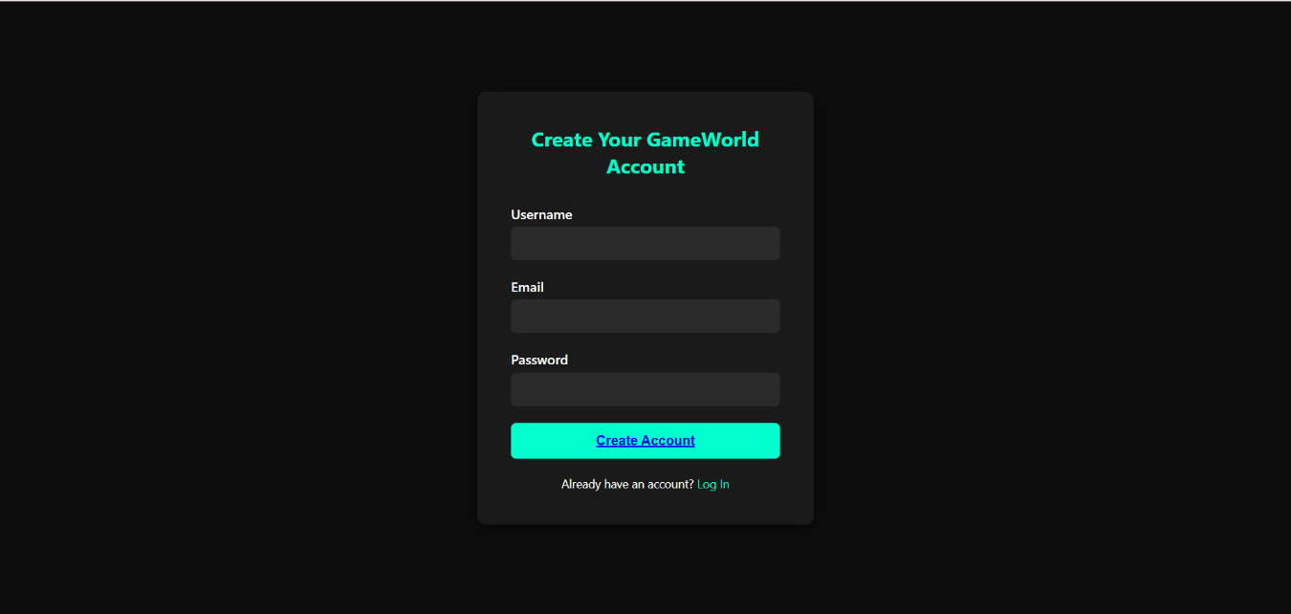
Fig: Register Page

And finally the user can enter into our gaming galaxy and enjoy the games. The game page looks like this,
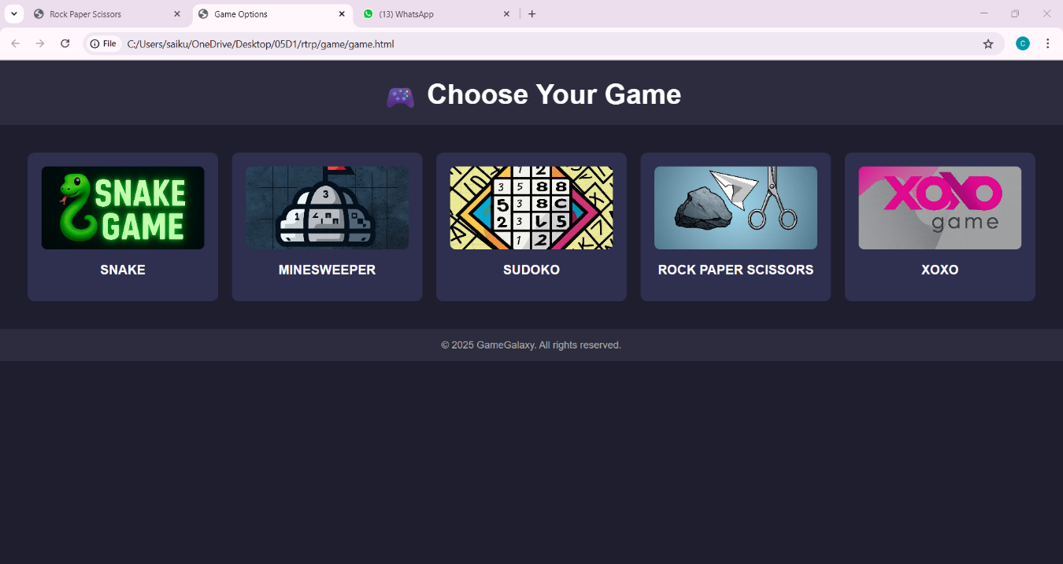
Fig: Game Page

CONCLUSION AND FUTURE ENHANCEMENTS

CONCLUSION
These websites are a great resource for gamers since they let users find new games, stay up to date on industry news, read reviews to make informed decisions about what to buy, and interact with other players through forums and social features. In addition, they provide downloadable content, gameplay footage, trailers, and game rankings. Websites dedicated to gaming accommodate a wide range of interests, genres, and platforms, so players may discover content that suits their tastes.
Game Zone offers a fun, user-friendly platform for casual gamers to enjoy a variety of simple games anytime, anywhere. With its clean design and easy navigation, it's perfect for quick entertainment and stress relief. Whether you're looking to kill time or challenge your high score, Game Zone is the go-to destination for simple, enjoyable gaming.

FUTURE ENHANCEMENTS
🌟 User Experience Enhancements
- Cross-Platform Integration
  - Seamless syncing of game progress across devices (PC, mobile, console).
  - Cloud saves and cross-play capabilities.
- Personalized Dashboards
  - AI-driven recommendations based on player behavior and preferences.
  - Dynamic UI customization (themes, widgets, favorite games, etc.).
- Voice & Gesture Controls
  - Voice commands for navigation and gameplay.
  - Integration with AR/VR for motion-based controls.

🎮 Game Library Expansion
- Indie Game Spotlight Section
  - Regularly feature indie games with reviews and community voting.
- Early Access Program
  - Let players test beta versions of upcoming games in exchange for feedback.
- Retro Games Collection
  - Classic titles available via emulation or remastered versions.

🌐 Community & Social Features
- Live Streaming & Watch Parties
  - Built-in tools for users to stream gameplay or host live watch parties.
- Clan/Guild Systems
  - Group systems with shared chat, missions, and achievements.
- Achievement Sharing & Leaderboards
  - Social integration for sharing trophies, badges, and ranks.

🛡️ Security & Fair Play
- Anti-Cheat AI Detection
  - Machine learning-based systems to detect and ban cheaters in real-time.
- Parental Controls & Screen Time Management
  - Role-based access, game filters, and detailed playtime analytics.

💰 Monetization & Marketplace
- NFT Integration (Ethical & Optional)
  - Cosmetic items as digital collectibles, not tied to pay-to-win mechanics.
- User-Created Content Marketplace
  - Allow players to sell skins, maps, mods, and more.
- Dynamic Subscription Plans
  - Pay-per-hour, family bundles, or themed seasonal passes.

📱 Tech & Innovation
- AR & VR Gaming Integration
  - Explore galaxies in VR or place AR games into your living room.
- AI Game Masters
  - Use AI to dynamically adjust gameplay difficulty or create narrative events in real-time.
- Procedural Game Discovery
  - AI-curated playlists of games based on trends and mood

