**DAY6 DATATYPES 19-06-2023**

DATATYPES:

To specify what a variable can hold that datatypes are used.

dat

a

pe

|  |  |
| --- | --- |
| primitive | non-primitive |
| 1.byte 2.short 3. int 4. long 5. float  6. double  7.boolean 8. char | 1. arrays  2.strings……….. |

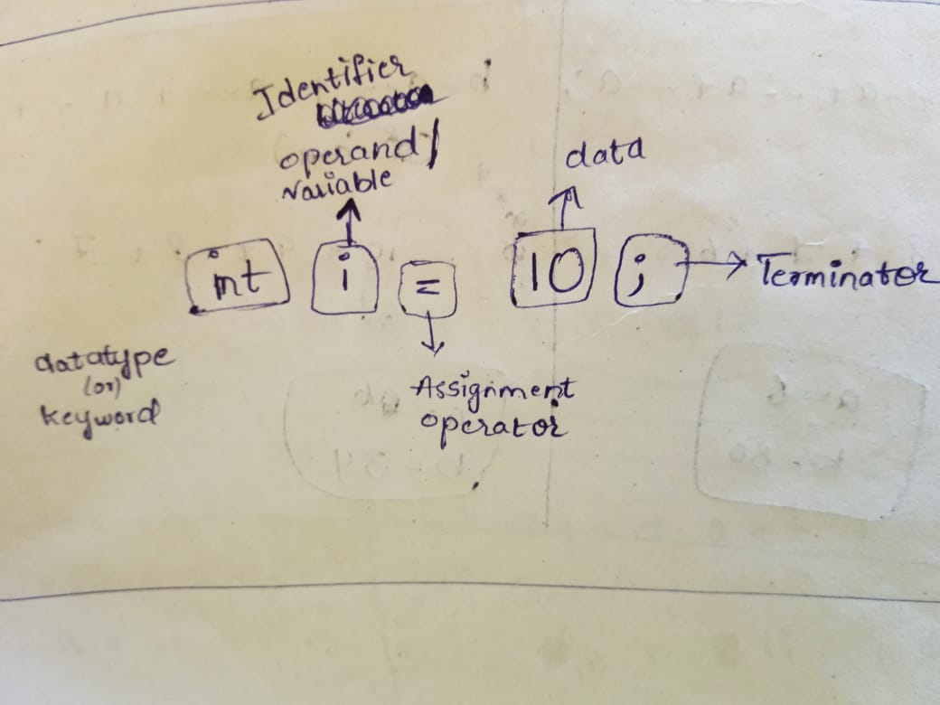

**1.Integer number datatypes:** without decimal number.

|  |  |  |  |
| --- | --- | --- | --- |
| **Byte:**1byte=8bits Range:  -128 to 127    Eg: byte age=20; | **Short:**2byte=16bits Range:  -32768 to 32767    Eg: short distane=30000; | **Int:**4byte=32bits Range:  -2147483648 to  2147483647  Eg:int views=  2147483647; | **Long:**8byte=64bits Range:  -263 to 263-1 |

Programs:

**1.Byte:**

Class bytedemo{

Psvm(String[]args){

Byte b=10; byte b=130;

s.o.p(b);}}

output:10 output:error:incompatibletypes:possible lossy //////////////////////////////////////conversion from int to byte.

**2.short:**

Short s=2138; short s=32769;

Output: 2138 : error:incompatible type:…….

**3.int:**

Int i =2576327;

Output:2576327

**4.long:**

Long l=123232849; longl=21l;

Output:error:incompatibletypes… :21l

**2.real number datatypes:** with decimal numbers.

|  |  |
| --- | --- |
| **Float:** 4byte=32bits  Follows single precision(digits after decimal). | **Double:** 8byte=64bits  Follow double precision. |

Programs:

Float f=12.35; output=error

Float f=12.35f; output=12.35

Double d= true; output=error

**Command** for other operations is: **javap java.lang.Float**(type in command prompt).

PROGRAM:

float f=12.35f;

sop(“java.lang.float”);

system.out.println(java.lang.float,MAX_VALUE);

Output:3.4…..

**3.boolean**: specify true or false condition.

Program:

boolean b =true output: true

boolean b = True output: cannot find symbol

boolean b = ‘true’ ouput:error…….

boolean b = 0; ouput : error……….

**4.char:** 2byte=16bits

Range: 0-35565

Program:

char c = ‘A’ output: A

char c = ‘AB’ output: error