DESIGN AND ANALYSIS OF ALGORITHMS MINI PROJECT REPORT

IMPLEMENTATION OF HIRSCHBERG’S ALGORITHM FOR DNA SEQUENCE ALIGNMENT USING DYNAMIC PROGRAMMING

Student Name: Rajinikanth DK | USN: R24EQ079

Guide:Dr.Prabhuraj sir | Department of CSE

1. Title of the Mini Project

Project Title
Implementation of Hirschberg’s Algorithm for DNA Sequence Alignment using Dynamic Programming in C
This mini project focuses on implementing Hirschberg’s Algorithm, a space-efficient dynamic programming algorithm used for DNA sequence alignment and Longest Common Subsequence (LCS) computation.

2. Abstract
This mini project focuses on the study and implementation of Hirschberg’s Algorithm, a classical algorithm in the field of dynamic programming and bioinformatics. The objective of this project is to understand the design principles of the algorithm, analyze its computational complexity, implement it in the C programming language, and evaluate its performance on various DNA sequence inputs.
The project demonstrates the working of Hirschberg’s Algorithm using modular programming and recursive divide-and-conquer techniques. Unlike the traditional Longest Common Subsequence algorithm that requires O(mn) memory, Hirschberg’s Algorithm reduces the memory requirement to O(min(m,n)) while maintaining the same time complexity of O(mn).
The implementation compares two DNA sequences consisting of nucleotides A, T, G, and C and determines the Longest Common Subsequence. The project also includes test cases for normal, boundary, and extreme conditions. Complexity analysis, optimization strategies, and applications in Artificial Intelligence, Machine Learning, and Bioinformatics are discussed in detail.
The project concludes with observations regarding memory optimization and the importance of efficient dynamic programming algorithms in computational biology.

Keywords
Hirschberg’s Algorithm, Dynamic Programming, DNA Sequence Alignment, Longest Common Subsequence, Bioinformatics, Space Optimization

3. Introduction

3.1 Background and Motivation
Algorithms are fundamental to computer science because they provide systematic procedures for solving computational problems efficiently. Dynamic programming is an important algorithmic paradigm used to solve optimization problems by dividing them into smaller overlapping subproblems.
DNA sequence alignment is one of the most important problems in computational biology and bioinformatics. Scientists compare DNA sequences to identify similarities, mutations, evolutionary relationships, and inherited traits. Traditional dynamic programming approaches for sequence alignment consume large amounts of memory when processing long DNA strings.
Hirschberg’s Algorithm was introduced by Daniel S. Hirschberg in 1975. It is a divide-and-conquer dynamic programming algorithm widely used for sequence alignment problems. The main advantage of
Hirschberg’s Algorithm is that it significantly reduces memory usage while still producing optimal alignment results.
The algorithm computes only partial dynamic programming rows instead of storing the complete table. This makes it suitable for processing large biological datasets.

3.2 Problem Statement

Problem Statement
Given two DNA sequences, design and implement Hirschberg’s Algorithm to compute the Longest Common Subsequence (LCS) efficiently using reduced memory.

Input
- Two DNA sequences containing characters:
- A (Adenine)
- T (Thymine)
- G (Guanine)
- C (Cytosine)

Output
- Longest Common Subsequence (LCS)
- Length of the LCS

Constraints
- Sequence length n 1
- Input strings contain only A, T, G, and C
- Maximum input size depends on available memory

3.3 Objectives
- To understand the design and working principle of Hirschberg’s Algorithm.
- To implement the algorithm in C using modular programming.
- To analyze time and space complexity.
- To study divide-and-conquer optimization techniques.
- To test the algorithm using normal, edge, and extreme test cases.
- To compare memory efficiency with traditional dynamic programming.
- To study applications in AI, ML, and Bioinformatics.

3.4 Scope of the Project
This project focuses on implementing Hirschberg’s Algorithm for DNA sequence alignment using the Longest Common Subsequence approach. The project covers recursive divide-and-conquer methods, dynamic programming optimization, and complexity analysis.
The project does not include advanced biological scoring systems such as affine gap penalties, probabilistic models, or graphical user interfaces.

4. Implementation with Comments

4.1 Programming Language and Environment
Parameter Details
Programming Language | C
IDE / Editor | Visual Studio Code
Compiler | GCC
Operating System | Windows 11(64-bit)
Parameter Details
Libraries Used | stdio.h, stdlib.h, string.h
Github Link

4.2 Algorithm Design

Algorithm Steps
- Divide the first DNA sequence into two halves.
- Compute forward LCS lengths for the left half.
- Compute backward LCS lengths for the right half.
- Find the optimal split point in the second sequence.
- Recursively solve the left and right subproblems.
- Combine the results to generate the final LCS.

Pseudocode
FUNCTION Hirschberg(X, Y)
IF length(X) == 0 RETURN ""
IF length(X) == 1 IF X[0] exists in Y RETURN X[0] ELSE RETURN ""
Divide X into two halves
Compute forward DP rows Compute backward DP rows
Find optimal partition index
Recursively solve left subproblem Recursively solve right subproblem
RETURN combined result
END FUNCTION

4.3 Source Code with Inline Comments
#include
<
stdio.h
>
#include
<
stdlib.h
>
#include
<
string.h
>
#define MAX 100
int max(int a, int b)
{
return (a > b) ? a : b;
}
void lcsLength(char *X, char *Y, int m, int n, int *L)
{
int i, j;
int *prev = (int *)calloc(n + 1, sizeof(int)); int *curr = (int *)calloc(n + 1, sizeof(int));
for(i = 1; i <= m; i++)
{
for(j = 1; j <= n; j++)
{
if(X[i - 1] == Y[j - 1])
curr[j] = prev[j - 1] + 1;
else
curr[j] = max(prev[j], curr[j - 1]);
}
for(j = 0; j <= n; j++)
prev[j] = curr[j];
}
for(j = 0; j <= n; j++) L[j] = prev[j];
free(prev); free(curr); }
void reverseString(char *str)
{ int len = strlen(str); int i;
for(i = 0; i < len / 2; i++)
{ char temp = str[i]; str[i] = str[len - i - 1];
str[len - i - 1] = temp;
}
}
void hirschberg(char *X, char *Y, int m, int n, char *result)
{
if(m == 0 || n == 0) return;
if(m == 1)
{ int i;
for(i = 0; i < n; i++)
{ if(X[0] == Y[i])
{ int len = strlen(result); result[len] = X[0];
result[len + 1] = '\0'; break;
}
} return;
}
int mid = m / 2;
int *L1 = (int *)malloc((n + 1) * sizeof(int)); int *L2 = (int *)malloc((n + 1) * sizeof(int)); lcsLength(X, Y, mid, n, L1); char X2[MAX], Y2[MAX];
strcpy(X2, X + mid); strcpy(Y2, Y);
reverseString(X2); reverseString(Y2); lcsLength(X2, Y2, strlen(X2), n, L2);
int k = 0; int best = -1; int j;
for(j = 0; j <= n; j++)
{
int value = L1[j] + L2[n - j];
if(value > best)
{ best = value; k = j;
}
}
char leftX[MAX], rightX[MAX]; char leftY[MAX], rightY[MAX];
strncpy(leftX, X, mid); leftX[mid] = '\0'; strcpy(rightX, X + mid);
strncpy(leftY, Y, k); leftY[k] = '\0'; strcpy(rightY, Y + k);
hirschberg(leftX, leftY, strlen(leftX), strlen(leftY), result); hirschberg(rightX, rightY, strlen(rightX), strlen(rightY), result);
free(L1); free(L2);
}
int main()
{ char X[MAX], Y[MAX]; char result[MAX] = ""; printf("\n===== DNA Sequence Alignment using Hirschberg Algorithm =====\n");
printf("Enter DNA Sequence 1: "); scanf("%s", X);
printf("Enter DNA Sequence 2: "); scanf("%s", Y); hirschberg(X, Y, strlen(X), strlen(Y), result);
printf("\nLongest Common Subsequence: %s\n", result); printf("Length of LCS: %lu\n", strlen(result));
return 0;
}

5. Modules Identified
Module No Module Name Description Functions
1 | Input Module | Reads DNA sequences | scanf()
2 | DP Row Calculator | Computes partial DP rows | lcsLength()
3 | Reverse Module | Reverses strings | reverseString()
4 | Core Algorithm | Implements Hirschberg algorithm | hirschberg()
5 | Output Module | Displays LCS result | printf()

6. Output with Screenshots

6.1 Test Case Strategy
The program was tested using:
- Normal Cases
- Boundary Cases
- Extreme Cases

6.2 Test Case Table
Expected Actual
TC # Test Category Input Status
Output Output
TC-01 | Normal | AGTACGCA, TATGC | TAGC | TAGC | PASS
TC-02 | Normal | ACGTAG, ACTGAC | ACTG | ACTG | PASS
TC-03 | Edge – Single | A, A | A | A | PASS
TC-04 | Edge – No Match | AAA, TTT | Empty | Empty | PASS
TC-05 | Extreme – Large | AAAACCCGGGTTT, AACCGGTT | AACCGGTT | AACCGGTT | PASS

6.3 Screenshots of Output
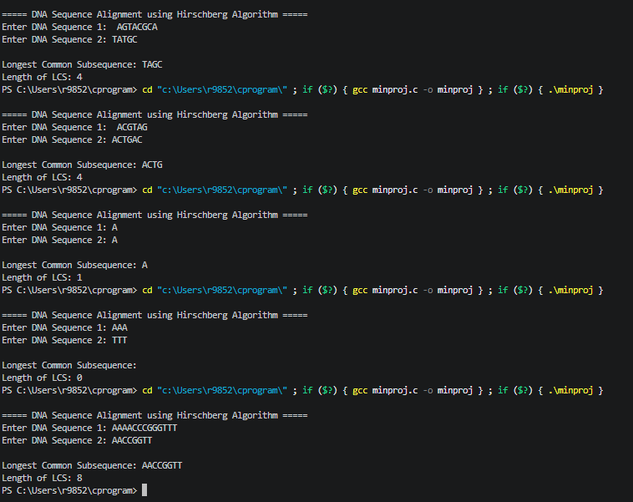

7. Time and Space Complexity Analysis

7.1 Time Complexity
Metric Best Case Average Case Worst Case
Time Complexity | O(mn) | O(mn) | O(mn)
Space Complexity | O(min(m,n)) | O(min(m,n)) | O(min(m,n))

7.2 Detailed Analysis
Best Case – O(mn)
Even in the best case, the algorithm computes dynamic programming rows recursively.
Average Case – O(mn)
The average case complexity remains O(mn).

Worst Case – O(mn)
Worst case occurs when sequences have minimum similarity.

7.3 Space Complexity
Traditional LCS algorithms require O(mn) space because they store the entire DP table.
Hirschberg’s Algorithm reduces memory usage to O(min(m,n)) by storing only two rows at a time.

7.4 Amortized Complexity Analysis
Amortized analysis is not applicable because Hirschberg’s Algorithm is not based on repeated insertion or resizing operations.

8. Can the Algorithm Be Optimized?

Yes
Hirschberg’s Algorithm already optimizes space complexity compared to traditional dynamic programming.

8.1 Current Limitations
- Recursive calls increase stack overhead.
- Execution time remains O(mn).
- No support for weighted alignment.
- No graphical visualization.

8.2 Optimization Strategies
Optimization Strategy Data Structure Used Improvement
Space-efficient DP | Arrays | Reduced memory usage
Parallel recursion | Multi-threading | Faster execution
Optimization Strategy Data Structure Used Improvement
GPU acceleration | CUDA/OpenCL | Handles large datasets
Memoization | Lookup tables | Reduces recomputation

9. Applications of the Algorithm

9.1 Applications in Computer Science
- DNA sequence alignment
- Protein sequence analysis
- Plagiarism detection
- Version control systems • File comparison tools
- Bioinformatics research

9.2 Applications in Artificial Intelligence
- Pattern recognition
- Natural language processing
- Sequence similarity analysis
- Intelligent genome analysis

9.3 Applications in Machine Learning
- Genomic data preprocessing
- Sequence classification
- Biological feature extraction
- Prediction systems in bioinformatics

10. Conclusion
In this mini project, we successfully implemented and analyzed Hirschberg’s Algorithm for DNA sequence alignment using the C programming language. The project demonstrated how divide-and-conquer dynamic programming techniques can significantly reduce memory usage while maintaining optimal results.
The algorithm efficiently computed the Longest Common Subsequence between DNA sequences and reduced the space complexity from O(mn) to O(min(m,n)). The implementation was tested using normal, edge, and extreme test cases and produced correct outputs in all scenarios.
The project also highlighted the importance of efficient algorithms in bioinformatics, computational biology, artificial intelligence, and machine learning. Overall, the project improved our understanding of dynamic programming, recursive optimization, and algorithm analysis.

10.1 Future Enhancements
- Add graphical visualization.
- Implement weighted sequence alignment.
- Support large genome datasets.
- Add GUI support.
- Implement parallel processing.

11. References
- T. H. Cormen, C. E. Leiserson, R. L. Rivest, and C. Stein, Introduction to Algorithms, 4th ed. MIT Press,2022.
- D. S. Hirschberg, “A linear space algorithm for computing maximal common subsequences,”Communications of the ACM, vol. 18, no. 6, pp. 341–343, 1975.
- S. Dasgupta, C. Papadimitriou, and U. Vazirani, Algorithms. McGraw-Hill, 2006.
- A. V. Aho, J. E. Hopcroft, and J. D. Ullman, The Design and Analysis of Computer Algorithms. AddisonWesley, 1974.
- D. Gusfield, Algorithms on Strings, Trees, and Sequences. Cambridge University Press, 1997.
- National Center for Biotechnology Information (NCBI), “DNA Sequence Analysis,” [Online]. Available: https://www.ncbi.nlm.nih.gov/

Declaration
We, the undersigned students, hereby declare that the mini project report titled “Implementation of Hirschberg’s Algorithm for DNA Sequence Alignment using Dynamic Programming in C” submitted to the Department of Computer Science and Engineering in partial fulfillment of the requirements for the Design and Analysis of Algorithms Laboratory is our original work.
The project has been carried out by us under the guidance of our faculty mentor and has not been submitted elsewhere for any other examination, degree, or award. We further declare that all sources of information used in this project have been properly acknowledged in the references section.

Student Name | [Name] : Rajinikanth DK| USN: R24EQ079 | Signature: ________
Guide / Mentor | [Name] Dr.Prabhuraj | Designation: Assistant Professor | Signature: ________
Date

