DELIVERY ROUTE OPTIMIZER
Project Report submitted for the partial fulfilment of grade for the course

Data Structures and Algorithms -3 (25CS2103E)
in

A.Y. 2026-2027

Submitted by
M. LAASYA SRI (2520090196)
M. RAJINI (2520090197)

Team Number: 21
Section: 12

Under the guidance of

Ms. K. Chandusha

Asst. Prof., CS&IT
Hyderabad-500090, Telangana, India.

K L (Deemed to be) University
DEPARTMENT OF COMPUTER SCIENCE AND INFORMATION TECHNOLOGY



DECLARATION

The Mini Project Report entitled “DELIVERY ROUTE OPTIMIZER” is a record of Bonafide work of M. LAASYA SRI – 2520090196, M. RAJINI – 2520090197 submitted in partial fulfillment for the award of B. Tech in Computer Science and Information Technology to the K L University. The results embodied in this report have not been copied from any other departments/University/Institute.

M. LAASYA SRI – 2520090196
M. RAJINI – 2520090197

K L (Deemed to be) University
DEPARTMENT OF COMPUTER SCIENCE AND INFORMATION TECHNOLOGY
CERTIFICATE

This is to certify that the mini project based report entitled “DELIVERY ROUTE OPTIMIZER” is a bonafide work done and submitted by M. LAASYA SRI – 2520090196, M. RAJINI – 2520090197 in partial fulfillment of the requirements for the award of the degree of BACHELOR OF TECHNOLOGY in Department of Computer Science and Information Technology, K L (Deemed to be University), during the academic year 2026-2027.

Signature of the Supervisor

Signature of the HOD Signature of the External Examiner

ACKNOWLEDGEMENT

The success of this project would not have been possible without the timely help and guidance of many people. We wish to express our sincere thanks to all those who have assisted us in one way or another in the completion of our project.

Our greatest appreciation goes to our guide, Ms. K. Chandusha, Asst. Prof., CS&IT, whose tremendous support, encouragement and guidance cannot be expressed in words.

We express our gratitude to Dr. Khaja Shareef, Head of the Department of Computer Science and Information Technology, for providing us with adequate facilities, ways and means by which we were able to complete this project-based lab.

We thank all the members of the teaching and non-teaching staff who have assisted us directly or indirectly in the successful completion of this project. Finally, we sincerely thank our parents, friends and classmates for their kind help and cooperation during our work.

M. LAASYA SRI – 2520090196
M. RAJINI – 2520090197
TABLE OF CONTENTS

S.No. | Contents | Page no.
1. | Abstract | 6
2. | Introduction | 7
3. | Literature survey | 8
4. | Problem Statement and Objectives | 10
5. | Hardware and Software requirements | 11
6. | Implementation | 12
7. | Results & Discussion | 15
8. | Conclusion & Future Scope | 24
9. | References | 25
1. ABSTRACT
The Delivery Route Optimizer is a smart logistics solution designed to improve the efficiency of daily delivery operations. The system processes raw and inconsistent address data by cleaning, validating, and standardizing delivery locations to ensure accurate route planning. It intelligently assigns delivery stops to available vehicles based on factors such as vehicle capacity, delivery demand, and operational constraints. Using route optimization algorithms, the system generates near-optimal delivery routes that minimize total travel distance, delivery time, and fuel consumption while considering time windows and real-world limitations. Since finding the exact optimal solution becomes computationally expensive for large-scale delivery networks, the proposed solution employs efficient approximation techniques to produce high-quality results within practical time limits. The system also provides detailed cost analysis, route quality metrics, and performance reports, enabling logistics operators to evaluate efficiency and make informed decisions. Overall, the Delivery Route Optimizer enhances productivity, reduces operational costs, and improves the reliability of delivery services.
Team Name: Team 21
Team Logo (if any): Not applicable
Team Members:
- M. LAASYA SRI, 2520090196
- M. RAJINI, 2520090197

- INTRODUCTION
Delivery is one of the most cost-intensive parts of any logistics operation. Every extra kilometre driven adds fuel cost, driver time and delay for the customer. Small and medium delivery businesses still plan most of their daily routes by hand, which makes it hard to decide which vehicle should carry which packages, in which order the stops should be visited, and how much a day of deliveries will really cost.
Choosing the best set of routes for several vehicles is known as the Vehicle Routing Problem (VRP). Its capacity-constrained form, the CVRP, is computationally hard: the time needed to find the exact optimum grows exponentially with the number of stops [2]. For this reason practical systems use heuristics that return good, near-optimal routes in a short time instead of searching for the perfect answer.
The Delivery Route Optimizer is a browser-based logistics management system built with HTML, CSS and JavaScript. It lets an operator record delivery requests and vehicles, models the road network as a weighted graph, finds shortest paths with Dijkstra’s algorithm, assigns packages to vehicles with a greedy capacity-based strategy, and builds a delivery sequence for each vehicle using a nearest-neighbour heuristic. For every route it estimates distance, travel time, fuel use and cost, and it presents the results through a route map, a performance report and graphical analytics. All data is kept in the browser’s localStorage, so the system runs without any backend or installation.
The project is organised as a simple workflow: add deliveries, add vehicles, build the delivery plan, assign packages to vehicles, optimize the routes, view them on the map, track delivery status, and finally review reports and analytics. The Data Structures and Algorithms concepts applied are graphs (adjacency lists), shortest-path search, greedy algorithms, sorting and arrays/objects for storage.
The rest of this report is organised as follows: Section 3 reviews similar work, Section 4 states the problem and objectives, Section 5 lists the hardware and software requirements, Section 6 presents the implementation of the main modules, Section 7 shows the results with screenshots, Section 8 gives the conclusion and future scope, and Section 9 lists the references.
- LITERATURE SURVEY
Google OR-Tools: Capacitated VRP. Google’s OR-Tools routing library models the capacitated vehicle routing problem, where vehicles with a limited carrying capacity must serve customers at different locations. Its guide shows how demand callbacks and a capacity dimension are added to a routing model so that no vehicle is overloaded while the total distance stays low. Our project uses the same capacity idea, but implements it with a simple greedy assignment that is easy to trace and explain. [1]
OR-Tools routing overview. The overview page of the same library explains that routing problems range from the single-vehicle travelling salesman problem to multi-vehicle problems with capacity and time constraints. It also states that the time needed to solve them grows exponentially with problem size. This is the main reason why practical systems, including ours, rely on heuristics that give good solutions quickly rather than an exact optimum. [2]
VROOM (Vehicle Routing Open-source Optimization Machine). VROOM is an open-source engine written in C++ that returns good solutions to real-life routing problems within a small computing time. It supports TSP, capacitated VRP, VRP with time windows and pickup-and-delivery variants, and can work on top of open-source routing engines or a custom cost matrix. It shows how the distance matrix can be kept separate from the solver, which is the structure our planning and optimization modules also follow. [3]
OSRM (Open Source Routing Machine). OSRM computes shortest paths on road networks built from OpenStreetMap data. Instead of a plain A* search it uses contraction hierarchies or multilevel Dijkstra, so queries on very large networks are answered in milliseconds. Our system applies the classical Dijkstra algorithm on a small weighted graph, which is the same foundation without the heavy preprocessing required for continental-scale maps. [4]
Route4Me route planner. Route4Me is a commercial multi-stop route planner. Its documentation describes importing delivery addresses, choosing single- or multi-driver optimization, adding rules such as delivery time windows, and dispatching the planned routes to drivers’ mobile devices. It illustrates the complete workflow expected by logistics users (plan, assign, dispatch, track), which we mirror at a smaller scale in our dashboard, assignment, map and tracking pages. [5]
Comparison of multi-stop route planners. A comparison article reviews fifteen multi-stop route planning tools, including Route4Me and OptimoRoute, in terms of stop limits, delivery windows, driver apps and delivery confirmation, and notes that OptimoRoute supports daily, weekly and multi-day planning. The survey helped us decide which features are essential in a delivery tool: handling many stops, constraints, status tracking and reporting. [6]
Review of the Clarke and Wright savings method. Rand’s historical review follows the Clarke and Wright savings method and the many variations of its savings formula that were later developed for vehicle routing problems with extra constraints. The method starts with one round trip per customer and merges routes that save the most distance. It is a natural next step beyond the greedy sequencing used in our current optimizer. [7]
Enhancement of the Clarke-Wright algorithm. Doyuran and Çatay study the Clarke-Wright savings algorithm for the capacitated VRP and propose a normalised savings function that does not depend on measurement units. Tested on a large set of benchmark instances from the literature, it produced shorter distances on most of them. Their work shows that a small change in a greedy construction rule can noticeably improve route quality, which motivates the comparison of two strategies in our optimization page. [8]
Improved Clarke and Wright algorithm. Pichpibul and Kawtummachai combine the Clarke-Wright algorithm with tournament and roulette-wheel selection to reduce travelling distance and the number of routes. On 84 test instances their method reached the optimal solution in 68 cases, with an average deviation of only 0.14%. This indicates that heuristic methods can come very close to the optimum, which supports our decision to use approximation instead of exact search. [9]
Clarke and Wright savings for chip distribution. A recent study applies the Clarke and Wright savings algorithm to the product distribution of a small snack business. Customer coordinates are converted to distances with the Euclidean formula, and routes are built in order of highest savings while respecting vehicle capacity, giving a more cost-effective distribution plan. It confirms that route optimization benefits even small local delivery businesses, who are the target users of our project. [10]
Summary of the gap. The surveyed solutions are either powerful engines that need programming expertise and external map data (OR-Tools, VROOM, OSRM) or commercial subscription tools (Route4Me, OptimoRoute). Few of them are simple, offline and transparent enough for learning or for a small business. Delivery Route Optimizer addresses this gap with a lightweight browser application that exposes every step: the graph, the shortest paths, the vehicle assignment, the visiting sequence and the cost metrics.
- PROBLEM STATEMENT AND OBJECTIVES
Problem Statement:
Manual delivery planning ignores vehicle capacity, road distances and fuel cost, which wastes distance, time and money.

Problem Description:
Given a warehouse, a road network, delivery requests with package counts and a fleet of capacity-limited vehicles, find an assignment of packages to vehicles and a visiting order that keeps total distance, time, fuel use and cost low.
Objectives:
Purpose: The project was started to reduce the distance, time and fuel wasted by unplanned delivery routes. Its objectives are:
- To store delivery requests and vehicles with validated input and standardized location names.
- To model the road network as a weighted graph and find shortest paths from the warehouse with Dijkstra’s algorithm.
- To assign packages to available vehicles with a greedy capacity-based method that never exceeds vehicle capacity and reports deliveries that do not fit.
- To generate a route for every vehicle by comparing separate Dijkstra round trips with a nearest-neighbour delivery sequence, and to use the shorter one.
- To estimate travel time, fuel consumption and cost for each route using a traffic factor, average speed, fuel efficiency and fuel price.
- To visualize routes on a map, re-route around traffic congestion and track delivery status from Pending to Delivered.
- To provide a dashboard, performance report and graphical analytics that help operators evaluate efficiency.
- HARDWARE AND SOFTWARE REQUIREMENTS
Hardware Requirements:
- Processor: Intel Core i3 (or equivalent AMD) or higher
- RAM: 4 GB minimum (8 GB recommended)
- Storage: 500 MB of free disk space
- Display: 1366 × 768 resolution or higher
- Input devices: keyboard and mouse
Software Requirements:
- Operating system: Windows 10/11, Linux or macOS
- Web browser: latest Google Chrome, Microsoft Edge or Mozilla Firefox (with localStorage enabled)
- Languages: HTML5, CSS3 and JavaScript (ES6), with the HTML5 Canvas and SVG APIs for charts and the route map
- Code editor: Visual Studio Code with the Live Server extension (optional)
- Storage: browser localStorage (no database or backend server required)
- IMPLEMENTATION
The system is written as a set of small JavaScript modules, one per page, on top of a shared data layer (data.js) and an algorithm library (graph.js). The four core modules are described below with their main code.
Module 1: Graph model and Dijkstra’s shortest path (graph.js)
The road network is stored as an adjacency list. Dijkstra’s algorithm repeatedly picks the unvisited node with the smallest known distance and relaxes its edges. With V nodes the implementation runs in O(V²), which is sufficient for the demo network; pathTo() rebuilds the path from the predecessor map.
function buildGraph(opts) {
opts = opts || {};
var t = opts.traffic || 1, pen = opts.penalties || {};
var g = {};
GRAPH_NODES.forEach(function (n) { g[n] = []; });
GRAPH_EDGES.forEach(function (e) {
var w = e[2] * t * (pen[edgeKey(e[0], e[1])] || 1);
g[e[0]].push({ to: e[1], w: w });
g[e[1]].push({ to: e[0], w: w });
});
return g;
}

function dijkstra(g, src) {
var dist = {}, prev = {}, done = {};
GRAPH_NODES.forEach(function (n) { dist[n] = Infinity; });
dist[src] = 0;
for (var i = 0; i < GRAPH_NODES.length; i++) {
var u = null;
GRAPH_NODES.forEach(function (n) { if (!done[n] && (u === null || dist[n] < dist[u])) u = n; });
if (u === null || dist[u] === Infinity) break;
done[u] = true;
g[u].forEach(function (e) {
if (dist[u] + e.w < dist[e.to]) { dist[e.to] = dist[u] + e.w; prev[e.to] = u; }
});
}
return { dist: dist, prev: prev };
}

function pathTo(res, src, dst) {
if (res.dist[dst] === Infinity) return null;
var path = [dst], c = dst;
while (c !== src) { c = res.prev[c]; if (c === undefined) return null; path.unshift(c); }
return path;
}
Module 2: Greedy capacity-based vehicle assignment (data.js)
Deliveries that are not yet delivered are sorted by package count in descending order and placed into the first available vehicle (largest capacity first) that still has enough room. Deliveries that fit nowhere are collected as unassigned. This is the first-fit decreasing greedy strategy.
function runAssignment() {
var vehicles = getVehicles().filter(function (v) { return v.availability === "Available"; })
.sort(function (a, b) { return b.capacity - a.capacity; });
var items = getDeliveries().filter(function (d) { return d.status !== "Delivered"; })
.sort(function (a, b) { return b.demand - a.demand; });
var result = {
vehicles: vehicles.map(function (v) {
return { vehicleId: v.id, capacity: v.capacity, assigned: 0, remaining: v.capacity, deliveries: [] };
}),
unassigned: [],
ranAt: Date.now()
};
items.forEach(function (d) {
var slot = null;
for (var i = 0; i < result.vehicles.length; i++) {
if (result.vehicles[i].remaining >= d.demand) { slot = result.vehicles[i]; break; }
}
if (slot) { slot.deliveries.push(d.id); slot.assigned += d.demand; slot.remaining -= d.demand; }
else result.unassigned.push(d.id);
});
save(KEYS.assignment, result);
removeKey(KEYS.routes); // old routes are stale after re-assigning
return result;
}
Module 3: Route generation and optimization (graph.js)
For each vehicle, two strategies are compared. Strategy 1 uses Dijkstra to serve each stop with a separate round trip from the warehouse. Strategy 2 is a greedy nearest-neighbour sequence: from the current location the closest remaining stop is visited next, and the vehicle returns to the warehouse at the end. The shorter route is selected. Time = distance / speed × 60 × traffic factor, fuel = distance / efficiency (km/L), and cost = fuel × fuel price.
function computeRoute(locs, opts) {
var W = "Warehouse";
var g = buildGraph({ penalties: (opts && opts.penalties) || {} });
var cache = {};
function sp(n) { return cache[n] || (cache[n] = dijkstra(g, n)); }
var stops = [];
locs.forEach(function (l) { if (g[l] && l !== W && stops.indexOf(l) < 0) stops.push(l); });

// Strategy 1: Dijkstra shortest path, separate round trip per stop
var dPath = [W];
stops.forEach(function (s) {
var p = pathTo(sp(W), W, s);
dPath = dPath.concat(p.slice(1)).concat(p.slice().reverse().slice(1));
});

// Strategy 2: greedy nearest-neighbour sequence using Dijkstra distances
var cur = W, remaining = stops.slice(), order = [], gPath = [W];
while (remaining.length) {
var from = sp(cur);
remaining.sort(function (a, b) { return from.dist[a] - from.dist[b]; });
var nxt = remaining.shift();
order.push(nxt);
gPath = gPath.concat(pathTo(from, cur, nxt).slice(1));
cur = nxt;
}
if (stops.length) gPath = gPath.concat(pathTo(sp(cur), cur, W).slice(1));

var dKm = pathKm(dPath), gKm = pathKm(gPath);
var greedyWins = gKm <= dKm;
return {
order: order,
dijkstra: { path: dPath, km: dKm },
greedy: { path: gPath, km: gKm },
best: greedyWins ? "Greedy" : "Dijkstra",
path: greedyWins ? gPath : dPath,
km: greedyWins ? gKm : dKm
};
}
Module 4: Delivery management with input validation (deliveries.js)
New delivery requests are validated before they are stored: the customer name must be present, the location must match a known graph node (case-insensitive, so it is standardized to the node name), the package count must be a positive integer, and the time window must follow the HH:MM-HH:MM format. Saving a delivery clears older assignment and route results so that stale data is never shown.
document.getElementById("deliveryForm").addEventListener("submit", function (e) {
e.preventDefault();
var customer = document.getElementById("customer").value.trim();
var locInput = document.getElementById("location").value.trim().toLowerCase();
var demand = parseInt(document.getElementById("demand").value, 10);
var win = document.getElementById("window").value.trim();
var status = document.getElementById("status").value;

var location = null;
GRAPH_NODES.forEach(function (n) { if (n !== "Warehouse" && n.toLowerCase() === locInput) location = n; });
- RESULTS & DISCUSSION
The application was run with the demo data (six deliveries, three vehicles, default speed of 30 km/h and fuel price of ₹105 per litre). The figures below show the output of each page, in the order of the workflow.
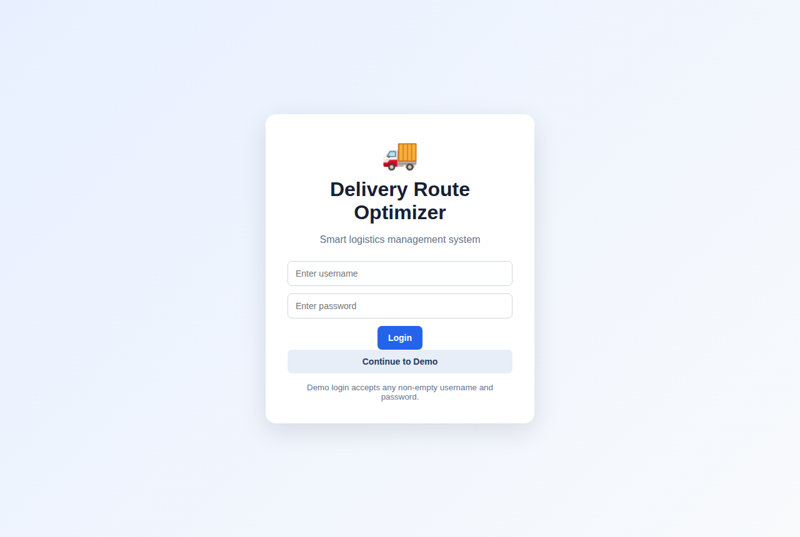
Figure 1: Login page
Login page of the system. Any non-empty username and password is accepted, or the Continue to Demo button opens the dashboard directly.
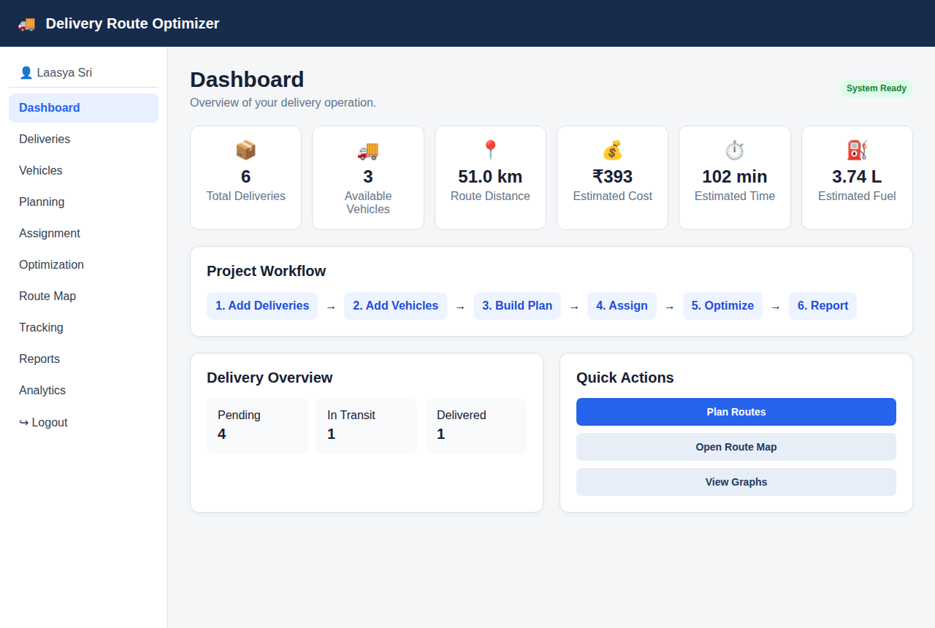
Figure 2: Dashboard
Dashboard showing total deliveries, available vehicles, route distance, estimated cost, time and fuel, with delivery status counts and links to each step of the workflow.
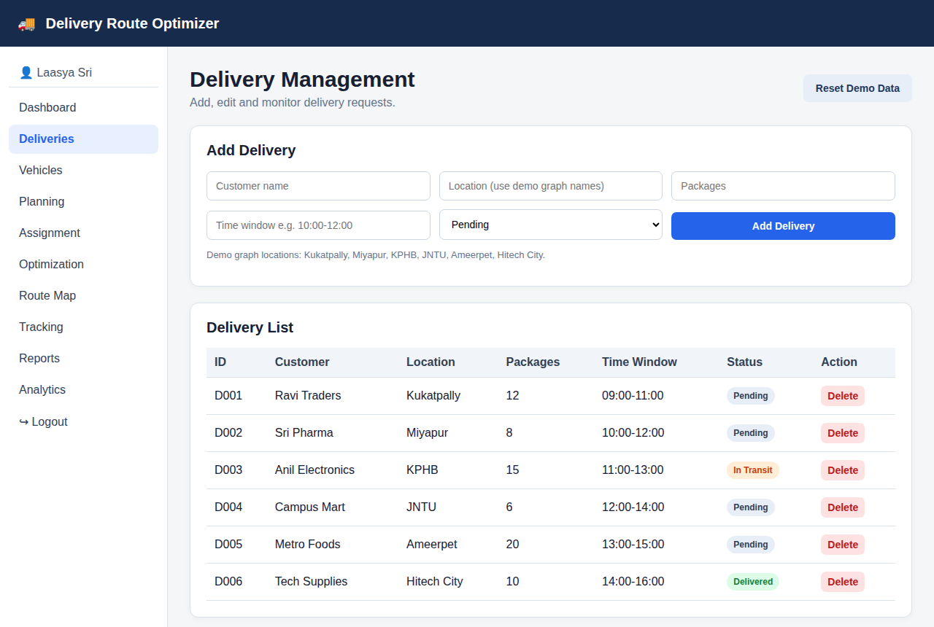
Figure 3: Delivery management
Delivery management page. A new request is accepted only if its location, package count and time window are valid; it then appears in the delivery list and can be deleted.
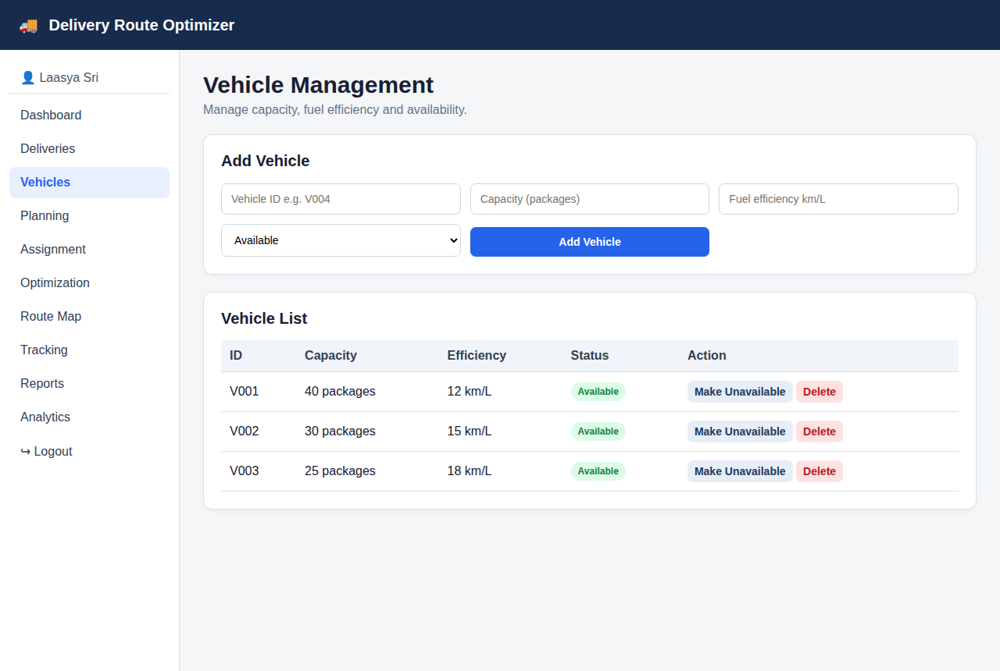
Figure 4: Vehicle management
Vehicle management page listing capacity, fuel efficiency and availability. Vehicles can be added, deleted or switched between Available and Unavailable.
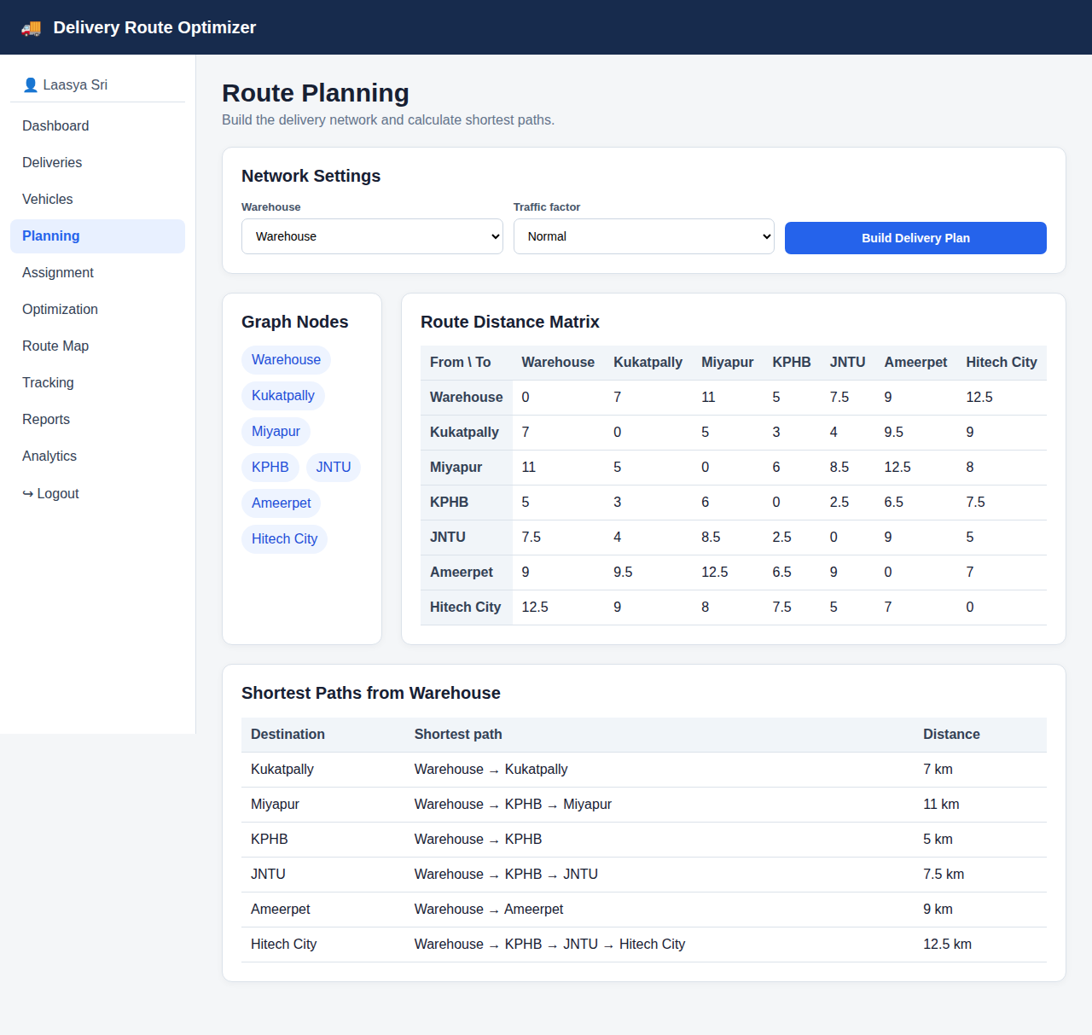
Figure 5: Route planning
Route planning page with the graph nodes, the all-pairs shortest-distance matrix and Dijkstra’s shortest path from the warehouse to every location, scaled by the traffic factor.
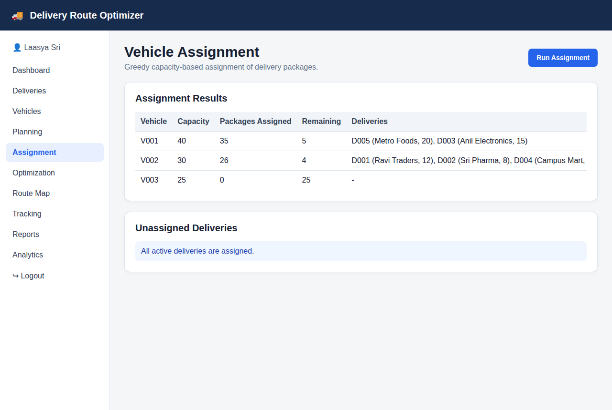
Figure 6: Vehicle assignment
Greedy capacity-based assignment. V001 carries 35 of 40 packages and V002 carries 26 of 30; V003 stays unused and no delivery is left unassigned.
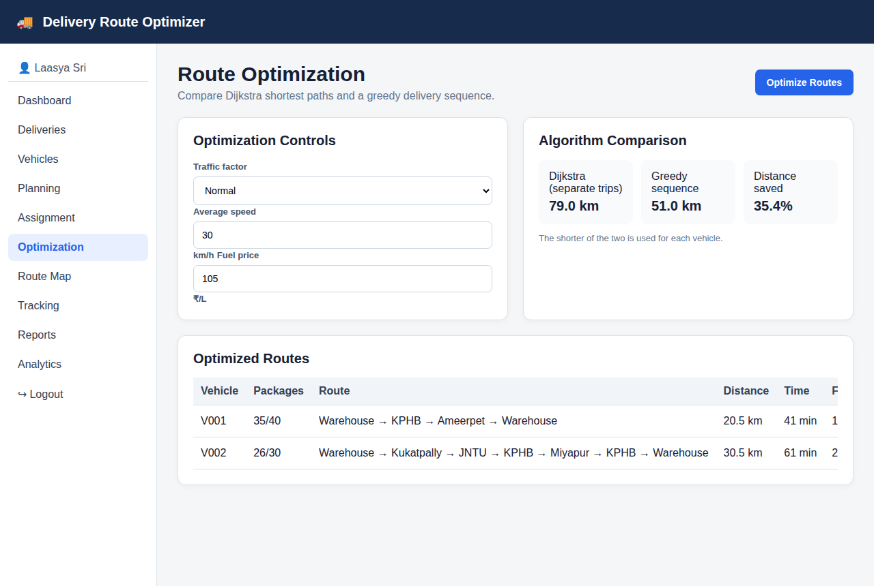
Figure 7: Route optimization
Optimization page comparing Dijkstra separate trips (79 km) with the greedy delivery sequence (51 km), and listing the distance, time, fuel and cost of each vehicle route.
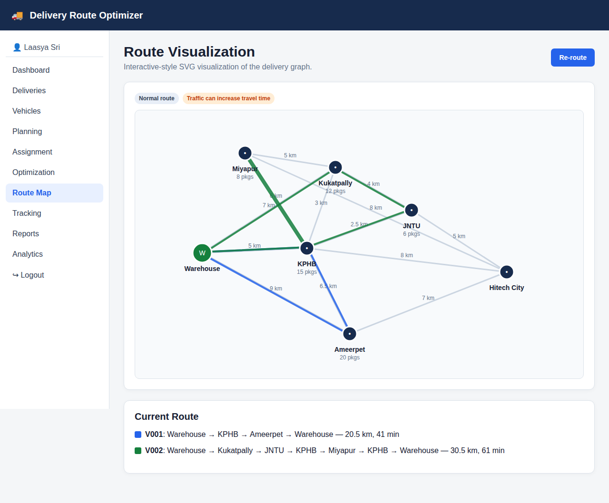
Figure 8: Route map
SVG route map showing roads with distances, package counts at each stop and each vehicle route in its own colour. Re-route simulates a traffic jam and recalculates the routes.
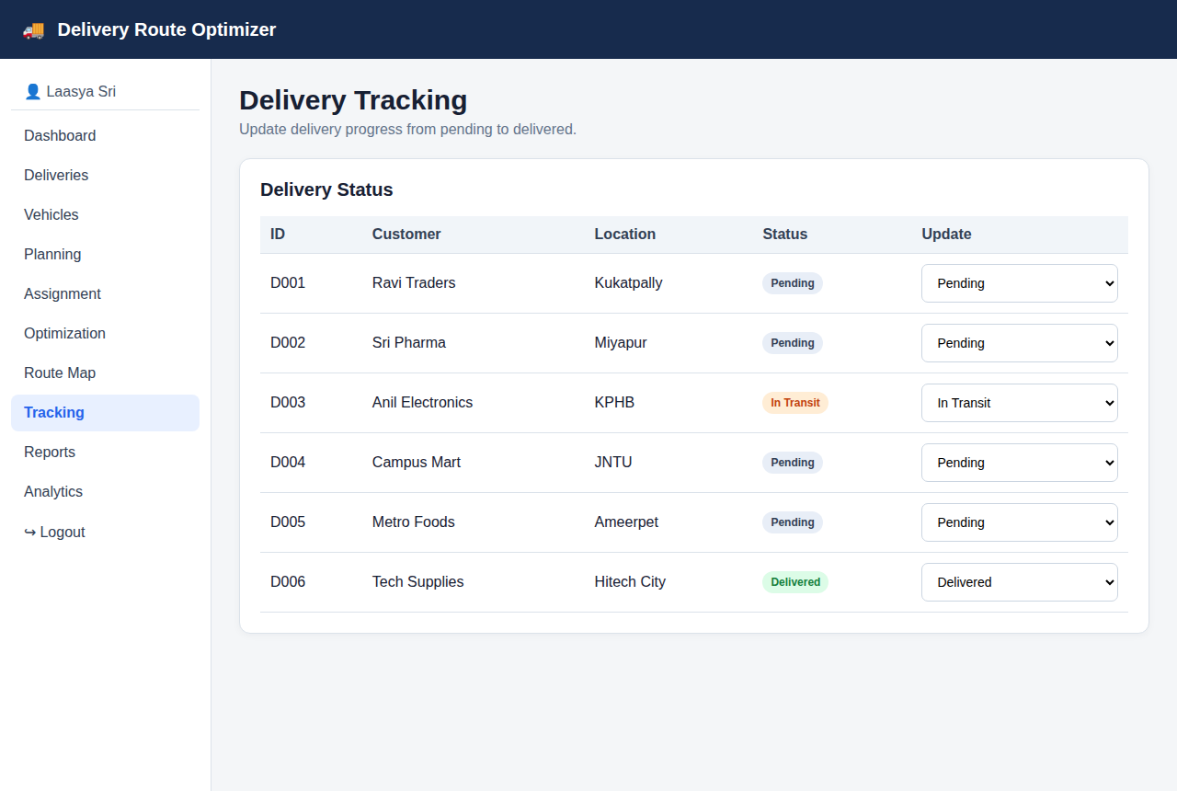
Figure 9: Delivery tracking
Tracking page where the status of every delivery can be changed between Pending, In Transit and Delivered; an update clears stale route calculations.
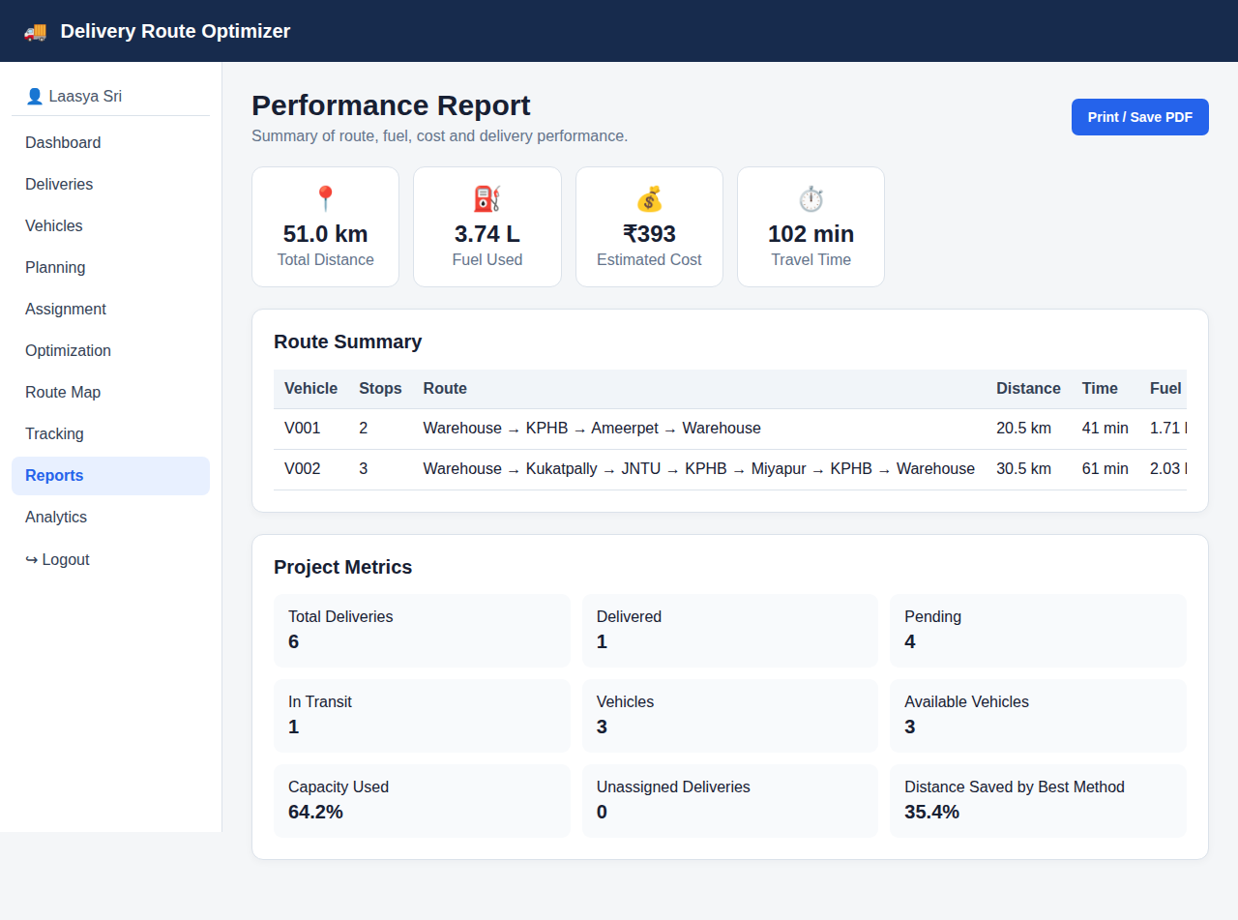
Figure 10: Performance report
Performance report with total distance, fuel, cost and travel time, the route summary table and project metrics such as capacity used. It can be saved as PDF.
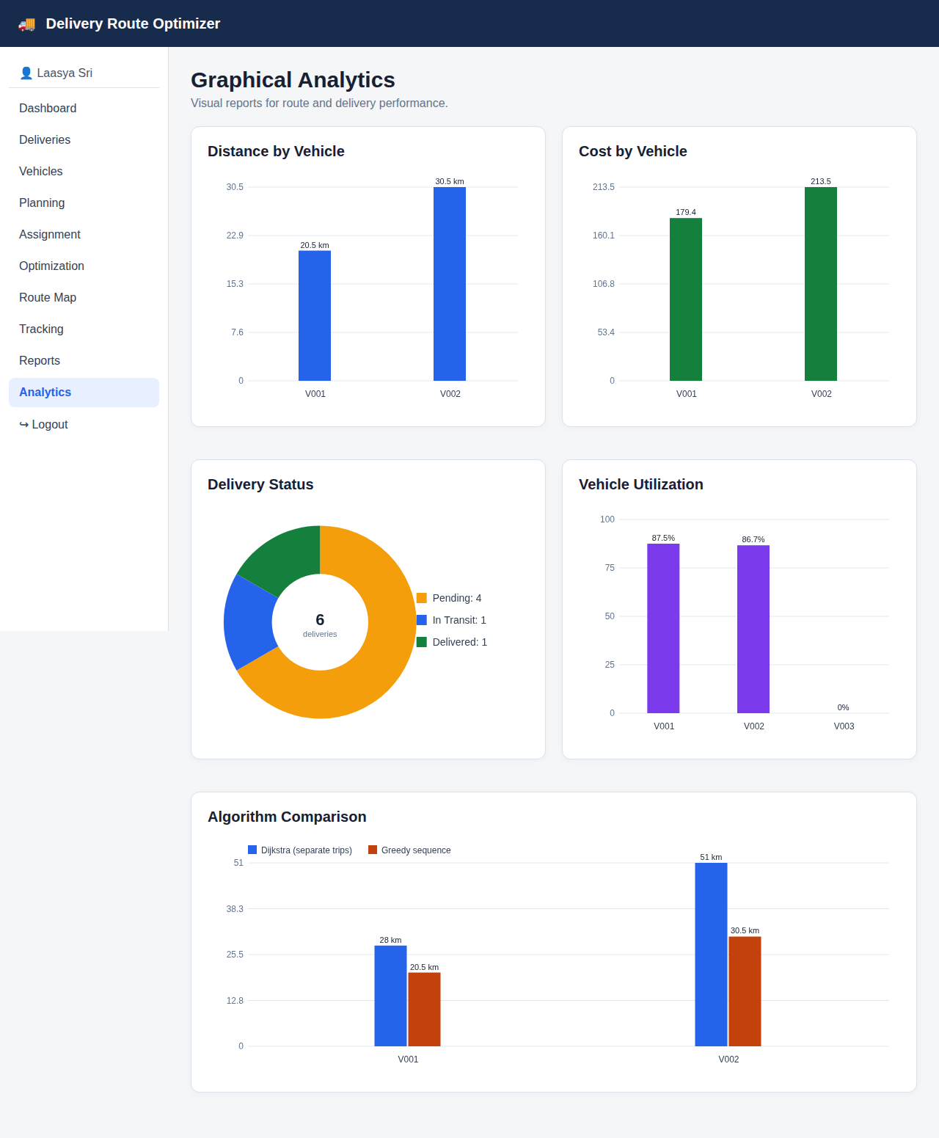
Figure 11: Graphical analytics
Charts for distance and cost per vehicle, delivery status, vehicle utilization and the comparison of the two routing algorithms for each vehicle.
Sample run: assignment and route results
Table 1 shows the greedy assignment of the five active deliveries (the delivered order D006 is excluded) and Table 2 shows the routes generated for the two vehicles that received packages.
Table 1: Vehicle assignment
Vehicle | Capacity | Assigned | Remaining | Deliveries
V001 | 40 | 35 | 5 | D005 (20), D003 (15)
V002 | 30 | 26 | 4 | D001 (12), D002 (8), D004 (6)
V003 | 25 | 0 | 25 | –

Table 2: Optimized routes
Vehicle | Route | Distance | Time | Fuel | Cost
V001 | Warehouse → KPHB → Ameerpet → Warehouse | 20.5 km | 41 min | 1.71 L | ₹179
V002 | Warehouse → Kukatpally → JNTU → KPHB → Miyapur → KPHB → Warehouse | 30.5 km | 61 min | 2.03 L | ₹214
Total |  | 51.0 km | 102 min | 3.74 L | ₹393

Table 3: Algorithm comparison (distance)
Vehicle | Dijkstra (separate trips) | Greedy sequence | Selected
V001 | 28.0 km | 20.5 km | Greedy
V002 | 51.0 km | 30.5 km | Greedy
Total | 79.0 km | 51.0 km | 35.4% shorter

Discussion
- The greedy delivery sequence reduced the total distance from 79 km (separate Dijkstra round trips) to 51 km, a saving of 35.4%, because several stops are now served in one trip instead of returning to the warehouse after each stop.
- Greedy assignment kept both loaded vehicles below their capacity (87.5% and 86.7% utilization) and left no delivery unassigned. V003 stayed idle, which shows that the first-fit rule uses larger vehicles first.
- The greedy sequence is a heuristic and is not guaranteed to be optimal. The route of V002 visits KPHB twice because Miyapur can only be reached through KPHB or Kukatpally in the demo network.
- Delivery time windows are stored and displayed for every request, but they are not yet enforced when the visiting order is chosen; this is listed in the future scope.
- CONCLUSION & FUTURE SCOPE
The Delivery Route Optimizer meets its main objectives. It validates and standardizes delivery locations, models the road network as a weighted graph, computes shortest paths with Dijkstra’s algorithm, assigns packages to vehicles without exceeding capacity, and builds a visiting sequence for each vehicle. On the demo data the selected routes were 35.4% shorter than serving each stop with a separate round trip, and the system reports time, fuel and cost for every route. The map, tracking page, dashboard, report and analytics make the results easy to read and to share.
The project also has limits. The route sequence is found by a nearest-neighbour heuristic, so it is near-optimal rather than guaranteed optimal; the road network and distances are a fixed demo graph; time windows are recorded but not enforced; and all data lives in one browser’s localStorage.
Future scope
Near term
- Enforce delivery time windows when ordering the stops, and warn when a window cannot be met.
- Import deliveries from CSV or Excel files and clean free-text addresses with fuzzy matching.
- Add an editable road network so that users can add their own locations and distances.
Medium term
- Improve route quality with the Clarke-Wright savings algorithm and local search such as 2-opt, and compare them with the current greedy method.
- Use real road distances and live traffic from a map service instead of the fixed demo graph.
- Add a backend database and user accounts so that several operators can share the same data.
Long term
- Build a driver mobile app with live GPS tracking, proof of delivery and automatic re-routing.
- Use historical delivery data to predict demand and travel times and to plan routes in advance.
- Support multiple depots, pickup-and-delivery orders and mixed vehicle fleets.
- REFERENCES
[1] Google Developers, “Capacity Constraints (Capacitated Vehicle Routing Problem),” OR-Tools. [Online]. Available: https://developers.google.com/optimization/routing/cvrp (accessed 8 Oct 2026).
[2] Google Developers, “Vehicle Routing,” OR-Tools. [Online]. Available: https://developers.google.com/optimization/routing (accessed 8 Oct 2026).
[3] VROOM Project, “VROOM: Vehicle Routing Open-source Optimization Machine,” GitHub. [Online]. Available: https://github.com/VROOM-Project/vroom (accessed 8 Oct 2026).
[4] OpenStreetMap Wiki, “Open Source Routing Machine (OSRM).” [Online]. Available: https://wiki.openstreetmap.org/wiki/OSRM (accessed 8 Oct 2026).
[5] Route4Me, “How to optimize a multi-stop delivery route.” [Online]. Available: https://support.route4me.com/faq/how-to-optimize-multi-stop-delivery-route/ (accessed 8 Oct 2026).
[6] SmartRoutes, “15 Best Multi Stop Route Planner Tools.” [Online]. Available: https://smartroutes.io/blogs/best-multi-stop-route-planner/ (accessed 8 Oct 2026).
[7] G. K. Rand, “The life and times of the Savings Method for Vehicle Routing Problems,” ORiON. [Online]. Available: https://www.ajol.info/index.php/orion/article/view/48716 (accessed 8 Oct 2026).
[8] T. Doyuran and B. Çatay, “A robust enhancement to the Clarke-Wright savings algorithm,” Sabancı University, 2009. [Online]. Available: https://research.sabanciuniv.edu/id/eprint/12597/ (accessed 8 Oct 2026).
[9] T. Pichpibul and R. Kawtummachai, “An improved Clarke and Wright savings algorithm for the capacitated vehicle routing problem,” ScienceAsia. [Online]. Available: https://scienceasia.org/content/viewabstract.php?ms=3262 (accessed 8 Oct 2026).
[10] “Application of the Clarke and Wright Savings Algorithm to Solve the Vehicle Routing Problem in Optimizing Chip Distribution,” Kubik (UIN Sunan Gunung Djati), vol. 10, no. 1. [Online]. Available: https://journal.uinsgd.ac.id/index.php/kubik/article/view/49162 (accessed 8 Oct 2026).

