**Example 1**:Practical Example Of Cross-Browser Testing In Browsers

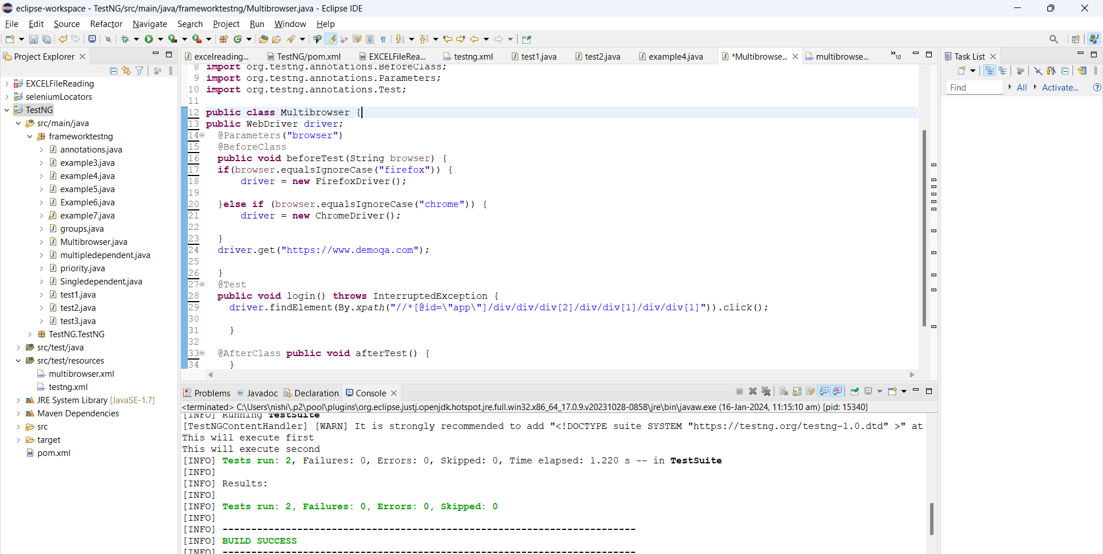

**Example 2**:How to perform Parallel Execution in TestNG?

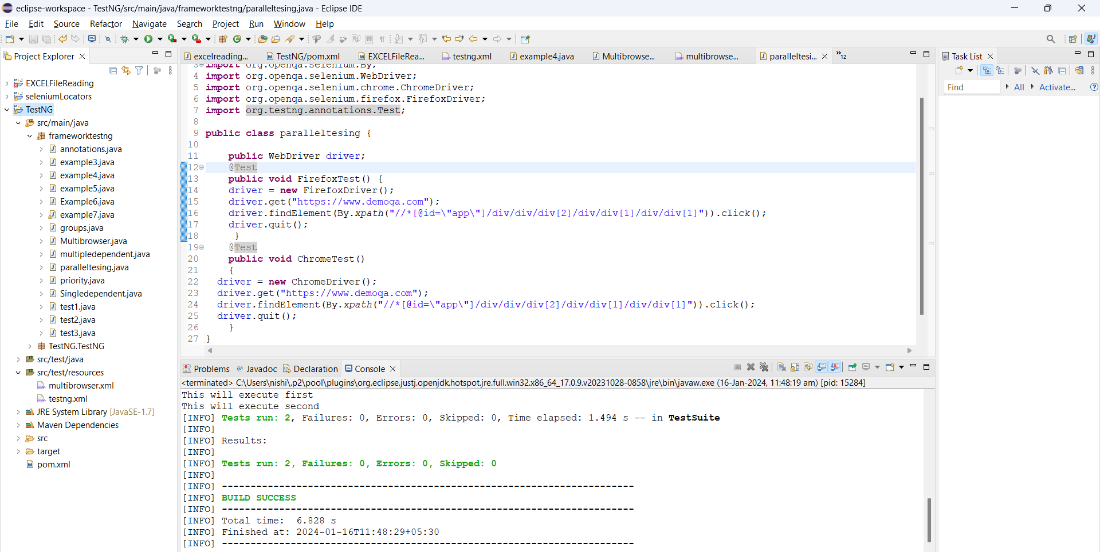

**Example 3**:Threads in TestNG

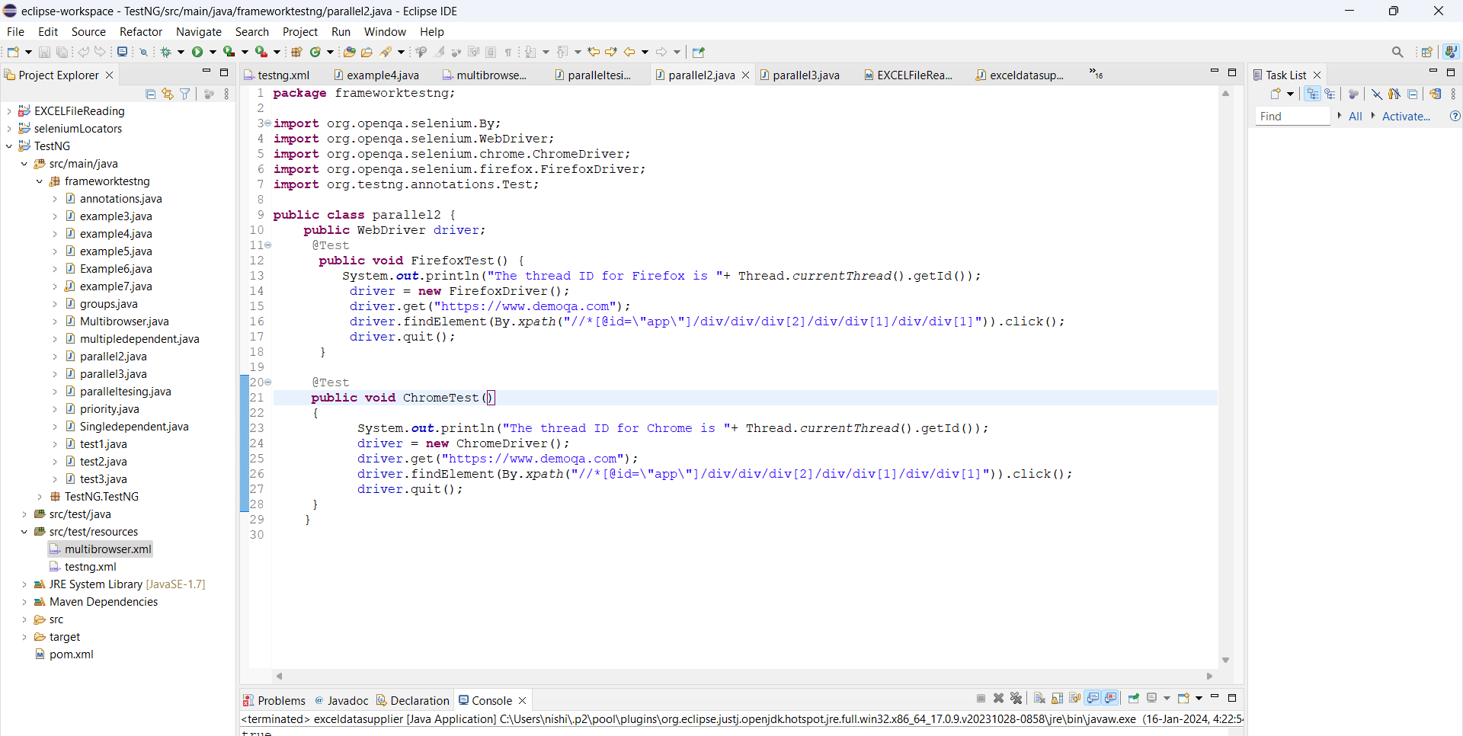

**Example 4:**Running test classes Parallelly in TestNG using Selenium

