1.14)Create a Webpage in which you generate alert message whenever mouse is clicked on the webpage

<!DOCTYPE html>

<html>

    <head><title>pgm1.14</title>

        <style>

            body{

                background: yellowgreen;

            }

            div{

                display: block;

               align-items: center;

            }

            #demo{

                padding: 30px;

                padding-top: 50%;

                padding-left: 50%;

            }

            </style>

    </head>

    <body id="demo">

     <script type="text/javascript">

            document.getElementById("demo").addEventListener("click",function()

             {

                alert("you clicked on the window");

            },true);

    </script>

    </body>

</html>

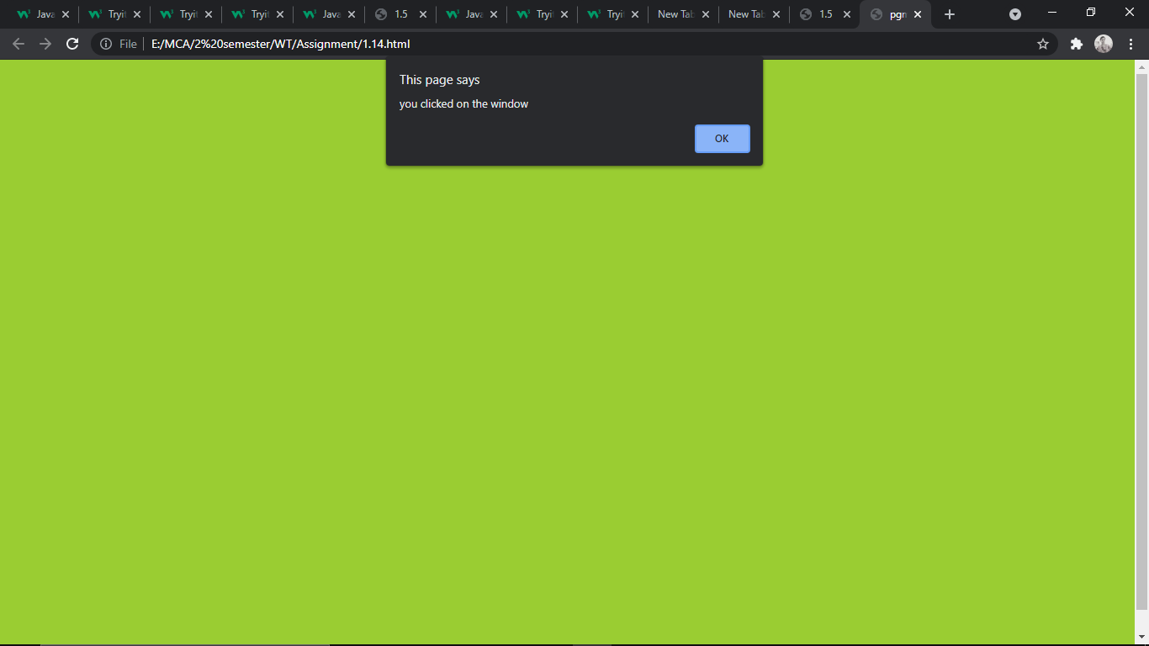

1.16) Create a page to change size of an image when mouse moves over the image and set image to its original size whenever mouse moves out the image

<!DOCTYPE html>

<html lang="eg">

    <head><title>mouse over</title>

        <link rel="preconnect" href="https://fonts.gstatic.com">

<link href="https://fonts.googleapis.com/css2?family=Satisfy&display=swap" rel="stylesheet">

    <style>

        p{

            padding-left: 200px;

            margin-bottom: 30px;

            padding-top: 30px;

            }

            body{

                background: linear-gradient(yellow,white);

                background-repeat: no-repeat;

                background-size: cover;

                padding-left: 500px;

            }

            .demo{

                border: 3px solid #ff0066;

                padding: 5px;

                box-shadow:2px 2px 10px black;

            }

            div{

               margin-bottom: 40px;

               font-family: cursive;

               font-size: 40px;

               text-shadow: 4px 4px 4px #ff0066;

               color:black;

               font-family: 'Satisfy', cursive;

            }

    </style>

    </head>

<body>

    <p>

        <div id="Text"> Before</div>

     <img src="aa.jpg"  id="img1" class="demo" alt="beautiful"  height="100px" width="100px"

     onmouseover="show('300px','After');" onmouseout="show('100px','Before');">

    </p>

    <script type="text/javascript">

        let show=(x,t)=>{

            /*document.getElementById("img1").style.height=x;*/

            let elt=document.getElementById("img1");

            let elt2=document.getElementById("Text").innerHTML=t;

            elt.setAttribute("width",x);

            elt.setAttribute("height",x);

}

        </script>

</body>

    </html>

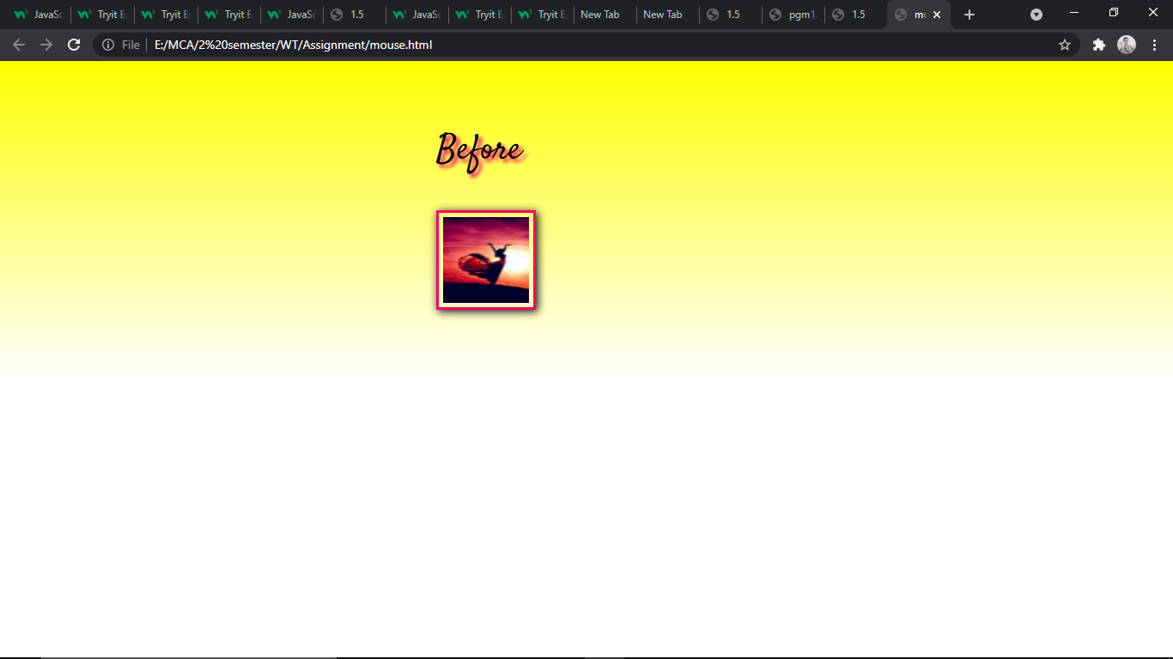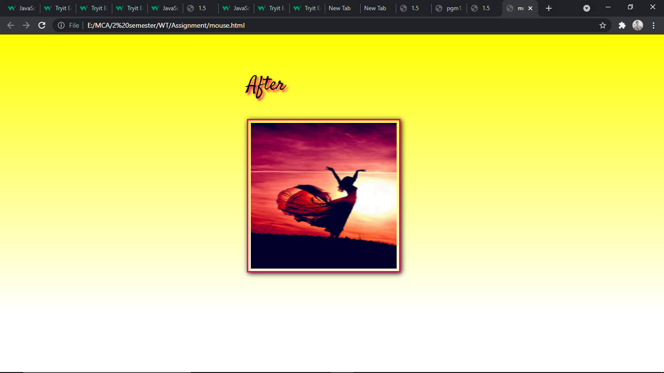

1.15) Create a program to display all the HTML elements in the web page in the alert box.

<!DOCTYPE html>

<html id="h">

    <head id="H1"><title>1.5</title>

        <style>

            body{

                background: yellowgreen;

            }

            div{

                display: block;

               align-items: center;

            }

            #demo{

                padding: 30px;

                padding-top: 50%;

                padding-left: 50%;

            }

    </style>

    </head>

    <body id="H2">

        <div></div>

        <div id="try"><h1><a href=""></a></h1></div>

        <div id="try2"><h1></h1></div>

        <div id="try3"></div>

  <button onclick="show()">click here</button>

        <script type="text/javascript">

                //d -recursive calling

        let  show=() =>{

               let show1=()=>{

                   return GetElement(document.documentElement,0);

               }

               let GetElement=(root,level)=>{

                   let str="";

                   let type=window.NODE ?NODE.ELEMENT_NODE:1;

                   document.getElementById("try3").innerHTML=type;

                   if(root.nodeType==type){

                       str+=setElement(level,root.nodeName)

                       let child=root.children;

                       for(let i=0;i<child.length;i++){

                           str+=GetElement(child[i],level+1);

                       }

                   }

              return str;

               }

               let setElement=(level,node_name)=>{

                   let str="  ";

                   for(let i=0;i<level;i++){

                       str+="*  "

                   }

                   str+=node_name+"\n";

                   return str;

               }

               alert(show1())

        }</script>

    </body>

</html>

