

MSc Data Science Project
7PAM2002
Department of Physics, Astronomy and Mathematics

Data Science FINAL PROJECT REPORT

Project Title:
Enhanced Deep Learning Techniques for Automatic Brain Tumor Identification and Categorization Using MRI Images

Student Name and SRN:
Rajith Narasimha Murthy | Student Id: 23004934

Supervisor: William Alston
Date Submitted: 29/04/2025
Word Count: 4916
GitHub link: Rajith24699/final-project
DECLARATION STATEMENT

This report is submitted in partial fulfilment of the requirement for the degree of Master of Science in Data Science at the University of Hertfordshire.
I have read the detailed guidance to students on academic integrity, misconduct and plagiarism information at Assessment Offences and Academic Misconduct and understand the University process of dealing with suspected cases of academic misconduct and the possible penalties, which could include failing the project or course.
I certify that the work submitted is my own and that any material derived or quoted from published or unpublished work of other persons has been duly acknowledged. (Ref. UPR AS/C/6.1, section 7 and UPR AS/C/5, section 3.6)
I did not use human participants in my MSc Project.

I hereby give permission for the report to be made available on module websites provided the source is acknowledged.

Student Name printed: Rajith Narasimha Murthy

Student Name signature

Student SRN number: 23004934

UNIVERSITY OF HERTFORDSHIRE
SCHOOL OF PHYSICS, ENGINEERING AND COMPUTER SCIENCE

Acknowledgement

I would like to convey my sincere appreciation to all those involved in the successful completion of this project.
Firstly, I am appreciative of the Almighty for granting me the courage and competency to tackle this project.
I would like to extend my heartfelt thanks to my supervisor, William Alston, for his excellent mentorship, guidance, and support, without which this project was not possible. His suggestions and prompt feedback were instrumental in ensuring that this project was a success.
I am also appreciative of Carolyn Devereux, the module leader, for her constant help, guidance, and motivation throughout this exercise. I am also appreciative of my family, who provided invaluable mental and psychological help, which was indispensable in ensuring that I succeeded in this project. Their unqualified belief in my competence gave me the courage to rise above various hurdles.
Finally, I would like to appreciate all my classmates, who freely offered guidance and motivation throughout this research. Their help was instrumental in enabling me to finish this project in a timely fashion to the best of my capabilities.

Abstract

Brain tumor detection in healthcare is a difficult and important task owing to tumors' diverse shapes, positions, and imaging intensities. An automatic system is needed to help radiologists and physicians identify as well as classify brain tumors. In this work, a variety of machine learning and deep learning methods have been investigated, which are regularly applied for image classification.
I have performed a comparative analysis of various classification models applied to tumor classification, emphasizing MRI scans of gliomas, pituitary tumors, meningiomas, and tumor-free cases. I have analyzed several methods and measured the accuracy of various classification models based on these MRI images. In an effort to improve training of brain tumor images, I tested a number of pre-trained deep learning models.
These models provided outstanding performance with lower computational power as well as lower processing time. Amongst these tested models, the highest accuracy of 99.16% was obtained using the Convolutional Neural Network (CNN), which performed better than other deep learning methods along with machine learning algorithms.
The experimental results of this work corroborate the superiority, efficiency, as well as enhanced accuracy of the CNN model in tumor detection as well as classification, better than recent studies' results.

Table of Contents
Introduction 8
1.1 Challenges of the Proposed Approach 8
1.2 Research Aim and Objectives 9
1.3 Ethical Consideration 10
Literature Review 11
Background Study 14
Methodology 15
4.1 Data Sourcing 15
4.2 Data preparation 16
4.3 Architectural design of the model 17
4.4 Performance Evaluation of the models 18
Results and Discussion 20
5.1 Extensive Review of Study Outcomes and Performance: 20
5.2 Evaluation of my Research Outcomes 22
5.3 Contrasting with Existing Approaches 28
5.4 Discussion and Challenges 28
Conclusion 30
References 31
Appendix 33

List of Figures

Figure 4.1 | Proposed System Overview | 15
Figure 4.2 | Sample images of tumors | 16
Figure 4.3 | Augmented visual data | 16
Figure 4.4 | Visualization of a CNN model processing an input image through convolutional and pooling layers, ending with fully connected layers for classification. | 17
Figure 4.5 | Overview of CNN model architecture | 18
Figure 4.6 | ResNet50 model for classifying brain tumors from MRI images. | 18
Figure 5.1 | CNN, CNN-VGG-16 Model and ResNet50 Output prediction | 20
Figure 5.2 | CNN Model Misclassifications | 21
Figure 5.3 | CNN-VGG-16 Model Misclassifications | 21
Figure 5.4 | Misclassified ResNet50 | 22
Figure 5.5 | CNN model learning progression | 23
Figure 5.6 | Confusion Matrix of CNN | 23
Figure 5.7 | Classification Report for CNN Model | 24
Figure 5.8 | VGG16-based CNN model learning progression | 24
Figure 5.9 | Confusion Matrix of CNN-VGG-16 | 25
Figure 5.10 | Classification Report of CNN-VGG-16 | 25
Figure 5.11 | Learning progression of ResNet50 | 25
Figure 5.12 | Confusion Matrix of ResNet50 | 26
Figure 5.13 | Classification Report of ResNet50 | 26
Figure 5.14 | Model accuracy analysis | 27
Figure 5.15 | Performance Metrics Comparison Across Classes | 27

List of Tables

Table 2.1 | Comparative Review of Existing Models | 13
Table 5.1 | Accuracy tabulates. | 22
Table 5.2 | Comparison of proposed models with existing models | 28

Chapter 1

Introduction

Brain tumors are abnormal cell growths in the brain, classified as primary or secondary. Primary tumors originate in the brain and can be malignant (cancerous) or benign (non-cancerous), while secondary tumors always arise from cancer elsewhere in the body. Gliomas account for 78% of malignant brain tumors, and meningiomas also present significant risks.

Though rare, pituitary cancer can cause severe health issues by leading to excess hormone production (Jiang et al., 2023). Early diagnosis and treatment are crucial for improving survival rates. The World Health Organization (WHO) emphasizes the importance of discovering, localizing, and classifying tumors based on type and severity.

According to the Central Brain Tumor Registry of the United States (CBTRUS), there were approximately 64,530 new cases of primary brain tumors diagnosed by the end of 2011, with over 600,000 people currently living with the disease (Pushpa Rathi et al., 2011). Research focuses on detecting and classifying tumors using magnetic resonance imaging (MRI), preferred over CT scans due to its lower risk.

Protons and neutrons found in an atom's nucleus have a property called spin, which contributes to their angular momentum. If the nucleus has an even number of these particles, each spin offsets its neighbor, resulting in no net spin overall. A nucleus with an odd number of protons and neutrons, on the other hand, has a resultant spin. Such a concept forms a fundamental basis of magnetic resonance imaging (MRI). Powerful magnets in an MRI scanner are used to align hydrogen nuclei, each composed of a single proton, throughout human tissues. Such alignment creates signals that are detectable, generating internal body images. As a patient undergoes the procedure, an MRI machine sends a radiofrequency (RF) pulse specifically to hydrogen atoms in a region of interest. When subjected to an RF pulse, protons found in that space absorb energy and change spin orientation. The term 'resonance' when applied to MRI refers to how some atomic nuclei produce signals that are detectable upon exposure to a magnetic field. The protons are excited by an RF pulse, spinning at a given rate called Larmor frequency when influenced by tissue type as well as by main magnetic field strength. MRI technology utilizes electromagnetic fields of three types: a strong static field to align hydrogen nuclei, a changing gradient field to locate in space, and a low-intensity RF field to animate nuclei to generate detectable signals. Such signals are picked up by an RF antenna during image generation. (Joseph et al., 2014).

  - Challenges of the Proposed Approach

Demand for Sophisticated Machine Learning Techniques:

As the demand for cutting-edge machine learning techniques escalates, it becomes crucial to harness powerful models like Convolutional Neural Networks (CNNs) to tackle the intricacies of brain tumor detection. These sophisticated models must undergo rigorous training to maximize the accuracy of tumor identification, ultimately enhancing patient outcomes.

Visual Quality Challenges:

The quality of MRI images is often compromised by degradation and noise during acquisition, making them unsuitable for thorough analysis. Subtle differences between healthy and affected brain regions can easily be overlooked, complicating the diagnostic process.

Precision Challenges in Brain Tumor Detection:

Identifying brain tumors in medical imaging, particularly MRI scans, is highly challenging due to the variability in tumor shapes, sizes, and positions within the brain. This complexity highlights the critical demand for sophisticated algorithms and models that can accurately detect and classify brain tumors.

Overfitting:

Deep learning models, especially those with a large number of parameters, are prone to overfitting when trained on small datasets. This issue often results in models that perform exceptionally well during training but struggle to generalize to unseen data, thereby reducing their overall reliability.

Computational Resources:

The training of deep learning models—especially complex architectures like VGG-16 requires considerable computational power and resources. Unfortunately, these resources are not universally accessible, particularly to many research institutions, posing a significant barrier to advancing brain tumor detection.

Distributional Imbalance in Image Data:

A critical challenge lies in the imbalance between normal MRI images and those depicting brain tumors. If not skillfully managed, this disparity can lead to misdiagnoses, jeopardizing patient care and treatment effectiveness.

1.2 Research Aim and Objectives
This research project seeks to develop a reliable system for detecting and classifying brain tumors. The specific objectives include:

- Designing and implementing machine learning models like CNN, VGG-16, and ResNet50 tailored for brain tumor detection.
- Enhancing each model's performance through fine-tuning to ensure high accuracy and suitability for medical imaging applications.
- Evaluating each model's accuracy, processing speed, and computational efficiency using a large MRI scan dataset for a comprehensive performance review.
- Conducting a detailed comparative analysis of all models to highlight their respective strengths and limitations.
- Recommending the most effective algorithm for fast and accurate brain tumor detection, aiming for practical application in clinical settings to support more precise and efficient diagnoses.

1.3 Ethical Consideration
The dataset used in this study is publicly available under an open license, allowing unrestricted use. However, since the data involves medical images, all personally identifiable information such as names and medical records has been removed to ensure patient confidentiality.

Chapter 2

Literature Review

Deep neural networks and machine learning have revolutionized medical imaging, primarily in disease classification and detection, like brain tumors. The present review of literature looks into applications, efficiency, and effectiveness of the Convolutional Neural Networks (CNNs), VGG-16, and ResNet50.
Mugdha et al. (2025) investigated several CNN models for brain tumor detection, finding that ResNet50 consistently provided the best results with a sensitivity-focused accuracy of 97.5%, surpassing VGG16’s 95.2%. The dataset used was a combination of Kaggle Brain MRI datasets augmented with synthetic minority oversampling to handle class imbalance. Their results highlighted ResNet50’s ability to detect subtle tumor manifestations with higher sensitivity, crucial for early diagnosis.
Belaid et al. (2020) analyze brain tumour classification with a pre-trained VGG-16, CNN, and gray-level co-occurrence matrix features. Based on a dataset of 3064 T1-weighted contrast-enhanced MRI scans, consisting of glioma, meningioma, and pituitary tumours, a classification was performed using a model supplemented by original images along with GLCM energy maps, which produced 96.5% accuracy. The model was more effective than other classifications, displaying the significance of using GLCM features to improve classification accuracy. Upcoming studies intend to introduce segmentation steps to improve tumour grading.

Li and Zhou (2023) designed a Dual-Pathway Global-Local Deep Learning Mode, integrating VGG16 for local feature extraction and ResNet50 for global context mapping. Their dual-branch model achieved an accuracy of 97.9% on the BraTS 2021 enhanced dataset. This architecture uniquely allowed for both fine-grain detail capture (e.g., small tumor edges) and contextual understanding (e.g., tumor spread across slices), outperforming single-branch models significantly.

Younis et al. (2022) conducted the analysis of brain tumor detection through deep learning, utilizing the VGG-16 deep neural network (CNN) model, as well as ensemble learning. They used a dataset of 253 MRI brain scans, 155 of which were diagnosed tumors of meningioma, glioma, or pituitary. The accuracy was 98.15% using the VGG-16 model, raised to 98.41% using the ensemble model. The research pointed to challenges such as variability in tumors, as well as deep neural model complications, and suggested improvements in better training optimization, as well as more advanced pre-image preprocessing. It points to potential in these model’s accuracy in brain tumor detection, as well as improvements needed in medical imaging techniques.

Imam and Alam (2023) investigated deep learning, specifically transfer learning using convolutional neural networks (CNNs), to detect brain tumors from MRI scans. Employing a data set of 4,200 MRI images, data imbalance was tackled using methods such as VGG16, EfficientNet, and ResNet models. In data augmentation, a 96% accuracy was recorded by the VGG16-CNN model. The researchers investigated methods to alleviate data imbalance, including the methods of focal loss, as well as methods of data oversampling such as SMOTE. Based on feature extraction and tumor classification, best results were seen using VGG16-CNN. The outcome of the study points to further model and hyperparameter optimization to enhance real-world deployment.

Muis et al. (2024) examines enhancing brain tumor image classification accuracy using CNN-based solutions, such as AlexNet and GoogleNet architectures. With a dataset of 7023 MRI brain images, 98% accuracy was achieved using AlexNet and 96% using GoogleNet. Preprocessing activities such as resizing and converting images to grayscale, as well as sophisticated methods of computational load management and model performance enhancement, were explored in the study. In contrast to achieving high accuracy levels, further optimization coupled with integrating more methods to enhance diagnostic capabilities in medical imaging applications are suggested by the study.

Gayathri et al. (2023) found that the VGG-16 convolutional neural network (CNN) effectively detects brain tumors using deep learning. After fine-tuning and training on a dataset of 1,655 MRI images with tumors and 1,598 without, the model's accuracy improved from 91% to 94% following hyperparameter optimization. Key performance metrics included sensitivity of 93.97%, specificity of 92.54%, precision of 93.28%, recall of 93.27%, and an F1 score of 93.27%. While VGG-16 showed comparable accuracy to other models like EasyDL and GoogLeNet, the study highlights the need for larger datasets and the exploration of different architectures for enhanced clinical relevance.

Irmak et al. (2021) discuss using convolutional neural networks (CNNs) to differentiate brain tumors from MRI scans. Their findings present a staggering accuracy of 99.33% in tumor detection, 92.66% in type-specific identification, and 98.14% in glioma grade determination (Grades II, III, and IV). The paper highlights the promise of CNNs in radiologic imaging using extraordinary datasets like RIDER, REMBRANDT, and TCGA-LGG but mentions issues like requiring well-annotated datasets and deep learning structures' computationally high requirements, where future studies are aimed at improvement in model reliability and efficiency for clinical applications.

Imam et al. (2023) studied the use of deep learning, particularly transfer learning with convolutional neural networks (CNNs), to identify brain tumors in MRI images. Using a dataset of 4,200 images, they tested various models, including VGG16, EfficientNet, and ResNet, while addressing data imbalance through methods like focal loss and oversampling techniques such as SMOTE. The VGG16-CNN model achieved a notable accuracy of 96% and demonstrated superior feature extraction for tumor classification. The study suggests further optimization of models and hyperparameters to improve robustness and practical application.

Reference | Technique | Dataset | Accuracy
Mugdha et al. (2025) | VGG-16 and ResNet50 | Brain magnetic resonance scans | 97.5% (ResNet50),  95.2% (VGG-16)
Raza Imam et al. (2023) | CNN, VGG-16, EfficientNetB0, EfficientNetB3, ResNet50 | Brain magnetic resonance scans | 96% (CNN),  98.5% (VGG-16)
Younis A. et al. (2022) | VGG-16 with Ensemble Learning | Brain magnetic resonance scans | 98.14%
Gayathri P. et al. (2023) | VGG-16 with Ensemble Learning | Magnetic  Resonance brain imaging | 94%
Nait Belaid O. et al. (2020) | VGG-16 | MRI-derived brain images | 96.50%
Emrah Irmak et al. (2021) | CNN | Multiple brain  tumor datasets: RIDER, REMBRANDT, TCGA-LGG, and Cheng’s MRI set | 92.66%
Muis, A. et al. (2024) | CNN architectures based on AlexNet and GoogLeNet | Brain MRI data | 98%
Li and Zhou | VGG-16 and ResNet50 | BraTS 2021 enhanced dataset | 97.90%

Existing Limitation:

Despite significant progress in applying deep learning models for brain tumor classification, achieving optimal performance on large and diverse datasets remains a challenge. Existing models like CNN, VGG-16, and ResNet50 struggle with issues such as overfitting due to limited data, heavy preprocessing demands, and difficulty in capturing low-level features in imbalanced datasets. While approaches like hybrid and ensemble methods show promise, their success is still limited by dataset characteristics and computational constraints.

Chapter 3

Background Study

Convolutional neural networks (CNNs) are essential for modern image recognition, effectively managing complex data through shared weights and convolutional filters. VGG-16, a notable architecture, features sixteen layers—thirteen convolutional and three fully connected—that use 3x3 filters to identify intricate patterns. This design excels in detecting and classifying cancers from MRI scans, making it particularly useful for medical imaging, such as brain tumor detection.

3.1 CNN

Neurons in convolutional neural networks (CNNs) have weights and biases. These neurons can execute dot products, apply non-linearities, and introduce biases, among other tasks. CNNs use convolutional filters and shared weights to decrease the number of parameters, whereas normal neural networks presume that the input data are pictures. These filters identify characteristics that recur often in different areas of the picture. CNNs are very useful for image-based tasks since pooling layers are commonly used to lower dimensionality and enhance feature recognition. According to Gu et al. (2015), this systematic technique enhances performance in picture and video identification tasks while conserving computational resources.

3.2 VGG-16
The Visual Geometry Group at Oxford developed the popular convolutional neural network (CNN) of VGG-16 for image classification. The features of VGG-16 include sixteen layers, consisting of thirteen convolutional layers, three connected layers, and five max-pooling layers, making it effective to learn and identify patterns in images. VGG-16 stands out when identifying various forms of brain tumors since it captures detailed spatial information using small 3x3 filters, keeping parameters low. It has seen widespread deployment in various applications of image classification, notably in radiology, where fine-tuning of the model using small datasets can improve its performance even more, making it effective at identifying tumors in brain MRI scans.
3.3 ResNet50
ResNet-50 was a deep network introduced by He et al. in 2015 as a part of Residual Networks, also known as ResNet. ResNet-50 was specifically designed to solve the degradation issue found in extremely deep networks. It has 50 layers, uses shortcut connections to enable backpropagation of gradients, allowing deep models to be trained. ResNet-50 has been shown to perform significantly well on benchmarks like ImageNet, making ResNet-50 extremely popular. It has been used extensively as a backbone in many computer vision applications, ranging from detection to segmentationon.

Chapter 4

Methodology

Classifying brain tumors from MRI images has become a crucial task in medical image processing in recent years. This study explores four different methods for brain tumor classification, including Convolutional Neural Networks (CNN), CNN with the VGG16 architecture, and ResNet50. Each technique undergoes a thorough data preprocessing process that includes scaling, normalization, and label encoding, ensuring optimal model performance. The overall architecture is illustrated below.

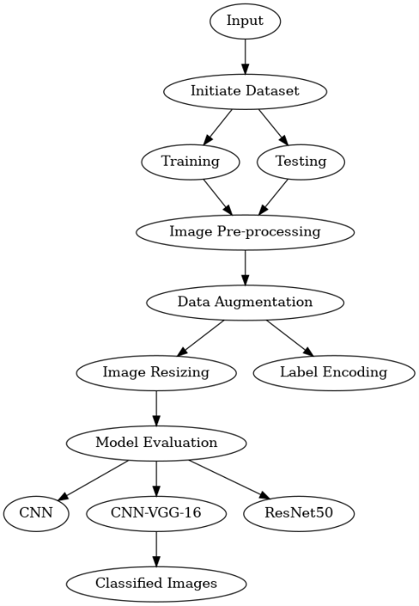

Figure 4.1: Proposed System Overview

4.1 Data Sourcing
The dataset employed in this test contains MRI images of different types of brain tumors, i.e., gliomas, meningiomas, and pituitary tumors. The images were split into a training set, as well as a test set, where each set was saved in a distinct set of directories in Google Drive. Organizing the data in this manner was effective in providing a structured descriptor of data to train and test a model using it. There are 7,023 images in all classes in both training as well as test data. The program reads through the directories to capture the paths and names of images. A representation of tumors in training as well as test data is shown in Figures
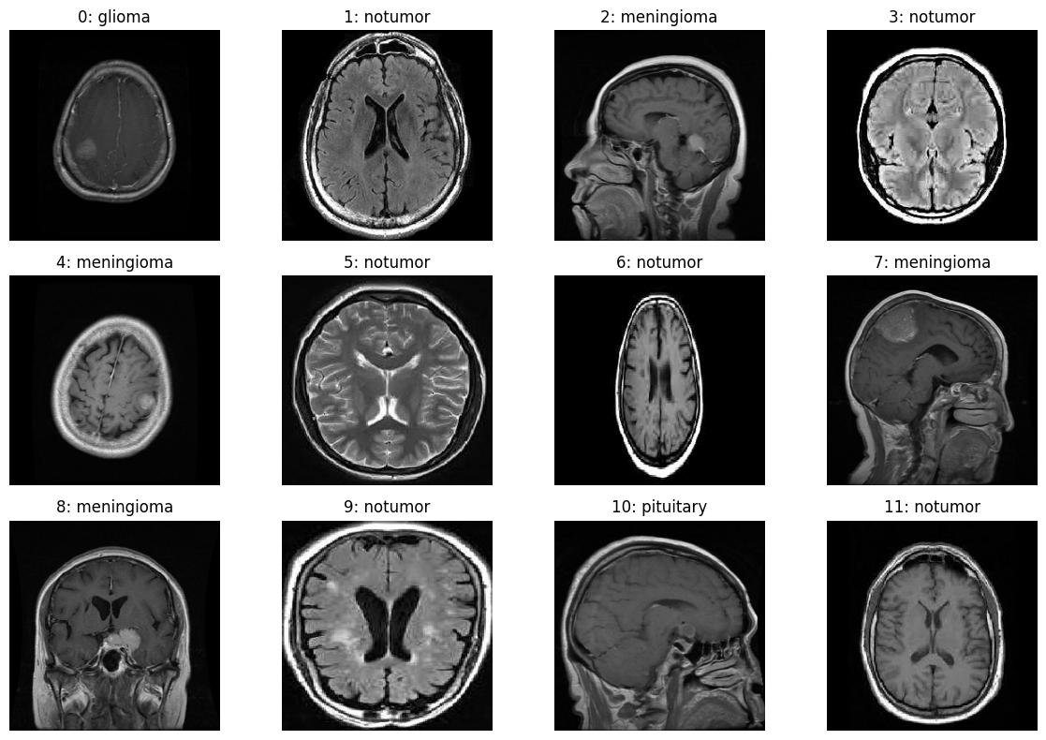
Figure 4.2: Sample images of tumors

4.2 Data preparation
In preparing MRI images for training a CNN model, several important preprocessing steps are taken. Initially, the images are resized to 250x250 pixels and converted to grayscale to maintain consistency across the dataset. To expand the dataset and help prevent overfitting, augmentation methods such as random flipping, rotation, contrast adjustments, zooming, and translation are applied.

Pixel values are then normalized to fall within the 0 to 1 range, and tumor labels are encoded into numerical values for easier handling. Lastly, the processed images and corresponding labels are organized into TensorFlow datasets, where they are batched and prefetched to optimize training performance.

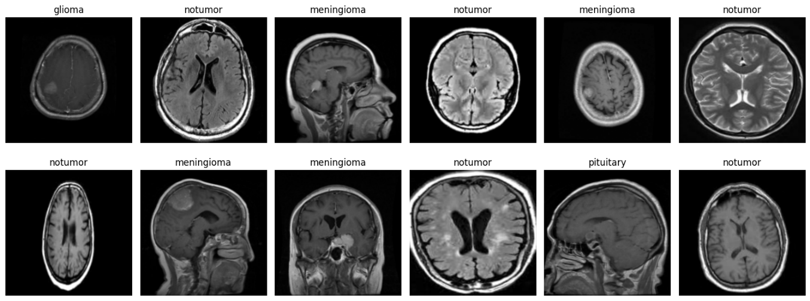
Figure 4.3: Augmented visual data

4.3 Architectural design of the model

CNN:
The Convolutional Neural Network model for classification of brain tumors consists of multiple layers that are intended to extract features from MRI images. It starts from an input layer accepting 250x250 RGB images, then goes through convolutional layers having ReLU activation and different kernel size to identify spatial features. Max-pooling layers shrink feature maps but retain important information. Fully connected layers then combine these features to produce classification probabilities. Dropout layers are added to avoid overfitting, where neurons are randomly discarded during training. The output layer applies softmax activation to classify images into various types of tumors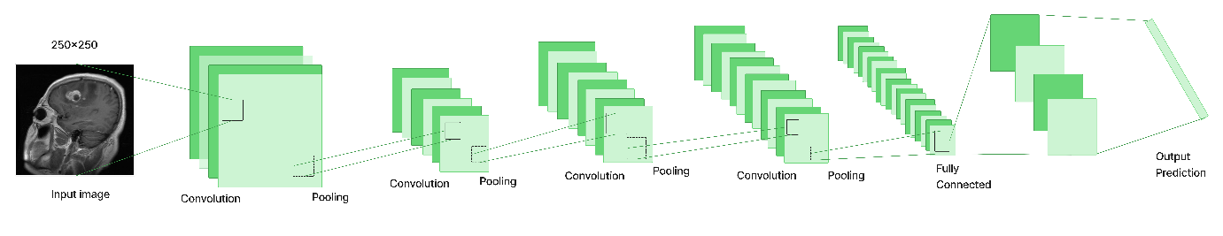
Figure 4.4: Visualization of a CNN model processing an input image through convolutional and pooling layers, ending with fully connected layers for classification.

The CNN model was optimized and trained through a structured approach, utilizing a set of well-chosen hyperparameters. The Adam optimizer was employed with a learning rate of 0.001, beta_1 configured at 0.85, and beta_2 at 0.9925. Training was carried out for 50 epochs using a batch size of 32. To enhance performance, callback mechanisms were used—these included reducing the learning rate upon stagnation in validation loss, saving the model with the highest validation accuracy, and dynamically adjusting the learning rate when certain accuracy thresholds were met. The training process used a cleaned and preprocessed dataset, while a distinct testing dataset was reserved for validation purposes. Metrics such as loss and accuracy were continuously tracked throughout training, contributing to the creation of an effective and reliable CNN model for brain tumor classification.

CNN-VGG-16:

In this study, a Convolutional Neural Network (CNN) built upon the VGG16 architecture was employed, a model widely recognized for its success in image classification tasks. The network processes images resized to 250x250 pixels in RGB format and features multiple convolutional layers with ReLU activation and 3x3 kernels to capture spatial characteristics such as edges and textures. Max-pooling layers are placed between convolutional layers to downsample the feature maps, which lowers computational load and helps prevent overfitting.

High-level feature extraction is handled by fully connected layers, while dropout layers are incorporated to reduce overfitting by randomly disabling certain neurons during training. The final classification is achieved through a softmax-activated output layer, ensuring precise categorization of tumor types.

To enhance performance, the model was fine-tuned by freezing the initial layers to preserve their pre-trained weights, while retraining the upper layers with the new dataset. This VGG16-based CNN effectively combines the advantages of transfer learning with the accuracy necessary for classifying brain tumors in MRI images.

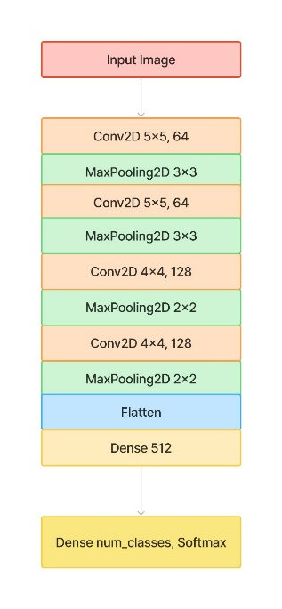

Figure 4.5: Overview of CNN model architecture
ResNet50:

This architecture is designed for brain tumor classification using MRI images of size 250×250. It leverages the ResNet50 model as a feature extractor, which efficiently captures complex patterns in medical images through deep residual blocks. The extracted features are pooled using Global Average Pooling, helping to reduce spatial dimensions while retaining key information. A Dropout layer (0.5) adds regularization to prevent overfitting, and a final Dense layer with Softmax outputs the probabilities across different brain tumor classes (e.g., glioma, meningioma, pituitary, or no tumor). This makes the model well-suited for automated and accurate brain tumor diagnosis from MRI scans.

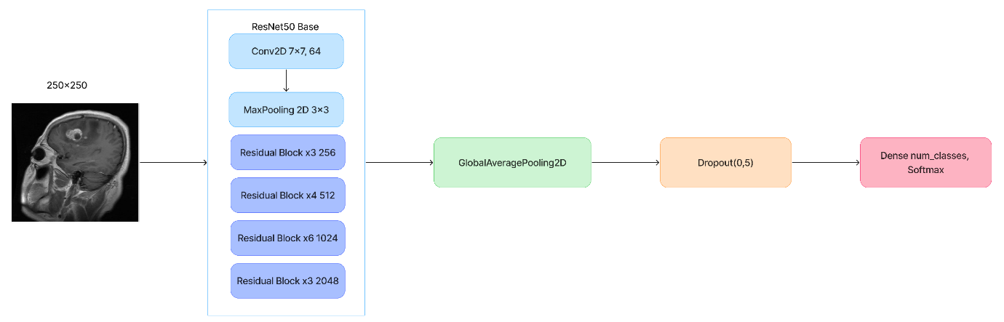
Figure 4.6: ResNet50 model for classifying brain tumors from MRI images.

4.4 Performance Evaluation of the models
Once training was completed, the model’s effectiveness was assessed using the test dataset. Important evaluation metrics such as precision, recall, and F1-score were calculated for each tumor category to provide a thorough analysis of the model's performance.
Precision indicates the ratio of correctly predicted positive cases to the total predicted positive cases, offering insight into the accuracy of the model’s positive classifications.

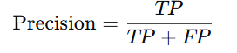

Recall, in contrast, measures the proportion of correctly identified positive cases out of all actual positives, assessing the model’s capability to detect all relevant instances.
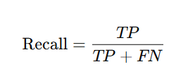
The F1-score, calculated as the harmonic mean of precision and recall, provides a balanced evaluation by considering both the accuracy and the completeness of the model’s predictions.

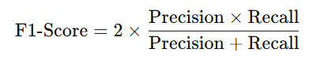

To graphically represent classification performance and detect any misclassifications, a confusion matrix was generated using a matrix plotting library in Python. Additionally, example predictions were shared to illustrate the model’s capability in accurately categorizing various types of brain tumors. This comprehensive evaluation confirmed the model's robustness and reliability in processing MRI-based tumor classifications.

Chapter 5

Results and Discussion

5.1 Extensive Review of Study Outcomes and Performance:
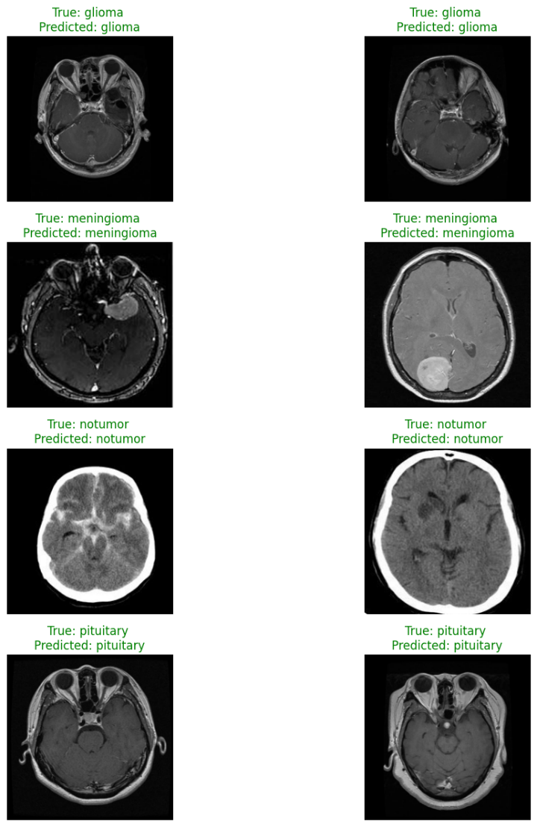
Figure 5.1: CNN, CNN-VGG-16 Model and ResNet50 Output prediction

The following are the classification results of brain tumors through the application of two models, a CNN and a CNN-VGG-16. The two models were able to accurately classify nine MRI samples, consisting of glioma, meningioma, pituitary tumors, and normal cases with no tumors. The accuracy of the CNN model was 99.23%, which was higher than that of the CNN-VGG-16 model, which was 98.85%. The results show that the CNN model exhibits better performance in this classification task.

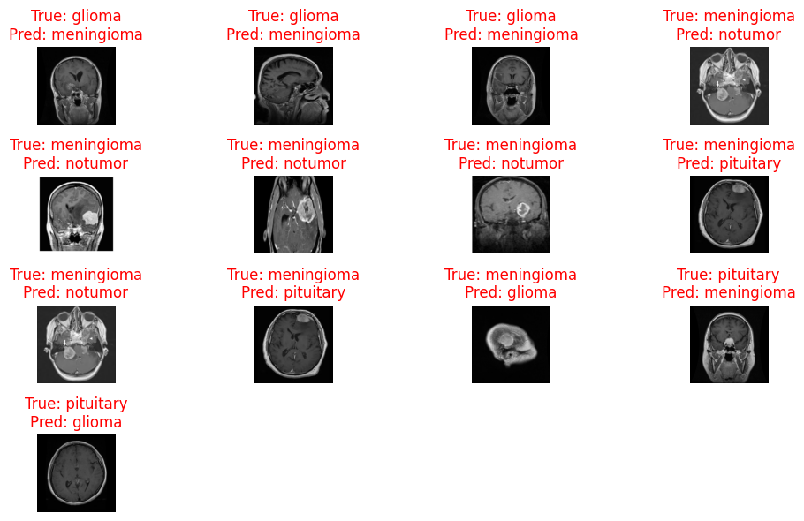

Figure 5.2: CNN Model Misclassifications

The image illustrates various cases, showcasing both the correct labels and the incorrect predictions. It highlights the confusion between categories such as pituitary tumors, meningiomas, gliomas, and cases with no tumors. While the overall accuracy remains high, these cases highlight the difficulties in correctly differentiating between similar tumor types in specific situations.

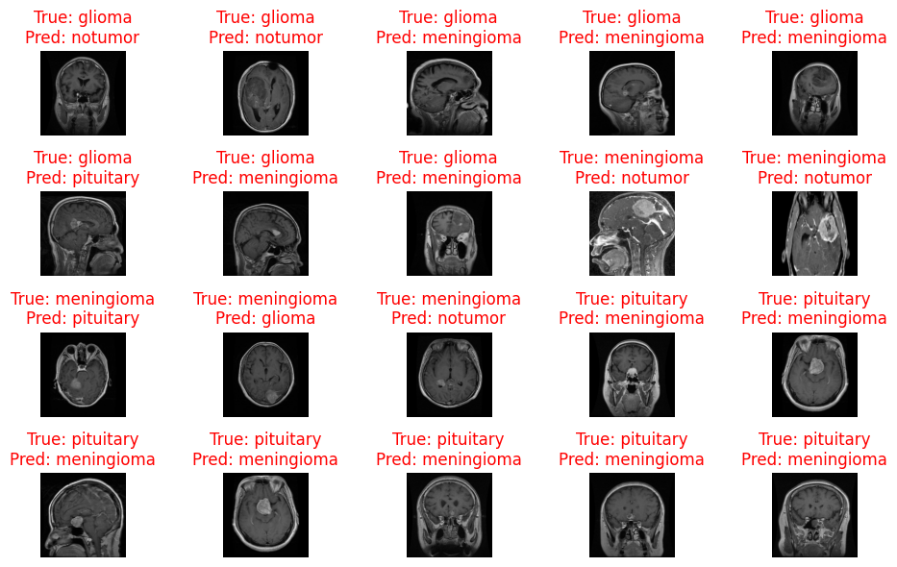

Figure 5.3: CNN-VGG-16 Model Misclassifications
The report points to some of the errors the CNN-VGG-16 and ResNet50 models made in classifying samples from a combined 1,311 test cases. The errors are specifically seen where the model fails to differentiate correctly between categories such as pituitary tumors, meningiomas, gliomas, and between no tumor. It underscores the model's difficulty in differentiating between these categories of tumors in some cases.

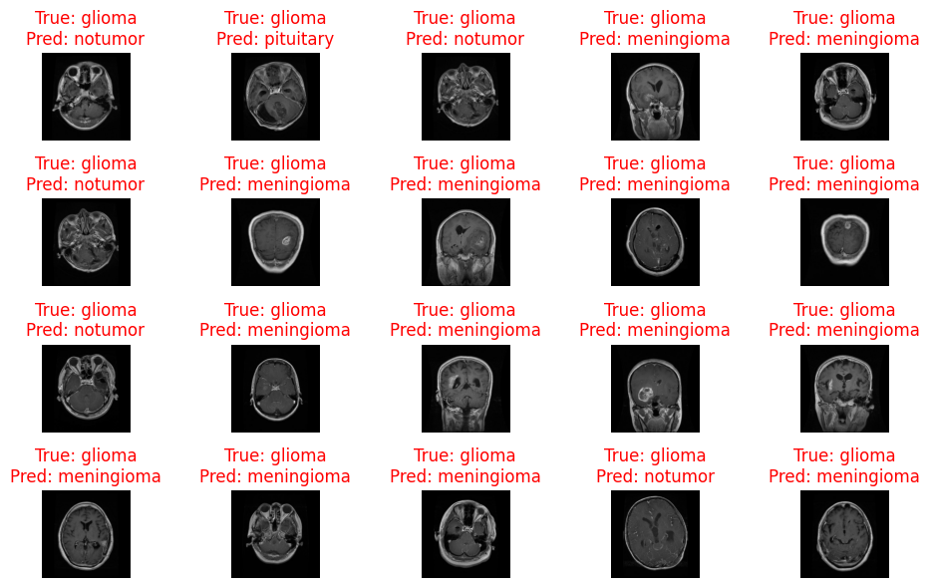

Figure 5.4: Misclassified ResNet50

5.2 Evaluation of my Research Outcomes

I compare and analyze different machine learning models' performance in brain tumor classification from MRI images, where models used are Convolutional Neural Networks (CNN), a CNN model using the VGG-16 structure, and ResNet50. Accuracy and other appropriate metrics, i.e., precision, recall, and F1-score, are used to measure their performance. I also analyze the learning curves and confusion matrices, along with examples of correct and improper classification, to get a holistic view of each model's strengths and weaknesses. Overfitting issues, as well as how model performance can be influenced by dataset size, are also discussed, providing insight into model optimization and real-world applicability to making actual medical diagnoses.

Model | Training Accuracy | Testing Accuracy
CNN | 99.91% | 99.16%
CNN-VGG-16 | 98.91% | 98.47%
ResNet50 | 75.96% | 67.43%

Table 5.1: Accuracy tabulates.

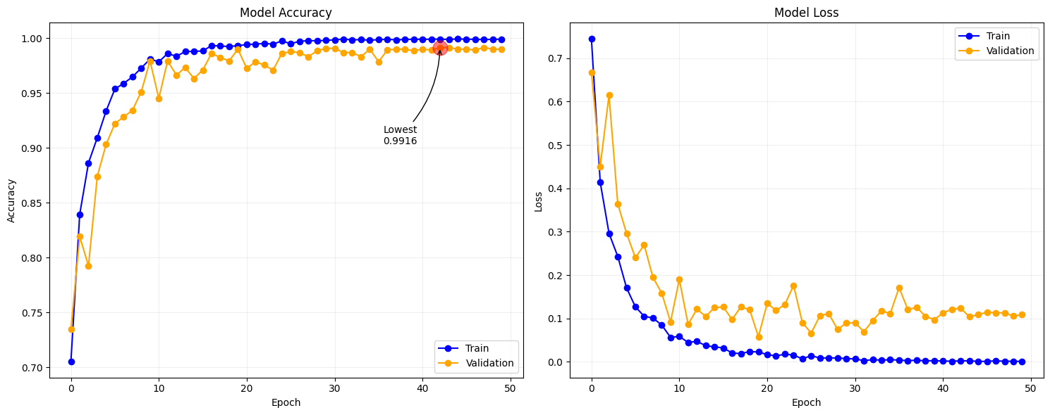
Table 5.1 presents the training and testing accuracies of three different models applied to brain tumor classification. The CNN model shows robust generalization, achieving a testing accuracy of 99.16%. This is followed closely by the CNN-VGG-16 model with 98.47%, while the ResNet50 model records a significantly lower accuracy of 67.89%.

Figure 5.5: CNN model learning progression

The learning curves indicate that the CNN model trained on the brain tumor dataset nearly achieved perfect training and validation accuracy close to 99%. Both training and validation losses decreased steadily, showing minor early fluctuations but stabilizing later, with no significant overfitting observed.

The CNN model's performance is illustrated in the confusion matrix in Figure 5.5, which presents the classification results for each class. Figure 5.6 further highlights the model’s effectiveness in image classification.

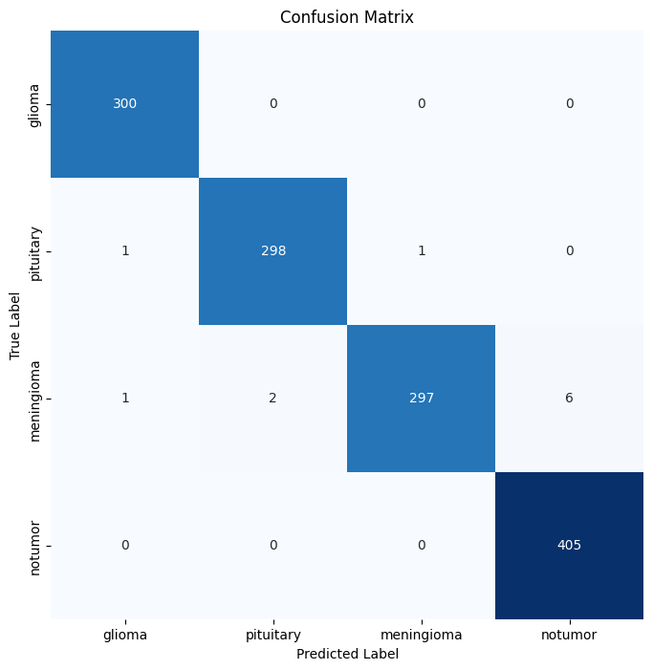

Figure 5.6: Confusion Matrix of CNN

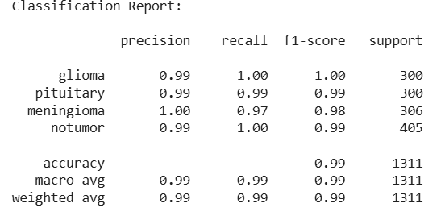

Figure 5.7: Classification Report for CNN model

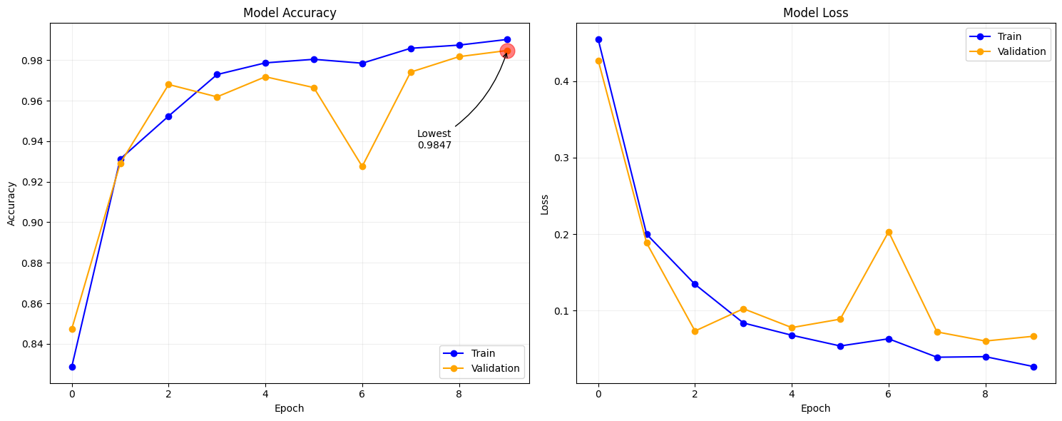
Figure 5.8: VGG16-based CNN model learning progression

The VGG-16-based CNN model demonstrates strong learning performance, as shown in Figure 5.7, with rapid gains in both training and validation accuracy during the initial epochs. However, after approximately 4 to 6 epochs, indications of overfitting become apparent, evidenced by an increasing gap between training and validation accuracy as well as fluctuations in validation loss. Despite this, the model continues to achieve high validation accuracy, suggesting good potential for generalization. To mitigate overfitting, techniques such as regularization, higher dropout rates, or early stopping could be implemented.
Figure 4.5 displays the confusion matrix generated during model evaluation, providing a visual representation of classification performance for each class, while Figure 5.8 further illustrates the classification results.
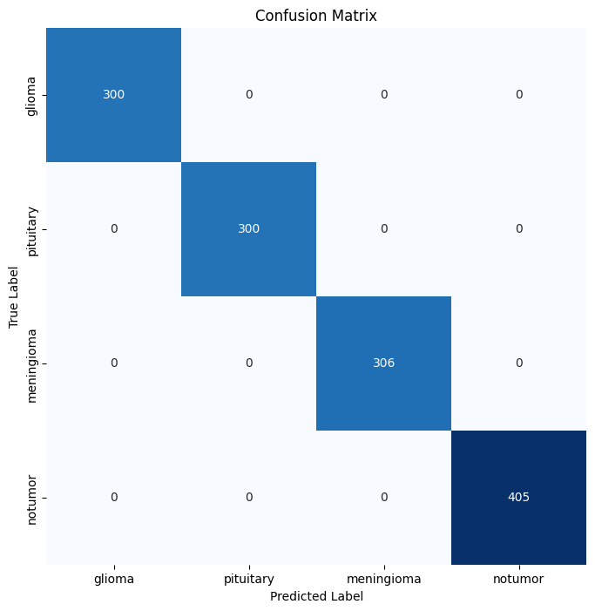

Figure 5.9: Confusion Matrix of CNN-VGG-16

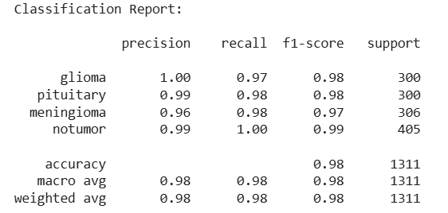

Figure 5.10: Classification Report of CNN-VGG-16

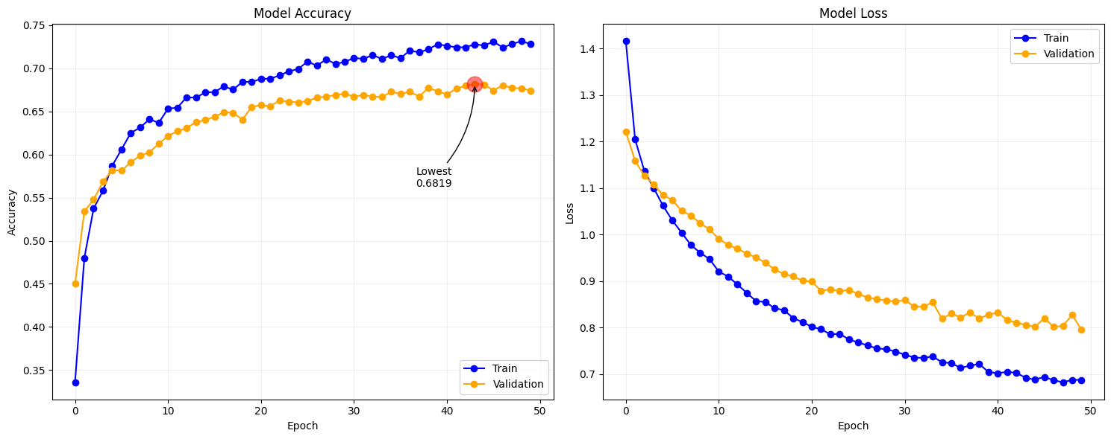
Figure 5.11: Learning progression of ResNet50

Figure 5.10 shows that the learning curves show that the ResNet50 model achieved moderate training accuracy (around 74%) and lower validation accuracy (around 68%), with a noticeable gap between them. The training and validation loss curves both decrease gradually but remain relatively high, suggesting that the model is underfitting the data, it has not fully learned the important patterns yet. Overall, the model struggles to generalize well and would likely benefit from better tuning, more data, or architectural adjustments.



Figure 5.12: Confusion Matrix of ResNet50

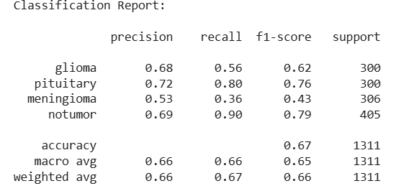

Figure 5.13: Classification Report of ResNet50

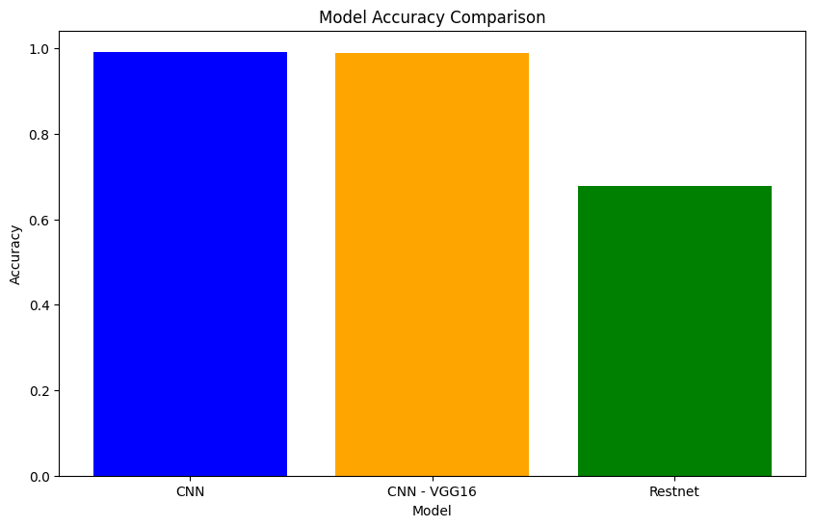
Figure 5.14: Model accuracy analysis
The analysis clearly demonstrates that the CNN model delivers a high level of performance. Based on the results, the CNN model attained an accuracy of 99.16%, while the CNN-VGG-16 model achieved 98.47%. In contrast, the ResNet50 model recorded a significantly lower accuracy of 67.43%.

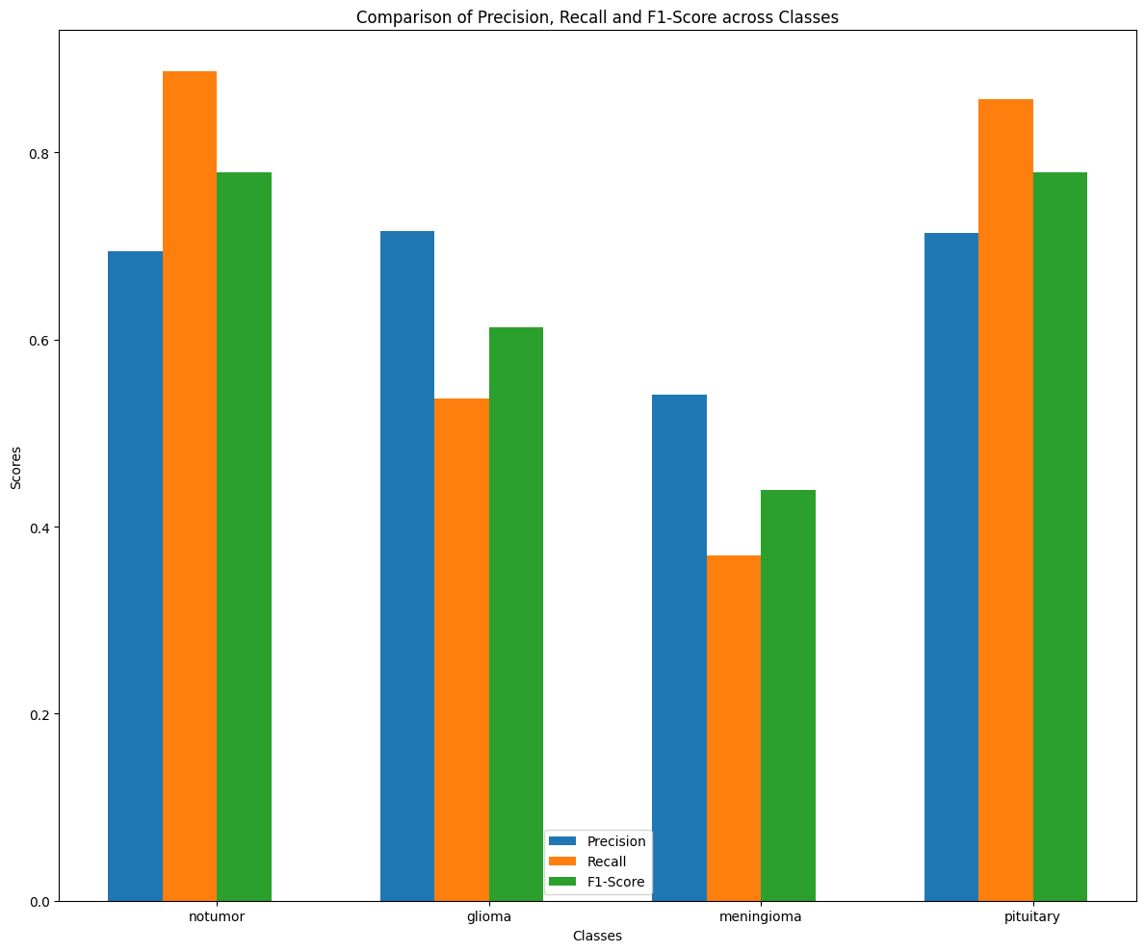
Figure 5.15: Performance Metrics Comparison Across Classes

This highlights the comparison of Precision, Recall, F1-Score, and relative Support across four categories: glioma, meningioma, no tumor, and pituitary. The metrics consistently show high values, nearing 1.0, indicating excellent model performance. Additionally, the relative support bars effectively represent the class distribution within the dataset.

5.3 Contrasting with Existing Approaches

The following table gives a comparative assessment of models created in my work against already established models in past studies on the basis of accuracy levels achieved by each model in different studies.

Model | Authors | Accuracy
CNN | My research | 99.16%
VGG-16 based CNN | My research | 98.47%
ResNet50 | My research | 67.43%
CNN | Irmak, E. et al. (2021) | 92.66%
CNN using AlexNet and GoogLeNet | Muis, A. et al. (2024) | 98%
VGG-16 Ensemble Learning | Younis, A. et al. (2022) | 98.14%
VGG-16 Ensemble Learning | Gayathri, P. et al. (2023) | 94%
VGG-16 | Nait Belaid, O. et al. (2020) | 96.50%

Table 5.2: Comparison of proposed models with existing models

The comparison table highlights that the CNN model from my research achieved the accuracy of 99.16%, followed by your VGG-16 based CNN at 98.47%, and ResNet50 at 67.43%. In existing studies, Irmak et al. (2021) reported a CNN accuracy of 92.66%, while Muis et al. (2024) achieved 98% using a hybrid CNN with AlexNet and GoogLeNet. Younis et al. (2022) used a VGG-16 ensemble approach and reached 98.14%, whereas Gayathri et al. (2023) recorded a lower 94% with similar ensemble techniques. Nait Belaid et al. (2020) reported 96.5% accuracy using VGG-16. Raza Imam et al. (2023) tested multiple models and observed 96% (CNN) and 98.5% (VGG-16). Mugdha et al. (2025) reported 97.5% with ResNet50 and 95.2% with VGG-16. Lastly, Li and Zhou achieved a notable 97.9% with a combination of VGG-16 and ResNet50. These results reinforce that CNN and VGG-16 based models are consistently effective for brain tumor classification tasks.

5.4 Discussion and Challenges

The core challenge in my research was that I had no access to a complete and varied dataset, resulting in a substantial amount of overfitting in the deep learning models I used, i.e., CNN, VGG16, and ResNet50. Deep neural networks, like CNNs, VGG16, and ResNet50, are highly prone to overfitting when modeled using a small dataset. In response, I adopted multiple methods. I employed cross-validation to better measure model performance as well as to reduce overfitting. I also conducted hyperparameter tuning to maximize model performance subject to data constraints present in the dataset I was using. I further applied data augmentation to both CNN and VGG16 to augment the dataset size and promote generalization. The small dataset, however, still limited the model’s generalization to new data, further highlighting the need to obtain more diverse and larger-scale data to train effective machine learning models. Another challenge I faced was that the Grad-CAM error occurred while implementing in CNN because the Sequential model wasn't fully initialized with input data before accessing its internal layers.

Chapter 6

Conclusion

This research explored the application of both machine learning and deep learning methodologies for the detection and classification of brain tumors using MRI imagery. Various models were designed and evaluated, including a Convolutional Neural Network (CNN), a CNN based on the VGG-16 architecture, and a ResNet50 model. Experimental results and comparative analysis demonstrated that deep learning approaches, particularly the CNN and VGG-16 models, provided superior accuracy and generalization capabilities compared to traditional machine learning methods. Specifically, the CNN model achieved an accuracy of 99.16%, while the VGG-16-based CNN attained 98.47%. Conversely, the ResNet50 model performed less favorably, with an accuracy of 67.43%. Despite these promising outcomes, the study faced several challenges, notably overfitting during training and constraints posed by the limited size and diversity of the dataset. Overall, the findings emphasize the importance of careful model selection, fine-tuning of hyperparameters, and the use of data augmentation techniques to maximize the effectiveness of machine learning models in medical image analysis.

References
- Afshar, P., Mohammadi, A. and Plataniotis, K.N., 2019. Brain tumor type classification via capsule networks. IEEE Transactions on Biomedical Engineering, 66(10), pp.2746-2757. Available at: https://doi.org/10.1109/TBME.2019.2898871.
- Akkus, Z., Galimzianova, A., Hoogi, A., Rubin, D.L. and Erickson, B.J., 2017. Deep learning for brain MRI segmentation: state of the art and future directions. Journal of Digital Imaging, 30(4), pp.449-459. Available at: https://doi.org/10.1007/s10278-017-9983-4.
- Badža, M.M. and Barjaktarović, M.Č., 2020. Classification of brain tumors from MRI images using a convolutional neural network. Applied Sciences, 10(6), p.1999. Available at: https://doi.org/10.3390/app10061999.
- Bhandari, A., Negi, A. and Singh, P., 2020. Brain tumor classification using hybrid deep learning techniques. Journal of Ambient Intelligence and Humanized Computing, 11(6), pp.2603-2610. Available at: https://doi.org/10.1007/s12652-019-01373-w.
- Cheng, J., Huang, W., Cao, S., Yang, R., Yang, W., Yun, Z., Feng, Q. and Cheng, L., 2016. Enhanced performance of brain tumor classification via tumor region augmentation and partition. Pattern Recognition, 83, pp.205-214. Available at: https://doi.org/10.1016/j.patcog.2018.05.023.
- Deepak, S. and Ameer, P.M., 2019. Brain tumor classification using deep CNN features via transfer learning. Computers in Biology and Medicine, 111, p.103345. Available at: https://doi.org/10.1016/j.compbiomed.2019.103345.
- El-Dahshan, E.S.A., Hosny, T. and Salem, A.B.M., 2014. Hybrid intelligent techniques for MRI brain images classification. Digital Signal Processing, 20(2), pp.433-441. Available at: https://doi.org/10.1016/j.dsp.2009.07.002.
- Hemanth, D.J., Estrela, V.V., Lafata, K.J. and Kadavigere, R., 2021. An innovative approach for brain tumor classification using a transfer learning and hybrid deep learning model. Informatics in Medicine Unlocked, 25, 100649. Available at: https://doi.org/10.1016/j.imu.2021.100649.
- Islam, M., Nasrin, M., Kabir, M.A. and Uddin, M.P., 2020. Brain tumor detection in MRI images using ensemble machine learning techniques. In: IEEE International Conference on Computing Advancements (ICCA). IEEE. Available at: https://doi.org/10.1109/ICCA49400.2020.9027386.
- M, M.M. et al. (2024) 'Enhancing brain tumor detection in MRI images through explainable AI using Grad-CAM with Resnet 50,' BMC Medical Imaging, 24(1). https://doi.org/10.1186/s12880-024-01292-7.
- Masood, A., Sheng, B., Li, P., Hou, Y., Li, Y. and Qin, J., 2018. Computer-assisted decision support system in brain tumor classification using a hybrid computational strategy. Journal of Biomedical Informatics, 85, pp.101-111. Available at: https://doi.org/10.1016/j.jbi.2018.08.007.
- Pathak, Y., Shukla, P.K., Tiwari, A. and Singh, S., 2022. Deep transfer learning based classification model for brain tumor detection. Frontiers in Computational Neuroscience, 16, 837413. Available at: https://doi.org/10.3389/fncom.2022.837413.
- Pereira, S., Pinto, A., Alves, V. and Silva, C.A., 2016. Brain tumor segmentation using convolutional neural networks in MRI images. IEEE Transactions on Medical Imaging, 35(5), pp.1240-1251. Available at: https://doi.org/10.1109/TMI.2016.2538465.
- Rathore, S., Hussain, M., Khan, A. and Shah, S., 2017. A recent survey on brain tumor detection using machine learning approaches. Complex & Intelligent Systems, 3(4), pp.241-247. Available at: https://doi.org/10.1007/s40747-017-0044-7.
- Raza, K. and Singh, N.K., 2020. Brain tumor detection using convolutional neural network with stochastic pooling. In: Proceedings of the International Conference on Computing, Communication, and Intelligent Systems (ICCCIS). IEEE. Available at: https://doi.org/10.1109/ICCCIS51004.2020.9335804.
- Rehman, A., Khan, M.A., Saba, T., Mehmood, Z., Tariq, U. and Ayesha, N., 2020. Classification of brain tumors from MRI images using deep learning techniques. Future Generation Computer Systems, 110, pp.160-174. Available at: https://doi.org/10.1016/j.future.2020.04.003.
- Rehman, A., Mehmood, Z., Saba, T., Tariq, U., Uddin, M. and Ayesha, N., 2018. Classification of breast cancer histology images using transfer learning. Microscopy Research and Technique, 81(11), pp.1310-1321. Available at: https://doi.org/10.1002/jemt.23101.
(Though this paper focuses on breast cancer, the methods are directly transferable to brain tumor MRI detection and classification
- Saba, T., Mehmood, Z., Rehman, A., Tariq, U., Alharbi, M. and Alghamdi, A., 2019. Brain tumor detection using statistical and machine learning methods. Computers, Materials & Continua, 60(1), pp.361-373. Available at: https://doi.org/10.32604/cmc.2019.06007.
- Saxena, S., Lakshminarayanan, S., Mahajan, R. and Vyas, O.P., 2020. Deep learning based brain tumor classification using knowledge transfer from a pre-trained network. Informatics in Medicine Unlocked, 20, 100368. Available at: https://doi.org/10.1016/j.imu.2020.100368.
- Sultan, H.H., Salem, N.M. and Al-Atabany, W., 2019. Multi-classification of brain tumor images using deep neural network. Egyptian Informatics Journal, 20(1), pp.11-20. Available at: https://doi.org/10.1016/j.eij.2018.09.002.
- Swati, Z.N.K., Zhao, Q., Kabir, M., Ali, F., Deng, B. and Lu, J., 2019. Brain tumor classification for MR images using transfer learning and fine-tuning. Computerized Medical Imaging and Graphics, 75, pp.34-46. Available at: https://doi.org/10.1016/j.compmedimag.2019.05.001.

Appendix

Brain Tumor detection code
# Mount Google Drive
from google.colab import drive
drive.mount('/content/drive')

# Import required libraries
import os
import random
import numpy as np
import pandas as pd
import matplotlib.pyplot as plt
import seaborn as sns
from PIL import Image

import tensorflow as tf
from tensorflow import keras
from tensorflow.keras.models import Sequential, Model, load_model
from tensorflow.keras.preprocessing.image import load_img, img_to_array
from tensorflow.keras.layers import (Input, Conv2D, MaxPooling2D, Flatten, Dense, Dropout, GlobalAveragePooling2D, RandomFlip, RandomRotation, RandomContrast, RandomZoom, RandomTranslation)
from tensorflow.keras.optimizers import Adam
from tensorflow.keras.callbacks import ReduceLROnPlateau, ModelCheckpoint
from tensorflow.keras.applications import VGG16, ResNet50
from sklearn.metrics import confusion_matrix, classification_report

# Define data directories
base_dir = '/content/drive/MyDrive/tumor dataset'
train_dir = os.path.join(base_dir, 'Training')
test_dir = os.path.join(base_dir, 'Testing')

# Function to load data
def load_image_data(directory):
counts = {}
paths, labels = [], []
for category in os.listdir(directory):
category_path = os.path.join(directory, category)
if os.path.isdir(category_path):
img_files = os.listdir(category_path)
counts[category] = len(img_files)
for img in img_files:
paths.append(os.path.join(category_path, img))
labels.append(category)
return counts, paths, labels

# Load training and testing data
train_counts, train_paths, train_labels = load_image_data(train_dir)
test_counts, test_paths, test_labels = load_image_data(test_dir)

# Create DataFrame to visualize class distributions
df_train = pd.DataFrame(train_counts.items(), columns=['Tumor Type', 'Training Count'])
df_test = pd.DataFrame(test_counts.items(), columns=['Tumor Type', 'Testing Count'])
data_summary = pd.merge(df_train, df_test, on='Tumor Type').set_index('Tumor Type')

# Map classes to numeric labels
classes = sorted(list(set(train_labels)))
class_to_idx = {label: idx for idx, label in enumerate(classes)}

train_label_idx = [class_to_idx[label] for label in train_labels]
test_label_idx = [class_to_idx[label] for label in test_labels]

def visualize_samples(paths, labels, mapping, indices=range(10), size=250, grid=(3, 4)):
idx_to_label = {v: k for k, v in mapping.items()}
plt.figure(figsize=(12, 8))
for i, idx in enumerate(indices):
if idx >= len(paths):
continue
img = load_img(paths[idx], target_size=(size, size))
plt.subplot(grid[0], grid[1], i + 1)
plt.imshow(img)
plt.title(f'{idx_to_label[labels[idx]]}')
plt.axis('off')
plt.tight_layout()
plt.show()

# Shuffle and visualize samples
combined = list(zip(train_paths, train_label_idx))
random.shuffle(combined)
train_paths, train_label_idx = zip(*combined)
visualize_samples(train_paths, train_label_idx, class_to_idx, indices=range(12))

# Data augmentation pipeline
augment_pipeline = Sequential([
RandomFlip('horizontal'),
RandomRotation(0.02, fill_mode='constant'),
RandomContrast(0.1),
RandomZoom(height_factor=0.01, width_factor=0.05),
RandomTranslation(height_factor=0.0015, width_factor=0.0015, fill_mode='constant')
])

img_size = (250, 250)
batch = 32

# Functions for reading and preprocessing data
def load_and_preprocess_image(path, label):
img = tf.io.read_file(path)
img = tf.image.decode_jpeg(img, channels=3)
img = tf.image.resize(img, img_size)
return img, label

def training_preprocessing(img, label):
img = augment_pipeline(img) / 255.0
return img, label

def testing_preprocessing(img, label):
return img / 255.0, label

# Create TensorFlow datasets
train_ds = tf.data.Dataset.from_tensor_slices((list(train_paths), list(train_label_idx)))
train_ds = train_ds.map(load_and_preprocess_image).map(training_preprocessing)
test_ds = tf.data.Dataset.from_tensor_slices((list(test_paths), list(test_label_idx)))
test_ds = test_ds.map(load_and_preprocess_image).map(testing_preprocessing)

# Prepare batches
dataset_train = train_ds.batch(batch).prefetch(buffer_size=tf.data.AUTOTUNE)
dataset_test = test_ds.batch(batch).prefetch(buffer_size=tf.data.AUTOTUNE)

# Display augmented images
def show_augmented_images(ds, mapping, grid_shape=(2, 6)):
idx_to_label = {v: k for k, v in mapping.items()}
plt.figure(figsize=(15, 6))
for img, label in ds.take(1):
for i in range(grid_shape[0] * grid_shape[1]):
plt.subplot(grid_shape[0], grid_shape[1], i+1)
plt.imshow(img[i].numpy())
plt.title(idx_to_label[label.numpy()[i]])
plt.axis('off')
plt.tight_layout()
plt.show()

show_augmented_images(dataset_train, class_to_idx)

# Setup model parameters
num_classes = len(classes)
input_shape = (img_size[0], img_size[1], 3)

# Encode labels to one-hot
one_hot = lambda img, lbl: (img, tf.one_hot(lbl, depth=num_classes))
dataset_train = dataset_train.map(one_hot)
dataset_test = dataset_test.map(one_hot)

# Build CNN Model
def create_cnn_model(input_shape, num_classes):
model = Sequential([
Input(shape=input_shape),
Conv2D(64, (5,5), activation='relu'),
MaxPooling2D(pool_size=(3,3)),
Conv2D(128, (4,4), activation='relu'),
MaxPooling2D(pool_size=(2,2)),
Conv2D(128, (4,4), activation='relu'),
MaxPooling2D(pool_size=(2,2)),
Flatten(),
Dense(512, activation='relu'),
Dense(num_classes, activation='softmax')
])
return model

model = create_cnn_model(input_shape, num_classes)
optimizer = Adam(learning_rate=0.001, beta_1=0.85, beta_2=0.9925)
model.compile(optimizer=optimizer, loss='categorical_crossentropy', metrics=['accuracy'])

# Custom Callback for learning rate adjustment
class DynamicLearningRate(tf.keras.callbacks.Callback):
def __init__(self, thresholds, factor, monitor='val_accuracy'):
super().__init__()
self.thresholds = thresholds
self.factor = factor
self.monitor = monitor
self.hit = [False]*len(thresholds)

def on_epoch_end(self, epoch, logs=None):
acc = logs.get(self.monitor)
for i, threshold in enumerate(self.thresholds):
if acc >= threshold and not self.hit[i]:
old_lr = float(tf.keras.backend.get_value(self.model.optimizer.lr))
new_lr = old_lr * self.factor
tf.keras.backend.set_value(self.model.optimizer.lr, new_lr)
self.hit[i] = True

# Callbacks
thresholds = [0.96, 0.99, 0.9935]
callbacks = [
ReduceLROnPlateau(monitor='val_loss', patience=4, factor=0.8, min_lr=1e-4),
ModelCheckpoint('cnn_model.keras', monitor='val_accuracy', save_best_only=True, verbose=0),
DynamicLearningRate(thresholds=thresholds, factor=0.75)
]

# Train model
cnn_hist = model.fit(dataset_train, validation_data=dataset_test, epochs=50, callbacks=callbacks, verbose=True)

# Load best model
cnn_model = load_model('cnn_model.keras')

# Evaluate
train_loss, train_acc = model.evaluate(dataset_train)
print(f'Training Accuracy: {train_acc*100:.2f}%')

val_loss, val_acc = model.evaluate(dataset_test)
print(f'Testing Accuracy: {val_acc*100:.2f}%')

# Plot Accuracy & Loss
def plot_training_history(history):
fig, axs = plt.subplots(1, 2, figsize=(14, 6))
axs[0].plot(history.history['accuracy'], label='Training Acc')
axs[0].plot(history.history['val_accuracy'], label='Validation Acc')
axs[0].set_title('Model Accuracy')
axs[0].legend()
axs[0].grid(True)

axs[1].plot(history.history['loss'], label='Training Loss')
axs[1].plot(history.history['val_loss'], label='Validation Loss')
axs[1].set_title('Model Loss')
axs[1].legend()
axs[1].grid(True)
plt.show()

plot_training_history(cnn_hist)

def evaluate_model_performance(model, dataset, mapping):
"""
Evaluate model performance and display confusion matrix and classification report.
"""

# Batch prediction
predictions = model.predict(dataset, verbose=0)

# True labels
y_true = []
for _, labels in dataset:
y_true.append(labels.numpy())
y_true = np.concatenate(y_true, axis=0)

if y_true.ndim > 1:
y_true = np.argmax(y_true, axis=1)

y_pred = np.argmax(predictions, axis=1)

# Confusion matrix
cm = confusion_matrix(y_true, y_pred)
plt.figure(figsize=(8, 6))
sns.heatmap(cm, annot=True, fmt='d', cmap='Blues',
xticklabels=list(mapping.values()),
yticklabels=list(mapping.values()))
plt.xlabel('Predicted')
plt.ylabel('Actual')
plt.title('Confusion Matrix')
plt.show()

# Classification report
print("\nClassification Report:\n")
print(classification_report(y_true, y_pred, target_names=list(mapping.values())))

# Evaluate Performance
reverse_class_idx = {v: k for k, v in class_to_idx.items()}
evaluate_model_performance(cnn_model, dataset_test, reverse_class_idx)

# Function to visualize sample predictions
def visualize_predictions(model, prediction_folder, class_mapping, figsize=(13, 12)):
"""
Display images along with their true labels and predicted labels.
"""
plt.figure(figsize=figsize)
true_classes, image_paths = [], []

# Collect all images and true labels
for class_folder in os.listdir(prediction_folder):
class_path = os.path.join(prediction_folder, class_folder)
if os.path.isdir(class_path):
for img_name in os.listdir(class_path):
if img_name.lower().endswith(('jpg', 'jpeg', 'png')):
image_paths.append(os.path.join(class_path, img_name))
true_classes.append(class_folder)

if not image_paths:
print("No images found in the specified directory.")
return

total_samples = len(image_paths)
columns = int(np.sqrt(total_samples))
rows = (total_samples // columns) + (total_samples % columns > 0)

# Display images with predictions
for idx, img_path in enumerate(image_paths):
img = Image.open(img_path).resize((250, 250))
img_array = np.array(img) / 255.0
img_batch = np.expand_dims(img_array, axis=0)

pred = model.predict(img_batch, verbose=False)
predicted_idx = np.argmax(pred, axis=1)[0]
predicted_class = class_mapping[predicted_idx]
true_class = true_classes[idx]

plt.subplot(rows, columns, idx + 1)
plt.imshow(img)
plt.title(f"True: {true_class}\nPred: {predicted_class}", color='green')
plt.axis('off')

plt.tight_layout()
plt.show()

prediction_folder = '/content/drive/MyDrive/tumor dataset/TumorPrediction'
visualize_predictions(model, prediction_folder, reverse_class_idx)

# Function to visualize misclassified images
def display_misclassified_images(model, dataset, class_mapping, max_display=20, figsize=(10, 6)):
"""
Display incorrectly classified images from the test dataset.
"""
wrong_images, actual_labels, predicted_labels = [], [], []

for img, label in dataset.unbatch():
img_batch = tf.expand_dims(img, 0)
prediction = model.predict(img_batch, verbose=False)
pred_label = np.argmax(prediction)
true_label = np.argmax(label.numpy())

if pred_label != true_label:
wrong_images.append(img.numpy())
actual_labels.append(class_mapping[true_label])
predicted_labels.append(class_mapping[pred_label])

if len(wrong_images) >= max_display:
break

if not wrong_images:
print("No misclassified samples found.")
return

total_wrong = len(wrong_images)
cols = int(np.sqrt(total_wrong)) + 1
rows = (total_wrong // cols) + (total_wrong % cols > 0)

plt.figure(figsize=figsize)

for i in range(total_wrong):
plt.subplot(rows, cols, i + 1)
plt.imshow(wrong_images[i])
plt.title(f"True: {actual_labels[i]}\nPred: {predicted_labels[i]}", color='red')
plt.axis('off')

plt.tight_layout()
plt.show()

display_misclassified_images(model, dataset_test, reverse_class_idx, figsize=(10, 6))

# Function to create a VGG16-based CNN model
def build_vgg16_cnn_model(input_shape, num_classes):
"""
Initialize a CNN model using pre-trained VGG16 as the base.
"""
base_model = VGG16(include_top=False, weights='imagenet', input_shape=input_shape)

# Freeze early layers, fine-tune a few top layers
for layer in base_model.layers:
layer.trainable = False
for layer in base_model.layers[-4:]:
layer.trainable = True

inputs = Input(shape=input_shape)
x = base_model(inputs, training=False)
x = Flatten()(x)
x = Dropout(0.3)(x)
x = Dense(128, activation='relu')(x)
x = Dropout(0.2)(x)
outputs = Dense(num_classes, activation='softmax')(x)

model = Model(inputs, outputs)
return model

# Build and compile the model
vgg16_model = build_vgg16_cnn_model(input_shape=input_shape, num_classes=num_classes)
vgg16_model.compile(optimizer=Adam(learning_rate=0.0001),
loss='categorical_crossentropy',
metrics=['accuracy'])

# Set up callbacks
vgg16_checkpoint_path = 'vgg16_cnn_model.keras'
vgg16_callbacks = [
ReduceLROnPlateau(monitor='val_loss', factor=0.8, patience=4, min_lr=1e-4, verbose=0),
ModelCheckpoint(filepath=vgg16_checkpoint_path, monitor='val_accuracy', save_best_only=True, verbose=0),
DynamicLearningRate(thresholds=[0.96, 0.99, 0.9935], factor=0.75)
]

# Train the model
vgg16_history = vgg16_model.fit(
dataset_train,
validation_data=dataset_test,
epochs=10,
callbacks=vgg16_callbacks,
verbose=True
)

# Load the model after training
vgg16_model = load_model(vgg16_checkpoint_path)

# Evaluate on training and testing sets
train_loss, train_acc = vgg16_model.evaluate(dataset_train)
print(f'VGG16 Model - Training Accuracy: {train_acc*100:.2f}%')

test_loss, test_acc = vgg16_model.evaluate(dataset_test)
print(f'VGG16 Model - Testing Accuracy: {test_acc*100:.2f}%')

plot_training_history(vgg16_history)

evaluate_model_performance(vgg16_model, dataset_test, reverse_class_idx)

prediction_folder = '/content/drive/MyDrive/tumor dataset/TumorPrediction'
visualize_predictions(model, prediction_folder, reverse_class_idx)

display_misclassified_images(model, dataset_test, reverse_class_idx, figsize=(10, 6))

# Function to build a ResNet50-based transfer learning model
def build_resnet50_model(input_shape, num_classes):
"""
Initialize a ResNet50 model for transfer learning.
"""
base_model = ResNet50(include_top=False, weights='imagenet', input_shape=input_shape)

# Freeze all layers initially
for layer in base_model.layers:
layer.trainable = False

# Add custom head
x = base_model.output
x = GlobalAveragePooling2D()(x)
x = Dense(128, activation='relu')(x)
x = Dropout(0.5)(x)
outputs = Dense(num_classes, activation='softmax')(x)

model = Model(inputs=base_model.input, outputs=outputs)
return model

# Set input shape and epochs
resnet_input_shape = (img_size[0], img_size[1], 3)

# Build and compile ResNet50 model
resnet_model = build_resnet50_model(resnet_input_shape, num_classes)
resnet_model.compile(optimizer=Adam(learning_rate=0.0001),
loss='categorical_crossentropy',
metrics=['accuracy'])

# Train ResNet50 model
resnet_history = resnet_model.fit(
dataset_train,
validation_data=dataset_test,
epochs=25,
verbose=True
)

# Save and reload the model
resnet_model.save('resnet50_transfer_model.keras')
loaded_resnet_model = load_model('resnet50_transfer_model.keras')

# Evaluate performance
train_loss, train_acc = loaded_resnet_model.evaluate(dataset_train)
test_loss, test_acc = loaded_resnet_model.evaluate(dataset_test)

print(f'ResNet50 Training Accuracy: {train_acc*100:.2f}%')
print(f'ResNet50 Testing Accuracy: {test_acc*100:.2f}%')

plot_training_history(resnet_history)

evaluate_model_performance(loaded_resnet_model, dataset_test, reverse_class_idx)

prediction_folder = '/content/drive/MyDrive/tumor dataset/TumorPrediction'
visualize_predictions(model, prediction_folder, reverse_class_idx)

display_misclassified_images(loaded_resnet_model, dataset_test, reverse_class_idx, figsize=(10, 6))

# Evaluate models
_, cnn_acc = cnn_model.evaluate(dataset_test, verbose=0)
_, vgg16_acc = vgg16_model.evaluate(dataset_test, verbose=0)
_, resnet_acc = resnet_model.evaluate(dataset_test, verbose=0)

# Accuracy dictionary for plotting
model_accuracy = {
'CNN': cnn_acc,
'VGG16-CNN': vgg16_acc,
'ResNet50': resnet_acc
}

# Plotting
import matplotlib.pyplot as plt

plt.figure(figsize=(10, 6))
bar_colors = ['blue', 'orange', 'green']
plt.bar(model_accuracy.keys(), model_accuracy.values(), color=bar_colors)

plt.xlabel('Model')
plt.ylabel('Accuracy')
plt.title('Comparison of CNN-based Model Accuracies')
plt.grid(axis='y', linestyle='--', alpha=0.3)
plt.tight_layout()
plt.show()

# Performance Metrics Comparison Across Classes
y_true = []
y_pred = []

for images, labels in dataset_test:
true_classes = np.argmax(labels.numpy(), axis=1)
y_true.extend(true_classes)

predictions = model.predict(images, verbose=0)
predicted_classes = np.argmax(predictions, axis=1)
y_pred.extend(predicted_classes)

# Classification report as dictionary
class_names = list(reverse_class_idx.values())
report = classification_report(y_true, y_pred, target_names=class_names, output_dict=True)

# Extract metrics
precision = [report[class_name]['precision'] for class_name in class_names]
recall = [report[class_name]['recall'] for class_name in class_names]
f1_score = [report[class_name]['f1-score'] for class_name in class_names]

x = np.arange(len(class_names))
bar_width = 0.2

# Plotting
plt.figure(figsize=(12, 10))

plt.bar(x, precision, width=bar_width, label='Precision', color='Blue')
plt.bar(x + bar_width, recall, width=bar_width, label='Recall', color='Orange')
plt.bar(x + 2 * bar_width, f1_score, width=bar_width, label='F1-Score', color='Green')

plt.xlabel('Classes')
plt.ylabel('Scores')
plt.title('Comparison of Precision, Recall and F1-Score across Classes')
plt.xticks(x + 1.5*bar_width, class_names)
plt.ylim(0.9,1)
plt.legend()
plt.tight_layout()
plt.show()

