TABLE OF CONTENTS
SI. NO. | TOPIC | PAGE NO.
1 | ABSTRACT | 2
2 | INTRODUCTION | 2
3 | PROJECT OBJECTIVES | 2
4 | LITERATURE SURVEY | 3
5 | INFERENCE FROM LITERATURE SURVEY | 4
6 | PROPOSED PROJECT | 5
7 | HIGH LEVEL ARCHITECTURE DIAGRAM | 5
8 | INPUT AND OUTPUT SPECIFICATIONS | 6
9 | PROJECT MODULES | 6
10 | SIMULATION/IMPLEMENTATION ENVIRONMENT | 8
11 | HARDWARE AND SOFTWARE REQUIREMENTS | 8
12 | WORK PLAN | 9
13 | CONCLUSION | 9
14 | REFERENCES | 10

ABSTRACT
In modern communication environments, individuals with hearing and speech impairments face significant challenges due to the lack of seamless, real-time translation of sign language into textual formats. Although recognition technologies have advanced, many existing systems lack the integration and temporal analysis required for practical application. Key issues include:
- Limited Real-Time Sign Recognition: Traditional models struggle with continuous movements.
- Insufficient Accuracy for Complex Gestures: Systems often fail to recognize fast gestures under varying conditions.
- Lack of Semantic Context: Most models perform simple label mapping without considering ASL grammar.
To address these, this project proposes a Real-Time Sign-to-Text Translation System using a multi-modal architecture. The system utilizes MediaPipe Holistic for 3D landmark extraction of hands, face, and pose, combined with a Long Short-Term Memory (LSTM) network for temporal sequence analysis. A Transformer-based NLP module then performs semantic correction, translating raw gestures into fluent English sentences to improve accessibility across education and healthcare.
INTRODUCTION
Communication is a fundamental part of human interaction; however, individuals with hearing and speech impairments often face significant barriers while communicating with the general population. Although sign language serves as an effective medium for deaf and hard-of-hearing individuals, it is not widely understood, which limits accessibility and inclusivity. Most conventional computer vision systems focus on static hand gestures, which fail to capture the critical temporal movements and non-manual signals—such as facial expressions—that define natural sign language.
Existing solutions often address sign language recognition as a simple classification task, lacking the real-time integrated support required for continuous conversation. To overcome these limitations, the project titled “Real-Time Sign-to-Text Translation System using Multi-Modal Feature Fusion and Semantic Correction” proposes an intelligent platform that moves beyond static alphabet recognition. The system utilizes the MediaPipe Holistic framework to extract 3D landmarks for the hands, face, and body pose, providing a richer feature set than raw image pixels. These features are processed by a Long Short-Term Memory (LSTM) network to interpret the temporal dynamics of dynamic signs. Furthermore, a Transformer-based NLP module is integrated to translate raw recognized signs into grammatically correct English text.
PROJECT OBJECTIVES
The primary objective of this project is to develop an advanced translation system that enables real-time communication support for individuals with hearing and speech impairments by converting dynamic sign language into grammatically correct text.
The specific objectives of the project are as follows:
- To design and develop a system capable of recognizing continuous sign language gestures and translating them into fluent text.
- To implement high-fidelity spatial feature extraction using MediaPipe Holistic for tracking hand, face, and pose landmarks.
- To develop a temporal sequence learning module using Long Short-Term Memory (LSTM) networks for the classification of dynamic signs.
- To integrate a Transformer-based Natural Language Processing (NLP) module to perform semantic correction on recognized sign glosses.
- To create a user-friendly web-based platform using the Flask framework that provides an accessible interface for real-time translation.
- To ensure high accuracy, low latency, and real-time performance in both gesture detection and linguistic translation.
LITERATURE SURVEY
SL NO. | Title of Paper | Journal Title with Year of Publication & Author | Technical Description | Research Gap
1 | Sign Language Recognition Dataset Cleaning for Robust Word Classification in a Landmark-Based Approach | IEEE Access, 2025  Pawel Antonowicz, David Kasperek, Michal Podpora | Focuses on a landmark-based approach using RNN models and introduces a methodology for video trimming and sign placement correction to stabilize model training. | Only supports word-level recognition and dataset cleaning. Does not handle sentence translation, real-time usage, multimodal inputs, transformer-based language modeling, or automated cleaning.
2 | Hand Gesture Recognition for Multi-Culture Sign Language Using Graph and General Deep Learning Network | IEEE Open Journal of the Computer Society, 2024  Abu Saleh Musa Miah, Md. Al Mehedi Hasan, Yoichi Tomioka, Jungpil Shin | Employs a Graph-based approach to recognize gestures across different cultures (Korean, American, Japanese). It focuses on the structural relationship between hand parts. | Recognizes gestures only at symbol/word level. Does not generate grammatically correct sentences, speech output, or real-time conversational communication system.
3 | Deep Learning-Based Standard Sign Language Discrimination | IEEE Access, 2023  Menglin Zhang, Shuying Yang, Min Zhao | This work presents a CNN-based deep learning framework for discriminating standard sign language gestures with improved classification accuracy. | Designed mainly for educational correctness checking, not real-time communication. Does not translate signs into natural language sentences or provide speech output interaction.
4 | Transfer Learning with YOLOv8 for Real-Time Recognition System of American Sign Language Alphabet | Franklin Open 2024, Bader Alsharif, Easa Alalwany, and Mohammad Ilyas | Utilizes YOLOv8 for hand detection and classification of the ASL alphabet. It employs Transfer Learning on a vision-based dataset to recognize static alphabet gestures. | Recognizes only alphabet-level gestures and not continuous words or sentences. Lacks language translation, speech output, contextual understanding, and conversational interaction.
5 | Deep Learning-Based Sign Language Recognition Using Efficient Multi-Feature Attention Mechanism | IEEE Access 2025, Esma Yenisari and Sirma Yavuz | Proposes a multimodal architecture using EfficientNet for visual features combined with an Attention Mechanism. It captures visuomotor elements like hand shapes and facial expressions from raw images. | Focuses only on isolated word recognition. Does not perform continuous sentence translation, natural language generation, or conversational real-time communication system.
INFERENCE FROM LITERATURE SURVEY
Analysis of recent literature indicates that while models like YOLOv8 achieve high accuracy in detecting static ASL alphabets, they often lack the temporal processing required for continuous signing. This highlights the need for a multi-modal approach combining MediaPipe Holistic for 3D landmarks with LSTMs to capture the complex dynamics of moving gestures.
Existing systems frequently struggle with the computational overhead of processing raw, high-resolution video frames, making them less suitable for real-time deployment. Our project addresses this by utilizing lightweight spatial feature extraction via MediaPipe, which reduces data dimensionality to essential joint coordinates without losing critical information.
Research further emphasizes that data quality is paramount, requiring novel cleaning methodologies like video trimming and sign placement correction to stabilize training. A significant remaining challenge is the lack of linguistic depth, justifying our integration of a Transformer-based NLP module to refine raw sign glosses into grammatically correct English sentences.
Finally, while many academic models remain isolated, there is a clear demand for integrated, web-based platforms for real-world accessibility. By deploying our solution as a Flask-based application with WebSockets, we bridge the gap between theoretical recognition and a seamless communication tool for the hearing-impaired community.

PROPOSED PROJECT “Real-Time Sign-to-Text Translation System using Multi-Modal Feature Fusion and Semantic Correction (RSTTS-MMFFSC)”
The proposed system accepts live video input in the form of hand gestures, facial expressions, and body movements to enable comprehensive sign language translation. Unlike traditional systems that focus solely on static hand shapes, this project utilizes a multi-modal approach to capture the full linguistic context of American Sign Language (ASL). The system operates through an integrated pipeline where live video frames are processed using the MediaPipe Holistic framework to extract 3D landmarks of the hands, face, and body pose. This converts raw pixel data into a normalized coordinate-based feature set, ensuring robustness against varying environmental conditions such as lighting and background noise.
These extracted landmarks are then fed into a Long Short-Term Memory (LSTM) network, which analyzes temporal sequences to recognize dynamic gestures and continuous signing rather than just static letters. To ensure the output is practical for real-world communication, a Transformer-based Natural Language Processing (NLP) module performs semantic correction and syntax reordering to convert raw ASL glosses into fluent English sentences. The entire workflow is integrated into a Flask-based web application, which handles real-time camera processing and displays the final translated text on a user-friendly interface. By interpreting complex dynamic gestures in a unified platform, the system significantly enhances accessibility and promotes inclusive communication across domains such as education and healthcare.
HIGH LEVEL ARCHITECTURAL DIAGRAM
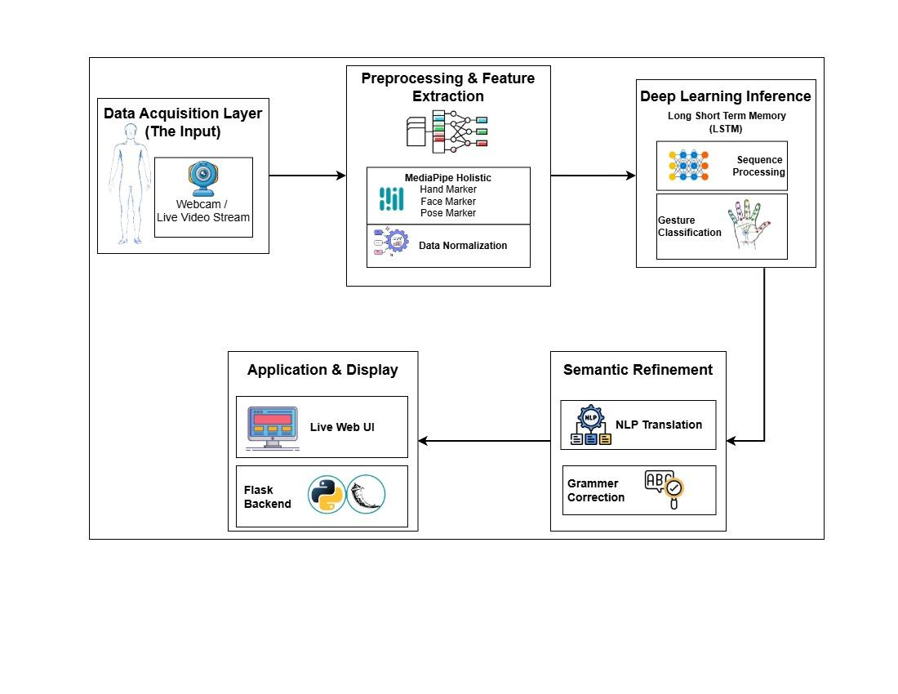
Fig1.1: High-Level Architecture of the Proposed System
INPUT DATA AND EXPECTED OUTPUT OF THE PROJECT
INPUTS:
- Live Camera Feed: Captures real-time video frames of hand gestures, facial expressions, and body movements for comprehensive sign language analysis.
- Spatial Keypoints: High-fidelity 3D landmarks extracted from the video stream representing hand, face, and body pose positioning.
- Temporal Sequences: Consecutive frames that capture the motion, direction, and duration of dynamic sign language gestures.
- User Interaction: Commands such as starting or stopping the detection process and clearing the history through the web interface.
OUTPUTS:
- Recognized Sign Labels: Displays the raw textual labels for detected individual signs in real-time on the user interface.
- Semantically Corrected Text: Displays the final, grammatically accurate English sentence after processing through the linguistic refinement module.
- Skeletal Feedback Overlay: Real-time visual rendering of the tracked landmarks on the video feed to confirm system alignment and tracking accuracy.
- Web Application Interface: A unified dashboard presenting the translated results and system status through the integrated platform.
PROJECT MODULES:
Module - I : Spatial Feature Extraction and Landmark Tracking:
This module serves as the primary input processing layer. It utilizes the MediaPipe Holistic framework to capture real-time video frames from the webcam. The module identifies and extracts high-fidelity 3D landmarks for the hands, face, and body pose simultaneously. Instead of processing raw pixel data, which is computationally expensive and sensitive to background noise, this module converts the visual information into a normalized coordinate-based skeletal representation. This ensures that the system remains robust across different lighting conditions and distances from the camera.
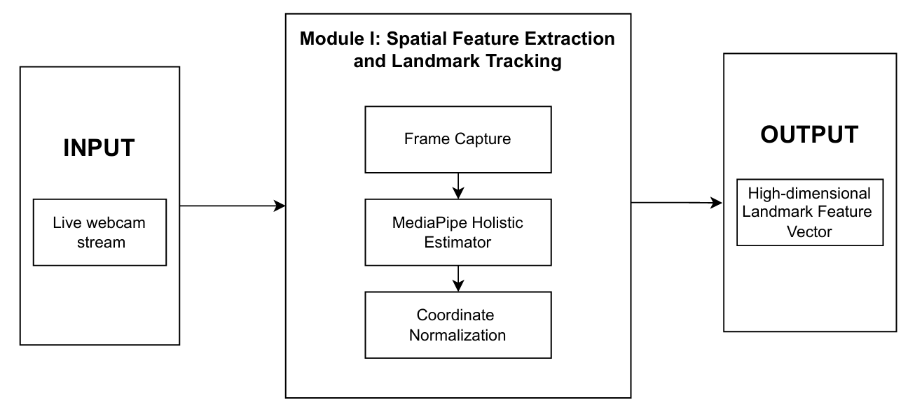
Fig1.2: Spatial Feature Extraction and Landmark Tracking
Module - II : Temporal Sequence Learning and Gesture Classification:
The second module focuses on interpreting movement over time. The coordinate data from the first module is organized into sequential time-series buffers. These sequences are processed using a Long Short-Term Memory (LSTM) neural network. Unlike standard image classifiers, the LSTM architecture is designed to remember previous frame states, allowing it to distinguish between signs that share similar hand shapes but different motion paths. This module effectively classifies dynamic gestures and continuous signing into raw sign labels or glosses.
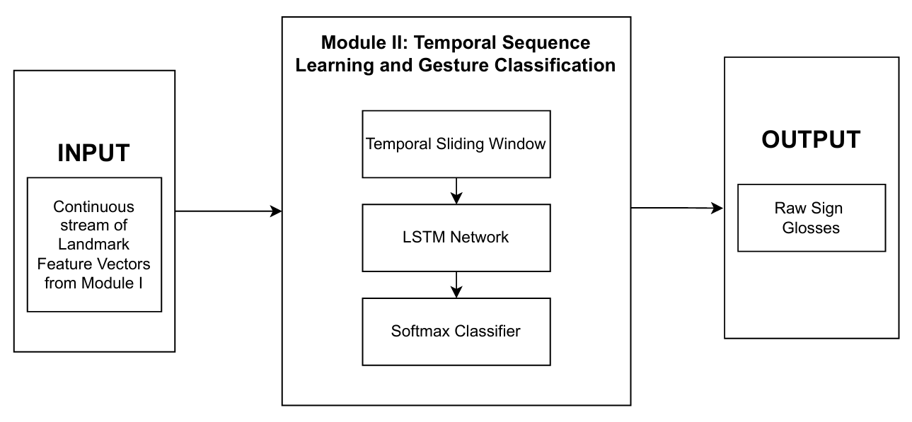
Fig1.3:Temporal Sequence Learning and Gesture Classification
Module - III : Semantic Correction and Web Integration:
The final module is responsible for linguistic accuracy and user interaction. It takes the raw recognized glosses and passes them through a Transformer-based Natural Language Processing (NLP) layer. This module performs syntax reordering and grammatical correction to ensure the final output follows English language rules rather than raw sign order. The entire pipeline is integrated into a Flask-based web application, providing a real-time dashboard where the translated text is displayed to the user in a clear and accessible format.
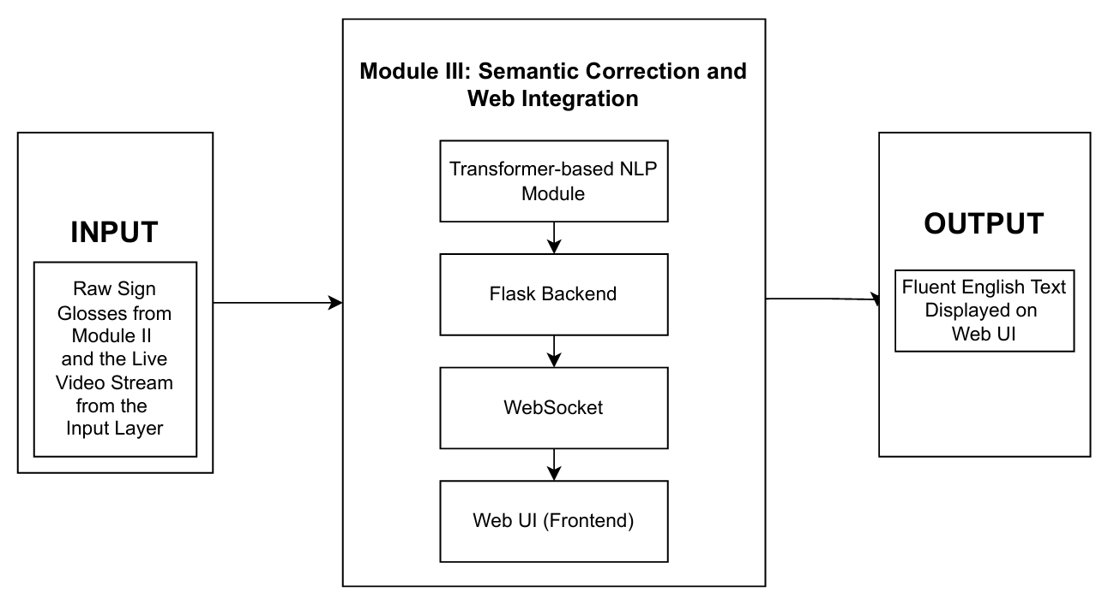
Fig1.4: Semantic Correction and Web Integration
SIMULATION/IMPLEMENTATION ENVIRONMENT
The project will be developed and implemented using Python-based deep learning and computer vision technologies in a high-performance development environment. The sign language recognition module will utilize the MediaPipe Holistic framework for 3D landmark extraction combined with a Long Short-Term Memory (LSTM) network, trained on a comprehensive dataset of dynamic signs. Appropriate data preprocessing techniques, including coordinate normalization and temporal sequence padding, are applied to ensure efficient real-time gesture detection and motion analysis from live video input.
In parallel, the linguistic refinement module will be implemented using Transformer-based Natural Language Processing (NLP) libraries to continuously process the raw recognized sign labels and convert them into grammatically correct English sentences in real time. These modules will be integrated into a Flask-based web application, where the backend processes the high-dimensional spatial-temporal data and displays the final refined text output on a seamless user interface. The implementation will focus on real-time performance, sequence accuracy, and linguistic fluency, ensuring a robust and accessible communication platform for individuals with hearing and speech impairments.
HARDWARE/SOFTWARE REQUIREMENTS
HARDWARE REQUIREMENTS | SOFTWARE REQUIREMENTS
Processor: Intel Core i5 (11th Gen) or AMD Ryzen 5 higher for multi-threaded processing. | Operating System: Windows 10/11 or Ubuntu 20.04+ for a stable development environment.
Memory (RAM): 8 GB minimum (16 GB recommended) to handle real-time vision buffers. | Programming Language: Python 3.9+ for its extensive deep learning and vision library support.
GPU: NVIDIA GTX 1050 or equivalent with CUDA support for accelerated LSTM and NLP inference. | Vision Libraries: MediaPipe Holistic for 3D landmarks and OpenCV for frame processing.
Camera: High-Definition (720p/1080p) Webcam capable of 30 FPS for capturing motion dynamics. | Deep Learning Frameworks: TensorFlow/Keras for sequence learning and PyTorch for NLP modules.
Storage: 20 GB of free space for dataset storage, pre-trained weights, and environment logs. | Web Framework: Flask for backend integration and real-time user interface rendering.

WORK PLAN
Phase 1: Research and literature review (Weeks 1-2)
Phase 2: System Architecture and User Interface Design (Weeks 3-4)
Phase 3: Dataset Preparation and Preprocessing (Weeks 5-6)
Phase 4: Implementation of LSTM and NLP Modules (Weeks 7-8)
Phase 5: System Integration and Testing (Weeks 9-10)
Phase 6: Real-World Evaluation and Performance Analysis (Weeks 11-12)
Phase 7: Final Documentation and Presentation (Weeks 13-14)
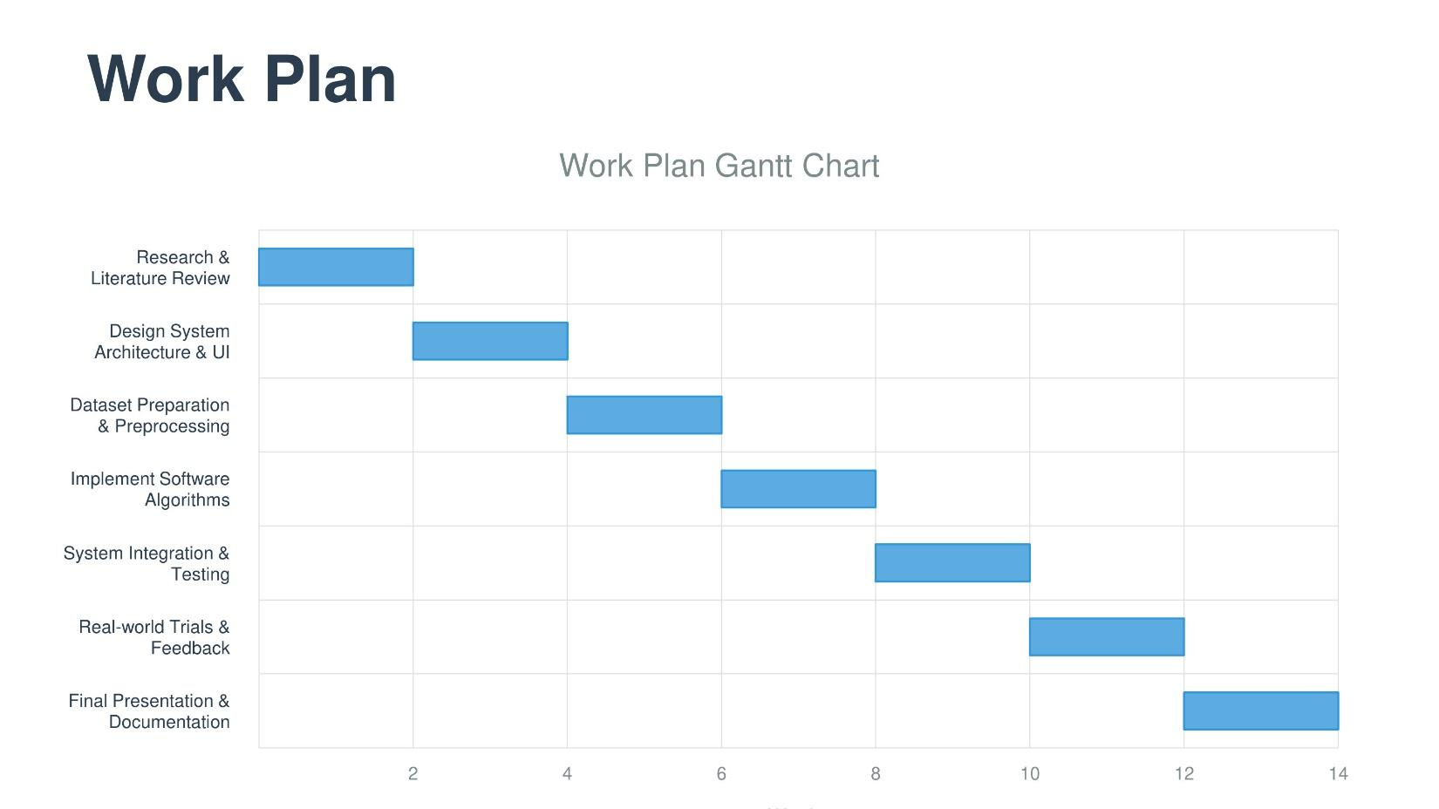CONCLUSION
This project successfully implements a Real-Time Sign-to-Text Translation System that bridges the communication gap for individuals with hearing and speech impairments. By utilizing a multi-modal framework, the system captures the complex nuances of American Sign Language more effectively than traditional static models. The integration of MediaPipe Holistic allows for the high-fidelity extraction of 3D landmarks across the hands, face, and body, providing a robust feature set that remains resilient to varying environmental backgrounds and lighting conditions.
The system’s intelligence is driven by the hybrid application of Long Short-Term Memory (LSTM) networks and Transformer-based NLP modules. The LSTM layer successfully interprets the temporal dynamics of continuous gestures, enabling the recognition of dynamic signs. Simultaneously, the NLP module ensures raw sign glosses are translated into grammatically correct English sentences. Integrated into a streamlined Flask-based web application, the final platform achieves high accuracy and low-latency performance, providing a reliable technological solution for real-time sign language translation in sectors such as healthcare and education.
REFERENCES
[1] Abu Saleh Musa Miah, Md. Al Mehedi Hasan, Yoichi Tomioka, and Jungpil Shin, “Hand Gesture Recognition for Multi-Culture Sign Language Using Graph and General Deep Learning Network,” IEEE Open Journal of the Computer Society, Vol. 5, pp. 144–156, 2024.

[2] Ilias Papastratis, Christos Chatzikonstantinou, Dimitrios Konstantinidis, Kosmas Dimitropoulos, and Petros Daras, “Artificial Intelligence Technologies for Sign Language,” Sensors, Vol. 21, Issue 17, pp. 1–25, 2021.
[3] Bader Alsharif, Easa Alalwany, and Mohammad Ilyas, “Transfer learning with YOLOV8 for real-time recognition system of American Sign Language Alphabet,” Franklin Open, Vol. 8, pp. 1–11, 2024.
[4] Menglin Zhang, Shuying Yang, and Min Zhao, “Deep Learning-Based Standard Sign Language Discrimination,” IEEE Access, Vol. 11, pp. 125822–125835, 2023.
[5] Esma Yenisari and Sirma Yavuz, “Deep Learning-Based Sign Language Recognition Using Efficient Multi-Feature Attention Mechanism,” IEEE Access, Vol. 13, pp. 126684–126702, 2025.
[6] Muhammad Al-Qurishi, Thariq Khalid, and Riad Souissi, “Deep Learning for Sign Language Recognition: Current Techniques, Benchmarks, and Open Issues,” IEEE Access, Vol. 9, pp. 126917–126951, 2021.
[7] Neena Aloysius, Geetha M, and Prema Nedungadi, “Optimized Multi-Modal Conformer-Based Framework for Continuous Sign Language Recognition,” IEEE Open Journal of the Computer Society, Vol. 6, pp. 739–749, 2025.
[8] Pawel Antonowicz, David Kasperek, and Michal Podpora, “Sign Language Recognition—Dataset Cleaning for Robust Word Classification in a Landmark-Based Approach,” IEEE Access, Vol. 13, pp. 81877–81888, 2025.
[9] Rejin Varghese and Sambath M., “YOLOv8: A Novel Object Detection Algorithm with Enhanced Performance and Robustness,” in Proceedings of the 2024 International Conference on Advances in Data Engineering and Intelligent Computing Systems (ADICS), Chennai, India, pp. 217–221, 2024.
[10] Zhigang Chen, Benjia Zhou, Yiqing Huang, Jun Wan, Yibo Hu, Hailin Shi, Yanyan Liang, Zhen Lei, and Du Zhang, “C2RL: Content and Context Representation Learning for Gloss-Free Sign Language Translation and Retrieval,” IEEE Transactions on Circuits and Systems for Video Technology, Vol. 35, Issue 9, pp. 8533–8545, 2025.

