RESUME
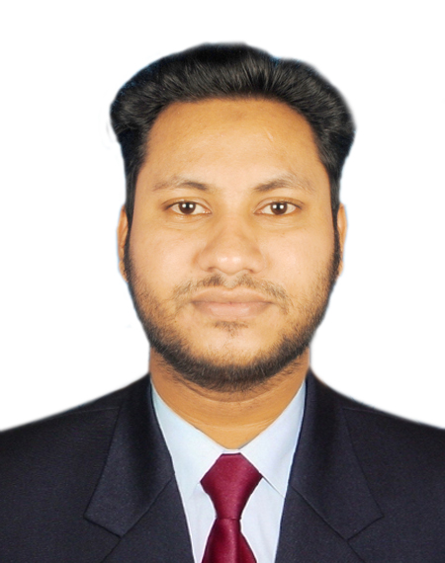

Photo

OF
Md. Rajiur Rahman

Mailing Address:  Md. Rajiur Rahman  1083, Malibagh Chowdhury Para, Dhaka 1217 |  | Contact Number:  Mobile: +8801868752464  E-mail: rajiurrahmanraj2021@gmail.com

CAREER OBJECTIVES

To achieve high degree of professional excellence by putting continuous efforts and exerting knowledge and skills this will ultimately contribute to the achievement of personal and organizational goals.

EDUCATIONAL QUALIFICATION

Bachelor of Science in Computer Science and Engineering (CSE)

 Institution | : | Stamford University Bangladesh
Department | : | Computer Science
Duration | : | 4 years
Major | : | --
Minor | : | --
Result |  | Appeared

Higher Secondary Certificate (HSC)
 Institution | : | Pirganj Govt. College
Group | : | Science
Year of Passing | : | 2014
Result | : | 3.75 (out of scale 5.00)
Board | : | Dinajpur

Secondary School Certificate (SSC)
 Institution | : | Pirganj Pilot High School
 Group | : | Science
Year of Passing | : | 2012
Result | : | 4.75 (out of scale 5.00)
Board | : | Dinajpur

Technical Skills

Application Software: MS Office, Excel, Code Blocks, Visual studio, Adobe, Microsoft SQL server.
Operating System: Windows (Microsoft), Ubuntu (linux)
Programming Language and Platform:
- Knowledge of C, C++, JAVA.
- PHP, OOP and LARAVEL (Framework)
- Working knowledge of HTML5, CSS3 & (Frontend Framework) BOOTSTRAP4.
- Strong Knowledge of Javascript, JQuery & Ajax.
- Working Knowledge of Database: SQL, Mysql.
- Specialist in Php and (Backend Framework) Laravel.
- I have experience in E-commerce, Blog, NGO, Admin panel, Management, Educational based website.
- I have also Working Knowledge of Adobe Photoshop and Illustrator for business card and logo design.

Working Projects Of [Frontend Web Development*]
Template Name | Technology | Link
Bazinger Landing Website | Language: Html5, Css3, JavaScript, JQuery, Bootstrap 4. | https://rajiurrahmanraj2021.github.io/Bazinger/
Appon Landing Website | Language: Html5, Css3, JavaScript, JQuery, Bootstrap 4. | https://rajiurrahmanraj2021.github.io/apon/
Sarajevo Landing Website | Language: Html5, Css3, JavaScript, JQuery, Bootstrap 4. | https://rajiurrahmanraj2021.github.io/Sarajevo/
Restaurant Multipage Website | Language: Html5, Css3, JavaScript, JQuery, Bootstrap 4. | https://rajiurrahmanraj2021.github.io/Food_for_desktop
Valentine Landing Website | Language: Html5, Css3, JavaScript, JQuery, Bootstrap 4. | https://rajiurrahmanraj2021.github.io/Valentina/
Petir Landing Website | Language: Html5, Css3, JavaScript, JQuery, Bootstrap 4. | https://rajiurrahmanraj2021.github.io/petir/

Working Projects Of [Backend Web Development*]
Project Name | Technology | Link
My Own It Training Website Management System | Frontend: Html5, Css3, JavaScript, JQuery, Bootstrap 4.  Backend: Php, Laravel Framework, Mysql Database | http://webtraininginstitute.com/
Custom pc build-up Ecommerce Website | Frontend: Html5, Css3, JavaScript, JQuery, Bootstrap 4.  Backend: Php, Laravel Framework, Mysql Database | https://custompc.devcom.club/
Doctor Appointment Management System | Frontend: Html5, Css3, JavaScript, JQuery, Bootstrap 4.  Backend: Php, Laravel Framework, Mysql Database. | https://appoinment.devcom.club/
Pharmacy Shop Management System | Frontend: Html5, Css3, JavaScript, JQuery, Bootstrap 4.  Backend: Php, Laravel Framework, Mysql Database | http://pharmacy.asianpetrochem.com/
Online Ecommerce Business System | Frontend: Html5, Css3, JavaScript, JQuery, Bootstrap 4.  Backend: Php, Laravel Framework, Mysql Database | http://ecommerce.asianpetrochem.com/
NGO Website Development | Frontend: Html5, Css3, JavaScript, JQuery, Bootstrap 4.  Backend: Php, Laravel Framework, Mysql Database | http://ngoforum.devcom.club/
Polytechnic Institute  Website Development | Frontend: Html5, Css3, JavaScript, JQuery, Bootstrap 4.  Backend: Only Raw Php, Mysql Database. | http://polytechnic.asianpetrochem.com/

My YouTube Channel

Name: Web Training Institute
Channel Link: https://www.youtube.com/webtraininginstitute

Course Achievement

Title: Web Design & Development.
ID: Web Dev-19030114
Title: Graphics Design
ID: PRGB-16103524
Organization: Creative IT Institute (CIT).
Location: Momtaz Plaza (4th floor)-House#7, Road#4, Dhanmondi, Dhaka-1205

LANGUAGE AND COMMUNICATION EFFICIENCY

Good command over reading, writing, listening and speaking in both English & Bengali.

PERSONAL DETAILS

Name | : | Md. Rajiur Rahman
Father’s Name | : | Golam Mostofa
Mother’s Name | : | Ayesha Akter
Permanent Address | : | Village: Khamarnarayonpur, Post: Narayonpur Thana: Pirganj District: Thakurgoan
Date of Birth | : | 12th July 1995
Martial Status | : | Single
Sex | : | Male
Religion | : | Muslim
Nationality | : | Bangladeshi (by born)
Home District | : | Thakurgoan

Declaration of Authenticity

I declare hereby that all information I have presented so far are true to my knowledge. If required and where applicable, this document can be supported by authentic certificates\papers.

Reference:
Sr. Software Engineer (Creative IT Institute of Bangladesh)
Md. Tarique Hasan
Cell-No. 01990-779760

