**Charotar University of Science and Technology [CHARUSAT]**

**Chandubhai S. Patel Institute of Technology [CSPIT]**

**U & P U. Patel Department of Computer Engineering**

**Lab Manual**

|  |  |  |  |  |  |  |  |  |
| --- | --- | --- | --- | --- | --- | --- | --- | --- |
| Subject code | : | CE-350 | Semester | : | 6 | Academic Year | : | 2021 |
| Subject name | : | Data Warehouse and Data Mining | | | | | | |

**Practical – 1**

**Aim:** Perform different operations using Tableau/Power BI (Different Visualization, OLAP operation, Star Schema Generation etc.)

* **Prerequisite:**

1. Basic idea about what is PowerBI?
2. Basics of OLAP operations & Star Schema Generation.
3. We require some knowledge about software also like PowerBI.

* **Steps To Install Software :**

Power BI Desktop lets you build advanced queries, models, and reports that visualize data. With Power BI Desktop, you can build data models, create reports, and share your work by publishing to the Power BI service. Power BI Desktop is a free download.

You can get Power BI Desktop in two ways, each of which is described in the following sections:

* [Install as an app from the Microsoft Store](https://data-flair.training/blogs/power-bi-dashboard/#install-as-an-app-from-the-microsoft-store).
* [Download directly, as an executable you download and install on your computer](https://www.youtube.com/watch#download-power-bi-desktop-directly).

Either approach gets the latest version of Power BI Desktop onto your computer, but there are some differences worth noting, as described in the following sections.

**Important**

Power BI Desktop is updated and released on a monthly basis, incorporating customer feedback and new features. Only the most recent version of Power BI Desktop is supported; customers who contact support for Power BI Desktop will be asked to upgrade to the most recent version. You can get the most recent version of Power BI Desktop from the [**Windows Store**](https://powerbi.microsoft.com/desktop/), or as a single executable containing all supported languages that you [**download**](https://docs.microsoft.com/en-us/power-bi/fundamentals/desktop-get-the-desktop?id=58494) and install on your computer.

## Install as an app from the Microsoft Store

There are a few ways to access the most recent version of Power BI Desktop from the Microsoft Store.

1. Use one of the following options to open the **Power BI Desktop** page of the Microsoft Store:
   * Open a browser and go directly to the [Power BI Desktop page](https://docs.microsoft.com/en-us/power-bi/fundamentals/desktop-get-the-desktop) of the Microsoft Store.
   * From the [Power BI service](https://docs.microsoft.com/en-us/power-bi/fundamentals/service-get-started), select the **Download** icon from the upper right corner, and then select **Power BI Desktop**.

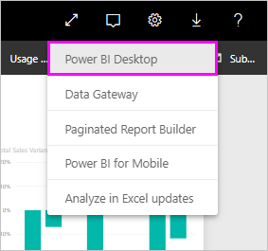

* + Go to the [Power BI Desktop product page](https://www.microsoft.com/download/details.aspx), and then select **Download Free**.

1. After you've landed on the **Power BI Desktop** page of the Microsoft Store, select **Install**.

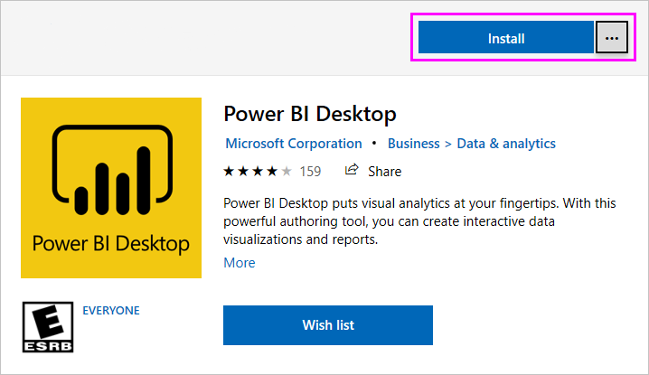

There are a few advantages to getting Power BI Desktop from the Microsoft Store:

* **Automatic updates**: Windows downloads the latest version automatically in the background as soon as it's available, so your version will always be up to date.
* **Smaller downloads**: Microsoft Store ensures only components that have changed in each update are downloaded to your machine, resulting in smaller downloads for each update.
* **Admin privilege isn't required**: When you download the package directly and install it, you must be an administrator for the installation to complete successfully. If you get Power BI Desktop from the Microsoft Store, admin privilege is not required.
* **IT roll-out enabled**: Through the Microsoft Store for Business, you can more easily deploy, or roll out, Power BI Desktop to everyone in your organization
* **Language detection**: The Microsoft Store version includes all supported languages, and checks the language used on your computer each time it's launched. This language support also affects the localization of models created in Power BI Desktop. For example, built-in date hierarchies match the language that Power BI Desktop is using when the .pbix file is created.

The following consideration and limitations apply when you install Power BI Desktop from the Microsoft Store:

* If you use the SAP connector, you may need to move your SAP driver files to the Windows\System32 folder.
* Installing Power BI Desktop from the Microsoft Store doesn't copy user settings from the .exe version. You might have to reconnect to your recent datasources and reenter your data source credentials.

**Note**

The Power BI Report Server version of Power BI Desktop is a separate and different installation from the versions discussed in this article. For information about the Report Server version of Power BI Desktop, see [**Create a Power BI report for Power BI Report Server**](https://aka.ms/pbidesktopstore).

## Download Power BI Desktop directly

To download the Power BI Desktop executable from the Download Center, select **Download** from the [Download Center page](https://www.microsoft.com/download/details.aspx?id=58494). Then, specify a 32-bit or 64-bit installation file to download.

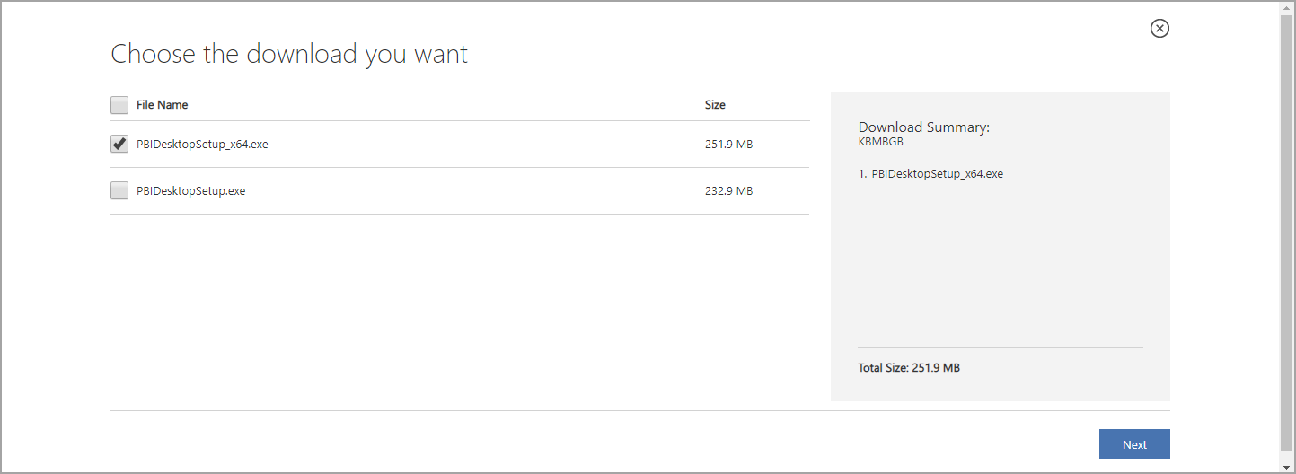

### Install Power BI Desktop after downloading it

You're prompted to run the installation file after you've finished downloading it.

Beginning with the July 2019 release, Power BI Desktop ships as a single .exe installation package that contains all supported languages, with a separate .exe file for the 32-bit and 64-bit versions. The .msi packages are discontinued beginning with the September 2019 release, requiring the .exe executable for installation. This approach makes distribution, updates, and installation (especially for administrators) much easier and more convenient. You can also use command-line parameters to customize the installation process, as described in [Using command-line options during installation](https://docs.microsoft.com/en-us/power-bi/report-server/quickstart-create-powerbi-report#using-command-line-options-during-installation).

After you launch the installation package, Power BI Desktop installs as an application and runs on your desktop.

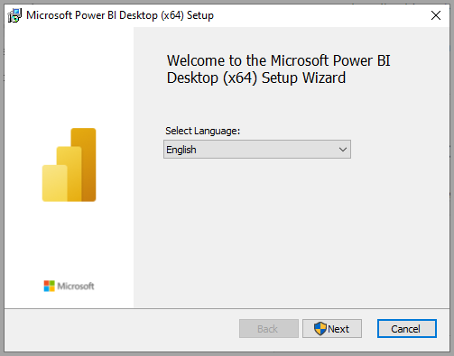

Click on Next…

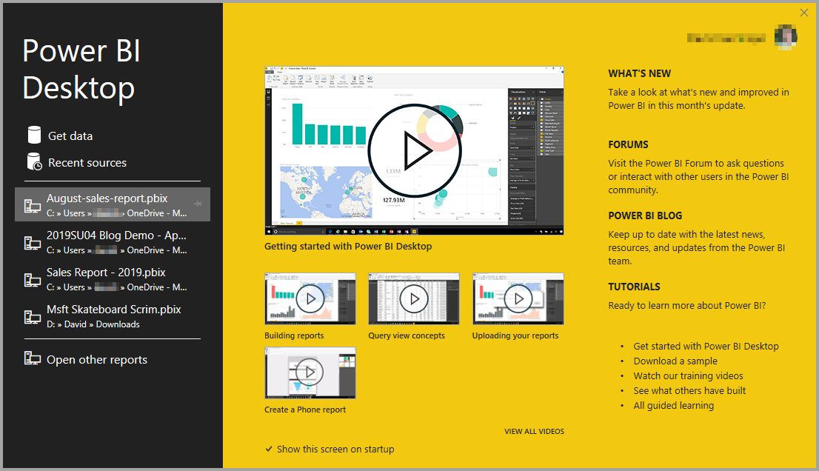

**SCREENSHOT:**

**Adventure Works Database Dashboard:**

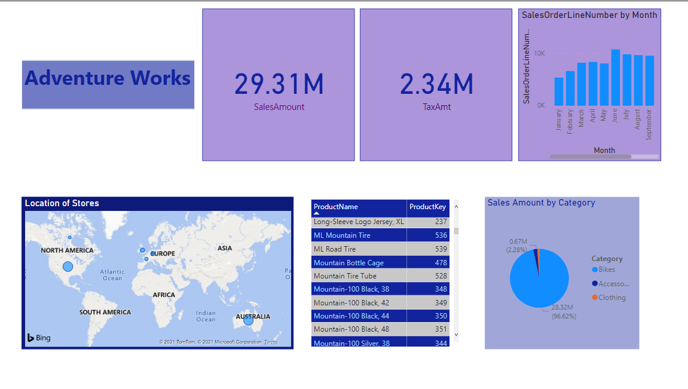

**Group Task:**

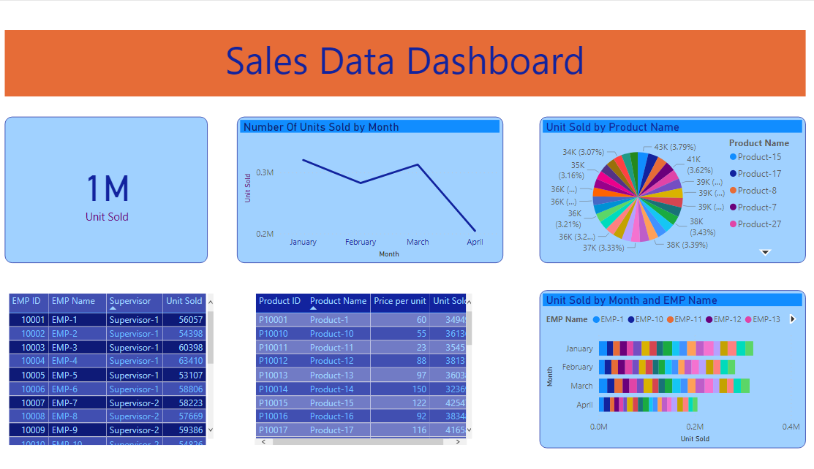

**Star Schema :**

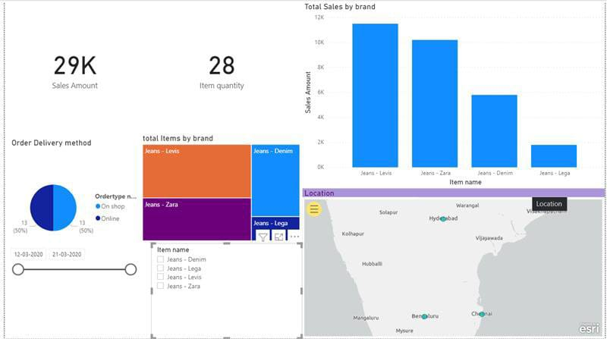

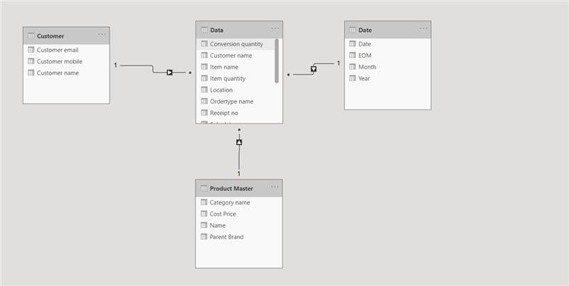

**Question/Answers:**

● What is PowerBI?

Power BI is a business analytics service by Microsoft. It aims to provide interactive visualizations and business intelligence capabilities with an interface simple enough for end users to create their own reports and dashboards.

● What is a Dataset?

Datasets are a collection of the Data which PowerBI utilities to create the visuals.

● What kind of Data Sources does PowerBI accept?

PowerBI accepts more than 100 data sources from excel file sheets to Azure SQL.

● How to load the Data in PowerBI?

To load the Data in PowerBI, click on “Add data to your report” option in the home screen and choose the appropriate data source followed by navigating to the source file in windows explorer and opening it and loading it in the PowerBI.

**CONCLUSION:**

From this practical, we were introduced to the software PowerBI which takes the data and converts the data into various visualizations. We learned how to load the data from the excel files and other database files and using the loaded data, we created multiple dashboards and interacted with the new visuals. Hence, we learned that PowerBI is extremely useful for Data Analysis.

|  |  |  |  |
| --- | --- | --- | --- |
| **Prepared By:** | Rajiv K Gupta [18CE137] | **Date:** | 20-03-2021 |