**PRACTICAL 4**

|  |  |
| --- | --- |
| **AIM**:   |  | | --- | | The transmission of information need to be secure over the communication channel and the data has to be confidential. Study and implement the practical approach for Steganography.  -Using DOS commands  -Using OpenPuff Tool | |
|  |

## Hiding message into image file using DOS command:

## Data file:

## 

## Code for generating output file:

## 

## Generated output file:

## 

## Message in output file:

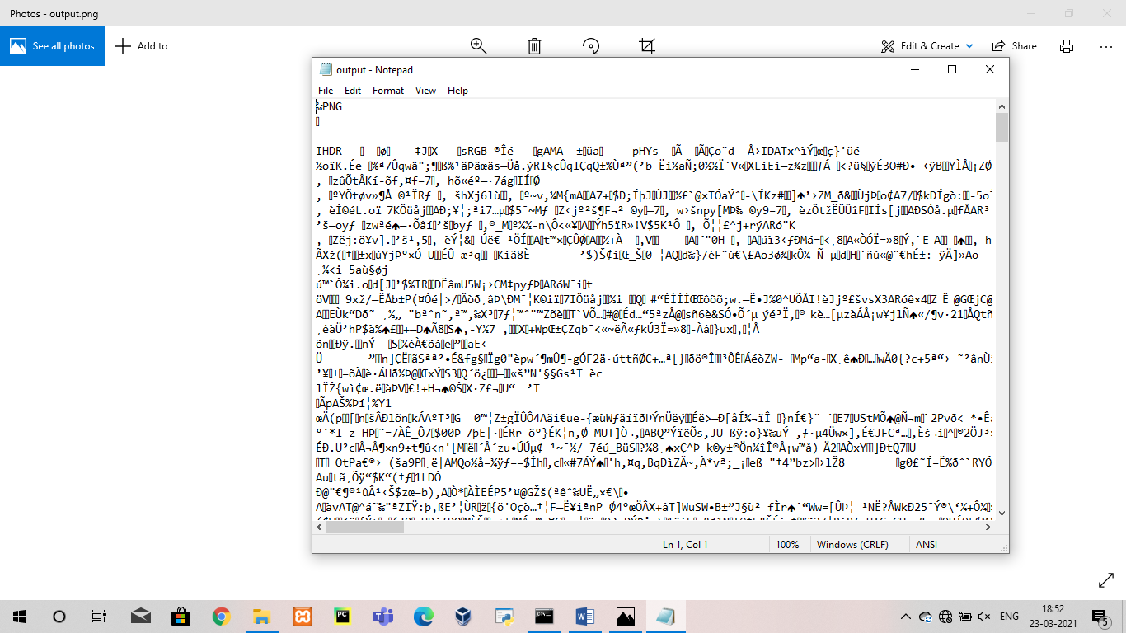

**OpenPuff**

## 

**Data Hiding**

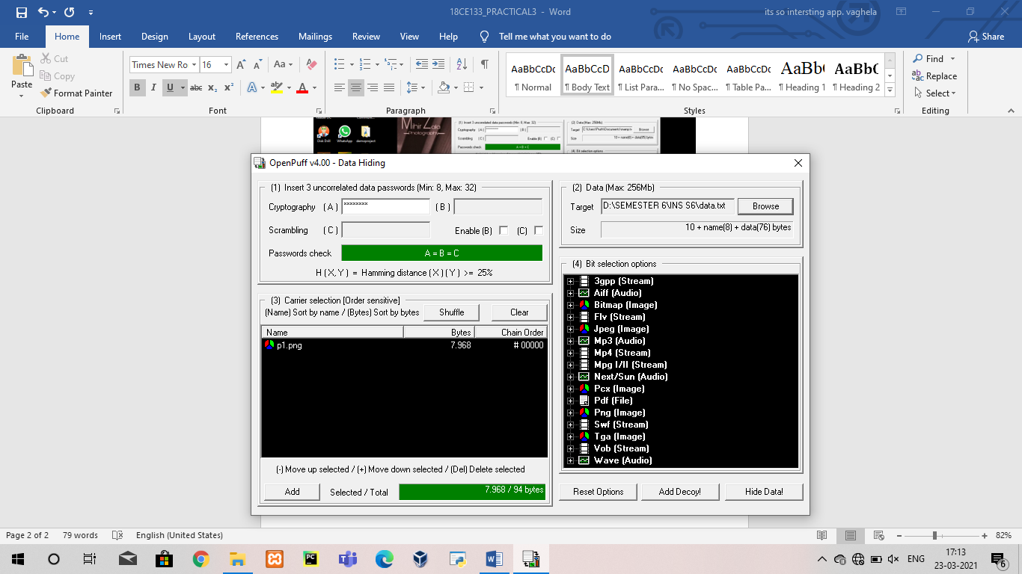

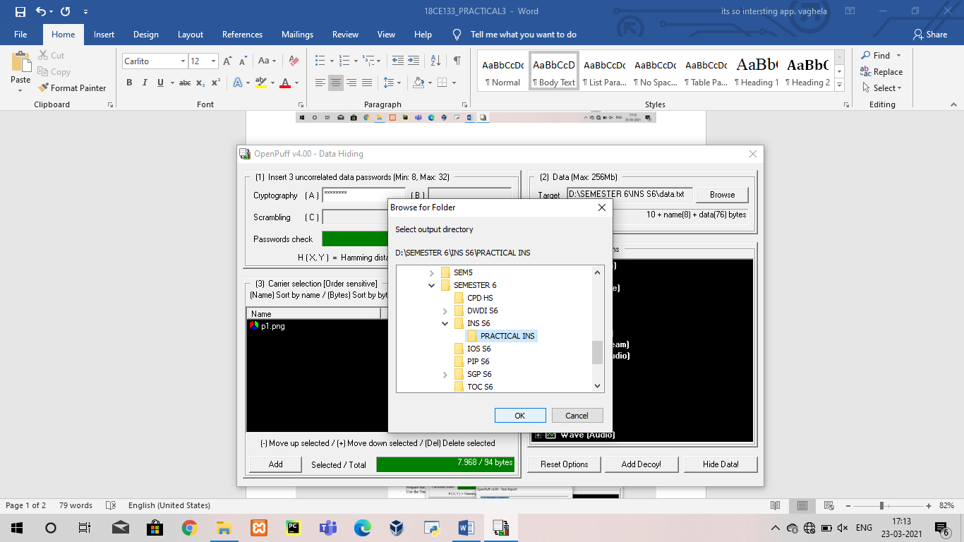

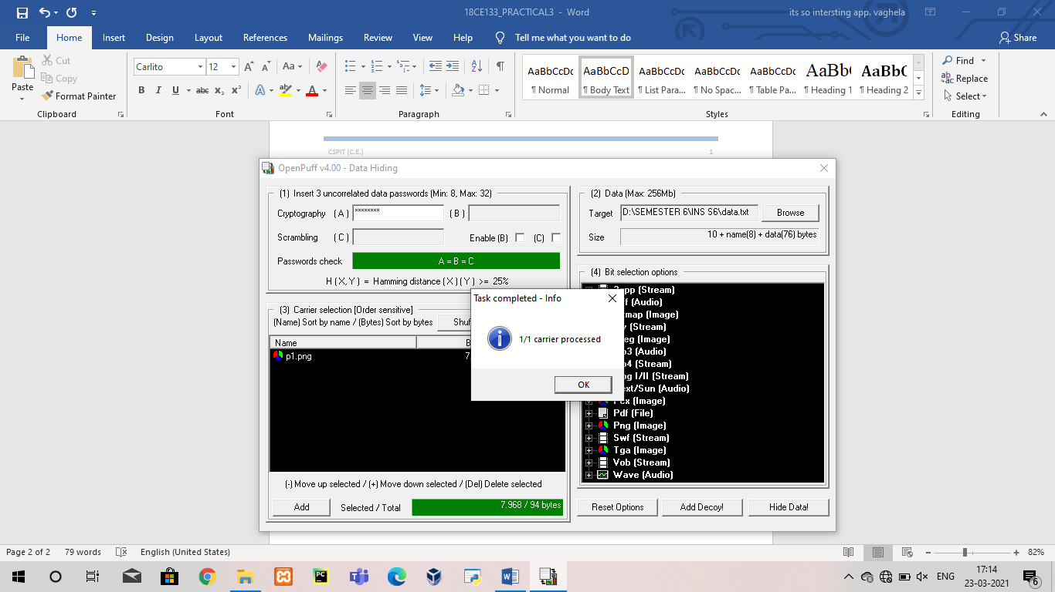

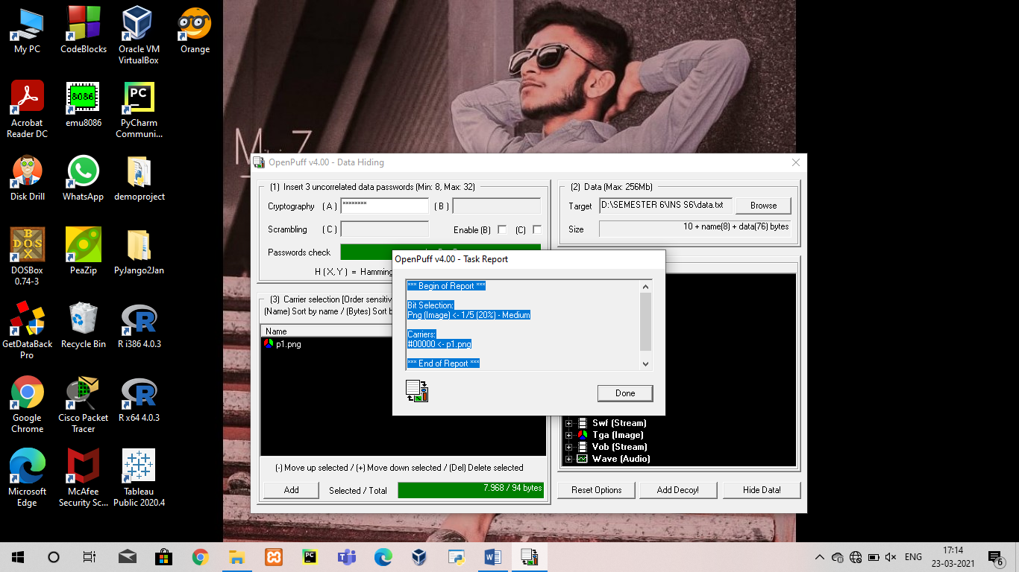

**Data hidden in image**

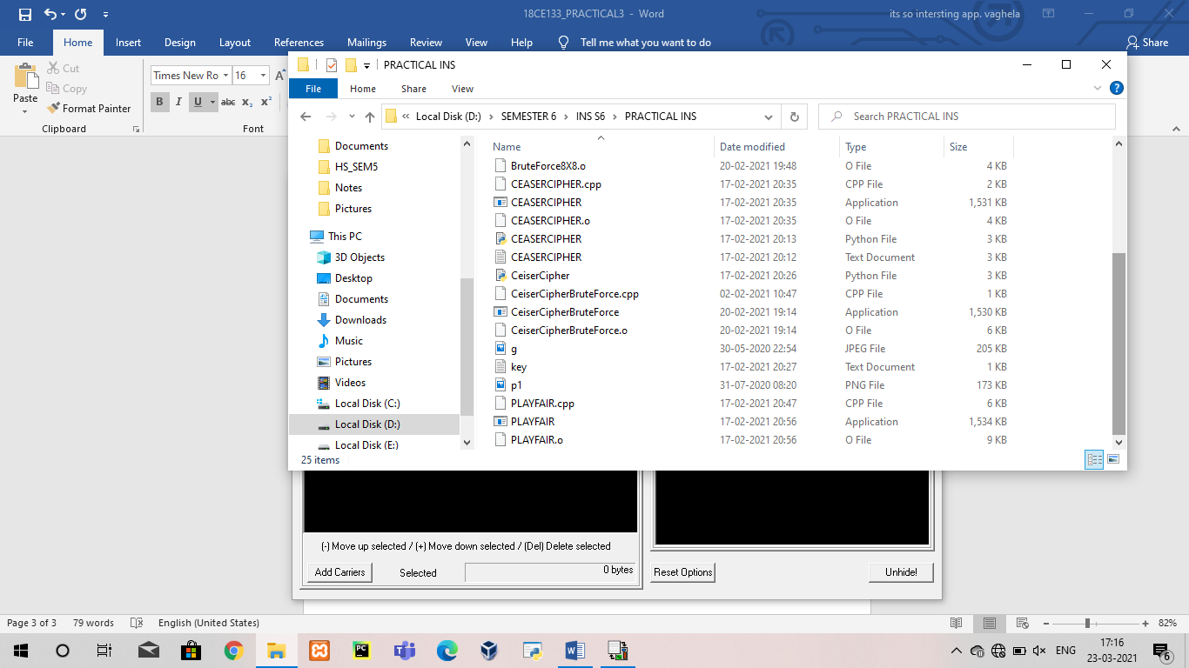

**Data Unhiding**

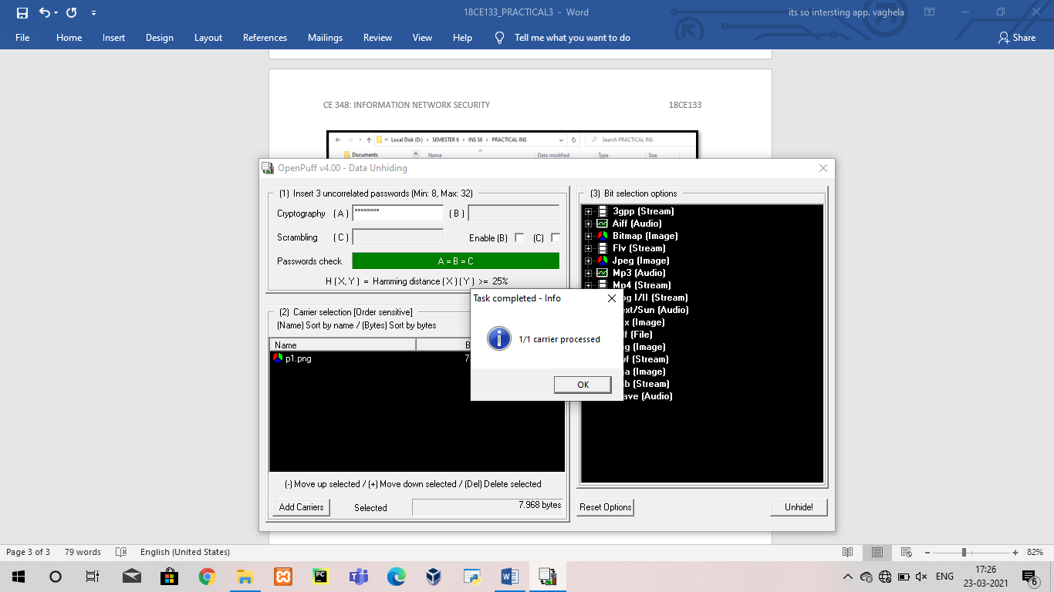

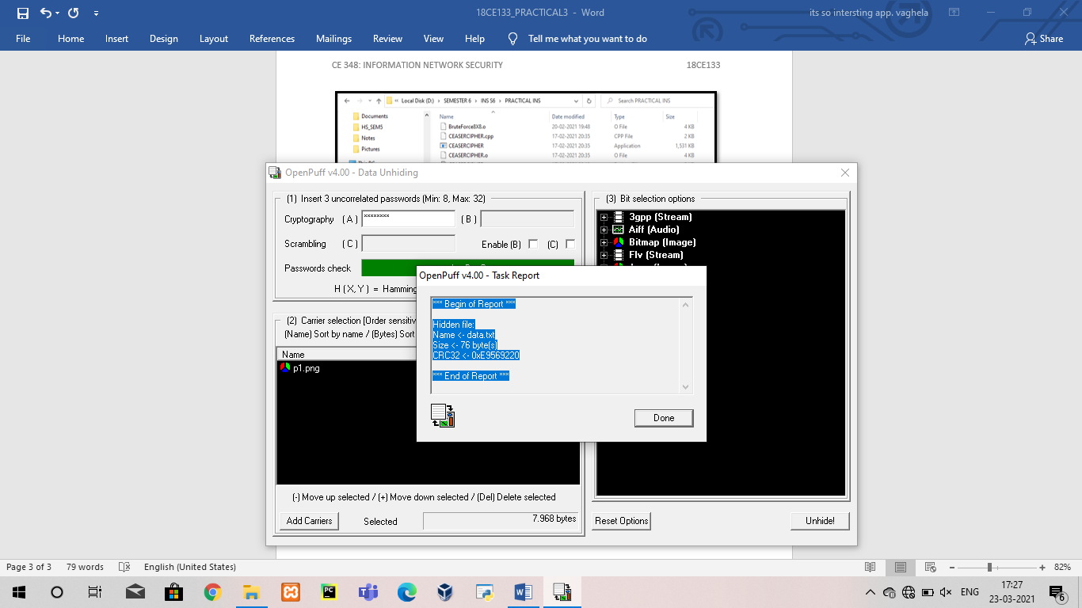

Conclusion: From this practical we can concluded that we have learnt about DOS command to generate image file from text message and image file and also used OpenPuff software for data hiding and data unhiding.