**Practical: 9**

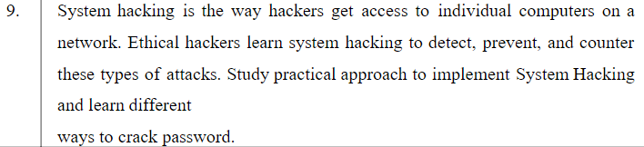

**Techniques:**

1. Phishing
2. Social Engineering
3. Malware
4. Brute Force Attack
5. Dictionary attack
6. Mass Attack
7. Rainbow Table Attack
8. Network Analysers
9. Spidering
10. Offline Cracking
11. Shoulder Surfing
12. Guess

**Phishing Attack:**

Phishing is a cyber-attack that uses disguised email as a weapon. The goal is to trick the email recipient into believing that the message is something they want or need — a request from their bank, for instance, or a note from someone in their company — and to click a link or download an attachment.

What really distinguishes phishing is the form the message takes: the attackers masquerade as a trusted entity of some kind, often a real or plausibly real person, or a company the victim might do business with. It's one of the oldest types of cyberattacks, dating back to the 1990s, and it's still one of the most widespread and pernicious, with phishing messages and techniques becoming increasingly sophisticated.

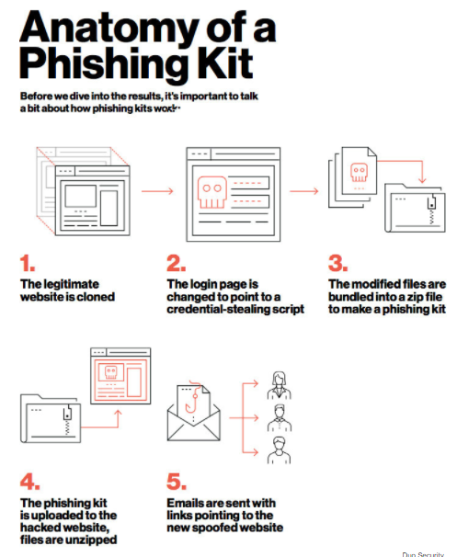

One common thread that runs through all types of phishing emails, including the examples below, is the use of [social engineering](https://terranovasecurity.com/what-is-social-engineering/) tactics. Like most phishing attacks, social engineering preys on the natural human tendency to trust people and companies.

This leads to many users failing to carefully review phishing email details and automatically trusting the sender’s request. Email phishing victims believe they’re helping their organizations by transferring funds, updating login details, or providing access to proprietary data.

(example of phishing email)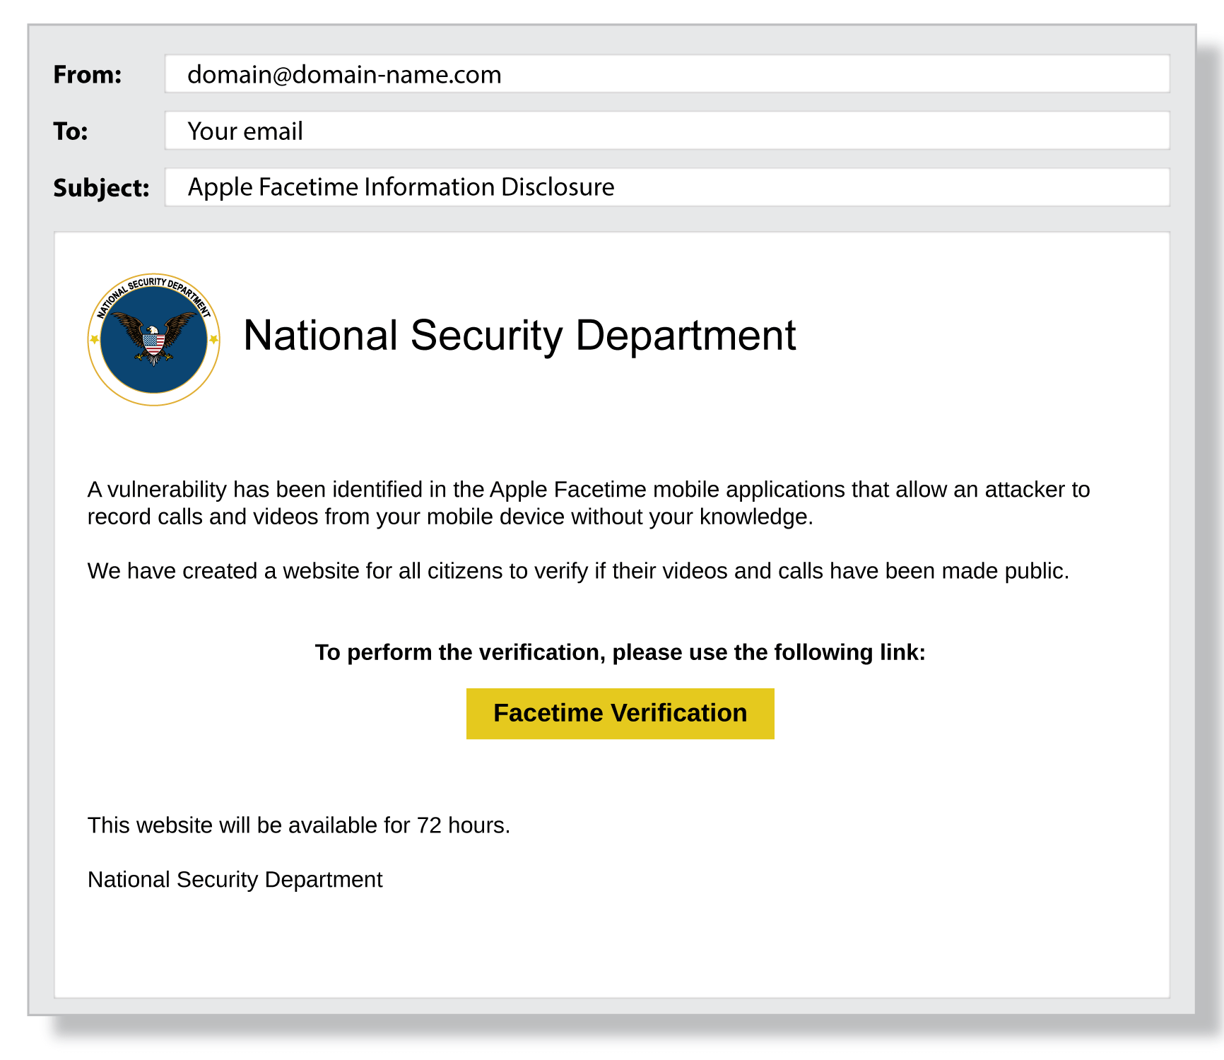

### **Fake Google Docs Login**

A cybercriminal creates a fake Google Docs login page and then sends a phishing email hoping to trick someone into logging into the faked website. The email might read “We’ve updated our login credential policy, please confirm your account by logging into Google Docs.” The sender’s email is a faked Google email address, for example [accountupdate@google.org.com](mailto:accountupdate@google.org.com).

(example of phishing email)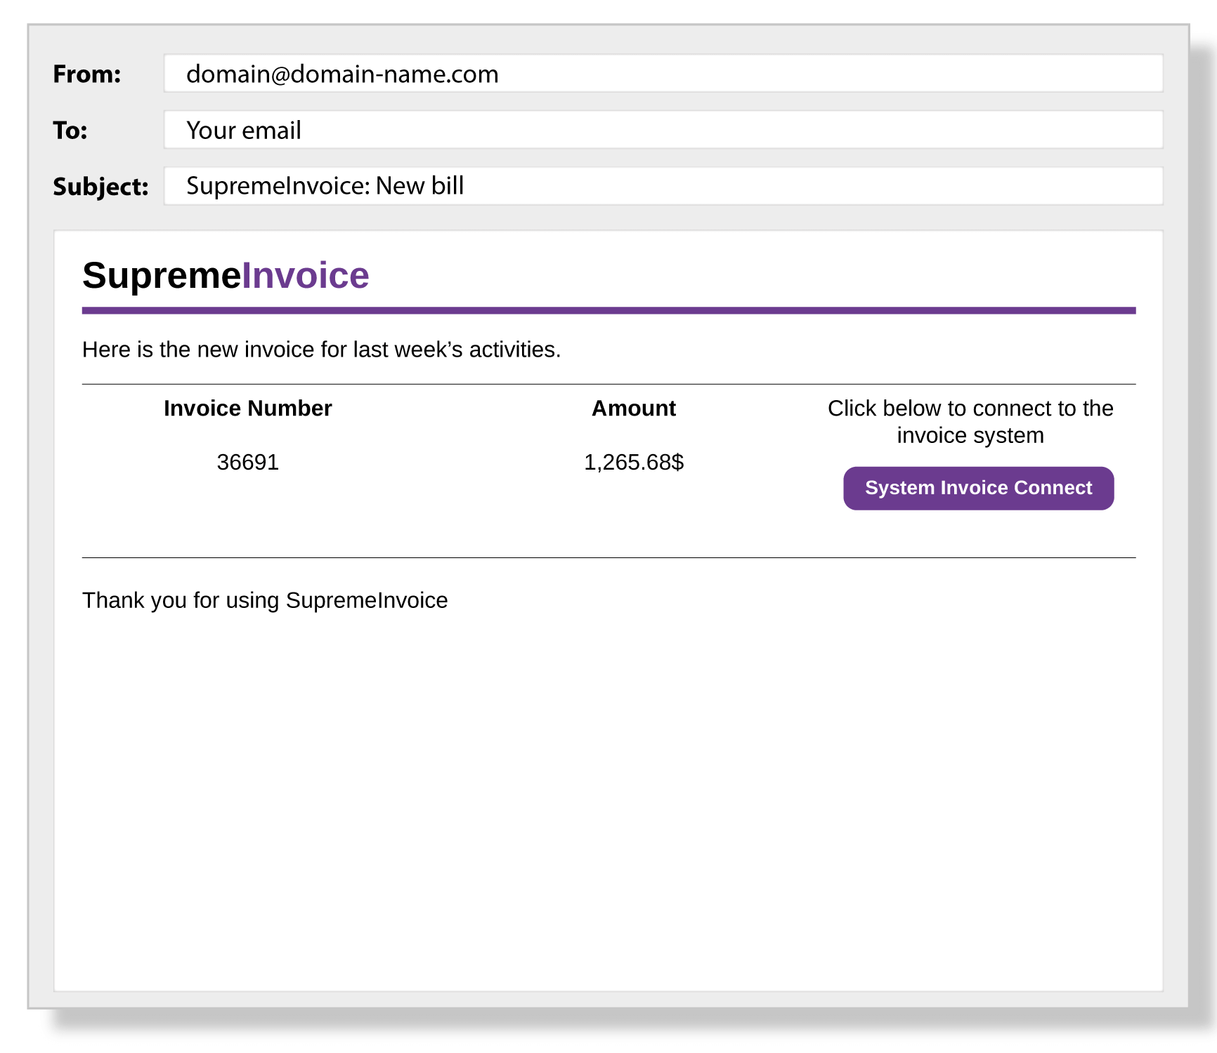

**Conclusion**

* In this practical, I have learnt 12 different techniques to crack password

And we have seen Phishing + Social Engineering attack implementation with theory.