**ASSIGNMENT-11**

**Aim:** Create a swap area of 512 MB on your machine and delete it.

1)Check the system for swap allocation

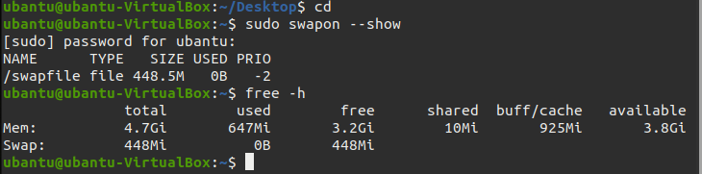

2)Check available space on hard drive

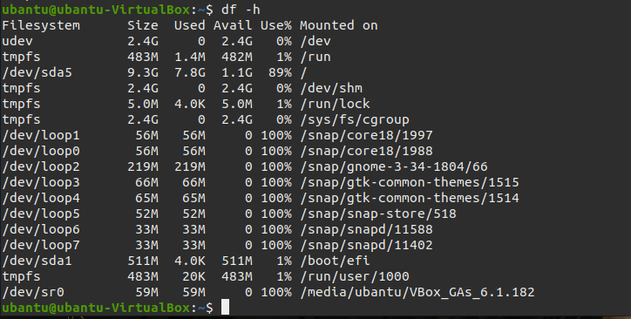

3)Create swap file

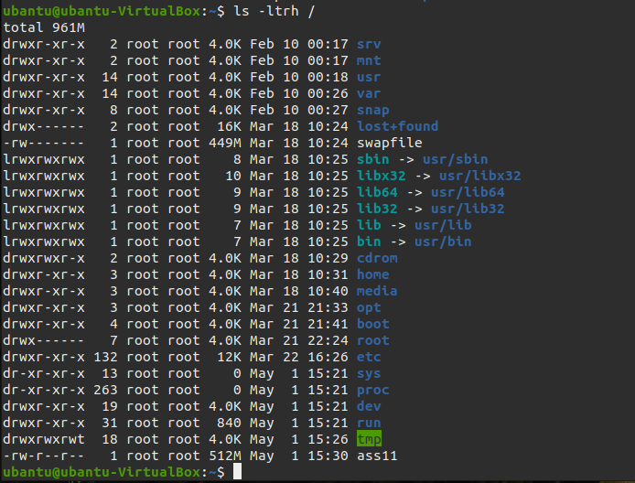

4)Change Permission

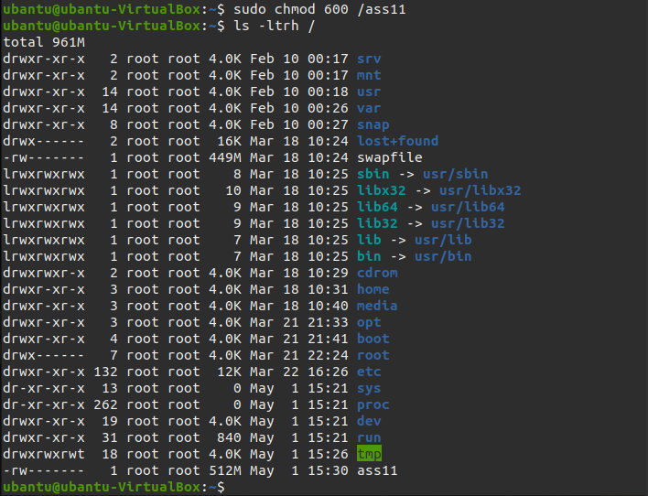

5)Mark file as swap area

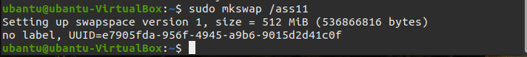

6)Here, we have enabled swap area for temporary

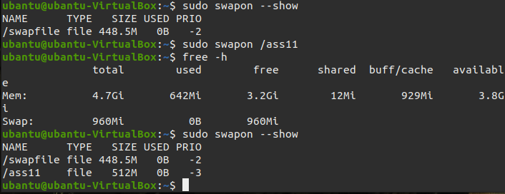

7) Make the swap area permeant.

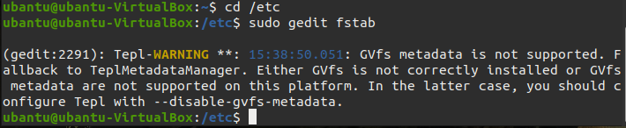

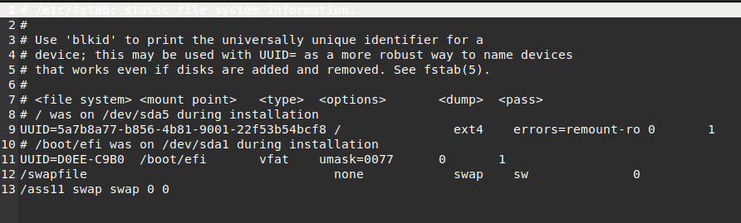

8) Remove the swap area. Here, swap area will be disabled but file is still in the system.

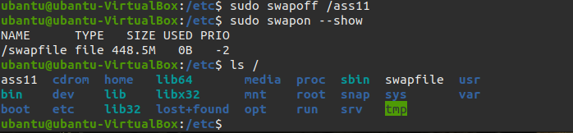

9)Remove the file from the system

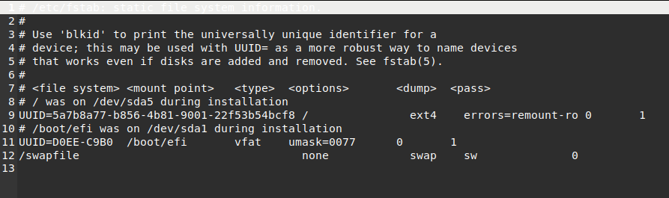

10) Delete the actual swap area file

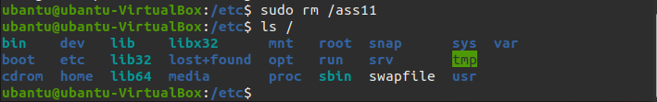

**ASSIGNMENT-12**

**Aim:** Mention any five information about superblock and inode.

1)Inode structure for directory



2)Displaying version of dumpe2fs

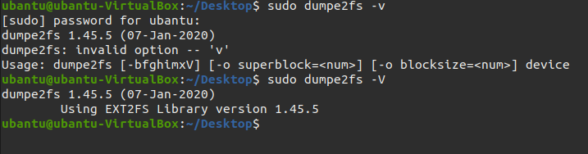

3)Displaying information of groups

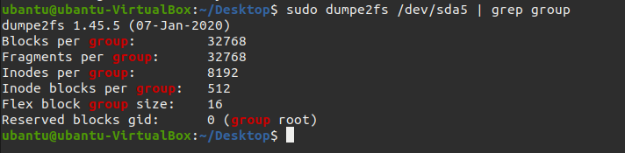

4)Find free fragment in system

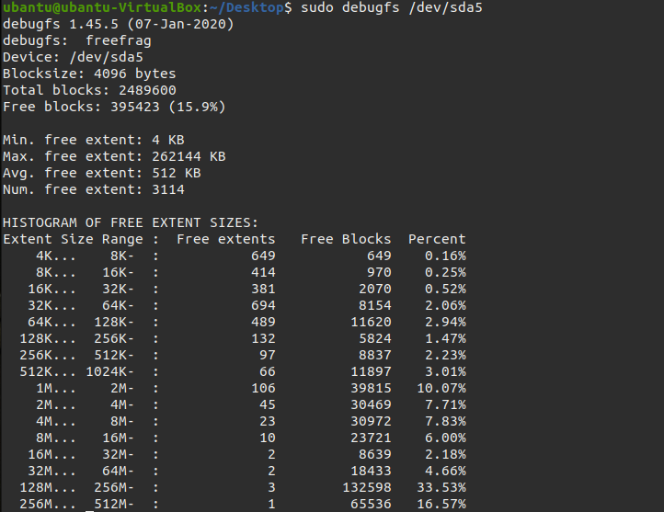

5)Set the interval of file system check

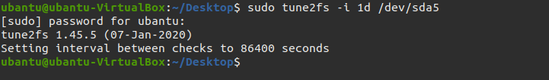

**PRACTICAL-10**

**A.Create a file and check the following information for it’s inode.**

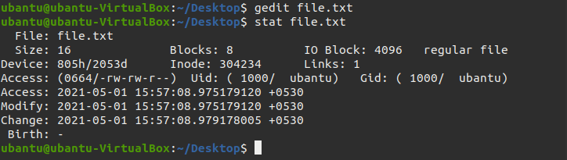

1.check inode number of that file



2.search the file using its inode number.

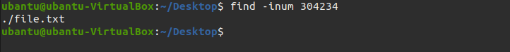

3.Find the total number of inodes in the system. (stat , -i , tune2fs)

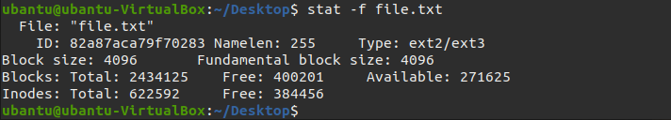

4.List all the statistics about inode usage (amountavailable, amount used and amount free and use percentage)

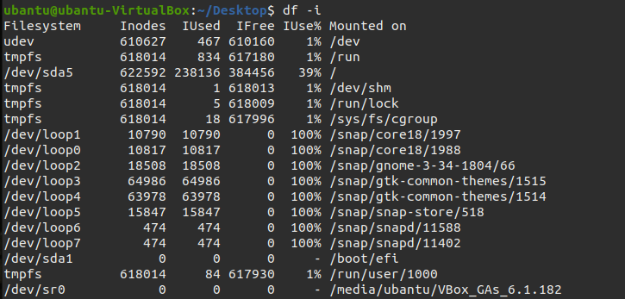

5.Check total number of free inodes.

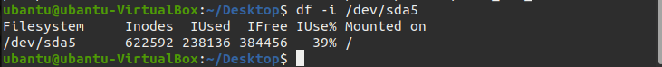

6.Check total number of used inodes.



7.Find inode utilization in the current directory.

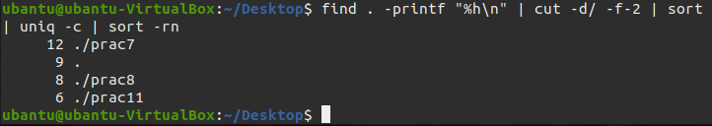

8.Count Inode Usage with Grand Total

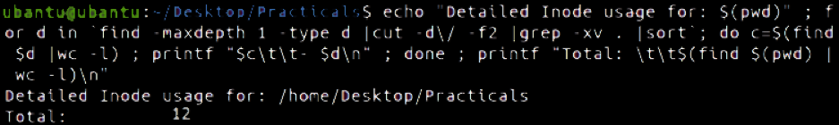

9.Does inode change when you copy and move the file?

Ans:- When we copy the file inode changes but if we move the file then inode will remain same.

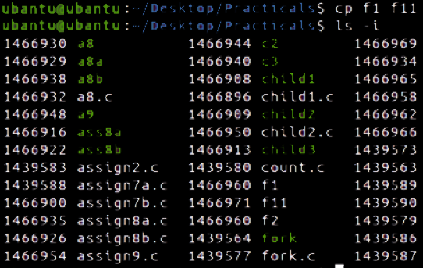

10.Can we reduce inode usage?

Ans:- The only option is to delete the unused files to reduce inode usage in linux.

11.Does the total number of inode depend on system configuration or flavours of Linux/Unix operating system?

Ans:- The total number of inodes and the space reserved for these inodes is set when the filesystem is first created.The inode limit can't be changed dynamically and every file system object must have an inode.

12.Specify size of inode. Does every inode have the same size?

Ans:- The inode-size value must be a power of 2 larger or equal to 128.

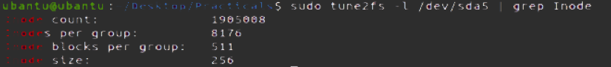

**B. Understand Superblock.**

1.List the contents of the filesystem

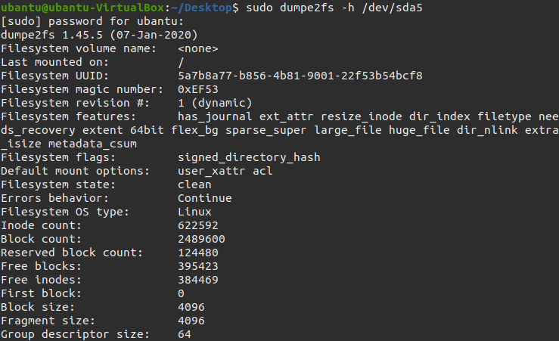

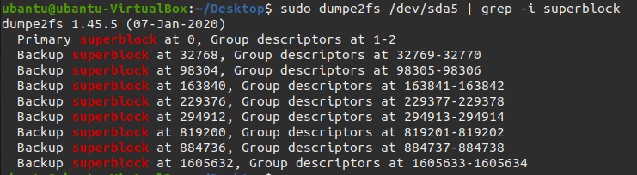

2.Manipulate the filesystem meta data

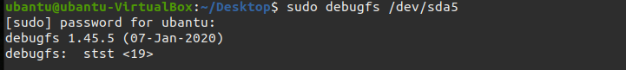

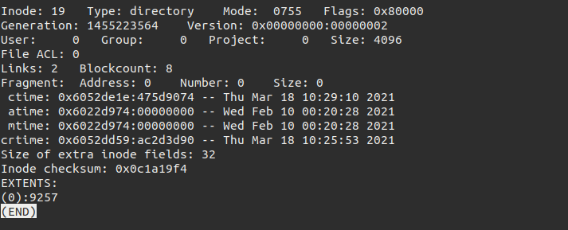

**C. Create hard link and soft link for a file.**



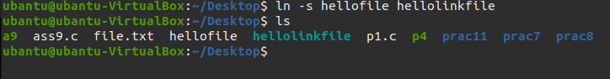

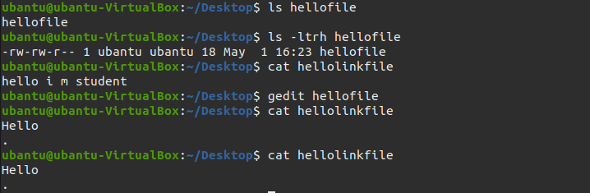

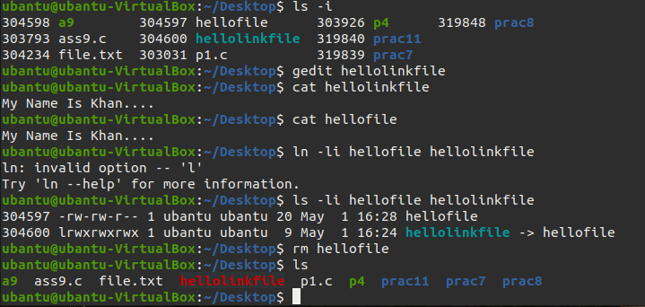

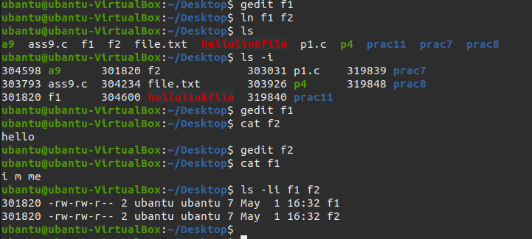

**D. Find hard link in Linux**

Ans:- Files that are hard-linked together share the same inode number.

