**PRACTICAL-4**

|  |
| --- |
| **Aim:**  [A] Write a C program that will print parent process id and child process id. Mention error checking if the child process is not created. |

**Program Code:**

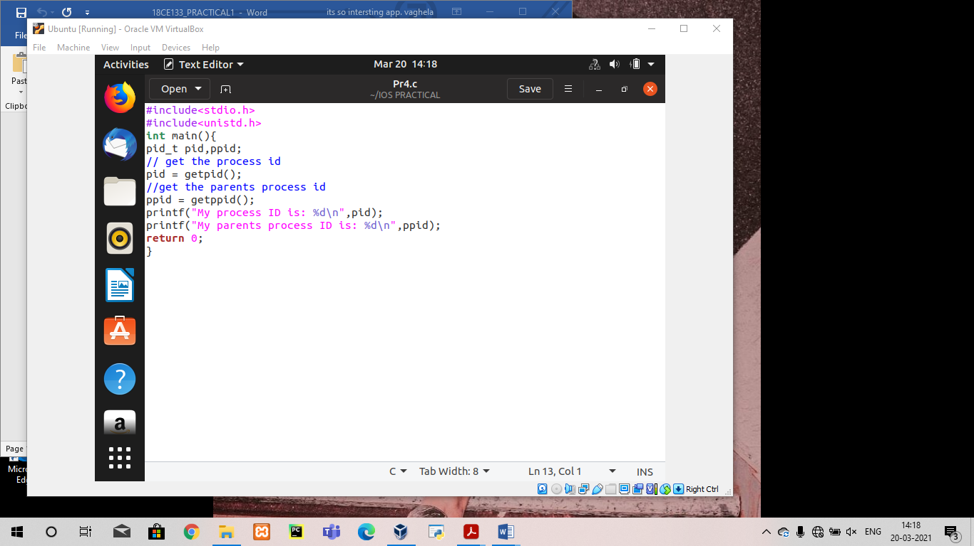

**OUTPUT:**

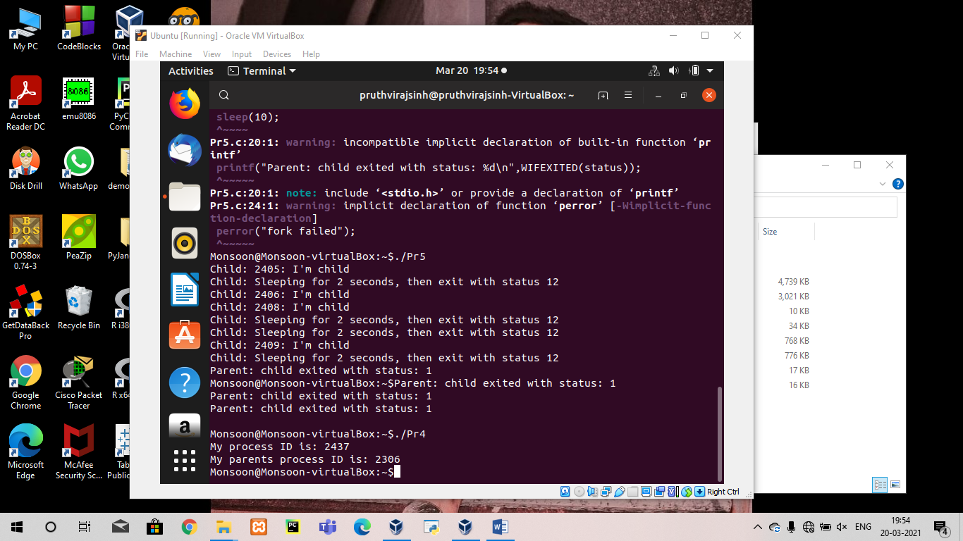

**ASSIGNMENT TASK**

**Program Code:**

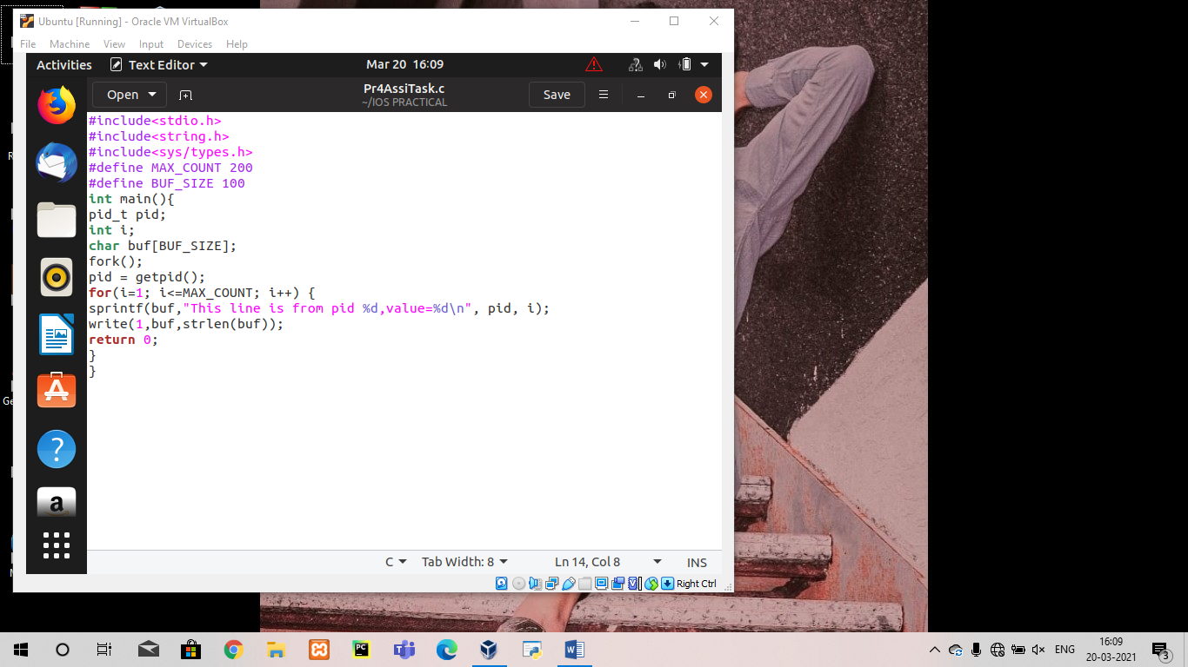

**OUTPUT:**

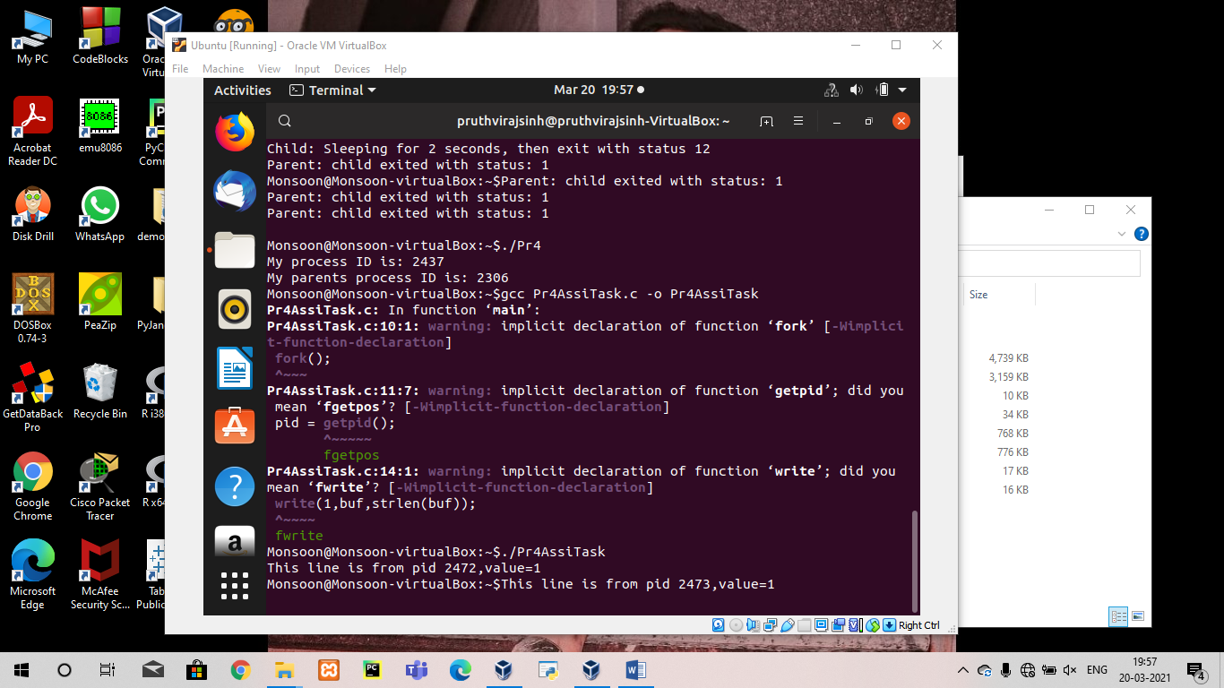

**PRACTICAL-5**

|  |
| --- |
| **Aim:** |

|  |
| --- |
| [B] In continuation of part (a), write a C program where the parent process waits for the child process to terminate. |

**Program Code:**

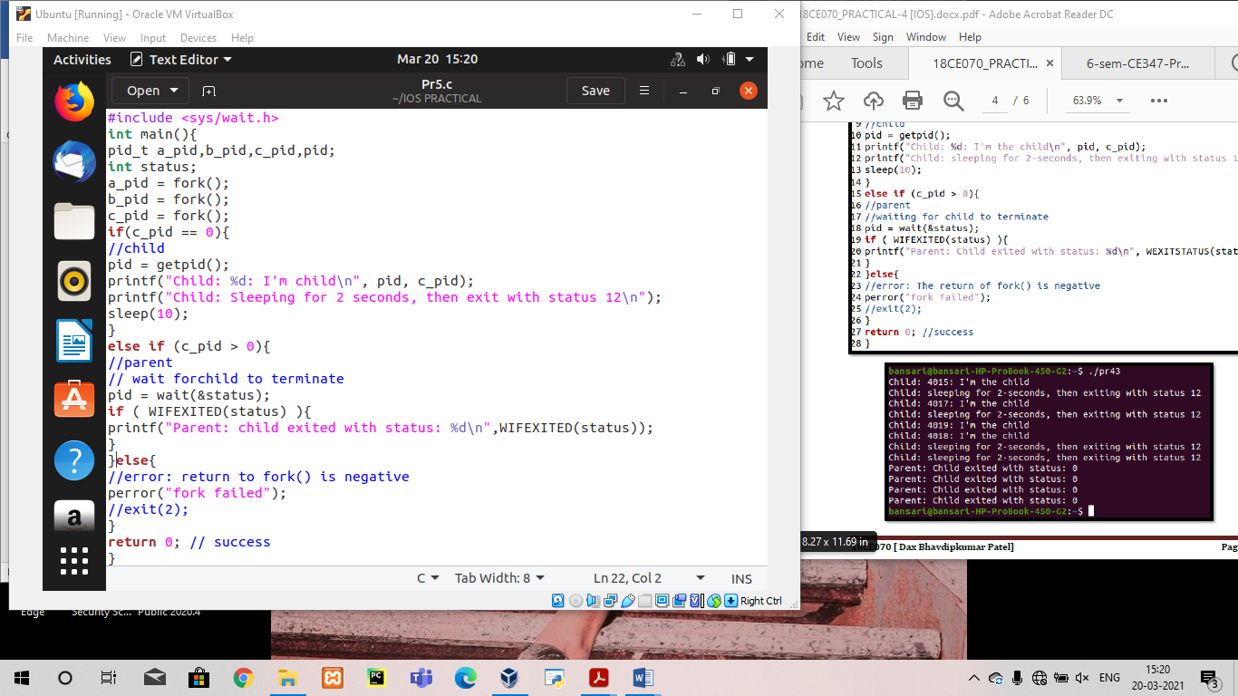

**OUTPUT:**

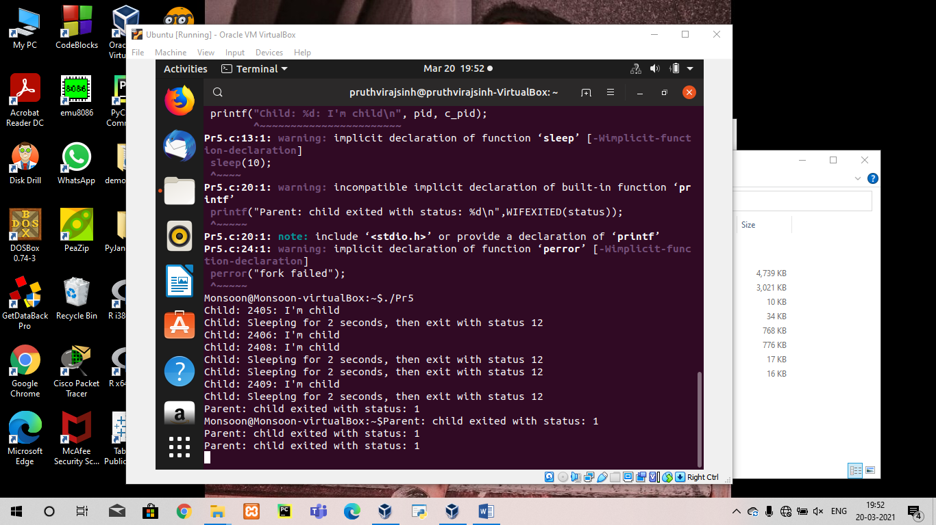

**PRACTICAL-6**

|  |  |
| --- | --- |
| **Aim:** | |
| |  | | --- | | [C] Write a C program using execvp() system call which will count the characters from file ‘wc’, using program ‘p.c’. | |

**Program Code:**

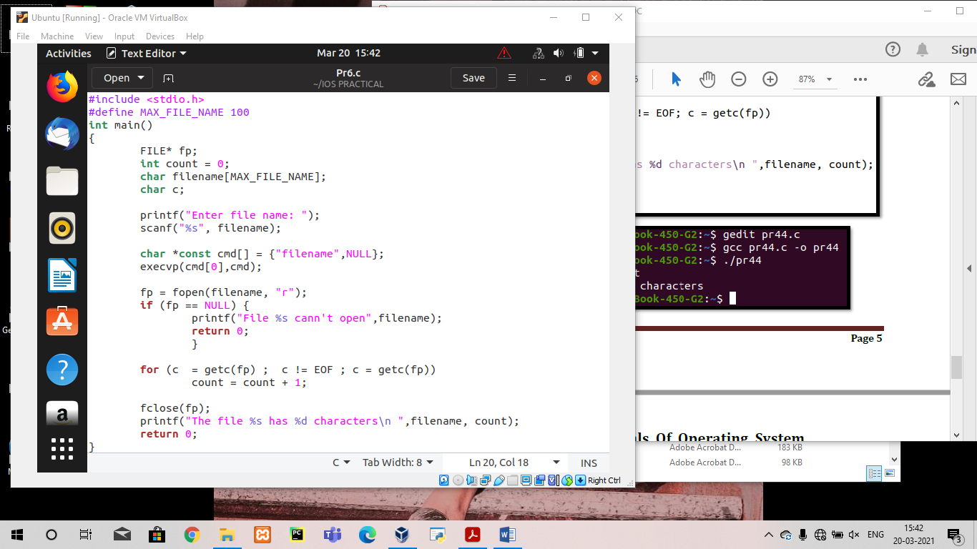

**OUTPUT:**

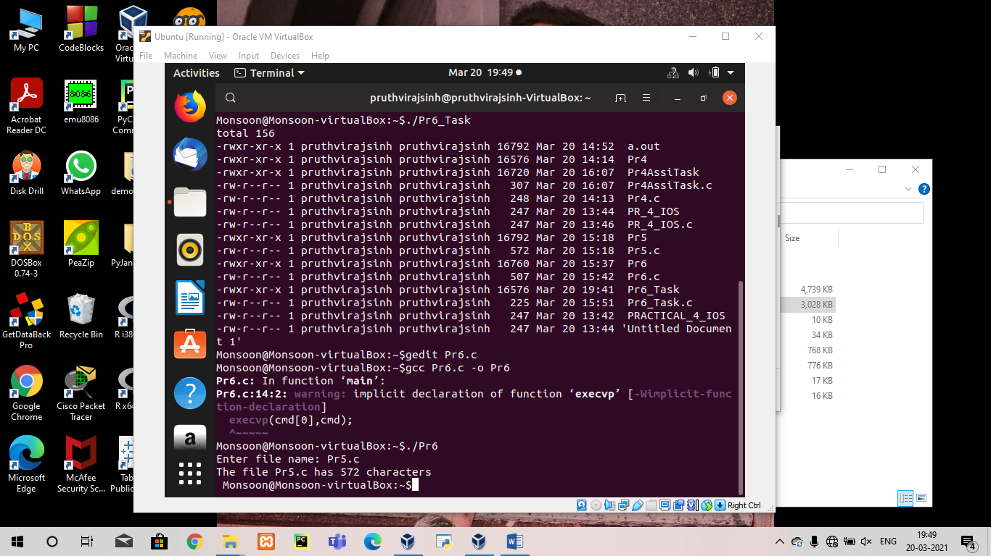

**ASSIGNMENT TASK**

**Program Code:**

