**PRACTICAL-1**

**Aim:**

Collect the following basic information about your machine using proc.

a. How many CPU cores does the machine have?

b. How much memory, and what fraction of it is free?

c. How many context switches has the system performed since bootup?

d. How many processes has it forked since bootup?

e. How many processors does your machine have?

f. What is the frequency of each processor?

g. Find out various states of process at time of observation.

**Program Code:**

a. How many CPU cores does the machine have?



b. How much memory, and what fraction of it is free?



c. How many context switches has the system performed since bootup?



d. How many processes has it forked since bootup?



e. How many processors does your machine have?

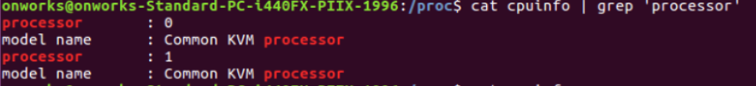



f. What is the frequency of each processor?



g. Find out various states of process at time of observation.



**Learning from practical:**

From this practical number-1, we have learnt how Ubuntu works and use of their commands and also observe what was happened internally in our machine like Cpu cores, process states, memory info, frequency etc.

**Assignment**

1. **What is the time spent by a process in user mode and Kernel mode?**

**User mode:**

The system is in user mode when the operating system is running a user application such as handling a text editor. The transition from user mode to kernel mode occurs when the application requests the help of operating system or an interrupt or a system call occurs.

The mode bit is set to 1 in the user mode. It is changed from 1 to 0 when switching from user mode to kernel mode.

**Kernel mode:**

The system starts in kernel mode when it boots and after the operating system is loaded, it executes applications in user mode. There are some privileged instructions that can only be executed in kernel mode.

These are interrupt instructions, input output management etc. If the privileged instructions are executed in user mode, it is illegal and a trap is generated.

The mode bit is set to 0 in the kernel mode. It is changed from 0 to 1 when switching from kernel mode to user mode.

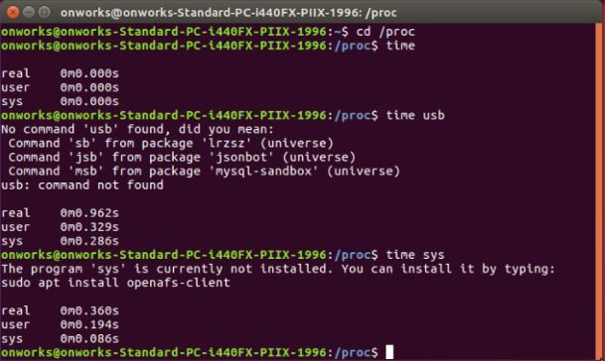

1. **Mention the difference between MemFree and MemAvailable fields of the file /proc/meminfo.**

Free memory is the amount of memory which is currently not used for anything. This number should be small, because memory which is not used is simply wasted. Available memory is the amount of memory which is available for allocation to a new process or to existing processes.

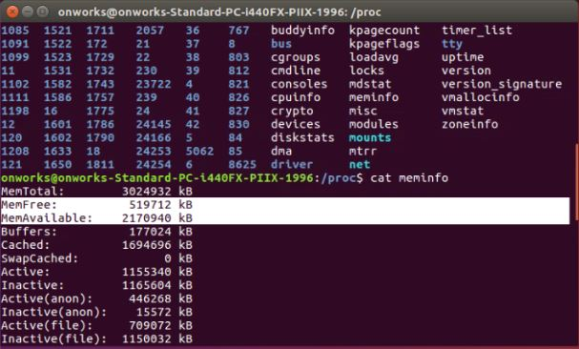

1. **Explain the content of /proc/key-users.**
   * uid The user ID.
   * usage: This is a kernel-internal usage count for the kernel structure used to record key users.
   * nkeys/nikeys
   * The total number of keys owned by the user, and the number of those keys that have been instantiated.
   * qnkeys/maxkeys
   * The number of keys owned by the user, and the maximum number of keys that the user may own.
   * qnbytes/maxbytes
   * The number of bytes consumed in payloads of the keys owned by this user, and the upper limit on the number of bytes in key payloads for that user.

**How many processes are running & how many are blocked?**

