**PRACTICAL-7**

|  |
| --- |
| **Aim:**  Write the following programs using inter process communication shared memory: [A]. The program ‘writer.c’ will write 1 to 100 in the shared memory region.  [B]. Another program ‘reader.c’ that will read all the numbers from shared memory to make addition of it & display it. |

**Program Code:**

**Writter.c:**

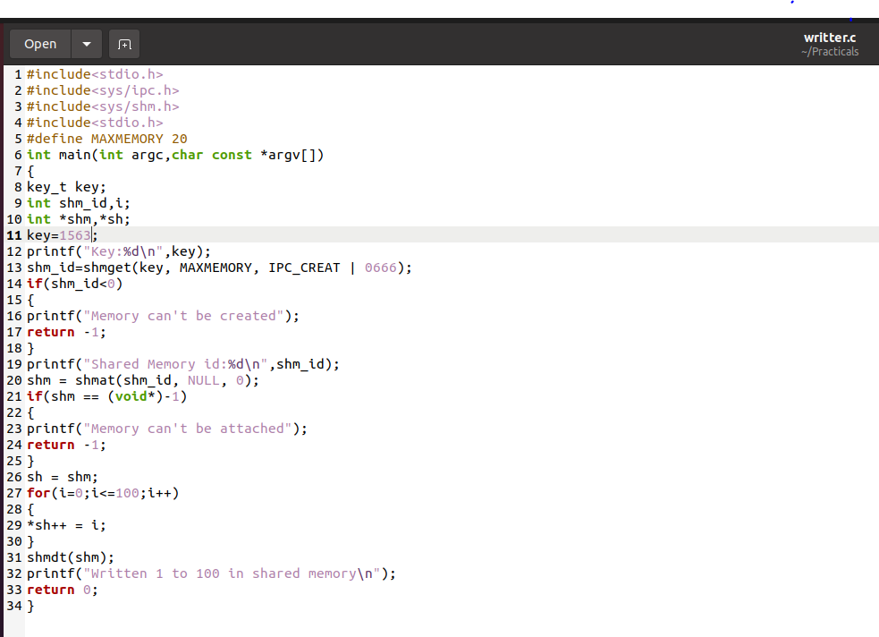

**Reader.c**

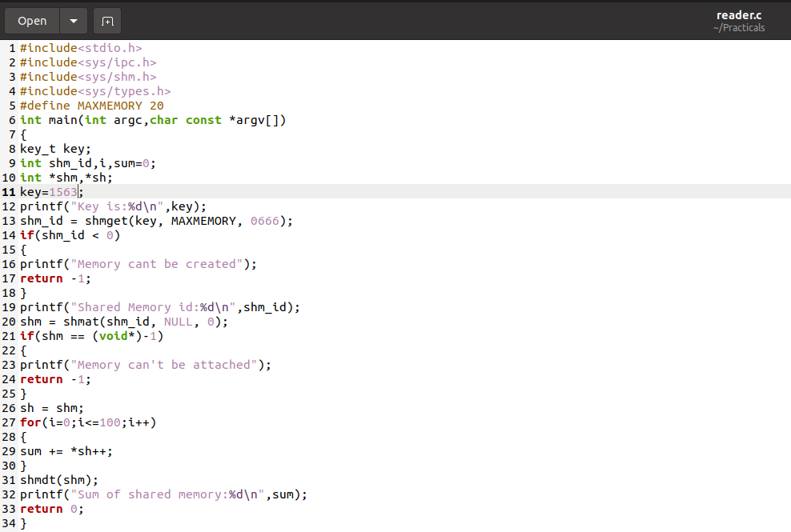

**OUTPUT:**

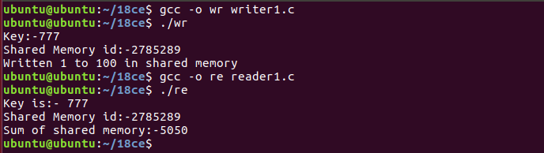

**ASSIGNMENT 7**

**Aim:** Create a shared memory that is going to be shared between 1 parent process and 3 child process. Parent process writes a random number in shared memory. After that following operations shold be done in strict following order. 1) child 1 reads the random number and mutliply with 10 and writes again in the shared memory (the number written by parent process should be removed) . 2) child 2 reads the number written by child 1 and perform modulo by 5 operation and writes again in the shared memory (the number written by child 1  should be removed).  3) Child 3 reads the number from shared memory and perform addition by last three digit of your enrollment number and  writes again in the shared memory (the number written by child 2  should be removed). Print the final result on terminal.

**Program Code:**

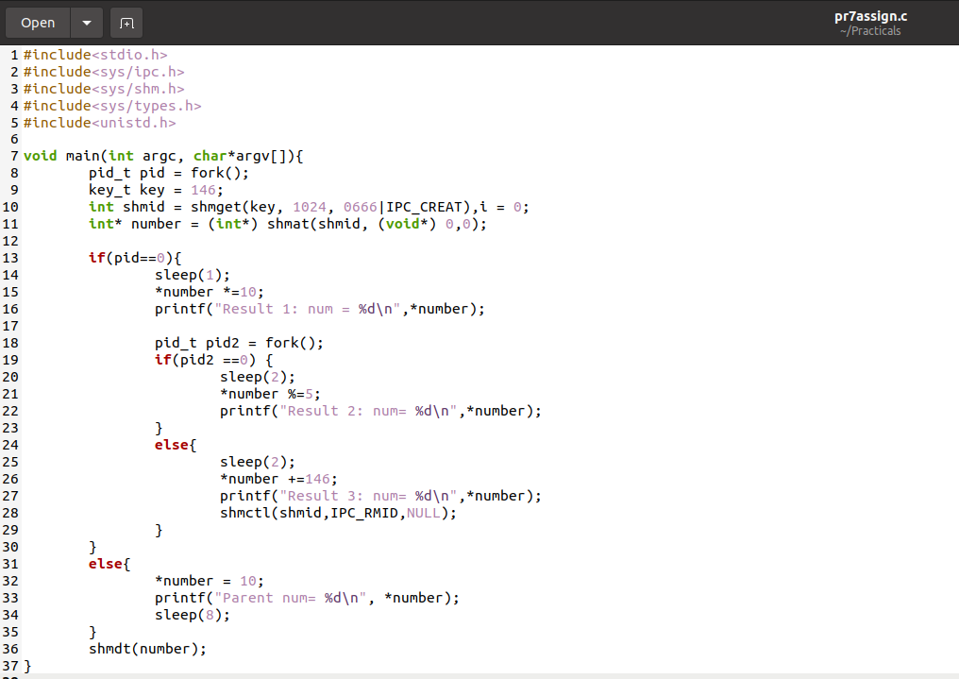

**OUTPUT:**

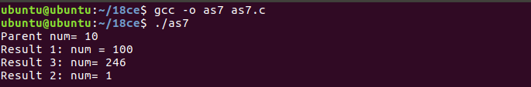

**PRACTICAL-8**

|  |
| --- |
| **Aim:** : Implement a message queue for message sharing. |

**Program Code:**

**Writer.c**

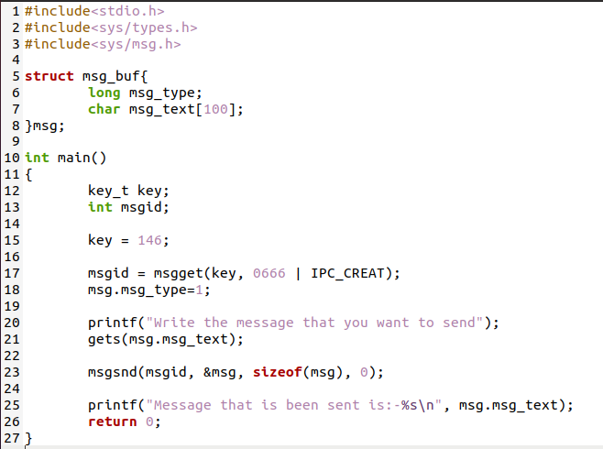

**Readder.c**

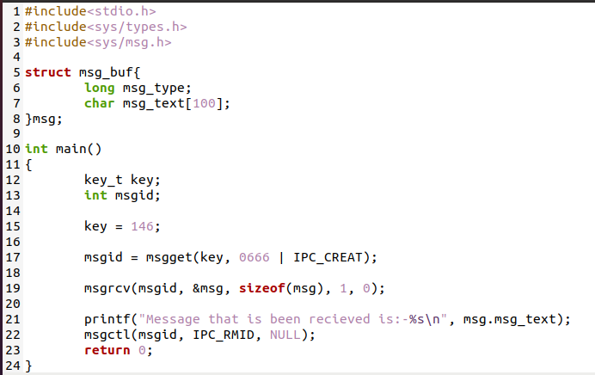

**OUTPUT:**

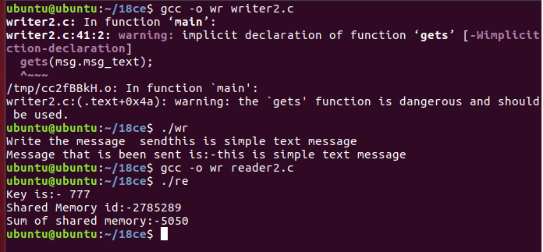

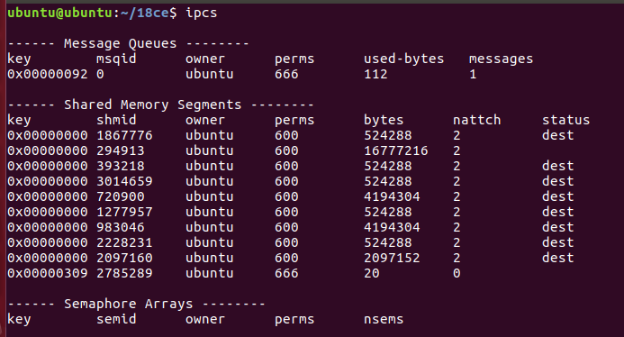

**Assignment 8**

|  |
| --- |
| **Aim:** Create a message passing queue. Suppose a Process 'A' sends five message in following strict order. 1) Unix 2) Linux 3)MAC 4)Windows 5)Android. The Process 'B' should retrieve  messages in following order. 1) MAC 2) Android 3)Linux 4) Windows 5)Unix. |

**Program Code:**

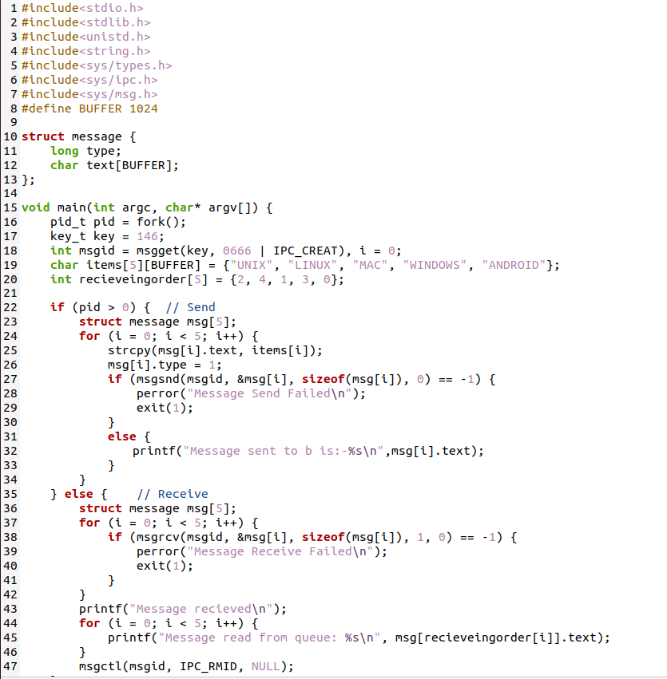

**Output:**

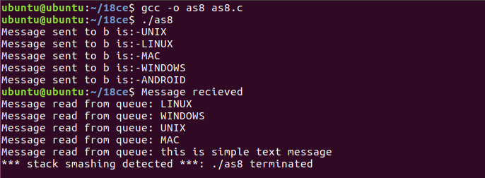

**Learning from practical:-**

By this practical we learnt inter process communication message passing sending and receiving using msgid, msgget , msgsnd, msgrcv and msgctl command using C program