ANUGNYA WHATSAPP SENDER
Standard Operating Procedure — Meta Cloud API Build
Version 1.1 | 12 May 2026 | Rajiv Lal

1. Application Description

Anugnya WhatsApp Sender is a full-stack web application built on the Meta WhatsApp Cloud API. It enables the Anugnya Holistic Care team to run personalised WhatsApp outreach campaigns to a contact database of 4,647 validated numbers, manage inbound replies, and track campaign performance — all from a browser-based dashboard secured by role-based authentication.

The system replaces a prior Puppeteer/whatsapp-web.js implementation and operates on a Google Cloud VM with a permanent HTTPS URL. It is designed for non-technical operators to run campaigns without any command-line access.

1.1 Full Feature List

Module | Feature | Detail
Dashboard | Live send engine status | Shows active campaign, batch progress bar, contacts sent/remaining, uptime
Dashboard | Live log | Real-time WebSocket log of every send attempt, success, failure, and delay
Dashboard | Reply badge | Unread reply count in sidebar badge, auto-updates via WebSocket
Dashboard | System stats | Total campaigns, total contacts, unread replies, server uptime
Campaigns | Create campaign | Name, select template, select contact list, configure batch/interval/delay/daily limit
Campaigns | Campaign status | Draft → Active → Paused lifecycle with lock/unlock controls
Campaigns | Load contacts | Pulls all contacts from selected list into campaign_contacts table
Campaigns | Pick to queue | Randomly selects N pending contacts and queues them for sending
Campaigns | Review queue | View all queued contacts before activation — edit first names inline, skip individual contacts
Campaigns | Activate / Pause | Start or pause the send engine for a specific campaign
Campaigns | Replenish queue | Top up the queue to a target count while campaign is running
Campaigns | Reset failed | Move failed contacts back to pending for retry
Campaigns | Progress stats | Total / Pending / Queued / Sent / Failed counts per campaign
Send Engine | Automated batch send | Sends contacts in configurable batches with random delay between each message
Send Engine | Interval between batches | Configurable cooldown between batches (default 100 minutes)
Send Engine | Daily limit | Hard cap on messages per day per campaign (default 100)
Send Engine | Manual send | Send N contacts immediately outside the automated schedule
Send Engine | Pause / Stop | Pause preserves queue; Stop clears active state
Send Engine | Meta API integration | Sends approved template with video header + personalised first name via Graph API v19
Contact Lists | Create list | Named contact lists with description
Contact Lists | Import from Excel | Upload .xlsx file — maps phone, name, first name, email, notes columns
Contact Lists | View members | Paginated view of all contacts in a list with search/filter
Contact Lists | Edit first name | Inline edit of first name for any contact
Contact Lists | Delete list | Remove list and unlink from campaigns
Templates | Create template | Store template metadata — name, language, category, body, header type, status
Templates | Edit / Delete | Full CRUD on local template records
Templates | Active filter | Campaign dropdown only shows active templates
Replies | Inbound reply list | All WhatsApp replies received via webhook, filterable by status
Replies | Reply to contact | Send free-text reply within 24-hour customer service window
Replies | Dismiss reply | Mark reply as handled without sending a message
Replies | Reply assets | Store reusable reply text snippets for quick responses
Meta Log | Full API log | Every outbound API call and inbound webhook event — payload, response, status code, error
Meta Log | Filter by type | Filter log by send_template, send_reply, inbound
Settings | System settings | Configure default batch size, interval, delay range, daily limit
Users | User management | Create, activate/deactivate operators; admin vs operator roles
Users | Password reset | Admin can reset any user password
Users | Session auth | Cookie-based session with secure: true on HTTPS

2. System Architecture

The diagram below shows all system components and data flows.

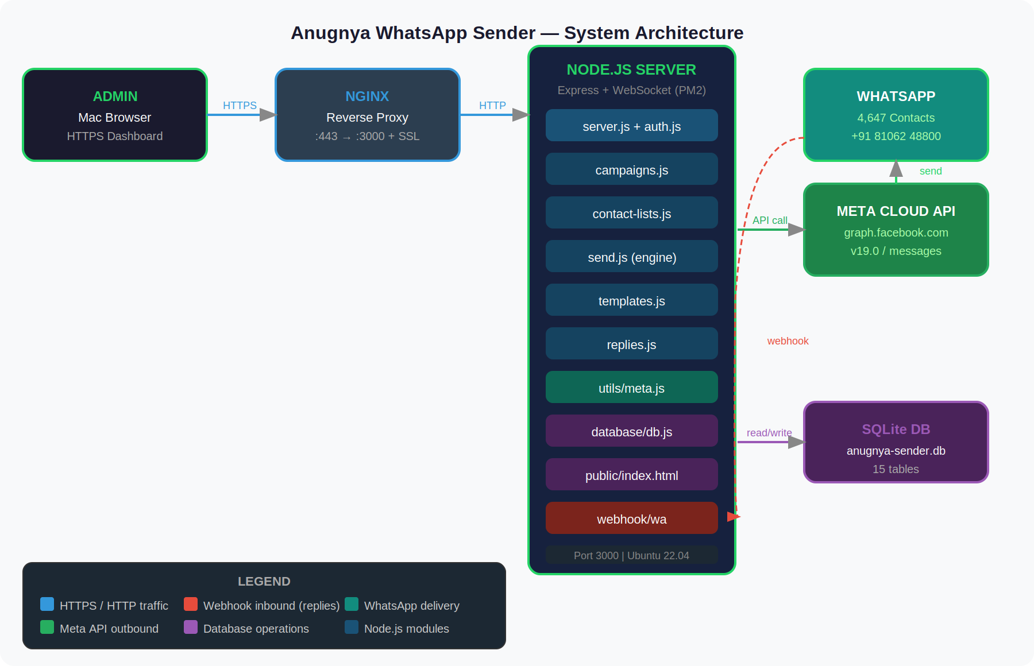

2.1 Component Summary
Component | Role
Mac Browser | Admin accesses the dashboard at https://sender.anugnyaholisticcare.com — all UI interactions go through HTTPS
Nginx | Reverse proxy on the VM — terminates SSL (Let's Encrypt), forwards :443 → :3000, handles WebSocket upgrade headers
Node.js (Express) | Core application server — serves dashboard, exposes REST API, runs WebSocket server, executes send engine timer
PM2 | Process manager — keeps Node.js running, restarts on crash, starts on VM reboot
SQLite (db.js) | 15-table relational database — contacts, campaigns, queue, replies, meta log, users, settings, reply assets
utils/meta.js | Wrapper for Meta Cloud API — builds template payload with video header + first name, logs every call
Meta Cloud API | WhatsApp Business Platform — receives template send requests, delivers messages to WhatsApp numbers
WhatsApp | End recipient receives personalised message with video, body text, footer, and website button
webhook/wa | POST endpoint — receives inbound reply events from Meta when a contact replies to the message

3. Infrastructure

3.1 Google Cloud VM
Parameter | Value
Provider | Google Cloud Platform
Instance name | anugnya-sender
Machine type | e2-small
Region / Zone | asia-south1-a (Mumbai)
OS | Ubuntu 22.04 LTS
External IP | 35.207.246.33 (static)
Node.js | v20.20.2
Process manager | PM2 (global)
PM2 process name | anugnya-sender
App port | 3000
App folder | ~/anugnya-whatsapp-sender

3.2 Domain & SSL
Parameter | Value
Dashboard URL | https://sender.anugnyaholisticcare.com
Webhook URL | https://sender.anugnyaholisticcare.com/webhook/wa
DNS A record | sender.anugnyaholisticcare.com → 35.207.246.33
SSL provider | Let's Encrypt (auto-renews)
SSL expiry | 2026-08-06
Nginx config | /etc/nginx/sites-available/anugnya-sender
Reverse proxy | Nginx :443 → localhost:3000

3.3 GitHub Repository
Parameter | Value
Repo | github.com/Rajiv-Lal/whatsapp_meta
Branch | main
Local Mac path | /Users/rajivlal/whatsapp meta

4. Meta Credentials & Configuration

4.1 Meta App Details
Parameter | Value
App name | Audience Test
App ID | 1196733245784357
App status | LIVE (published 12 May 2026)
WABA ID | 2232412034233400
Phone Number ID | 1026858123851956
Display number | +91 81062 48800
Verified name | Anugnya Holistic Care
Account mode | LIVE
Quality rating | High

4.2 Template Details
Parameter | Value
Template name | introducing_anugnya_holisitic_care (typo intentional — must match Meta exactly)
Template ID | 914969988221055
Language | en
Category | MARKETING
Status | APPROVED
Header type | VIDEO
Body variable | {{1}} = first name of recipient
Footer | Best Rajiv
Button | Visit website → https://anugnyaholisticcare.com

4.3 Complete .env File
Location on VM: ~/anugnya-whatsapp-sender/.env

PHONE_NUMBER_ID=1026858123851956
ACCESS_TOKEN=<permanent system user token>
TEMPLATE_NAME=introducing_anugnya_holisitic_care
TEMPLATE_HEADER_MEDIA_ID=954878467170987
PORT=3000
SEED_ADMIN_EMAIL=rajiv@anugnyaholisticcare.com
SEED_ADMIN_PASSWORD=Aroh@26
SEED_ADMIN_NAME=Rajiv Lal
WEBHOOK_VERIFY_TOKEN=anugnya2026
NODE_ENV=production

5. .env Errors Made & Corrections

Three critical errors were discovered in the .env during initial testing. All caused API failures.

Error 1 — Wrong template name
Wrong | TEMPLATE_NAME=introducing_anugnya
Correct | TEMPLATE_NAME=introducing_anugnya_holisitic_care
Impact | Meta returned error #132001 — template name does not exist
How found | Queried WABA via Graph API for all templates
Fix command | sed -i 's/TEMPLATE_NAME=introducing_anugnya$/TEMPLATE_NAME=introducing_anugnya_holisitic_care/' .env

Error 2 — Wrong env key for media ID
Wrong | TEMPLATE_HEADER_HANDLE=638453927_914969991554388
Correct | TEMPLATE_HEADER_MEDIA_ID=954878467170987
Impact | meta.js read null — header dropped silently. Meta returned #100 Invalid parameter
How found | Code review — key mismatch between .env and process.env read in meta.js
Fix command | sed -i 's/TEMPLATE_HEADER_HANDLE=.*/TEMPLATE_HEADER_MEDIA_ID=954878467170987/' .env

Error 3 — Expired media ID
Wrong | TEMPLATE_HEADER_MEDIA_ID=4526698114217021 (expired after 30 days)
Correct | TEMPLATE_HEADER_MEDIA_ID=954878467170987 (fresh upload 12 May 2026)
Impact | Meta returned "An unknown error has occurred" (error code 1)
Root cause | Meta media IDs expire after 30 days. Original ID was from a prior session.
Fix | Re-upload the video .mp4 to Meta media API to get a fresh ID
Upload command | curl -X POST "https://graph.facebook.com/v19.0/<PHONE_NUMBER_ID>/media" -H "Authorization: Bearer <TOKEN>" -F "file=@/path/to/video.mp4;type=video/mp4" -F "messaging_product=whatsapp"
Permanent fix | Upload MP4 to anugnyaholisticcare.com and switch to URL-based header — no expiry

6. Webhook Configuration

6.1 Registration Steps
- developers.facebook.com → Audience Test app
- Use cases → Customize → Connect with customers through WhatsApp → Configuration
- Callback URL: https://sender.anugnyaholisticcare.com/webhook/wa
- Verify token: anugnya2026
- Click Verify and save
- Scroll to Webhook fields → toggle messages → Subscribe

6.2 Important Notes
- Webhook only receives test events while app is in Development mode
- App published live on 12 May 2026 — all contacts can now trigger webhook
- Publishing requires: Privacy Policy URL, Category, User data deletion URL

7. File Structure on VM

~/anugnya-whatsapp-sender/
├── server.js — Express app, routes, webhook, WebSocket
├── .env — 10 environment variables
├── database/
│ ├── schema.sql — 15-table SQLite schema
│ └── db.js — Database module v2.3
├── middleware/
│ └── auth.js — Auth middleware v1.2
├── routes/
│ ├── campaigns.js — Campaign CRUD + queue management
│ ├── contact-lists.js — Contact list CRUD + import
│ ├── templates.js — Template CRUD
│ ├── send.js — Send engine v1.5
│ └── replies.js — Inbound replies + reply assets
├── utils/
│ └── meta.js — Meta Cloud API utility v1.3
├── public/
│ └── index.html — Dashboard UI 1448 lines
└── data/
└── anugnya-sender.db — SQLite database

8. SOP for Creating a New Instance

Follow these steps to create a second instance (e.g. for Sangeeta Bhalla).

Step 1 — Meta Setup
- Create a new Meta App in developers.facebook.com
- Add WhatsApp product → Connect with customers use case
- Create or link a WABA (WhatsApp Business Account)
- Add a phone number and verify it
- Create message template with video header — submit for approval (1-2 days)
- Create System User in Business Manager → generate permanent access token
- Note: PHONE_NUMBER_ID, WABA_ID, ACCESS_TOKEN, TEMPLATE_NAME

Step 2 — Upload Video to Meta Media API
One-time upload after template is approved:
curl -X POST "https://graph.facebook.com/v19.0/<PHONE_NUMBER_ID>/media" \
-H "Authorization: Bearer <ACCESS_TOKEN>" \
-F "file=@/path/to/video.mp4;type=video/mp4" \
-F "messaging_product=whatsapp"
Returns {"id":"XXXXXXXXX"} — store as TEMPLATE_HEADER_MEDIA_ID in .env
IMPORTANT: Repeat every 30 days — media IDs expire.

Step 3 — VM Setup
- Clone repo: git clone https://github.com/Rajiv-Lal/whatsapp_meta.git
- cd into folder → npm install
- Create .env with all 10 variables (see Section 4.3)
- pm2 start server.js --name <instance-name>
- pm2 save && pm2 startup

Step 4 — Nginx & SSL
- Add Nginx server block for the new subdomain
- Point DNS A record to VM external IP
- Run: sudo certbot --nginx -d <new-subdomain>

Step 5 — Webhook & Publish
- Register webhook URL in Meta app → Configuration
- Subscribe to messages field
- Add Privacy Policy URL → publish the app

9. Ongoing Maintenance

Task | How / When
Refresh media ID | Re-upload video every 30 days → update TEMPLATE_HEADER_MEDIA_ID → pm2 restart anugnya-sender --update-env
SSL renewal | Auto-renews via certbot. Verify: sudo certbot renew --dry-run
PM2 on reboot | Already configured via pm2 startup. Check: pm2 list
Git sync | cd ~/anugnya-whatsapp-sender && git add -A && git commit -m "..." && git push origin main
Rotate access token | Meta Business Manager → System Users → regenerate → update .env
View logs | pm2 logs anugnya-sender

Anugnya Holistic Care | WhatsApp Sender SOP v1.1 | 12 May 2026

