IRCTC: The Monopoly in the Railways

* By S. Rajiv 205PGE033

*Abstract*

The Indian Railway Catering and Tourism Corporation (IRCTC) plays a crucial role in the world of railway services in India, essentially holding a monopoly in the extensive rail network. Established in 2002 as a subsidiary of Indian Railways, IRCTC has grown into a diverse organization, not only handling ticketing services but also overseeing catering, tourism, and online transactions. This overview explores the distinctive position of IRCTC, examining its influence on the country's railway system and discussing the challenges and opportunities associated with its monopoly. Through a thorough analysis, this study aims to highlight the effects of IRCTC's monopoly on factors such as service quality, pricing structures, and overall customer satisfaction in the Indian railway sector.

*Introduction*

India's railway system, one of the largest in the world, has undergone a transformative shift with the emergence of the Indian Railway Catering and Tourism Corporation (IRCTC) as the monopoly in railway services. Established in 2002 as a subsidiary of Indian Railways, IRCTC was tasked with revolutionizing ticketing, catering, and tourism-related services. Over the years, IRCTC's influence has expanded, cementing its role as the primary facilitator of railway-related transactions in the country.

The idea behind IRCTC's creation was recognizing the need for a dedicated entity to handle the increasing demands of railway passengers. Indian Railways aimed to streamline operations, improve customer experiences, and integrate technological advancements by consolidating various services under one roof. While IRCTC's monopoly status highlights its success, it has come under scrutiny, with both benefits and drawbacks sparking discussions about its dominance.

IRCTC's monopoly focuses on its exclusive control over online ticketing services. The widely used platform allows passengers to easily book tickets, check train schedules, and explore various tourism packages. The digital infrastructure provided by IRCTC has revolutionized travel for Indians, doing away with long queues and offering real-time information.

However, challenges have emerged within this monopoly. IRCTC has faced criticism for occasional technical glitches, website crashes during peak hours, and concerns about data security. The lack of viable alternatives has raised questions about market competition and innovation in the railway sector, with critics arguing that this situation may hinder the development of a more responsive and competitive railway ecosystem.

On the positive side, IRCTC's monopoly has brought about the standardization of services and pricing, introducing a level of consistency to the railway experience. The corporation has also ventured into catering services, providing a range of onboard meals and refreshments, enhancing the overall travel experience.

*Literature Review*

The monopoly of the Indian Railway Catering and Tourism Corporation (IRCTC) within the Indian railway services sector has been a subject of academic inquiry, policy debates, and industry analyses. This literature review aims to synthesize existing research on various aspects of IRCTC's monopoly, shedding light on its evolution, impact, challenges, and broader implications for the transportation landscape in India.

Monopoly Dynamics in Transportation:

(Joshi)have extensively examined the dynamics of monopolies in transportation sectors globally, providing insights into the consequences for service quality, pricing structures, and innovation. These studies offer a theoretical framework for understanding the broader implications of IRCTC's monopoly within the context of Indian Railways.

IRCTC's Evolution and Mandate:

Research on the history and mandate of IRCTC (GB Panchal) reveals the corporation's transformation from a subsidiary of Indian Railways to a multifaceted entity responsible for ticketing, catering, and tourism services. Understanding the historical context is essential for analyzing how IRCTC's mandate has shaped its current functions and objectives.

Technological Integration and Digital Transformation:

Several studies (J CASTANHA) delve into the technological advancements introduced by IRCTC, emphasizing the digitalization of ticketing services and its impact on user experience. The literature highlights how digital platforms have reshaped railway services and discusses the implications for customer expectations and satisfaction.

Customer Satisfaction and Service Quality:

Academic inquiries into customer satisfaction (U Chadha, 2022) provide valuable insights into passengers' perceptions of IRCTC's services. These studies assess factors contributing to or hindering customer satisfaction, such as service quality, reliability, and ease of use, offering a nuanced understanding of the customer experience.

Pricing Strategies and Revenue Models:

Research on pricing strategies employed by monopolistic entities in the transportation sector (SS Roy, 2021) is crucial for evaluating the impact of IRCTC's pricing models on revenue generation and financial sustainability. Understanding the economic implications of the monopoly is vital for policymakers and industry stakeholders.

Market Competition and Entry Barriers:

Studies on market competition and entry barriers (Hazarika, 2013) explore the landscape of the railway services sector. The literature examines how IRCTC's monopoly affects the entry of new players and the potential for market diversification, providing valuable insights into the broader market dynamics.

Challenges and Criticisms:

Scholarly examinations of challenges and criticisms faced by IRCTC (Tandon, 2008) contribute to a holistic understanding of the corporation's performance. Issues related to service interruptions, technical glitches, and customer dissatisfaction are explored, shedding light on areas for improvement and potential reforms.

Regulatory Framework and Policy Implications:

Research on the regulatory framework governing IRCTC (Kumar, 2007) elucidates the policy landscape surrounding the monopoly. Discussions on potential reforms and their consequences offer insights into the role of regulatory bodies in shaping the trajectory of railway services in India.

Comparative Studies:

Comparative studies between IRCTC and entities in other countries or industries (Scholar et al., Year) provide valuable benchmarks for evaluating alternative models and practices. These studies offer a broader perspective on how different approaches to monopolies have influenced service delivery and market dynamics.

In synthesizing these diverse strands of literature, this review aims to provide a comprehensive understanding of the monopoly of IRCTC in Indian railway services, identify gaps in current knowledge, and suggest potential avenues for future research.

*Data and Methodology*

Monopoly in Ticket Booking System

Established in 1999 as a wholly government-owned Central Public Sector Enterprise (CPSE), the Indian Railway Catering & Tourism Corporation Ltd (IRCTC) holds a monopoly in the provision of online ticket booking, packaged drinking water, and catering services for Indian Railways (IR) passengers. With a market share of approximately 73% in online rail bookings and 45% in packaged drinking water, IRCTC also extends its services to hospitality on trains and other locations. Additionally, it actively promotes tourism in India through public-private partnerships (PPP) and has earned the designation of Mini Ratna (Category-I Public Sector Enterprise) from the Government of India. This regulated monopoly serves as a robust protective barrier, offering a substantial and sustainable competitive advantage over competitors.

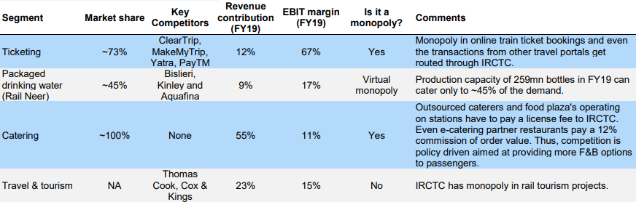

*Source- Prabhudar Liladhar*

The railway electronic booking services offered by IRCTC were introduced in 2002, and it remains the sole entity authorized by Indian Railways (IR) to provide online ticketing, commanding a substantial market share of approximately 73%. Other online travel agents (OTAs) facilitating e-ticketing services are required to channel their transactions through the IRCTC booking engine.

The online bookings for long-distance trains, excluding suburban services, have experienced a Compound Annual Growth Rate (CAGR) of 16.5% from FY10 to FY19. In FY19, 284 million tickets were booked online, resulting in an e-booking penetration of 70%. The CAGR for non-suburban passenger traffic on online-booked tickets during FY10-19 was 16.1%. On average, around 1.7 to 1.8 passengers have traveled per e-ticket booked over the same period.

Anticipating a CAGR of 10.3% in online rail bookings from FY19 to FY22E, we project an increase in e-booking penetration from 70% to 80% by FY22E. The Government of India's initiative to encourage cashless and digital transactions is expected to drive online ticket bookings, with additional support from growing traction and incentive-driven promotions by OTAs such as Yatra, MakeMyTrip, PayTM, etc.

Consequently, we forecast a CAGR of 9% in e-booking passenger traffic from FY19 to FY22E. Given its monopoly status, we believe that IRCTC will be the primary beneficiary of the expanding e-booking penetration and the subsequent surge in online ticket volumes.

E-booking passenger traffic has risen steadily

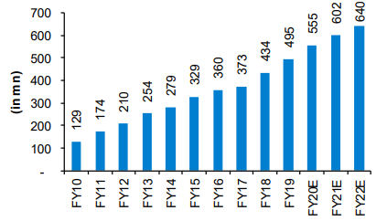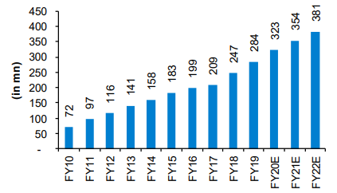

Rail e-bookings CAGR at 10% over FY19-22E

E-booking penetration est at ~80% by FY22E

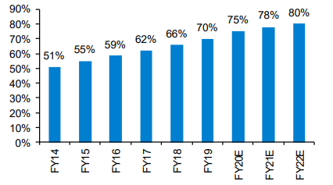

Passengers travel per e-ticket

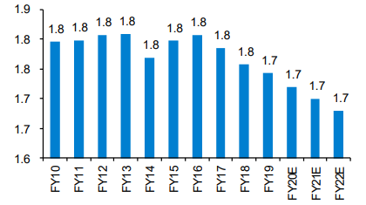

Rail Neer

IRCTC holds the exclusive authorization from Indian Railways for the production and distribution of packaged drinking water (PDW) across all railway stations and on trains. Operating under the "Rail Neer" brand, the company runs eleven operational plants with a combined production capacity of 1,116,000 bottles per day. Additionally, it has installed 1,950 water vending machines (WVM) at 700 railway stations, offering affordable potable drinking water.

Despite a receptive market and the presence of 11 Rail Neer plants capable of producing 1.1 million bottles daily, IRCTC currently commands only around 45% of the volume market share for packaged water demand originating from railway premises and within trains.

Rail Neer plants have capacity of 1.1mn bottles/day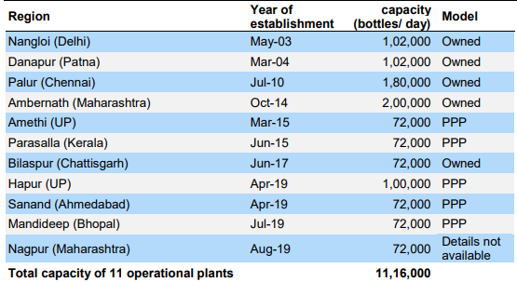

Catering Services

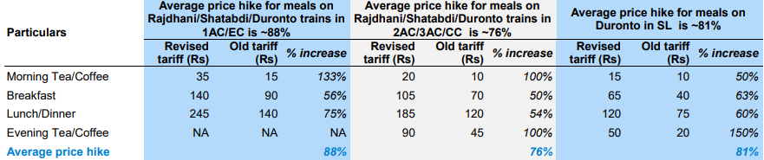The implementation of a new catering policy and tariff revision contributes to enhanced revenue predictability. IRCTC extends its food catering services to train passengers (mobile catering) and at stations (static catering). These services encompass mobile catering units, base kitchens, cell kitchens, refreshment rooms, food plazas, food courts, train-side vending, and Jan Ahaars across the extensive Indian Railways network. However, zonal railways oversee the management of refreshment rooms at stations categorized as B or below, as well as milk stalls and trolleys. Additionally, IRCTC provides e-catering services, facilitating online food ordering for passengers through collaborations with partner restaurants.

E- Catering Services

In September 2014, IRCTC introduced e-catering services as a pilot project, covering 14 trains initially and later expanding to 201 trains in FY15. E-catering services can be accessed through IRCTC's e-catering website, the Food on Track app, online platforms of approved aggregator partners, or by calling 1323. As of July 2019, the e-catering services had approximately 700 partner restaurants listed on its portal. The selection of partner restaurants is done through a tendering process, and these restaurants pay IRCTC a flat 12% commission on the order value.

Since its introduction in FY15, the annual order volumes for e-catering services have shown a remarkable Compound Annual Growth Rate (CAGR) of about 541%, rising from around 800 orders in FY15 to approximately 1.3 million orders in FY19. Anticipating an increased internet accessibility, a growing list of popular restaurants and Quick Service Restaurants (QSR) on the e-catering platform, and an enhanced awareness of food brands with a focus on quality and hygiene, we project the order volumes to rise at a CAGR of 25% from FY19 to FY22E.

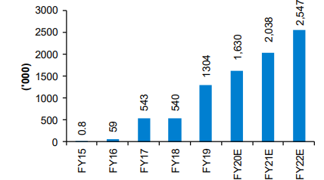

One stop solution of all travel & tourism related services

IRCTC has a presence in key tourism sectors, including hotel reservations, rail journeys, land tours, cruise vacations, and air tour packages, as well as air ticket bookings. As an entity overseen by the Ministry of Railways, it specializes in rail tourism and manages a range of theme-based tourist trains, luxury trains, and state special trains.

The annual growth rate of domestic tourist visits (DTVs) in India reached 12% from CY12 to CY18. Projections for the next five years anticipate a continued growth of DTVs at a Compound Annual Growth Rate (CAGR) ranging between 9% and 10%. This growth is attributed to factors such as increasing disposable incomes, enhanced rail and air connectivity, the emergence of low-cost carriers, and the expanding room inventory across budget, mid-segment, and premium hotels in the country. Additional contributing factors include the rise in business travel, the popularity of weekend getaways, and the younger generation's increasing interest in exploring undiscovered tourist destinations within India.

Foreign tourist arrivals (FTAs) exhibited a CAGR of 7.7% from CY10 to CY18. Looking ahead, FTAs are expected to grow at a CAGR of 9-10% over the next five years. This anticipated growth is influenced by India's rich natural and cultural heritage, which attracts foreign tourists, favorable government policies (including the new visa policy introduced in November 2014 to boost tourism), and ongoing improvements in infrastructure and connectivity across the country.

The increasing number of domestic tourist visits (DTVs) and foreign tourist arrivals (FTAs) is expected to positively impact the rail tourism revenue of IRCTC, which manages various tourist trains, including the following:

* Maharaja Express: A luxury tourist train operated by IRCTC.
* Buddhist Circuit Special Train: Operated by IRCTC for the past 12 years, it covers all Buddhist pilgrimage locations in India and Lumbini in Nepal.
* State Special Trains: These trains are run in collaboration with various state governments, with beneficiaries primarily being senior citizens.
* Bharat Darshan Trains: IRCTC's popular tourism product targeting tourists seeking affordable travel and holidays.

In addition to these, the robust growth in DTVs and FTAs is advantageous for IRCTC, serving as a comprehensive one-stop-shop for all travel and tourism-related services. IRCTC offers rail tour packages, land tour packages, charter trains and coach services, hill charters, educational tours, online air ticketing, corporate travel services (including corporate air ticketing and visa services), outbound air packages, domestic air packages, online and offline hotel booking services, cab rental services, customized packages, and LTC packages.

While complete travel solutions, such as tour packages, constitute approximately 3% of tourism sales and present significant untapped opportunities, the competition in this space is intense, with numerous small and regional tour operators in the largely unorganized market.

Financial Projections

There’s an anticipation that substantial increase in revenues, projecting a Compound Annual Growth Rate (CAGR) of 22.5% from FY19 to FY22E. This optimistic outlook is underpinned by several key factors:

* A substantial uptick in ticketing revenue, expected to amount to Rs3.6 billion/Rs6.7 billion/Rs7 billion in FY20E/FY21E/FY22E, respectively, following the implementation of service charges.
* A noteworthy 2.4x surge in Rail Neer sales, involving a strategic expansion that will double the number of operational plants to a total of 20.
* A robust 14.5% CAGR in catering sales, driven by significant price adjustments in mobile/static catering by approximately 70%/61%, respectively.
* An encouraging 9.1% CAGR in travel and tourism revenue, indicative of sustained growth in these sectors.

Furthermore, revenues from internet ticketing are poised for remarkable expansion at an impressive CAGR of 57.3% over the same period. This category encompasses various income streams, including:

* License fee call center income, which is anticipated to remain stable over the next three years, covering essential passenger enquiry services such as PNR status, accommodation availability, and cancellations.
* Advertisement/SBI co-branded cards income, showing promising growth with a projected CAGR of 10.6% from FY19 to FY22E. This income source results from displaying advertisements on the IRCTC web portal, Rail Neer bottles, and trains. A recent initiative called "Promotion on Wheels" has been introduced to facilitate promotional activities.
* Fees from RTSA/Internet café are expected to witness a steady rise at a CAGR of 9%, involving authorized agents (RTSAs) who incur charges for booking e-tickets.
* Service charges on e-tickets are anticipated to experience a substantial increase, reaching Rs3.6 billion/Rs6.7 billion/Rs7 billion in FY20E/FY21E/FY22E, respectively. This surge follows the reinstatement of convenience fees from September 1, 2019.

Valuations

Monopolistic entity deserves premium valuations

IRCTC stands as a dominant conglomerate in a monopolistic position, unique in its category without direct comparable listed peers, especially considering its recent listing. Consequently, we aim to conduct a segmented peer comparison to establish a fair value multiple for the stock.

In the realm of internet ticketing, MakeMyTrip, Yatra, and ClearTrip serve as other online travel agents (OTAs) that provide alternatives for booking rail tickets online. While they may not be direct peers since customers are redirected to IRCTC's booking engine even when opting for alternative platforms to book rail e-tickets, they do compete with IRCTC in flights and domestic hotels. Notably, due to the intensely competitive market, none of these players have reported profits over the past three years. In contrast, IRCTC, benefitting from its monopolistic position in the ticketing business, has reported an average Profit After Tax (PAT) of Rs965 million over the same period.

Considering that peers are currently incurring losses at the Earnings Before Interest, Taxes, Depreciation, and Amortization (EBITDA)/PAT level, earnings-based multiples lose relevance. As a result, we present a market/sales multiple snapshot for peers. It's important to note that Yatra's consensus forward estimates are unavailable, and ClearTrip is a private company, making it challenging to provide a comprehensive comparison on valuation multiples due to insufficient data.

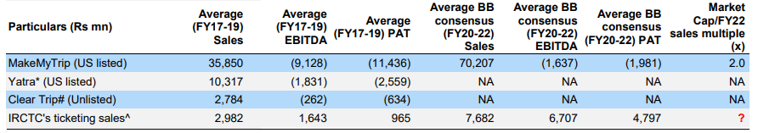

In the catering segment, IRCTC holds a monopoly on Indian Railways (IR), making Jubilant Foodworks and Westlife Development not precisely classified as direct peers. Interestingly, some of these entities are identified as partner restaurants with IRCTC, actively participating in offering e-catering services to passengers traveling on Indian Railways. Due to robust growth prospects, both Jubilant Foodworks and Westlife Development are currently trading at valuation multiples of 37.2x and 59.5x, respectively, based on the FY22E BB consensus forward earnings.

*Conclusion*

In conclusion, the Indian Railway Catering and Tourism Corporation (IRCTC) emerges as a transformative force within India's vast railway network, wielding a monopoly that has reshaped the dynamics of passenger services. While the corporation's digital prowess has streamlined ticketing processes, improved accessibility, and standardized services, the monopoly status has not been without its challenges. Technical glitches and concerns about market competition underscore the need for a balanced approach that preserves the benefits of efficiency while fostering a climate of innovation.

IRCTC's foray into diverse services, from online ticketing to onboard catering and tourism packages, showcases its adaptability and commitment to enhancing the passenger experience. However, the monopoly raises questions about the need for alternative models that can spur competition and drive improvements. Striking this delicate balance becomes imperative for sustaining a vibrant and responsive railway ecosystem.

As India's railway landscape continues to evolve, policymakers, industry stakeholders, and IRCTC itself must navigate the complex terrain of monopoly dynamics. Collaborative efforts that encourage innovation, technological resilience, and customer-centric solutions can pave the way for a railway sector that not only meets the current demands but anticipates and adapts to the future needs of a diverse and dynamic populace. In the final analysis, the story of IRCTC's monopoly is one of transformation, challenges, and the ongoing quest for a more efficient and customer-friendly railway experience in the world's most populous nation.

# References

GB Panchal, V. J. (n.d.). Multidimensional utility analysis in a two-tier supply chain.

Hazarika, A. (2013). E-Commerce: Expectations and Shortfalls. *Christ ULJ*.

J CASTANHA, M. P. (n.d.). Behavior intention to adopt IRCTC application for railway ticket reservation service: A case study of Goan consumers.

Joshi, J. (n.d.). Monopoly play on rail travel & tourism. *Prabhudar Liladhar*.

Kumar, K. (2007). Public-Private Partnership in Indian Railways.

SS Roy, M. K. (2021). Performance Assessment Study of Indian Railways–Case of Low Efficiencies in Large Government Monopoly. *Transportation Research Record*.

Tandon, H. (2008). B2C offerings in India: a critical review.

U Chadha, A. P. (2022). Quality management and passenger satisfaction in Indian railways: A critical review of stations, offices, IRCTC, workshops, and an on-ground survey of Sabarmati .