**CO1**

**INTRODUCTION**

**OPERTAING SYSTEM:**

An operating system is software that acts as an interface between the user of a computer and computer hardware. The purpose of an operating system is to provide an environment in which a user can execute programs conveniently and efficiently.

**Example:** Windows, Linux, Mac, Android etc. are examples of Operating systems which are generally used nowadays.

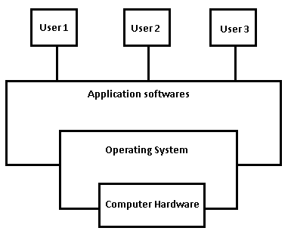

In the above diagram, Basically, Computer System mainly consists of hardware, software, and data.

* The **Computer Hardware**contains a central processing unit(CPU), the memory, and the input/output (I/O) devices and it provides the basic computing resources for the system.
* The **Application programs like spreadsheets, Web browsers, word processors, etc.**are used to define the ways in which these resources are used to solve the computing problems of the users. And the System program mainly consists of compilers, loaders, editors, OS, etc.
* The Operating System is mainly used to control the hardware and coordinate its use among the various application programs for the different users.

**Types of OS:**

1) Uniprogramming OS.

2)Multiprogramming OS.

3) Multitasking OS(Time Sharing).

4) Multiprocessing OS.

5) Multiuser OS.

6)Realtime OS.

7)Embedded OS.

8)Handheld device OS.

**Goals of OS:**

1)Convenience (User-Friendly).

2)Efficiency.

3)Portability.

4)Reliability.

5)Scalability.

6)Robustness.