**THRASHING**

When system is spending more time on paging than executing is said to be thrashing. In other words, it means, that the process doesn't have enough frames to hold all the pages for its execution, so it is swapping pages in and out very frequently to keep executing. Sometimes, the pages which will be required in the near future have to be swapped out.

**Causes of Thrashing:**

The main causes of thrashing in an operating system are:

**1. High degree of multiprogramming:**

When too many processes are running on a system, the operating system may not have enough physical memory to accommodate them all. This can lead to thrashing, as the operating system is constantly swapping pages of memory between physical memory and disk.

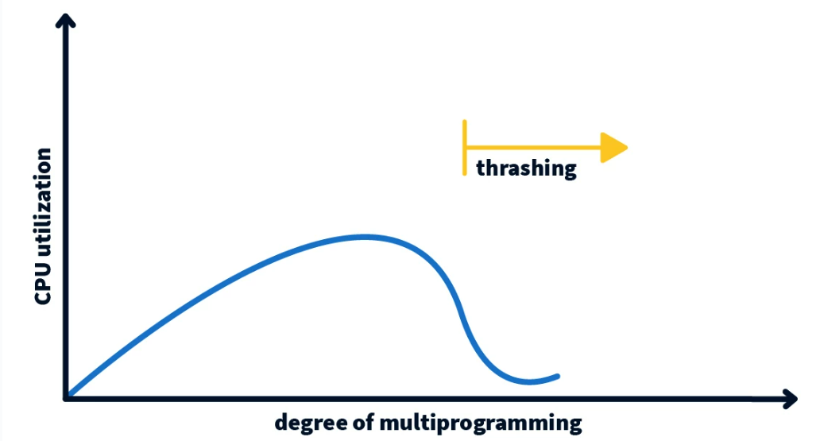

### 2. Lack of frames:

Frames are the units of memory that are used to store pages of memory. If there are not enough frames available, the operating system will have to swap pages of memory to disk, which can lead to thrashing.

### 3. Page replacement policy:

The page replacement policy is the algorithm that the operating system uses to decide which pages of memory to swap to disk. If the page replacement policy is not effective, it can lead to thrashing.

### 4. Insufficient physical memory:

If the system does not have enough physical memory, it will have to swap pages of memory to disk more often, which can lead to thrashing.

### 5. Inefficient memory management:

If the operating system is not managing memory efficiently, it can lead to fragmentation of physical memory, which can also lead to thrashing.

## **Techniques to Prevent Thrashing:**

There are two Techniques that are used to handle thrashing:

**1)Page-Fault Frequency:**

If the actual page-fault rate exceeds the upper limit, we allocate the process another frame. If the page-fault rate falls below the lower limit, we remove a frame from the process. Thus, we can directly measure and control the page-fault rate to prevent thrashing.

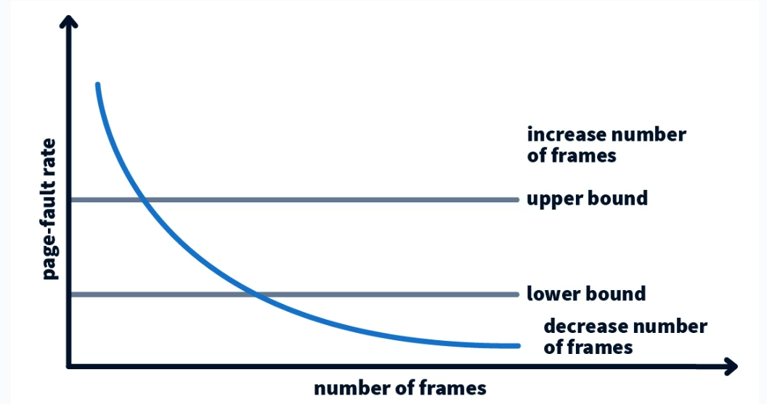

**2)Working set Model:**

The working set model estimates the set of pages that a process will need in the near future. By keeping track of the working set of each process and allocating memory accordingly, the operating system can reduce Thrashing in OS.