| NAME | RAJ SANJAY JADHAV |
| --- | --- |
| CLASS | BE-3-CSE |
| ROLL NO | 512024 |
| PRN | 2019033800129402 |

**PRACTICAL-1**

**.NET IN-BROWSER TUTORIAL**

## Step 1: Intro

## code:

**Console.WriteLine("Hello World!");**

output:

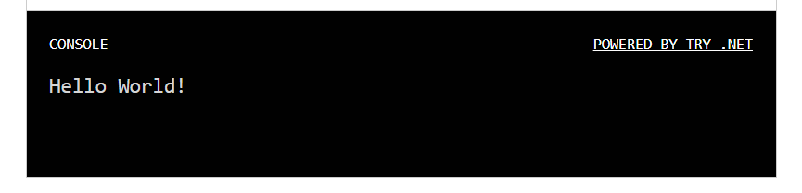

## 

## Step 2: Strings

## code:

## **Console.WriteLine("Hello Raj!");**

output:

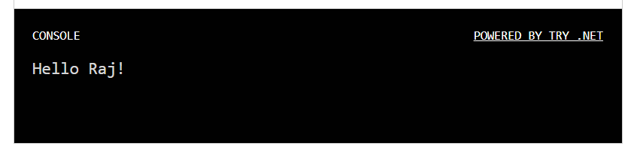

## Step 3: Variables

## code:

**var name = "Raj";**

**Console.WriteLine("Hello " + name + "!");**

output:

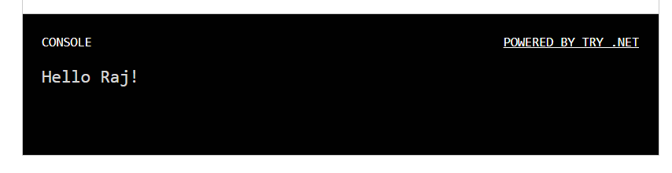

## Step 4: String interpolation

## code:

**var name = "Raj";**

**Console.WriteLine($"Hello {name}!");**

output:



## Step 5: Methods

## code:

**var name = "Raj";**

**Console.WriteLine($"Hello {name.ToUpper()}!");**

output:

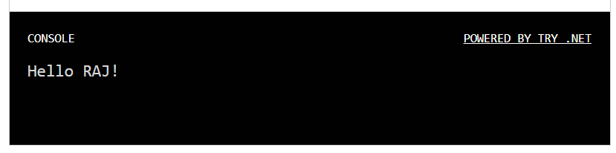

## Step 6: Collections

## code:

**var names = new[] { "Raj", "Felipe", "Emillia" };**

**foreach (var name in names)**

**{**

**Console.WriteLine($"Hello {name.ToUpper()}!");**

**}**

output:

