| NAME | RAJ SANJAY JADHAV |
| --- | --- |
| CLASS | BE-3-CSE |
| BATCH | B |
| ROLL NO | 512024 |
| PRN | 2019033800129402 |

**PRACTICAL - ASP.NET CORE MVC PROJECT**

**GIT REPOSITORY :** [**ASP.NET CORE MVC PROJECT**](https://github.com/Rajjadhav1710/.NET_Practical/tree/main/Practical-ASP.NET-CORE-MVC-PROJECT)

**OUTPUT:**

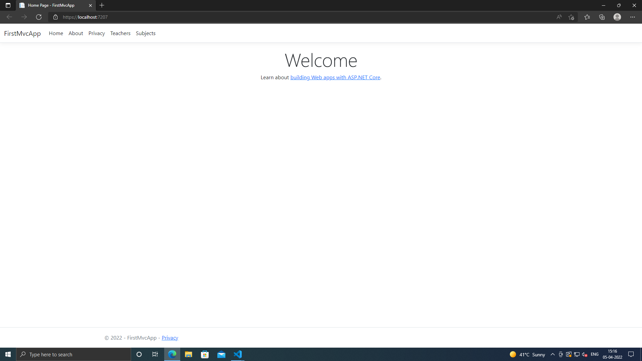

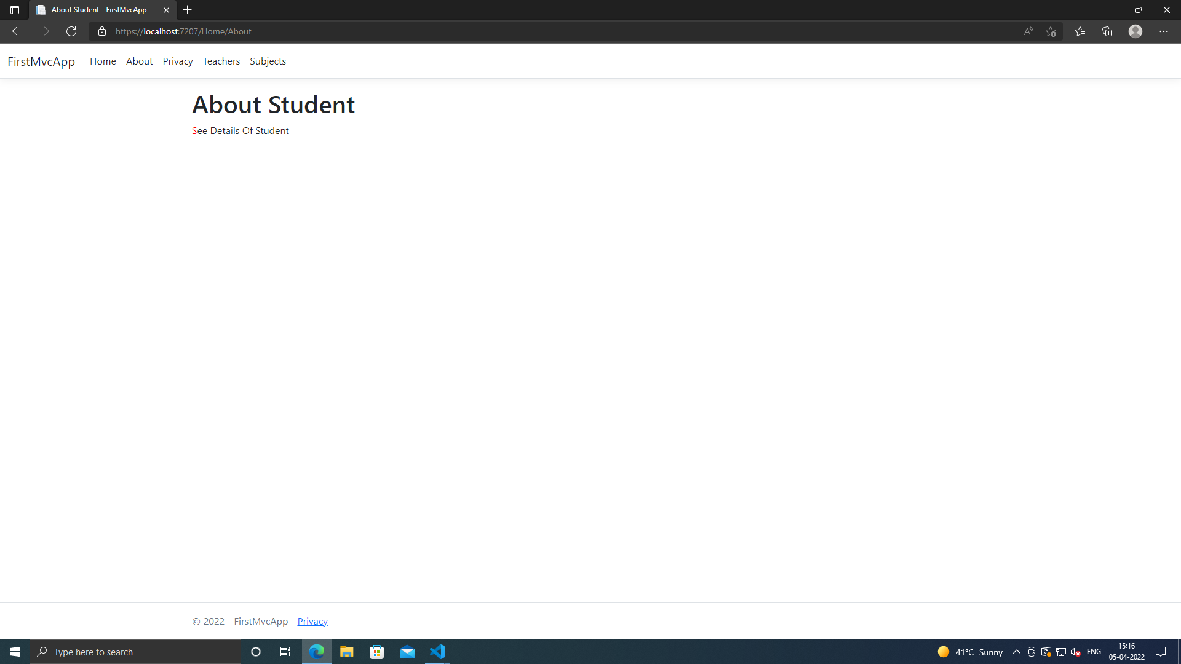

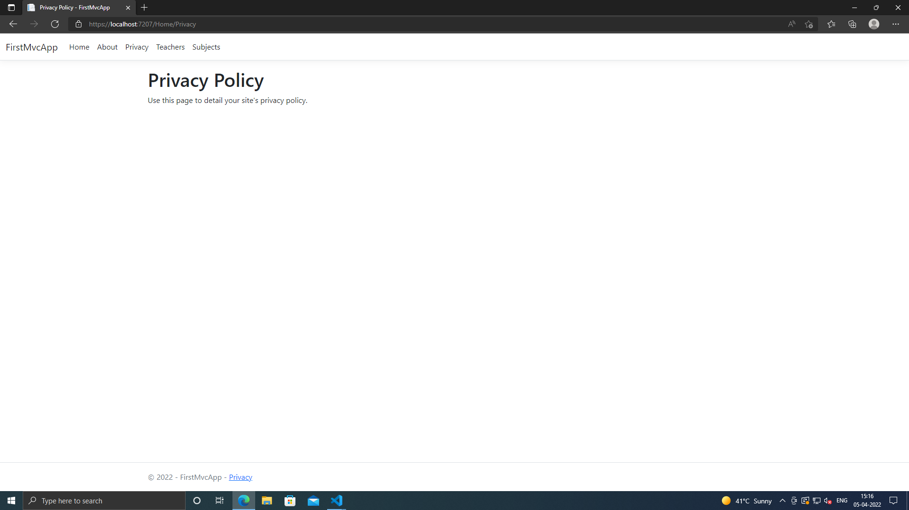

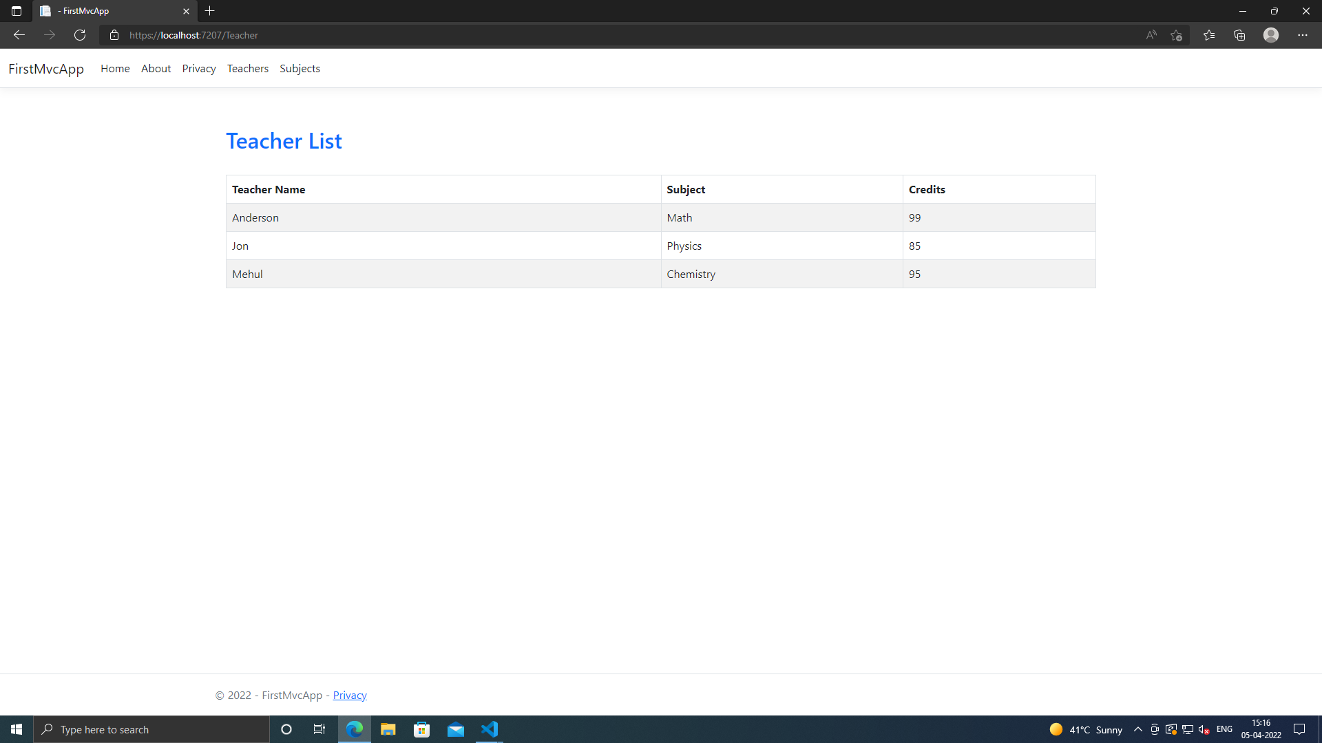

**SEARCH:**

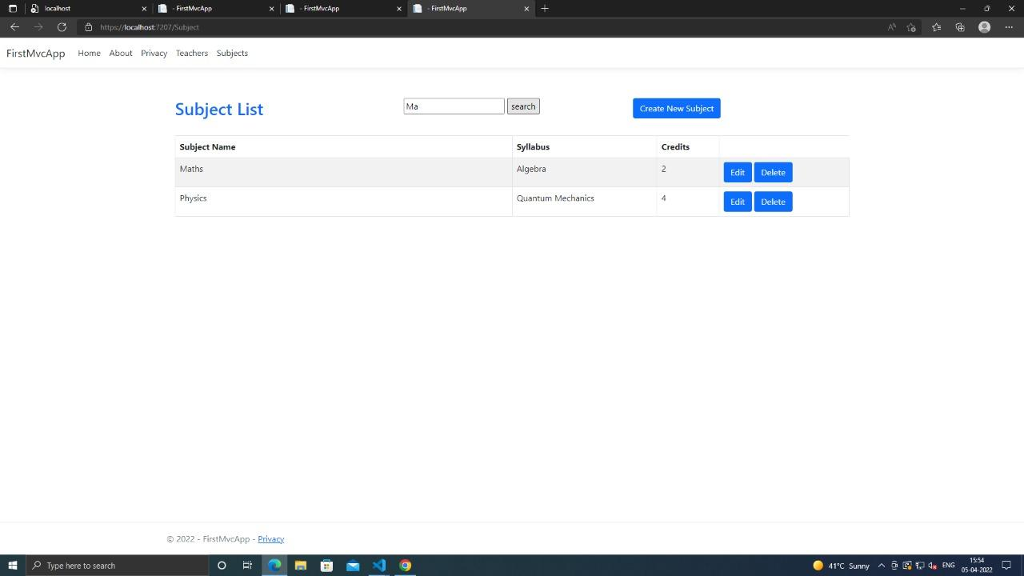

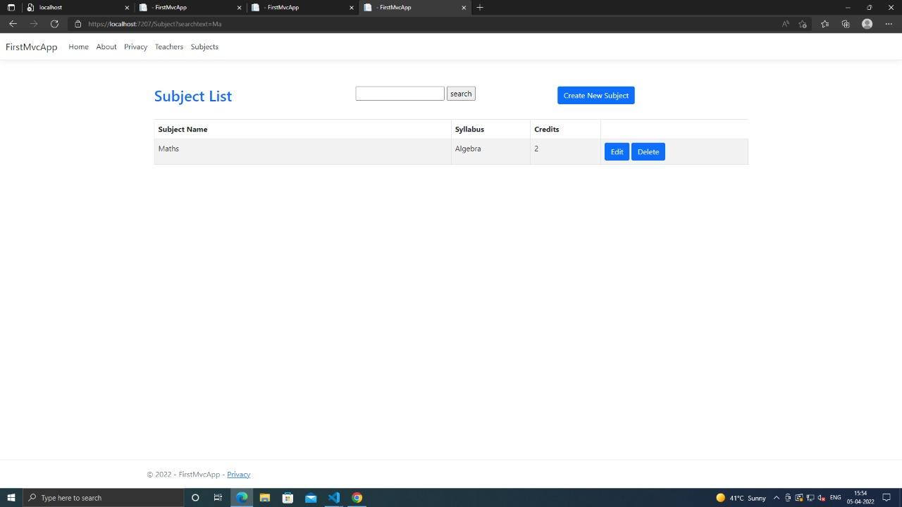

**CREATE:**

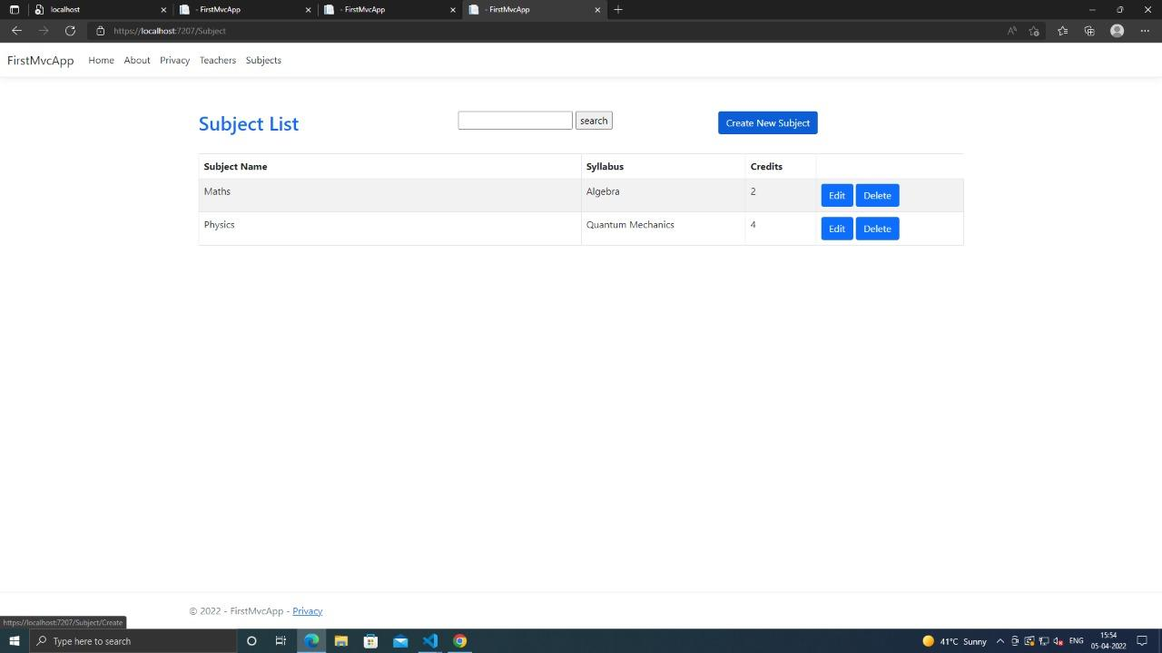

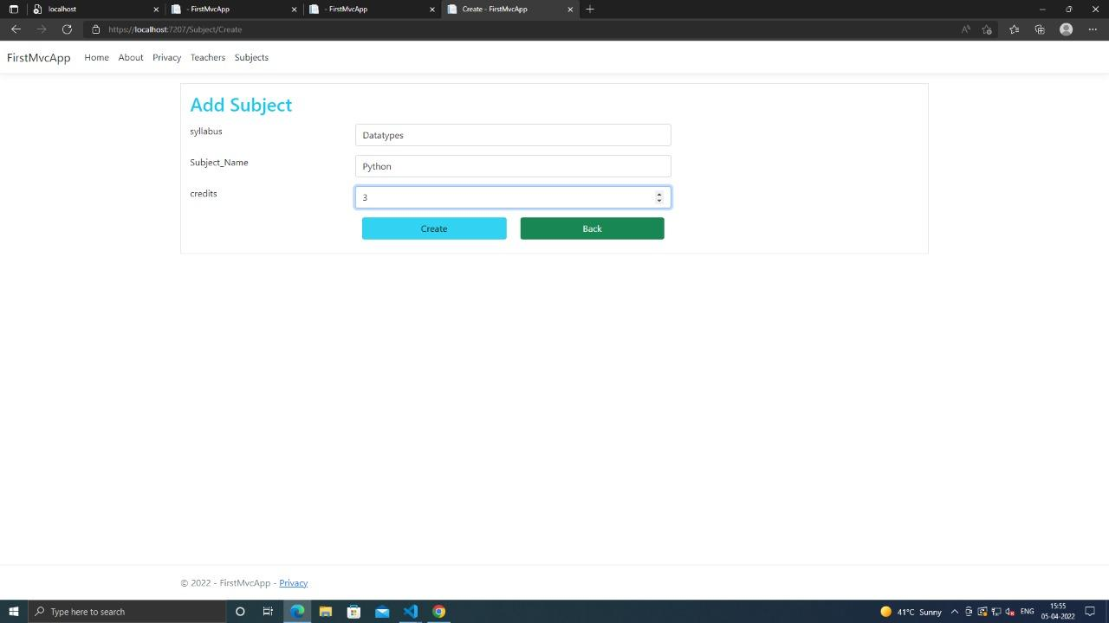

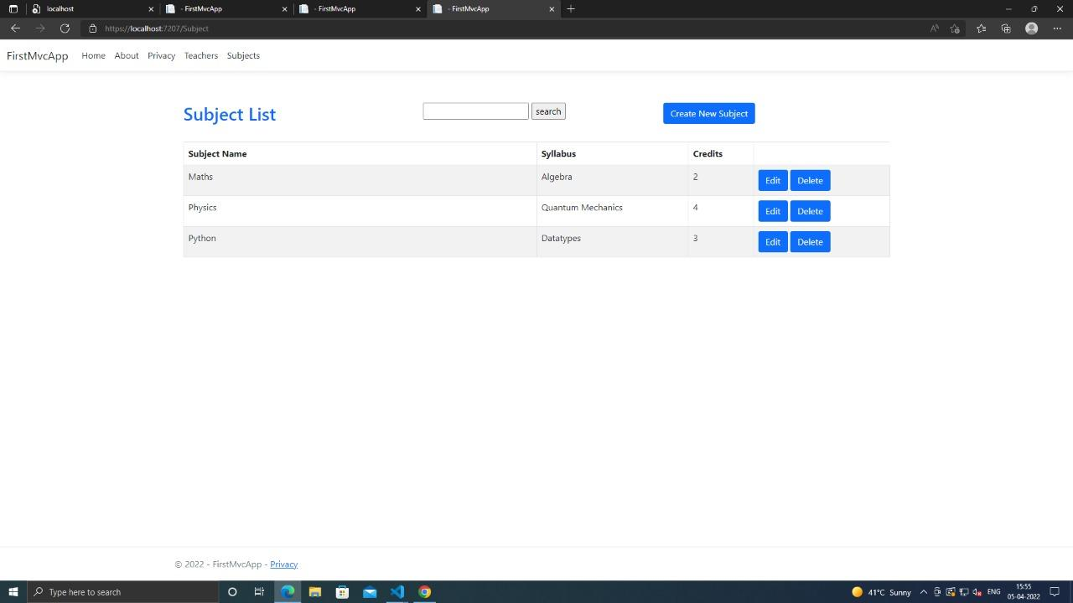

**EDIT:**

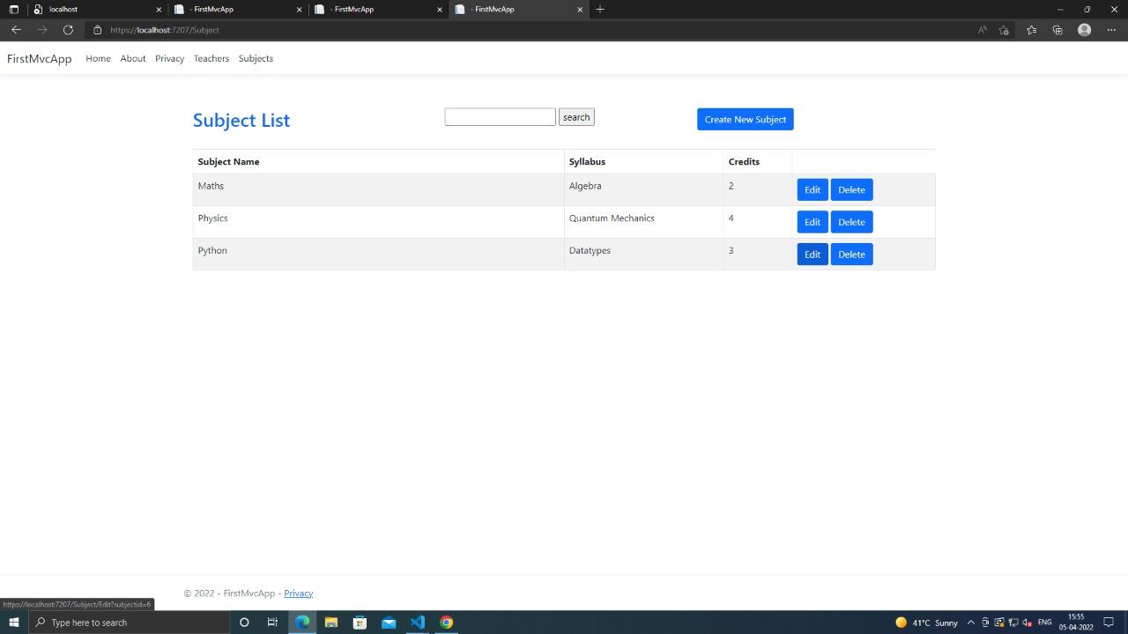

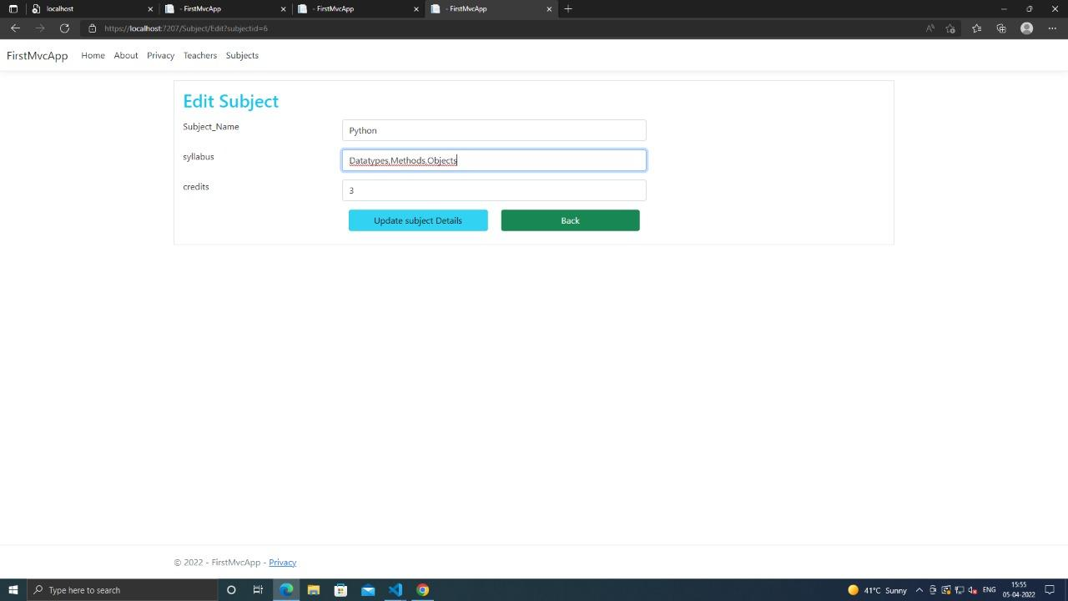

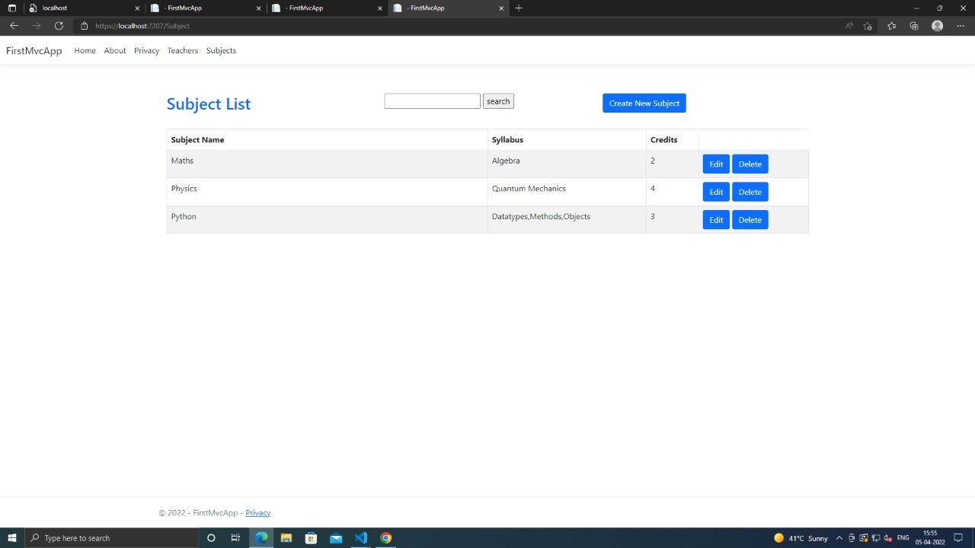

**DELETE:**

